PE Project-Part 5

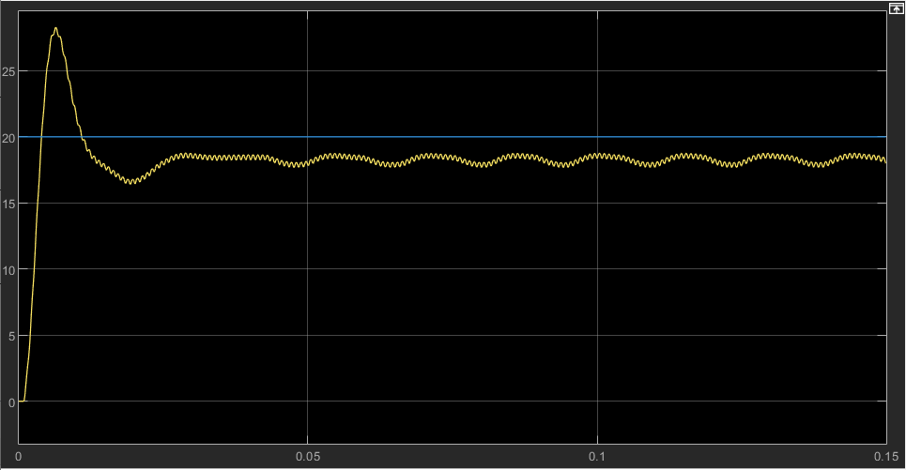
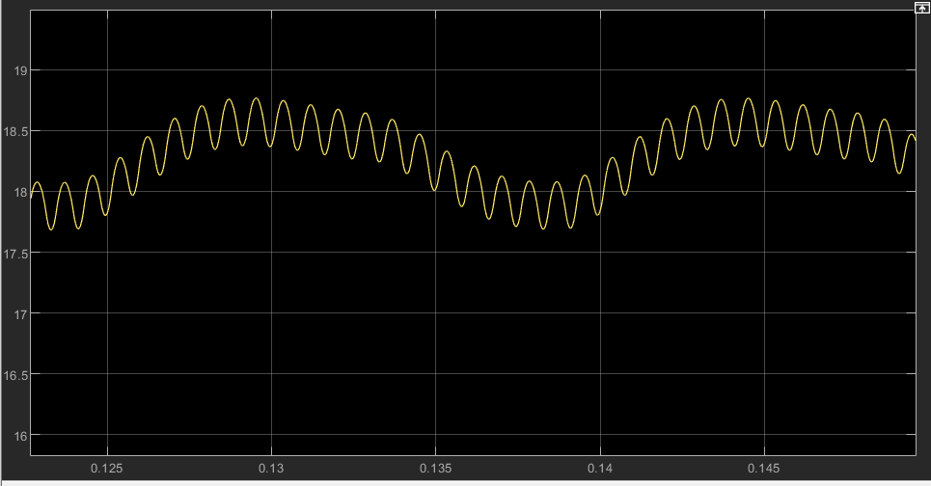
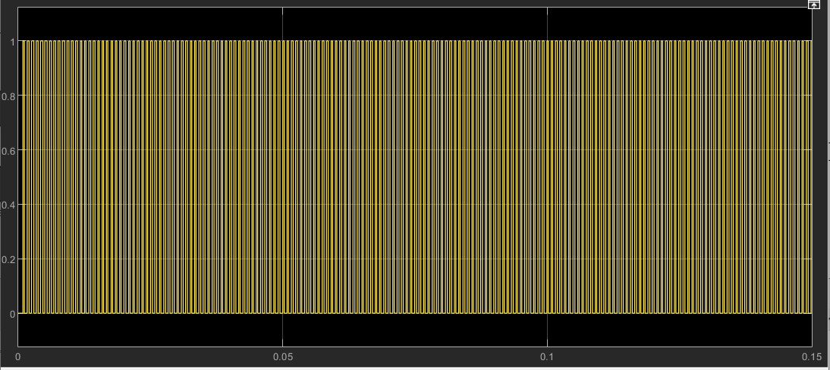
The model is stable (oscilant intretinut) has an overshoot of 54% and settles at 18.3 V with oscillations of $±$0.5 V. The ripple is $±$0.2V. It reaches a value close to the setpoint of 20V (~1.7 V smaller)
Now I am going to add values of the filteringFactor from 0 to 1 (0, 0.2, 0.5, 0.7 and 1)
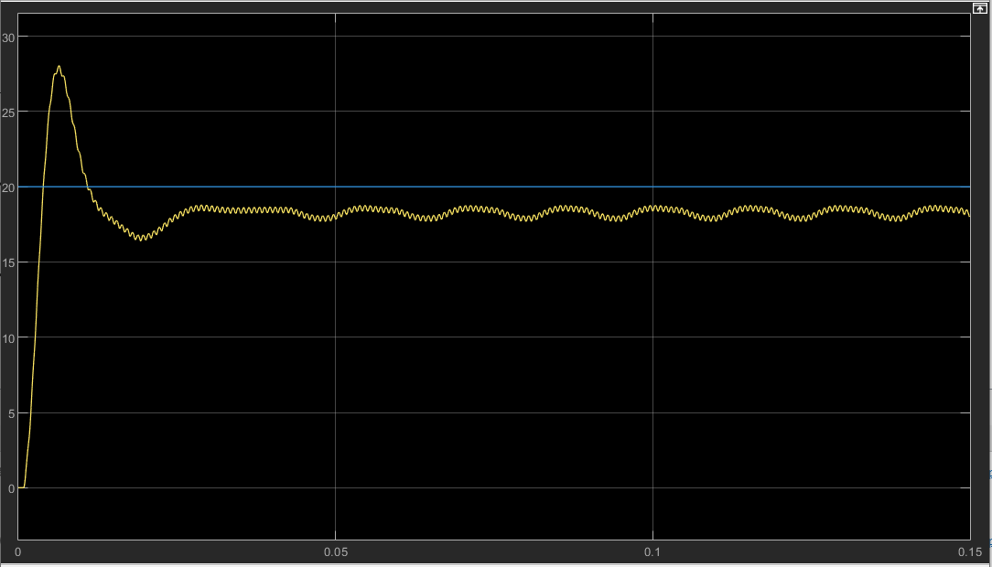
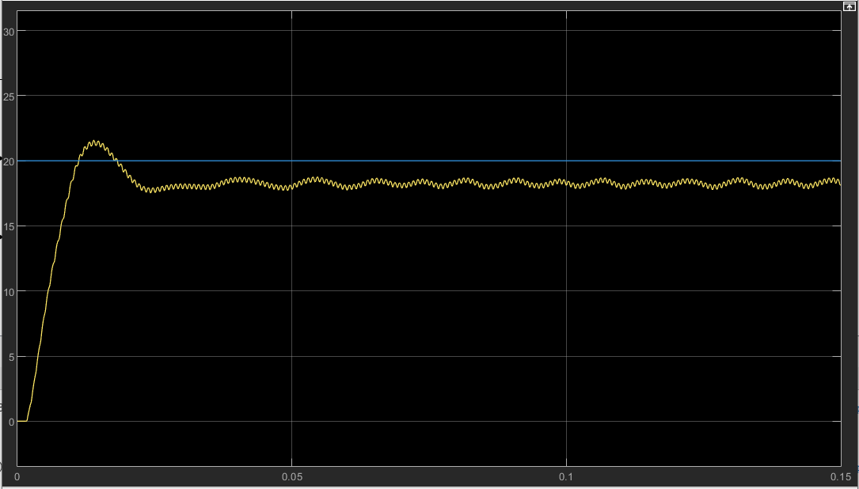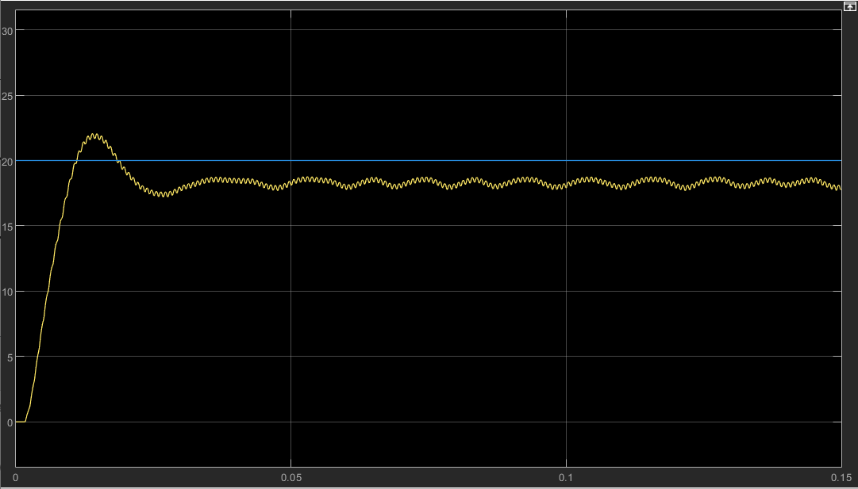

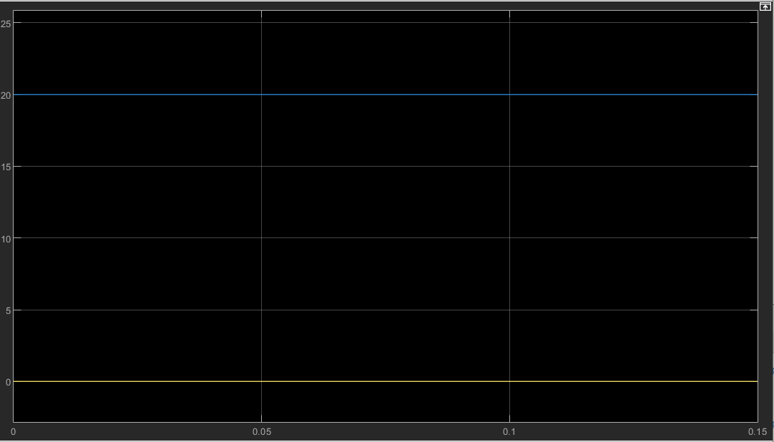
We notice that overshoot may differ for different values and the aspect of the periodic steady state signal may also change a little. In the 1 case we have no iutput at all because none of the input signal is filtered. The period of the steady state signal decreases as the filteringFactor increases.

I will also add the controller function and the plant for extra information
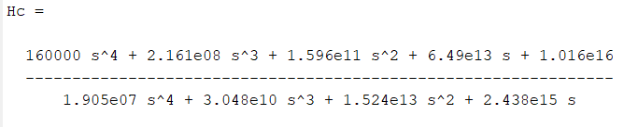
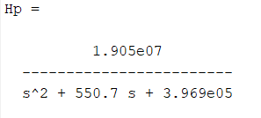

This is the reccurence equation written in code
