DISBURSEMENT TRACKING MANAGEMENT INFORMATION SYSTEM
FOR THE LOCAL GOVERNMENT UNIT OF LUNA

In Partial Fulfillment of the Requirements for the Course
ELECT COG 3 – Research Methods for IT

Submitted to:
MARIE ANN G. FONTANILLA, MIT

Submitted by:
DE GUZMAN, Kathleen Anne A.
NEGRANZA, Jem Vladimir L.
OCHANGCO, Andrei Luise E.
SERVITO, Louis Ricardo G.
MILAN, Jhuneille Mark A.
RIVERA, John Michael N.

March 2026
APPROVAL
hi

ACKNOWLEDGEMENT
We, the researchers of the study, wholeheartedly thank Almighty God for granting us wisdom, knowledge, strength, and inspiration, as well as the patience and guidance needed to successfully complete this research methods project.
We sincerely thank our Research Methods Teacher, Mrs. Marie Ann G. Fontanilla, for her guidance and encouragement. We also extend our deepest and most sincere gratitude to Saint Louis College for wholeheartedly allowing us to conduct this study, thereby giving us the valuable opportunity to explore and gain meaningful insights that empowered us to develop solutions grounded on the discoveries of our project.
Special recognition is sincerely given to the Local Government Unit of Luna (LGU Luna) – Accounting Office for their invaluable support, continuous guidance, valuable collaboration, and openness to adopting modern technology, innovative approaches, and methods in fostering financial management and program implementation.
Finally, we sincerely and wholeheartedly express our deepest gratitude to our families, friends, and classmates, whose constant encouragement, patience, and supports were vital to the successful completion of this project.

DEDICATION
We dedicate this research methods project to the chiefs and clerks of the Local Government Unit of Luna - Accounting Office, sincerely hoping that this Disbursement Tracking Management Information System will significantly improve the efficiency, accuracy, and transparency of financial support provided to the Filipino citizens.
We also dedicate this to our classmates and friends for their unwavering support and encouragement, and to our parents, grandparents, aunts, uncles, and sponsors for their generous financial assistance, which made our participation in Research Methods Project at Saint Louis College possible.
A special thanks to our research methods teacher for their patience, expertise, and dedication in guiding and supporting us in improving our studies and enhancing our system development skills.
Above all, we wholeheartedly and gratefully dedicate this research to Almighty God for granting us wisdom, perseverance, guidance, and steadfast strength and courage, which enabled us to successfully complete this project.
As we diligently progressed in writing this manuscript, we often and continually reflected on this inspiring quote, which served as a meaningful, powerful, and enduring reminder of our effort and unwavering determination.
ABSTRACT
hi
TABLE OF CONTENTS
Preliminaries | Pages
Title Page ………………………………………………………… | i
Approval …………………………………………………………. | ii
Acknowledgement ……………………………………………… | Iii
Dedication ……………………………………………………….. | iv
Abstract ………………………………………………………….. | v
Table of Contents ………………………………………………. | vi
List of Figures …………………………………………………… | viii
List of Appendices ……………………………………………… | ix
CHAPTER I: INTRODUCTION
Rationale …………………………………………………………. | 1
Conceptual Framework ………………………………………. | 6
Problem Definition …………………………………………….. | 9
Objectives of the Study ……………………………………….. | 11
Scope and Limitation …………………………………………. | 13
Definition of Terms …………………………………………….. | 16
Hardware and Software Requirements ……………………. | 19
CHAPTER II: DATA GATHERING METHODS
Research Design ……………………………………………….. | 20
Locale of the Study …………………………………………….. | 23
Primary Source of Data ………………………………………. | 25
Secondary Source of Data ……………………………………. | 26
Ethical Consideration …………………………………………. | 28
CHAPTER III: DATA MODELS
Existing Process Flowchart ………………………………..…. | 29
Proposed Process Flowchart …………………………………. | 32
Use Case Diagram ……………………………………………… | 36
Top Level Diagram …………………………………………….. | 37
Input – Process – Output Diagram ………………………… | n/a
CHAPTER IV: SCREENSHOTS
Forms …………………………………………………………….. | n/a
Reports …………………………………………………………… | n/a
REFERENCES | n/a
APPENDICES | n/a
INSTITUTIONAL VISION AND MISSION | n/a

LIST OF FIGURES
Figures |  | Pages
1 | Hardware Requirements ……………………………………. | 19
2 | Software Requirements …………………………………….. | 19
3 | Existing Process Flowchart ………………………………… | 29
4 | Proposed Process Flowchart ………………………………. | 32
5 | Use Case Diagram …………………………………………… | 36
6 | Top Level Diagram …………………………………………… | 37
7 | Input – Process – Output Diagram ………………………. | n/a

LIST OF APPENDICES
Appendix |  | Pages
A | Letter of Request to Conduct Study ……………………. | n/a
B | Letter of Invitation to External Panelist ……………….. | n/a
C | Sample Company Forms …………………………………. | n/a
D | Interview Questions ………………………………………. | n/a
E | Picture taken during the Interview …………………….. | n/a
F | Certificate of Language Editor ………………………….. | n/a
G | Gantt Chart …………………………………………………. | n/a
H | User Manual ………………………………………………… | n/a

Chapter I
INTRODUCTION
Rationale
Effective financial management is vital for LGUs to ensure responsible, transparent use of funds in accordance with regulations. Monitoring disbursements maintains accountability and proper resource allocation. Agencies such as the Department of Budget and Management and the Commission on Audit emphasize accurate documentation, proper authorization, and systematic monitoring to strengthen controls and transparency. Many LGUs still use manual or semi-automated processes, leading to delays, limited real-time oversight, and errors. As financial activities grow, a more efficient, tech-driven approach becomes crucial. A Disbursement Tracking Management Information System can provide a centralized platform for recording, tracking, and managing transactions, enhancing transparency, reporting, and accountability.
Governments worldwide are rapidly shifting from manual, fragmented financial processes to Integrated Financial Management Information Systems (IFMIS) and even blockchain-based tracking to improve transparency and efficiency in public spending. Many countries now use real-time digital disbursement models, such as India’s Public Financial Management System, which tracks funds from central treasuries to final beneficiaries to reduce diversion and leakage (Ministry of Finance, 2025). Standardization efforts, such as South Africa’s Municipal Standard Chart of Accounts, further strengthen fiscal discipline by enabling national oversight of local government spending through unified digital reporting systems (National Treasury, 2025). Emerging innovations, including the World Bank’s blockchain-based FundsChain initiative, are creating tamper-proof audit trails that enhance accountability and public trust (Gourfinkel & Fernández, 2025). However, persistent challenges such as weak infrastructure, poor system interoperability, and limited digital skills among local staff continue to slow adoption in many developing regions (UN DESA, 2024).
According to the Philippine Department of Budget and Management (DBM, 2023), the Philippine government has strengthened its public financial management reforms through the digitalization of government financial processes. One of the major initiatives under this reform is the implementation of Integrated Financial Management Information Systems (IFMIS) and the Budget and Treasury Management System (BTMS). These centralized digital platforms were developed to improve the monitoring, recording, and reporting of government financial transactions, particularly for fund releases and disbursements. Managed by the DBM in coordination with national government agencies, IFMIS and BTMS serve as unified systems that integrate financial data into a single platform. These systems allow government offices to track the status of budget allocations and disbursements in real time, generate accurate financial reports, and maintain reliable audit trails. By automating previously manual processes, the systems help reduce administrative delays, minimize human errors, and improve overall efficiency in public financial operations. Furthermore, the Philippine government continues to expand its digital governance initiatives under the Public Financial Management Reforms Roadmap 2024–2028, which emphasizes transparency, accountability, and fiscal discipline. The roadmap highlights the importance of modern information systems in strengthening financial controls and ensuring that public funds are properly utilized. Through these national reforms, the government aims to provide citizens with greater access to financial information and enhance trust in public institutions.
According to the Department of Budget and Management (DBM, 2022), effective public financial management requires organized systems, procedures, and practices that support transparent, accountable, and efficient management of public funds, including budgeting, accounting, auditing, and reporting mechanisms within local government units. Effective tracking of disbursements at the regional level is crucial for ensuring that municipal funds in the Municipality of Luna, La Union, are utilized efficiently, transparently, and in accordance with approved budgets and government regulations. While the municipality generally complies with national accounting and auditing standards, evidenced by consistently achieving the Department of the Interior and Local Government’s Seal of Good Financial Housekeeping, its reliance on manual or semi-automated systems for monitoring disbursements hampers real-time visibility, delays financial reconciliation and reporting, and increases reliance on time-consuming manual verification during audits. As development programs and public service initiatives expand, the volume and complexity of disbursement transactions continue to rise, emphasizing the need for a centralized, real-time Disbursement Tracking Management Information System to enhance internal controls, improve reporting accuracy, and align the LGU of Luna with modern digital financial management practices within the Province of La Union.
According to Nationales (2025), the Accounting Office utilizes Google Sheets as a centralized tracking mechanism for disbursements. This digital ledger facilitates real-time monitoring of the document workflow, ensuring transparency as vouchers circulate through various departments before returning to the Accounting Office for final processing. By leveraging cloud-based technology, the office eliminates the traditional reliance on physical logbooks, which often lead to information silos and delayed tracking. This system allows authorized personnel across different units to update the status of financial documents simultaneously, creating a single source of truth that reduces the need for redundant follow-ups. Furthermore, the use of automated timestamps and data validation within the spreadsheet enables the office to identify specific bottlenecks in the approval cycle, thereby improving the overall speed and accountability of the disbursement process.
Technology plays a vital role in improving efficiency, accuracy, and transparency in organizational processes, particularly in the management of financial transactions within public institutions. Despite the availability of technological solutions for data handling, the Local Government Unit of Luna continues to rely on manual, paper-based procedures for its disbursement processes, leading to slow record retrieval, a higher risk of data loss and duplication, limited inter-departmental coordination, and delays in financial reporting. These conditions highlight the need for a more systematic and technology-driven approach to managing disbursement information. In response to these challenges, this study proposes the development of a Disbursement Tracking Management Information System for the Local Government Unit of Luna, which applies Information Technology through a centralized database, automated workflows, and digital reporting tools to track disbursement transactions from request to release, improve data accuracy and accessibility, and strengthen financial control. The implementation of this IT-based solution is necessary to address current operational limitations and to support more efficient, transparent, and accountable financial management within the Local Government Unit of Luna.

Conceptual Framework
Local Budget Memorandum No. 92, dated June 9, 2025, issued by the Department of Budget and Management (DBM) provides the indicative National Tax Allotment (NTA) shares of Local Government Units and sets forth guidelines for the preparation of the FY 2026 annual budgets. The memorandum outlines the fiscal framework within which LGUs are expected to plan, allocate, and manage public funds in accordance with national budgeting policies. It emphasizes adherence to budget ceilings, prioritization of programs and projects, and compliance with prescribed budget preparation timelines and procedures.
Further, Local Budget Memorandum No. 92 details the responsibilities of LGUs in ensuring accurate documentation, proper classification of expenditures, and consistency in financial reporting. It highlights the importance of aligning local budgets with national development priorities and maintaining fiscal discipline throughout the budget cycle. The memorandum also underscores the need for organized financial records and timely submission of budget-related reports, reinforcing the role of systematic financial management in promoting transparency and accountability at the local government level.
National Government Disbursements as of December 2024, issued by the Department of Budget and Management (DBM) presents a comprehensive report on the disbursement performance of the national government for the fiscal year. The report provides detailed data on the release and utilization of public funds across various expenditure categories, including personnel services, maintenance and other operating expenses, and capital outlays. It reflects how government resources are allocated and disbursed over time, serving as an official record of financial execution at the national level.
Additionally, the NG Disbursements December 2024 report demonstrates the scale, volume, and complexity of government disbursement activities and the importance of systematic tracking and reporting mechanisms. The document highlights the reliance of national financial management on structured data, consolidated reporting, and timely monitoring of fund utilization to ensure fiscal discipline and transparency. Through its detailed presentation of disbursement figures and trends, the report illustrates how organized financial data supports oversight, analysis, and accountability in government financial operations.
Chapter 6 of the Government Accounting Manual (GAM) Volume I, issued by the Commission on Audit, outlines the policies and procedures for disbursement transactions in government agencies. Disbursement is defined as cash payment or settlement of obligations from authorized expenditures. The chapter details the necessary documentation, approval processes, and internal controls required before payments are made, including the flow from obligation requests to the preparation and approval of Disbursement Vouchers (DVs) and related accounting records.
Further, Chapter 6 provides structured documentation requirements, including the preparation and processing of the Disbursement Voucher, the Journal Entry Voucher (JEV), and other supporting forms, to ensure proper recording and an audit trail of transactions. It specifies the roles and responsibilities of accountable officers, including the Budget Officer, Accountant, Treasurer, and approving authority, emphasizing accountability and traceability in financial operations. The chapter also discusses modes of disbursement, including cash advances, checks, and electronic payments, as well as reconciliation and reporting procedures to maintain the integrity of government financial records. Through standardized workflows and defined documentation protocols, the chapter serves as the authoritative reference for lawful, transparent, and controlled government disbursement practices.
Problem Definition
The researchers proposed the development of Disbursement Tracking Management Information System to solve existing problems encountered by the Local Government Unit of Luna.
The identified problems in the current process are as follows:
- Reliance on Physical Storage of Financial Statements
The financial statements and accompanying documents are meticulously housed in a dedicated room designed for security. While this setup effectively safeguards these crucial records from unauthorized access, it also imposes significant limitations on accessibility. This restricted environment not only elevates the risk of potential loss or damage to these vital documents but also leads to delays in timely reporting. The cumbersome retrieval process complicates audits and financial oversight, ultimately diminishing the overall efficiency and transparency of financial operations.
- Manual and Unstructured Disbursement Voucher with Journal Processing
The Municipality of Luna manages Disbursement Vouchers with attached Journal entries through a manual and unstructured process that lacks standardized categorization, labeling, and indexing. Employees are required to manually locate and review physical or loosely organized records before encoding or verifying financial data. This process is time-consuming and increases the likelihood of misplaced documents, data entry errors, and duplication of records. The absence of a systematic classification and retrieval mechanism limits transaction traceability, delays financial recording and reconciliation, and weakens overall efficiency in documenting disbursement-related journal entries for reporting and audit purposes.
- Inefficient Inter-Departmental Disbursement Tracking
The Municipality of Luna currently depends on cumbersome manual processes and simplistic tools like Google Sheets to oversee its disbursement-related financial data. This reliance leads to a disjointed collection of information, which complicates coordination among departments and introduces significant processing delays. The possibility of human error increases, further undermining the integrity of financial operations. As a result, accountability in financial matters is compromised; the speed and accuracy of reporting and reconciliation suffer, and the ability to make prompt budget adjustments, which are crucial for effective service delivery, becomes severely limited.

Objectives of the Study
The primary objective of this study is to design and develop a Disbursement Tracking Management Information System for the Local Government Unit of Luna to improve efficiency, accuracy, accessibility, and transparency in the management of disbursement and financial records.
Specifically, this study aims to:
- To design and develop a centralized Disbursement Tracking Management Information System to streamline inter-departmental disbursement tracking with structured workflows, automation, real-time status monitoring, and role-based access control. This system includes automated notifications and reports to inform personnel of approvals and transactions. These features reduce delays, manual follow-ups, data inconsistencies, and human errors from fragmented spreadsheets.
- To develop and implement a structured digital module for managing Disbursement Vouchers with Journal Entries by introducing standardized categorization, labeling, and indexing mechanisms through automated voucher numbering, predefined account code selection, searchable metadata fields, and digital record tagging within a centralized database. These features will enable faster document retrieval, improve transaction traceability, reduce encoding errors via validated input forms and dropdown selections, and streamline financial recording and reconciliation processes by automating the linking of Disbursement Vouchers and corresponding Journal Entries.
- To improve the existing spreadsheet-based disbursement tracking system, a web-based workflow will be implemented. This system will feature automated routing of disbursement records, task assignment, and status monitoring across departments, along with system-generated notifications and approval queues to reduce manual follow-ups. It will also employ role-based access control through authenticated user accounts with predefined permissions for budget officers, accountants, and approving authorities, ensuring that users can only view, edit, or approve transactions pertinent to their roles. These features will enhance coordination, enable real-time tracking of transaction progress, and reduce processing delays.
Scope and Limitation
In the proposed system, there are six (6) types of users, namely: System Administrator, Accountant, Budget Officer, Treasurer, Secretary, and Technical Officer. Each user is required to have an authorized account to access the system, and system functions are restricted through role-based access control.
The System Administrator is responsible for overall system management, including user account creation, modification, and access control. The administrator also manages system configurations, maintains centralized records, and ensures data availability for reporting purposes.
The Accountant is authorized to record, review, and monitor disbursement vouchers, generate financial summaries, and validate budget versus actual expenditure reports. This role focuses on ensuring the completeness and accuracy of financial transaction records.
The Budget Officer is responsible for monitoring fund utilization, managing budget allocations, and generating budget utilization and comparison reports per office. The system allows the Budget Officer to track approved budgets against actual disbursements to support fiscal planning and control.
The Treasurer handles the recording and monitoring of cash-related transactions, including petty cash fund balances and disbursements. The system provides tools for tracking fund releases and maintaining updated cash records for reference and reporting.
The Secretary is tasked with encoding, filing, and tracking the status of disbursement documents and requests. This role supports document flow monitoring and ensures that transaction records are properly logged within the system.
The Technical Officer is granted access to office-based financial reports and disbursement status updates to support internal monitoring, coordination, and administrative decision-making.
Overall, the system tracks disbursement voucher status, monitors fund utilization, generates budget versus actual reports, records petty cash transactions, and provides centralized financial records to enhance transparency and decision-making within the Local Government Unit (LGU).
Despite its capabilities, the proposed system has several limitations. First, the system is not a full-scale accounting system and does not include core accounting functions such as general ledger management, payroll processing, revenue collection, or automated financial posting.
Second, user access is strictly role-based, limiting each office to viewing and managing only the records related to their assigned responsibilities. Cross-office access to detailed financial data is restricted unless explicitly authorized.
Third, the system does not automatically integrate with national government financial systems or external accounting platforms. All financial data must be encoded manually, making the system dependent on timely and accurate user input.
Fourth, the accuracy and reliability of generated reports depend on the correctness of the data entered by users. Errors or delays in data encoding may affect report validity and decision-making outputs.
Lastly, the system’s operation is dependent on the availability of computer equipment, stable electricity, and network connectivity within the LGU. System performance and accessibility may be affected by hardware limitations or infrastructure issues.
The proposed system has several limitations: (a) It is not a comprehensive accounting system and lacks functions like general ledger, payroll, and revenue collection. (b) User access is limited to specific office roles, allowing access only to relevant records. (c) There is no automatic integration with national government financial systems, requiring manual data entry. (d) Report accuracy depends on the correctness of user-entered data. (e) The system relies on available computer equipment, electricity, and network connectivity within the LGU.
Definition of Terms
To ensure clarity and consistency of this study, the following contextual terms, concepts, and expressions used throughout are explicitly and thoroughly defined.
Barangay Financial Data refers to financial records and data submitted by barangays, including budget allocations, expenditures, and disbursement-related information. These data are consolidated within the system to support municipal-level monitoring and analysis.
Centralized Database is a single digital repository where all disbursement-related records and financial data are stored and managed. The centralized database enables consistent data access, reduces duplication, and supports efficient retrieval and reporting.
Disbursement refers to the release of municipal funds for approved financial obligations of the Local Government Unit of Luna. In this study, disbursement involves the processing, monitoring, and recording of fund releases through a computerized system to ensure accuracy, transparency, and timely financial reporting.
Disbursement Tracking Management Information System (DTMIS) is a computerized information system designed to record, monitor, and manage disbursement transactions from request to fund release. The system centralizes financial records, automates transaction tracking, and supports reporting to improve efficiency, accountability, and transparency within the LGU.
Disbursement Transaction refers to the complete process of requesting, reviewing, approving, and releasing funds recorded within the disbursement tracking system. Each transaction is documented to ensure proper authorization, accountability, and auditability.
Financial Reporting is the process of generating summaries, statements, and analytical reports related to disbursement transactions and fund utilization. In this system, reports are generated electronically to support transparency, auditing, and management decision-making.
Municipal Finance is the management of financial resources of the municipality, including budgeting, fund allocation, and disbursement. In this study, municipal finance activities are monitored through the disbursement tracking system to support informed decision-making and financial control.
Municipal Funds or Public Funds allocated to the municipality for operational and developmental purposes, including salaries, maintenance of public facilities, and infrastructure projects. These funds are monitored through the system to ensure proper utilization and compliance with government regulations.
Role-Based Access Control is a security mechanism that restricts system access and functions based on user roles such as Administrator, Accountant, Budget Officer, Treasurer, Secretary, and Administrative Officer. This ensures that users can only access data and functions relevant to their responsibilities.
Transaction Status indicates the current stage of a disbursement transaction within the system. Transaction statuses include Pending (awaiting approval or required documents), Approved (authorized for fund release), and Released (funds have been successfully disbursed).
Audit Trail refers to a chronological record of system activities that documents all actions performed on disbursement transactions, including data entry, approval, modification, and release. In this study, the audit trail supports accountability, traceability, and compliance with government auditing requirements.
Workflow Process is the structured sequence of steps that a disbursement transaction follows within the system, from request submission to final fund release. The workflow process defines roles, approvals, and document movement to ensure orderly processing, reduce delays, and improve coordination among LGU departments.

Hardware and Software Requirements
Hardware Requirements
Hardware | Server | Client
Memory | 8 GB | 8 GB or Higher
Processor | 3 GHz | 3 GHz or Higher
Storage | 512 GB SSD | 512 GB SSD or Higher

Software Requirements
Software | Server | Client
Operating System | Windows 10/11 | Windows 10/11
Web Browser | Any Web Browser | Any Web Browser
Database Server | XAMPP/Cloud | XAMPP/Cloud

Chapter II
DATA GATHERING METHODS
Research Design
Descriptive and developmental research designs were utilized in the creation of the Disbursement Tracking Management Information System for the Local Government Unit of Luna. Descriptive research design is a crucial methodology for studies aiming to describe phenomena, such as the improvement of efficiency, accuracy, and transparency in organizational processes. This type of research focuses on providing an accurate portrayal of the characteristics of a particular subject or process.
In this study, employing a descriptive research design will allow the researchers to systematically gather, organize, and present information about the Disbursement Tracking Management Information System. Descriptive research aids in understanding the phenomenon, identifying patterns and trends, and serves as a foundation for future research and improvements. Data collection will involve documenting the steps involved in the design features of the grain collector machine and the efficiency of the machine itself.
Developmental research design is defined as the systematic study of designing, developing, and evaluating instructional programs, processes, and products that must meet the criteria of internal consistency and effectiveness. Developmental research is fundamental in the field of instructional technology. The most common types of developmental research involve situations in which the product-development process is analyzed and described, and the final product is evaluated (International Journal of Research Publication and Reviews, 2024).
Design and development research are "the systematic study of design, development, and evaluation processes with the aim of establishing an empirical basis for the creation of instructional and non-instructional products and new or enhanced models that govern their development." Design and development research, in its most basic form, is the study of the process and effects of particular design and development efforts, or the study of the process as a whole, or of specific process components. This type of research can involve situations where someone is studying other people's design and development work, but it can also include situations where someone is doing design and development activities while also studying the process (International Journal of Research Publication and Reviews, 2024).
There is a difference between researching the process and actually carrying out design and development in both scenarios. The design and development research design were suitable for this study since the researchers conceptualized the design of the Disbursement Tracking Management Information System for the Local Government Unit of Luna. With the effectiveness and functionality of the system in mind, observations will be made to ensure correct alignment and proper assembly. Trials will be conducted on the project in order to evaluate its effectiveness and test the system. Up until the design is deemed functional and acceptable, any errors in the system will be corrected immediately.

Locale of the Study
This study was conducted at the Local Government Unit (LGU) of the Municipality of Luna, a coastal municipality in the Province of La Union, Philippines. As a frontline government institution, the Luna LGU is responsible for local administration and the delivery of public services, including the effective management and utilization of municipal resources. It is guided by its mission “to provide excellent public service through good governance, fostering a sustainable economy and environment guided by the Almighty God,” which underscores its commitment to transparency, accountability, and efficiency in governance, particularly in the handling of public funds. As a component LGU of the Province of La Union, it operates within the province's broader governance and development framework.
Anchoring its institutional direction in the provincial development roadmap, the LGU of Luna aligns with La Union’s long-term vision to become a Center of Innovation and Growth in Region 1 by 2035. This roadmap emphasizes effective and inclusive governance, including strengthening policy and regulatory systems and, most notably, integrating digital solutions in processes and services. Such a governance thrust supports the modernization of municipal-level administrative and financial systems. In this regard, LGU of Luna provides an appropriate and relevant setting for a capstone project that proposes a technology-enabled solution to strengthen financial monitoring and accountability in local public administration.
Within this setting, the study focuses on the disbursement-related processes of the LGU of Luna, particularly the monitoring and documentation of disbursement transactions. Existing practices remain largely manual and semi-automated, relying on paper-based documentation and spreadsheet-based tracking. These conditions may lead to operational concerns, such as delayed verification, fragmented and duplicated records, difficulty retrieving supporting documents, and increased exposure to errors or data loss, which directly affect the traceability, reliability, and integrity of disbursement management.
Hence, the Municipality of Luna serves as an appropriate locale for the development of the proposed Disbursement Tracking Management Information System (DTMIS). The system is intended to systematize the disbursement trail from request initiation and processing through approval and fund release, improving record integrity, minimizing redundancy, and strengthening monitoring and reporting mechanisms. Ultimately, the DTMIS supports Luna’s mission of excellent public service through good governance while aligning with the province’s direction toward digital integration and innovation-driven governance processes.
Primary Sources of Data
Interview
An interview method was utilized to gather essential information throughout the study. The first interview was conducted with the Local Government Unit (LGU) of Luna, Head of the Accounting and Budget Office, on January 23, 2026, after the company hunt and the submission of the permission-to-conduct letter, which served as initial preparation for the title presentation. On January 30, 2026, another interview was conducted to have a follow-up questionnaire regarding the existing disbursement system and request a physical copy of the sample forms.
Focused Group Discussion
Focused Group Discussions was utilized to gather essential information throughout the study. On January 30, 2026, the first focused group discussion was conducted with the Local Government Unit (LGU) of Luna, Head for the Accounting and Budget Office and accountants to gather more information about the existing disbursement tracking problems and request for a copy of the sample forms that is related to the study including the copy of the sample spreadsheets.

Secondary Sources of Data
Articles
Several online articles and government reports support the technological and policy background of this study. The Department of Budget and Management (2023) article on digital transformation explains the government’s initiative to modernize public financial management through digital systems, emphasizing automation and improved transparency in financial transactions. Similarly, the Department of Budget and Management (2024) report titled National Government Disbursements as of December 2024 provides detailed data on government fund utilization and highlights the importance of structured disbursement monitoring and financial reporting for accountability. The Department of Budget and Management (2025) Local Budget Memorandum No. 92 outlines guidelines for local government budget preparation, emphasizing proper documentation, compliance with standards, and responsible fiscal management.
From an international perspective, the World Bank (2023) states that Financial Management Information Systems (FMIS) enhance transparency and efficiency through centralized financial databases and automated processes. The International Journal of Research Publication and Reviews (2024) describes developmental research as a systematic approach involving the design, development, and evaluation of technology-based products for information system projects. The National Privacy Commission, through the Data Privacy Act of 2012, emphasizes the importance of protecting personal and financial data, highlighting privacy, security, and proper data handling in digital systems.
Books
The primary book supporting the methodological foundation of this study is the work of Rita C. Richey and James D. Klein (2007), Design and Development Research: Methods, Strategies, and Issues. This book defines design and development research as the systematic study of design, development, and evaluation processes aimed at producing effective instructional and non-instructional products. It emphasizes analyzing both the process and outcomes of development efforts, making it a strong foundation for system development research.
In addition, the Commission on Audit (2015) Government Accounting Manual (GAM) Volume I serves as a key reference for government financial procedures. The manual provides standardized rules for disbursement processing, accounting documentation, and financial control mechanisms, including the preparation of disbursement and journal entry vouchers. This book establishes the formal accounting framework followed by government agencies and local government units, ensuring compliance and accountability in financial transactions.
Ethical Consideration
The development of the Disbursement Tracking Management Information System for Luna’s Local Government Unit adhered to rigorous ethical standards throughout the research process. Before data collection, the research team secured informed consent from the municipal office head, who served as the sole participant, through formal coordination channels. Consent was obtained through a process grounded in trust, enthusiasm, and mutual respect, ensuring complete transparency regarding the study’s objectives and scope. The municipal office head was informed that the discussions would be audio-recorded, and participation remained entirely voluntary. All financial and operational data shared were handled under strict confidentiality protocols, with access limited exclusively to the research team and personal identifiers systematically removed to protect privacy. Data were maintained in a secure database, with strong protection measures aligned with the Data Privacy Act of 2012, safeguarding all six system user accounts against unauthorized access or misuse. The research team-maintained integrity in reporting findings, presenting results without alteration or manipulation, and consistently upheld a high level of objectivity throughout data gathering and analysis, minimizing potential influence from personal assumptions. The proposed system was designed with the primary aim of enhancing operational efficiency and supporting evidence-based decision-making within the LGU, while ensuring no adverse effects on the organization or its personnel.
Chapter III
DATA MODELS
Existing Process Flowcharts
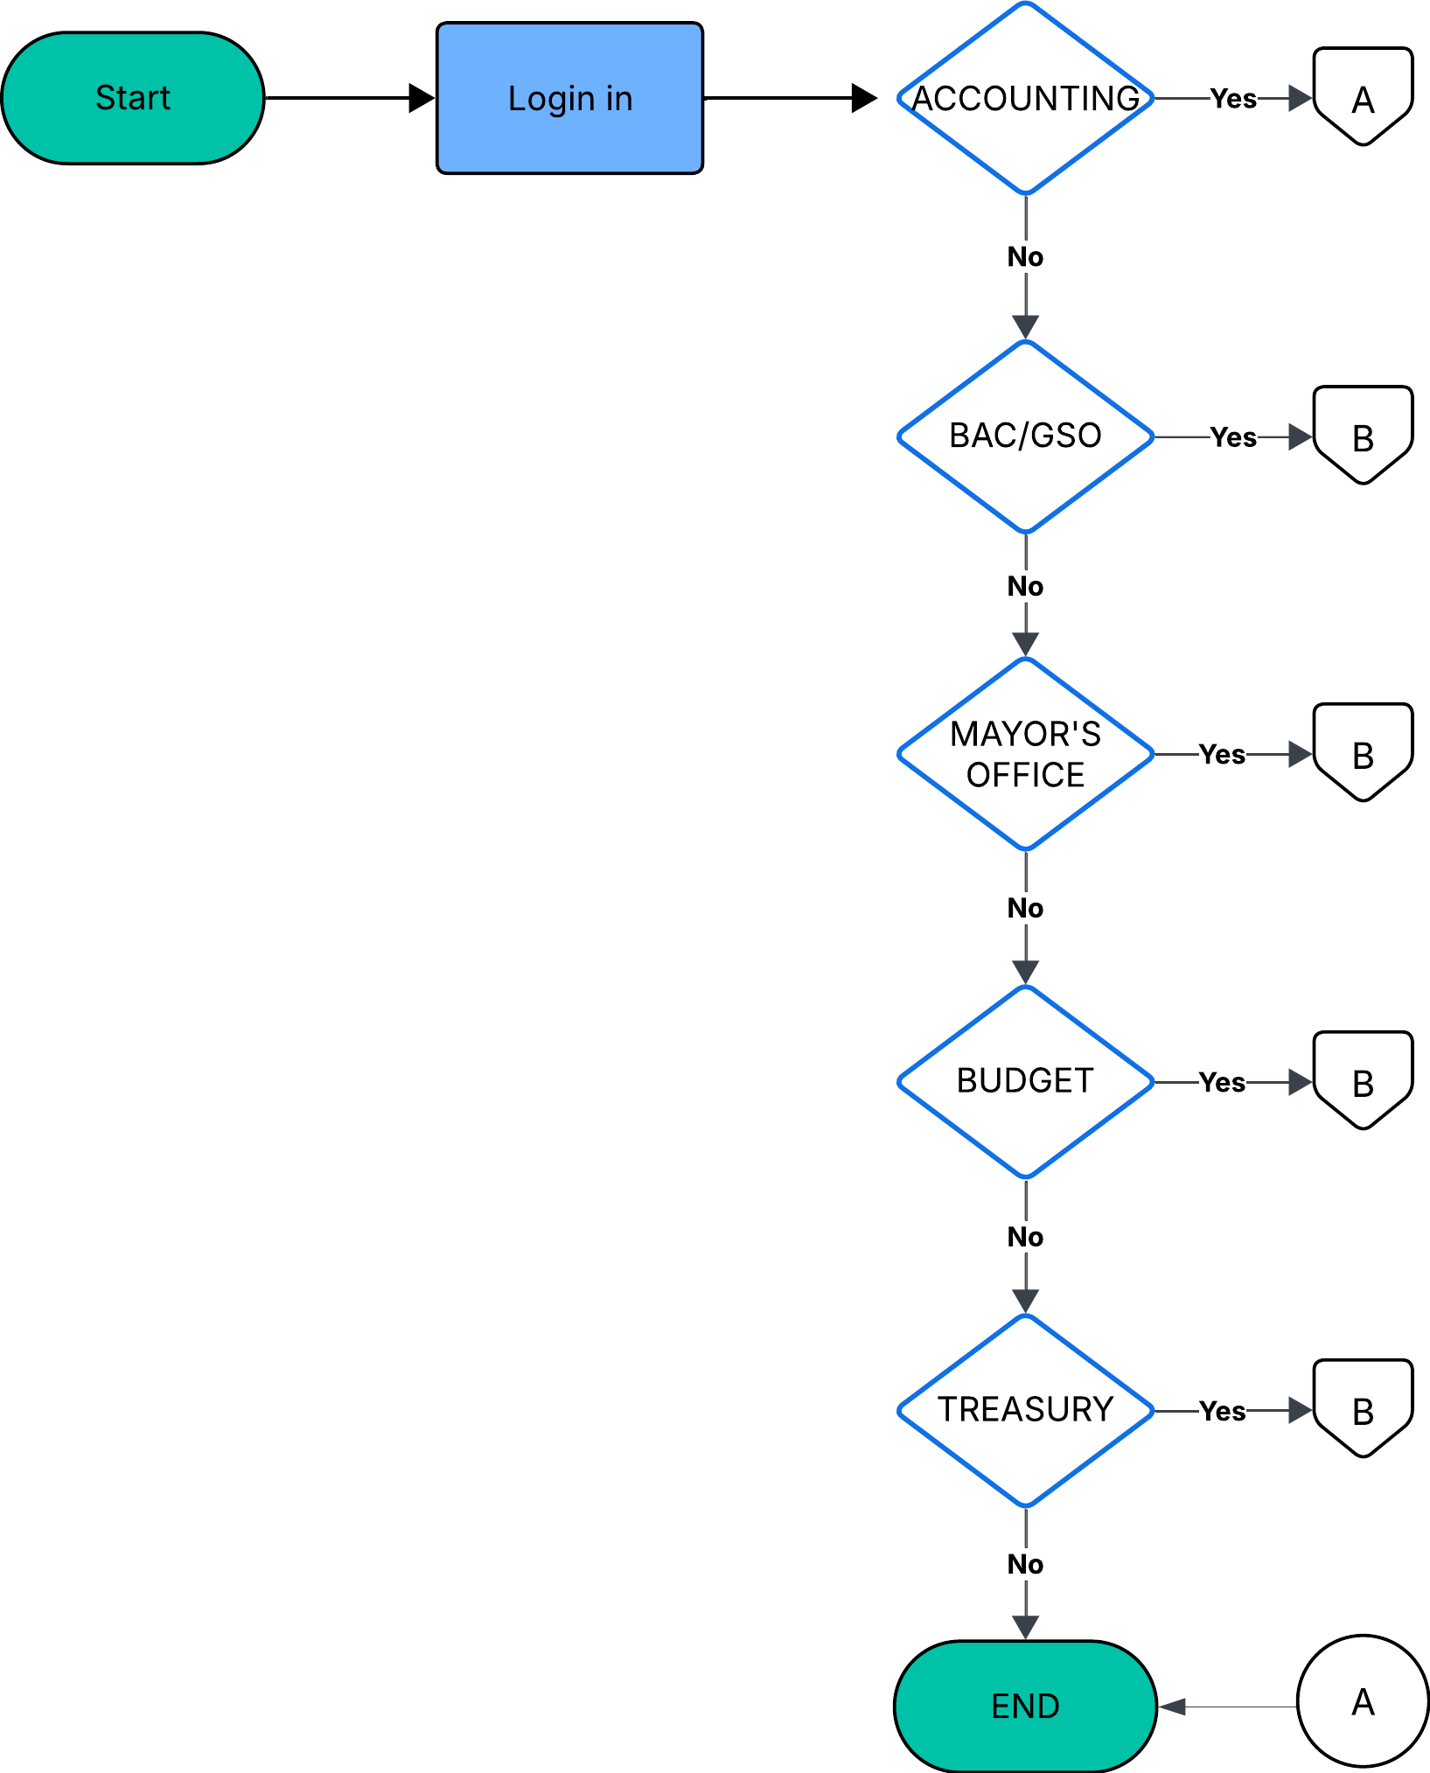

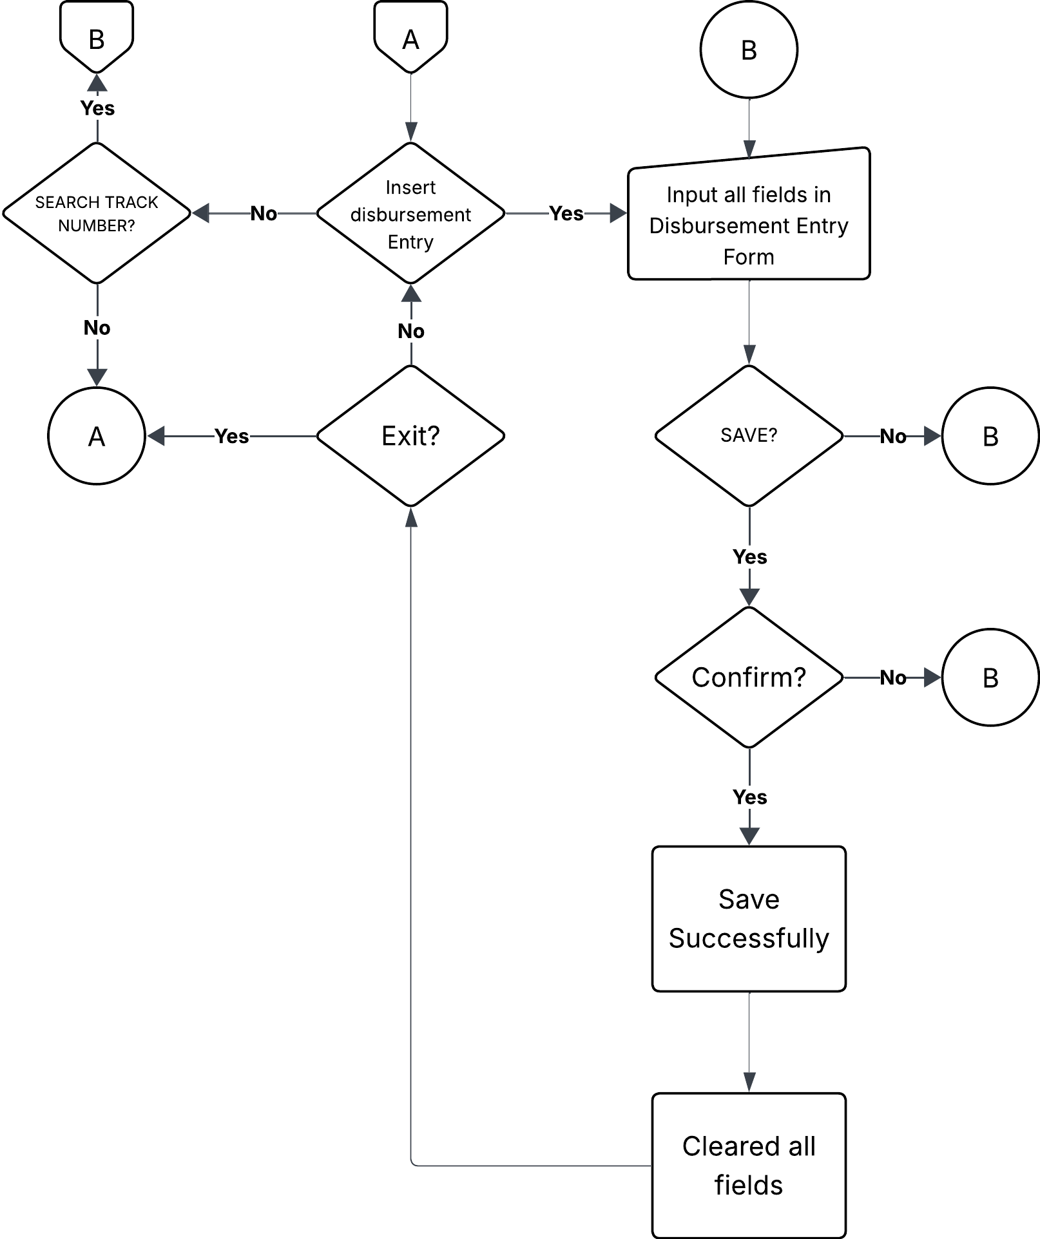

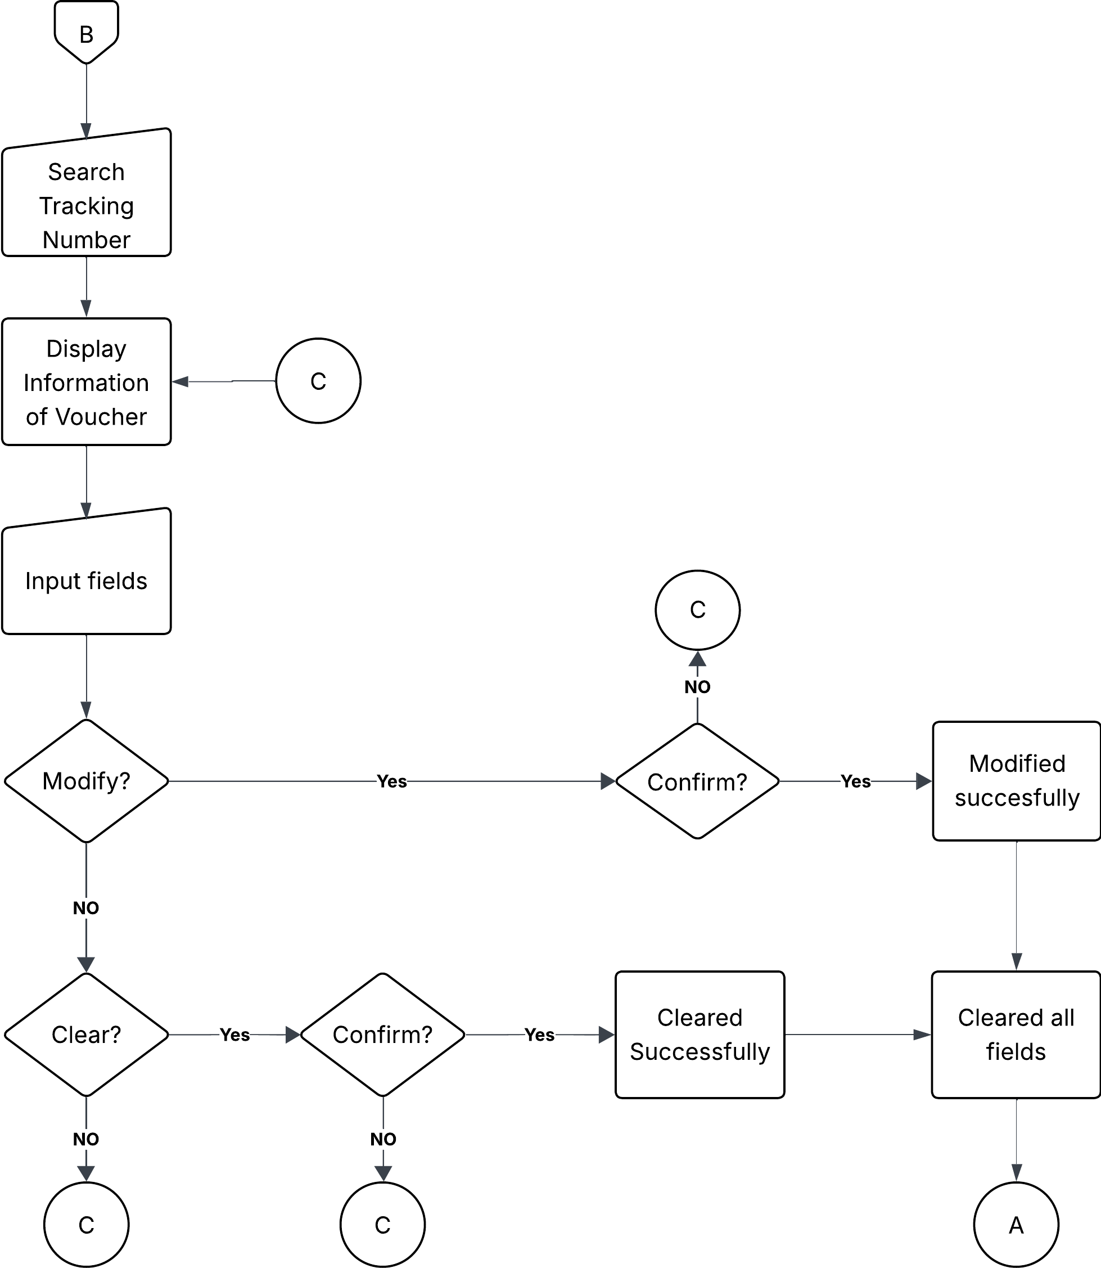

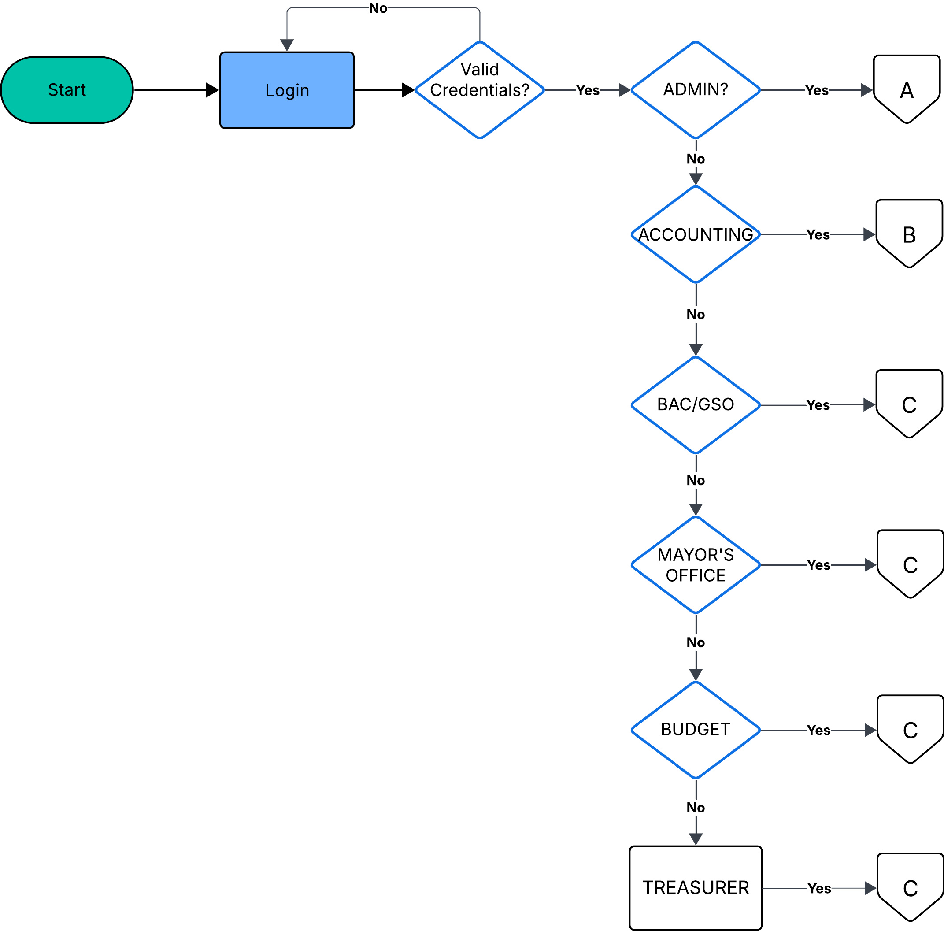
Proposed Process Flowcharts

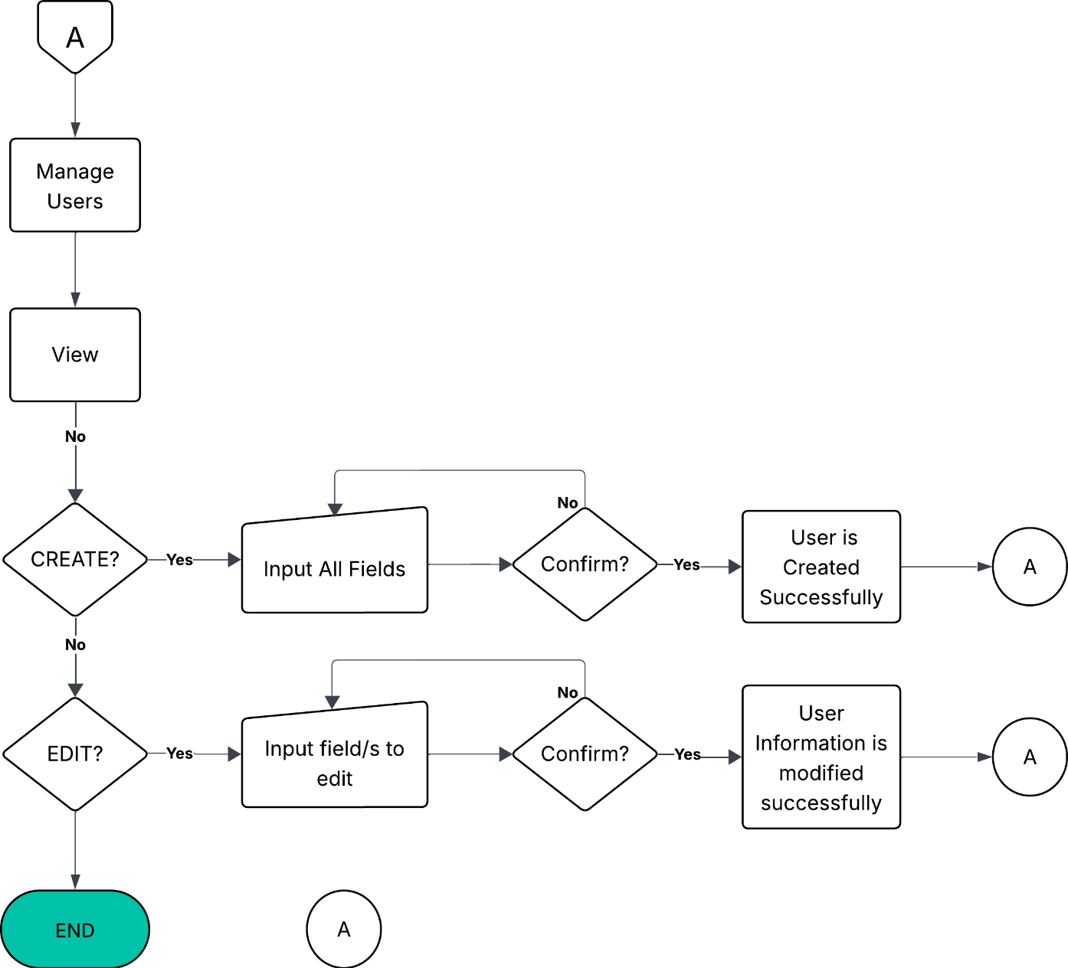

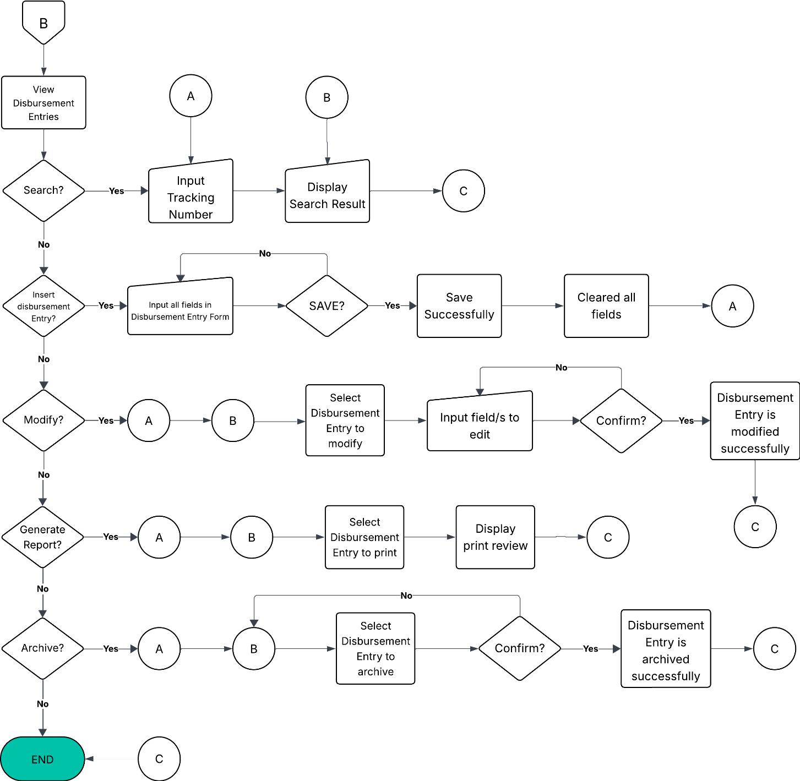

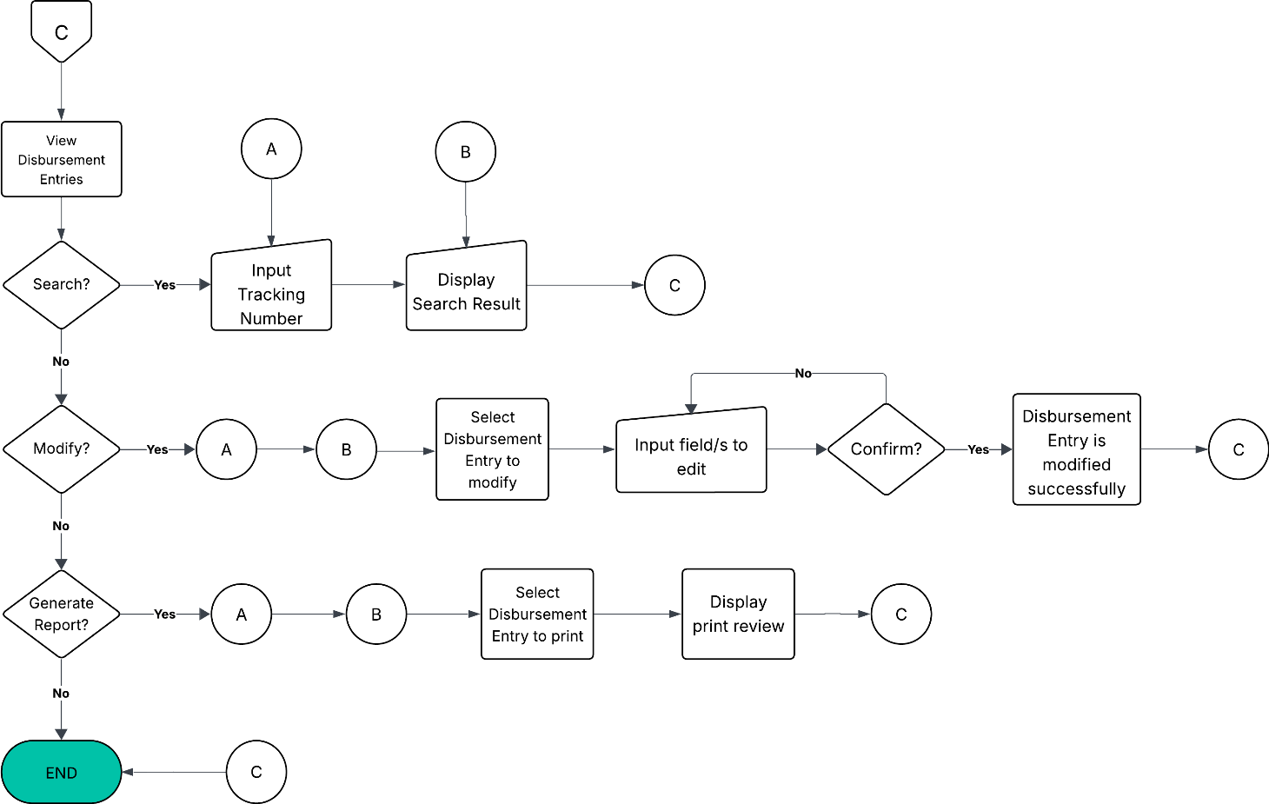

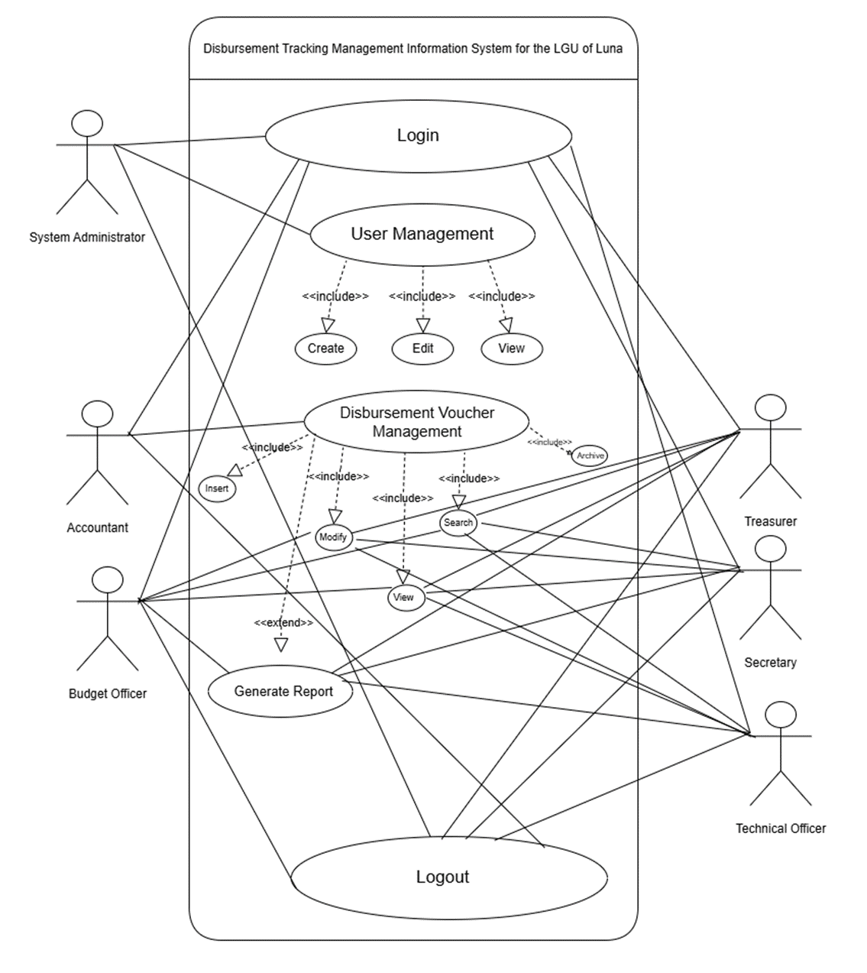
Use Case Diagrams (Draft)

Top Level Diagrams (Draft)
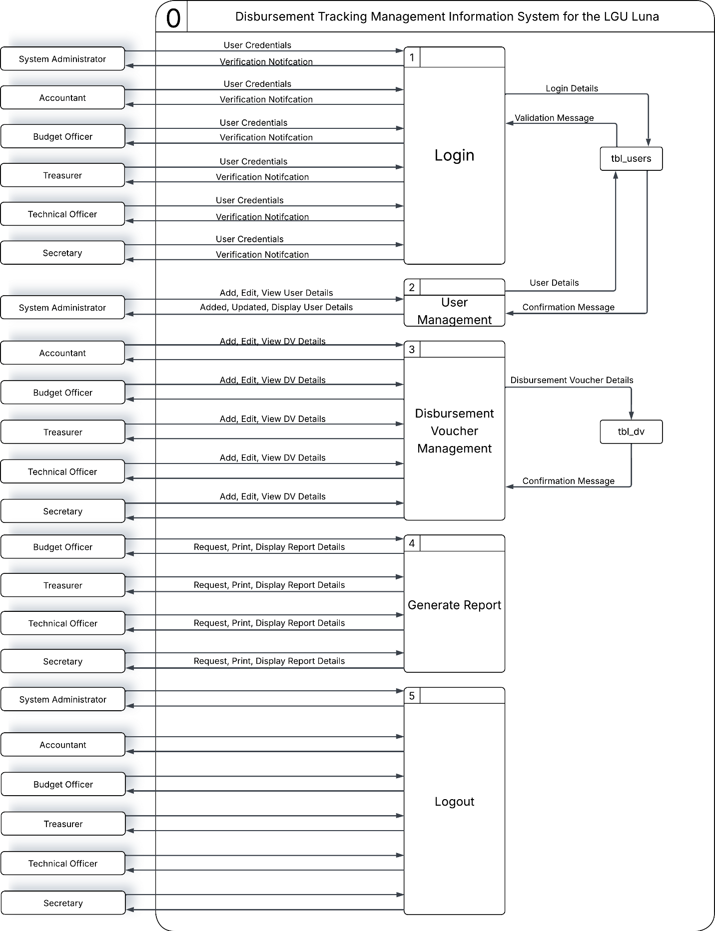

Input – Output – Process (IPO) Diagrams
Login
Input | Process | Output
username  password | Validate the Username and Password | Access to Dashboard

Add User

Input | Process | Output
firstname  middlename  lastname  userlevel  email  password | Check if Password Input Matched  Validate User Details Save New User Details | Display New Added User Details

Edit User

Input | Process | Output
firstname  middlename  lastname  userlevel  status  email  password | Validate the Username and Password  Update Existing User Details  Validate User Details  View Existing User Details | Display updated user information  Display Existing User Information

View User

Input | Process | Output
firstname  middlename  lastname  userlevel  status  email  password | Fetch from the Database | Display the Specific Information

REFERENCES
ClearGov. (2024). Why transparency alone isn’t enough to rebuild trust in local government. https://cleargov.com/rc/article/smart-transparency-and-trust
Congruence Market Insights. (2024). Financial management information system market: Global industry analysis and forecast (2025). https://www.congruencemarketinsights.com/report/financial-management-information-system-market
ResearchGate. (2025). How public expenditure tracking systems are improving budget implementation and accountability in developing countries. https://doi.org/10.5281/zenodo.15037051
ResearchGate. (2025). Public Financial Management System (PFMS) in India: Introduction and evaluation in the context of Indian education system. https://www.researchgate.net/publication/394151795
World Bank. (2026). Financial management information systems (FMIS). https://www.worldbank.org/en/topic/governance/brief/financial-management-information-systems-fmis
Department of Budget and Management. (2023). DBM launches digital transformation roadmap. Philippine News Agency. https://www.pna.gov.ph/articles/1206496
Department of Budget and Management. (2024). Ushering a new era of public accountability: DBM, ADB launches Philippine PFM reforms roadmap 2024–2028. DBM. https://www.dbm.gov.ph/index.php/press-releases/ushering-a-new-era-of-public-accountability
Department of Budget and Management. (2024). Digitalizing PFM and fulfilling our agenda for prosperity [Speech]. DBM. https://www.dbm.gov.ph/index.php/speeches/digitalizing-pfm-agenda-for-prosperity
Executive Order No. 29. (2023). Strengthening the integration of public financial management information systems [Government issuance]. Republic of the Philippines. https://www.officialgazette.gov.ph/downloads/2023/02feb/20230202-EO-29-RRD.pdf
Department of Budget and Management. (2025). DBM to launch real-time apps for gov’t transactions, infra projects. Philippine News Agency. https://www.pna.gov.ph/articles/1247041
Department of Budget and Management & Asian Development Bank. (2024). Philippine public financial management reforms roadmap 2024–2028 [Public financial management reform document]. https://www.adb.org/sites/default/files/institutional-document/856136/phi-pfm-reforms-roadmap.pdf
La Union Provincial Government. (2025, March 5). La Union prov’l gov’t, LGUs earn seal of financial housekeeping. Philippine News Agency. https://www.pna.gov.ph/articles/1245434
Department of Budget and Management. (2025, June 9). Local Budget Memorandum No. 92: Indicative FY 2026 National Tax Allotment (NTA) shares of Local Government Units (LGUs) and guidelines on the preparation of the FY 2026 annual budgets of LGUs. Government of the Philippines. https://www.dbm.gov.ph/index.php/local-budget-memorandum?view=article&id=3434:local-budget-memorandum-no-92&catid=402
Department of Budget and Management. (2024, December). National Government disbursements as of December 2024. Government of the Philippines. https://www.dbm.gov.ph/wp-content/uploads/DBCC/2024/NG-Disbursements_December-2024.pdf
Commission on Audit. (2015). Government accounting manual (GAM) for national government agencies, Volume I. https://www.coa.gov.ph/wp-content/uploads/2015/12/GAM-Volume-I.pdf
National Privacy Commission. (2012). Data Privacy Act of 2012 (RA 10173). https://privacy.gov.ph/data-privacy-act/
Department of Budget and Management. (2022). Public Financial Management Assessment Tool (PFMAT) for Local Government Units. https://www.dbm.gov.ph/wp-content/uploads/downloads/caraga/6-Public-Financial-Management-Assessment-Tool-for-Local-Government-Units.pdf
Provincial Government of La Union. (n.d.). Luna, La Union - Provincial Government of La Union. https://launion.gov.ph/city-and-municipalities/luna-la-union/
Provincial Government of La Union. (2025). Mission and Vision - Provincial Government of La Union. https://launion.gov.ph/mission-and-vision/
International Journal of Research Publication and Reviews. (2024). Developmental research design in instructional technology. International Journal of Research Publication and Reviews, 5(7), 2191–2203. https://ijrpr.com/uploads/V5ISSUE7/IJRPR31496.pdf
International Journal of Research Publication and Reviews. (2024). Design and development research in instructional and educational technology. International Journal of Research Publication and Reviews, 5(8), 3012–3024. https://ijrpr.com/uploads/V5ISSUE8/IJRPR32844.pdf

APPENDIX A
Letter of Request to Conduct Study
Hi

APPENDIX D
Interview Questions
- What are the most common problems you have encountered in your work recently?
- How long has this problem been occurring?
- Is this problem recurring or occasional?
- Which department or role is most affected?
- Where do delays usually occur in your daily work?
- Can you specify which process or activity caused the delay?
- What factors contributed to this delay (e.g., approvals, missing data, manual recording)?
- How long do these delays typically last?

- What causes errors in your work progress?
- Are these errors related to manual encoding, data transfer, or document handling?
- How often do these errors require rework or correction?
- What are the consequences of these errors?

- What problems affect your productivity the most?
- Which tasks consume the most time?
- Are these productivity issues caused by system limitations or process inefficiencies?
- How do these problems affect your ability to meet deadlines?

- Are you using manual processes, spreadsheets, or software in your work?
- Could you describe your experience with this current or traditional process?
- What limitations do you encounter while using these tools?
- How often do you switch between different tools to complete one task?

- What problems do you experience with the current method being used?
- Are there tasks that are not supported by the existing tools or methods?
- Which processes require workarounds?
- What risks do these limitations introduce?

- What type of data do you frequently handle the most?
- Is the data financial, transactional, or administrative in nature?
- How frequently is this data updated?
- Who is responsible for maintaining data accuracy?

- How is information currently stored and retrieved?
- Do you experience data loss, duplication, or inconsistency?
- How long does it usually take to retrieve needed information?
- Who has access to these records?

- What tasks do you wish were easier or faster to perform?
- Which processes need the most improvement?
- What steps could be reduced or eliminated?
- How would improving these tasks affect your work efficiency?

- How often does this problem occur?
- Does it happen daily, weekly, or monthly?
- Are there specific periods when the problem worsens?
- Is the issue predictable or random?

- Who else is affected by this problem?
- Are other departments or barangays impacted?
- Does it affect management decision-making?
- Does it cause delays in reporting or approvals?

APPENDIX H
User Manual
XAMPP Installation
XAMPP is a free, open-source, cross-platform web server solution providing Apache, MySQL, PHP, and Perl, designed to simplify local web development and testing with the following step-by-step full download guide.
  - Visit the website: https://www.apachefriends.org/index.html
  - Confirm you review all available OS options before proceeding.
  - Choose the operating system appropriate with your computer.
  - Click Download button to properly download your chosen OS.
  - Wait until the installer file to download fully before proceeding.
  - Verify the downloaded file for safety before opening or running.
Step-by-step full guide for installing XAMPP
  - Run the XAMPP installer, review the setup information and options, then click “Next” to begin the installation process on your computer.
  - Select the components you want to install from the list, review your choices carefully, and then click “Next” to continue the installation.
  - Choose the folder where you want XAMPP to be installed on your computer, then simply click “Next” to proceed with the installation.
  - Choose your preferred language for the installation process, review your selection, and then click “Next” to continue with the setup.
  - Click “Next” to officially start the installation process and proceed with properly setting up the program successfully on your computer.
  - XAMPP is now installing on your computer. Please just wait while the program completes the installation procedures successfully.
  - XAMPP has successfully finished installing. Click the “Finish” to complete the setup and launch the program on your computer.
phpMyAdmin Instruction
phpMyAdmin is an open-source, web-based management tool used to easily manage and organize MySQL and MariaDB databases. To import a MySQL or MariaDB database through phpMyAdmin, follow these clear steps.
  - Open the XAMPP Control Panel and then start both the Apache and MySQL services to properly run your local server environment.
  - Click the Admin button next to MySQL in the XAMPP Control Panel to quickly open and access phpMyAdmin in your web browser.
  - Select the “New” command in the left navigation pane to create a new database for your project and manage its structure efficiently.
  - On the Databases page, enter a name for the database (for example, db_smis), choose the collation utf8_general_ci, and click Create to database.
  - Once the database has been properly created, it will automatically appear in the left navigation pane for easy access and management.
  - Select the new database from the left pane, click the Import tab at the top, then click “Choose File” to select your .sql backup file.
  - Scroll down to the bottom of the page and then click Import to begin the database import process safely and efficiently without errors.
  - phpMyAdmin imports data from the backup file, and once finished, a screen appears. Browsing the database shows your original data.

Getting Started
The Disbursement Tracking Management Information System is thoughtfully and systematically designed to help efficiently manage all transaction records, accurately track disbursement, provide timely, clear, and reliable feedback, generate comprehensive, insightful reports, and automate essential administrative processes smoothly and efficiently for six (6) primary users:
    - System Administrator
    - Accountant
    - Budget Officer
    - Treasurer
    - Secretary
    - Technical Officer
Step-by-step full guide for accessing DTMIS
  - The users can access the system by providing their registered email address and password on the designated login page and proceed to login page.
  - Explore the main dashboard and all system sections at a glance.


INSTITUTIONAL VISION-MISSION
Saint Louis College - San Fernando, La Union is the premier innovative educational hub in Northern Philippines imbued with the Christian spirit and at the service of the world.
We nurture missionary stewardship animated by the spirit and values of collective growth, innovation-driven education, talent-enriched community life, and servant leadership.
Furthermore, we commit ourselves to design and deliver policies, programs, partnerships, and services intended to transform the lives of our stakeholders, especially our learners.
CORE VALUES
We embrace the core values of Christ-Centeredness, Excellence and Missionary as inspired by the charism of CICM Founder Fr. Theophile Verbist and our Patron Saint St. Aloysius Gonzaga.

