Software Architecture Document

SUE Data Science platform – SA-RB-01

By: Mohammed Bouali, Andrei Pieleanu,   
Calvin Kwan, Wildeman Björn

Contents

C1 3

C2 4

C3 5

### C1

The data scientist accesses the whole system, which is comprised of our own system, but also external systems.

### C2

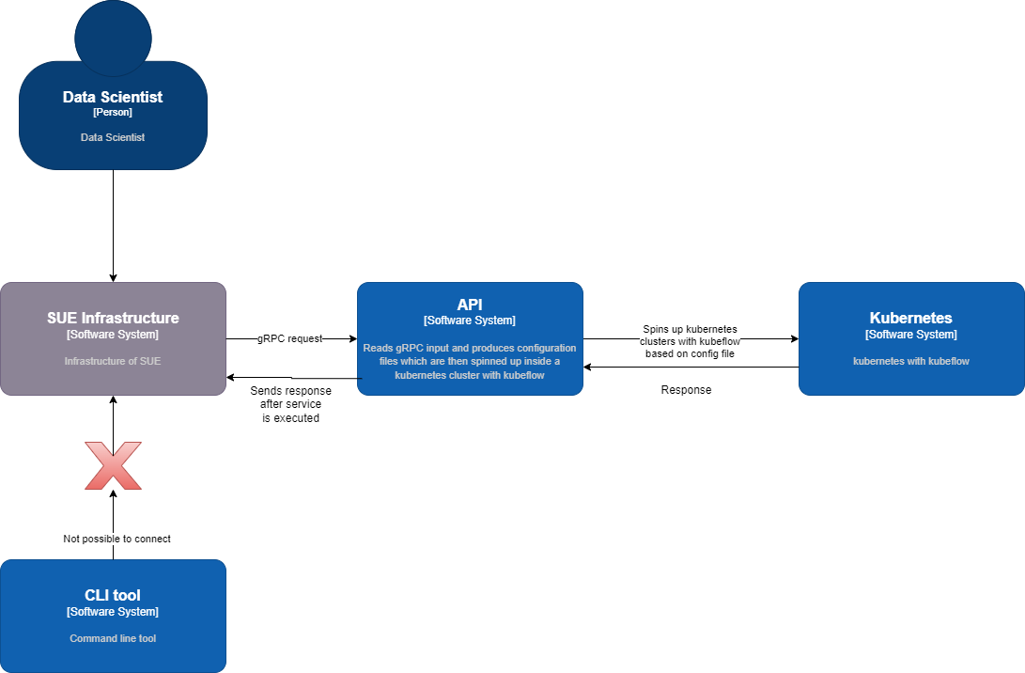

The data scientist accesses the SUE infrastructure which then sends a request via gRPC. The API system then spins up Kubernetes clusters with Kubeflow based on config file. The cluster returns a response which is sent back to the SUE infrastructure.

### C3

The API system is comprised of an API gateway, which is responsible for handling request and responses. The backend consists of multiple microservices which are responsible for handling the work.