DSTI, Machine Learning with Python Labs

Predicting diabetes outcome for women Group Project Report

The project report presents an end-to-end machine learning pipeline for predicting diabetes in women. Designed, built, and deployed by DSTI students, this pipeline is developed as part of the Group Project for the Machine Learning with Python Labs course.

Students: Mahamadou Ousmane Keita, Rosine Muna, Malathi Karuppasamy, Jean Daniel Houssou, Arthur Choisnet, Andrei Roumiantsev
Instructor: Christophe Bécavin, PhD, Université Côte d’Azur
Professor: Hanna Abi Akl, DSTI
Report author: Andrei Roumiantsev
Project dates: start December 2024 – end March 2025
Last document version: the 23 of March 2025
Andrei Roumiantsev project GitHub link: https://github.com/AndreiRRR/dsti_diabetes_predicting/

Table of Contents
Introduction 3
Team presentation 3
Software and Tools 5
Methodology 6
Exploratory Data Analysis (EDA) 6
Data Overview 6
Duplicate Values 6
Feature Engineering and Selection 7
Handling Duplicates 7
Feature Selection 7
Target Variable Encoding 7
Model Selection, Comparison, and Evaluation 7
Model Selection 7
Model Training and Evaluation 7
Model Comparison 8
Hyperparameter Tuning 8
Results 9
Analysis of Model Performances 9
Justification of the Best Model Choice 9
Deployement 10
Web application 10
Software and tools 11
Serializing Gradient Boost model 11
Application code 11
Web Application installation procedure 12
Conclusion 14

Introduction
The goal of the project is to build and deploy a predictive model capable of classifying individuals as diabetic or non-diabetic. The end product will be a web application that allows users to input individual health metrics and receive real-time diabetes predictions, supporting better diagnostic decision-making.
The project focuses on predicting diabetes outcomes using machine learning models based on the TAIPEI_diabetes.csv dataset. This dataset contains health metrics for 15,000 women aged 20–80 who visited the Taipei Municipal Medical Center between 2018 and 2022. The dataset includes 8 features such as pregnancies, plasma glucose levels, BMI, and family history, with the target variable indicating whether diabetes was diagnosed.

Team presentation
The team is composed of DSTI students from the Data Science, Data Analytics, and Data Engineering cohorts of 2025. Below is a brief introduction to each member of the team:
Rosine Muna
Background:
- Origin: Cameroon, currently based in France.
- Pursuing a thesis in Applied Data Analytics (second year in alternance).
- Previously worked as a Data Analyst for two years.
- Gained significant experience handling large datasets during a six-month internship at Carrefour.
Key Skills:
- Proficient in Excel for advanced data cleaning, transformation, and analysis.
- Familiar with Power Query for data transformation.
- Experienced in handling datasets with millions of records.
- Strong data visualization skills.
- Beginner in Python, currently learning through hands-on practice and classroom exercises.

Mahamadou Keita
Background:
- Mathematics specialist with three master’s degrees, transitioning into Data Science and Artificial Intelligence.
- Over seven years of Python programming experience.
- Currently working on a chatbot project, demonstrating strong AI and machine learning expertise.
Key Skills:
- Extensive knowledge in machine learning, including model optimization and algorithm development.
- Solid mathematical foundation, especially for advanced modeling techniques.
- Familiarity with end-to-end data science workflows.
- Strong project management skills, particularly in team coordination and leveraging group strengths.

Andrei Roumiantsev
Background:
- Russian origin with over 25 years of experience in IT, primarily with BNPP PF Paris.
- Specialized in data engineering and business intelligence tools.
- Recently transitioned into data science to expand technical skills.
Key Skills:
- Extensive experience with data pipelines, cleaning, and wrangling.
- Proficient in Power BI and Microsoft Azure tools.
- Beginner in Python, focusing on learning data visualization and modeling.

Jean Daniel Houssou
Background:
- M1 student in Data Science and Artificial Intelligence with a Bachelor's in Computer Science from Epitech.
- Strong programming foundation with a focus on algorithm design and software development.
Key Skills:
- Proficient in programming languages such as C and Python.
- Experienced in implementing advanced algorithms like Monte Carlo simulations.
- Beginner in machine learning, eager to gain practical experience through projects.

Arthur Choisnet
Background:
- Freelance Data Scientist with a personal agency established for two years.
- Former media buyer for Google and Facebook, with experience in automation and client-driven machine learning solutions.
- Alumni of Le Wagon Bootcamp, where he gained foundational skills in data science.
Key Skills:
- Well-rounded knowledge across data science disciplines, including automation and classification projects.
- Experienced in tools like GitHub, VS Code, and virtual environments for collaborative coding.
- Strong leadership and organizational skills, demonstrated in prior group projects.

Software and Tools
The software tools used for the project include
- Anaconda Navigator 2.6.3
- Jupiter Notebook 7.0.8
- PyCharm IDE 2024.3.3.
- Internet browser Firefox 136.0.1
- Python 3.8 or higher and Python Libraries.
- Flask, a lightweight Python web framework.
- Pickle, a Python library for serializing and deserializing Python objects.

Methodology
Source : the step-by-step analysis is detailed in the Diabetes_Predicting.ipynb Jupiter notebook.

Exploratory Data Analysis (EDA)
The initial step in the analysis was to explore the dataset to understand its structure and identify any potential issues such as missing values, duplicates, or inconsistencies.

Data Overview
The dataset contains 15,000 records with 9 features and a target variable (Diabetic).
The features include
- PatientID,
- Pregnancies,
- PlasmaGlucose,
- DiastolicBloodPressure,
- TricepsThickness,
- SerumInsulin,
- BMI,
- DiabetesPedigree,
- and Age.
The target variable Diabetic is binary, with 0 indicating no diabetes and 1 indicating diabetes.

Duplicate Values
The analysis revealed that there are 105 duplicate PatientID values, affecting 210 records. Upon further inspection, it was found that these duplicates represent the same patient returning for multiple visits. The decision was made to drop these duplicates, resulting in a clean dataset of 15,000 unique individuals.
Missing Values
The dataset was checked for missing values, and none were found. This is a positive sign, as missing data can complicate the modeling process.
Data Distribution
The distribution of the target variable Diabetic was examined to check for class imbalance. The dataset appears to be relatively balanced, with a slight skew towards non-diabetic cases.

Feature Engineering and Selection
Feature engineering is a crucial step in preparing the data for modeling. The goal is to create new features or transform existing ones to improve the model's performance.

Handling Duplicates
As mentioned earlier, duplicate PatientID values were removed to ensure that each patient is represented only once in the dataset.

Feature Selection
The dataset already contains a relatively small number of features, so no features were removed at this stage. However, the importance of each feature will be evaluated during the model selection process.

Target Variable Encoding
The target variable Diabetic is already binary-encoded, so no further encoding was necessary.

Model Selection, Comparison, and Evaluation
The next step was to select, compare, and evaluate different machine learning models to predict diabetes.

Model Selection
Several machine learning models were considered, including Logistic Regression, Decision Tree, Random Forest and Gradient Boosting XGBoost. These models were chosen because they are commonly used for binary classification tasks and have different strengths and weaknesses.

Model Training and Evaluation
The dataset was split into training and testing sets (80% training, 20% testing). Each model was trained on the training set and evaluated on the testing set using 100-fold cross-validation method analyzing the accuracy of the model and also the variance of the prediction quality.

Logistic Regression
This model is simple and interpretable, making it a good baseline. It achieved an accuracy of 78%.

Decision Tree
Decision Tree achieved an accuracy of 90%. While it performed well, it was computationally expensive compared to the other models.

Random Forest
This ensemble method performed well, with an accuracy of 94%. It is robust to overfitting and can handle non-linear relationships.

Gradient Boosting
This model achieved the highest accuracy of 96% and an ROC-AUC of 0.91. It is known for its high performance in classification tasks.

Model Comparison
Model comparison is performed using 100-fold stratified cross-validation.
The strengths of the cross-validation are :
- Robust Evaluation: 100-fold validation provides reliable performance estimates.
- Stratification: Maintains class balance in each fold.
- Visual Clarity: The boxplot effectively compares model stability and accuracy.
- Reproducibility: Fixed random states ensure consistent results.
The evaluation metrics of the Logistic Regression, Decision Tree, Random Forest and Gradient Boosting models were plotted to provide a visual representation.
Based on evaluation metrics, the Gradient Boosting XGBoost model performed the best, with the highest accuracy. The Gradient Boosting model also shows the better IQR (Interquartile Range) which signifies that the model is more reliable than other models.

Hyperparameter Tuning
The Gradient Boosting model was further optimized using hyperparameter tuning. Grid search was used to find the best combination of hyperparameters, which didn’t really improve the model's performance.

Results

Analysis of Model Performances

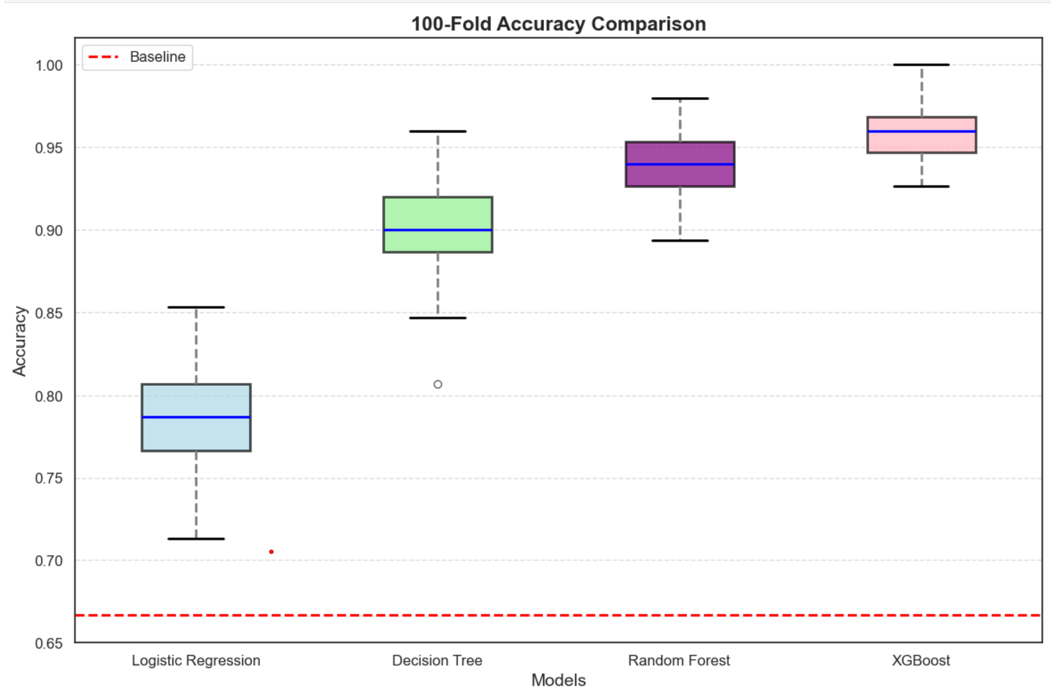
Picture 1. Box plot of models accuracy and IQR
XGBoost outperformed Logistic Regression, Decision Tree, and Random Forest in 100-fold stratified cross-validation, achieving an average accuracy of 96% (±1.3) vs. 93% (±2.1) for the next-best model (Random Forest).

Justification of the Best Model Choice
The Gradient Boosting XGBoost model emerged as the best-performing model due to its superior performance across all evaluation metrics, with an accuracy of 0.96 (see Picture 1).
This indicates that the model is highly effective at distinguishing between diabetic and non-diabetic cases. The model is not only accurate but also reliable in its predictions.
Additionally, Gradient Boosting is known for its ability to handle complex, non-linear relationships in the data, which is likely why it performed so well in this task.
The Gradient Boosting XGBoost model was chosen as the best model.

Deployement

Web application
The primary goal of this project is to develop and deploy a web application that calls the best machine learning model to predict diabetes.
The web application will serve as an interactive platform where users can input health metrics and receive immediate predictions about their diabetes risk. This deployment will make the machine learning model accessible to end-users, such as healthcare providers enabling them to make informed decisions based on the model's predictions.
The project focuses on the machine model deployement in the web application, this is the reason why the web application is simple, it contains only one page.
The application interface is shown below :
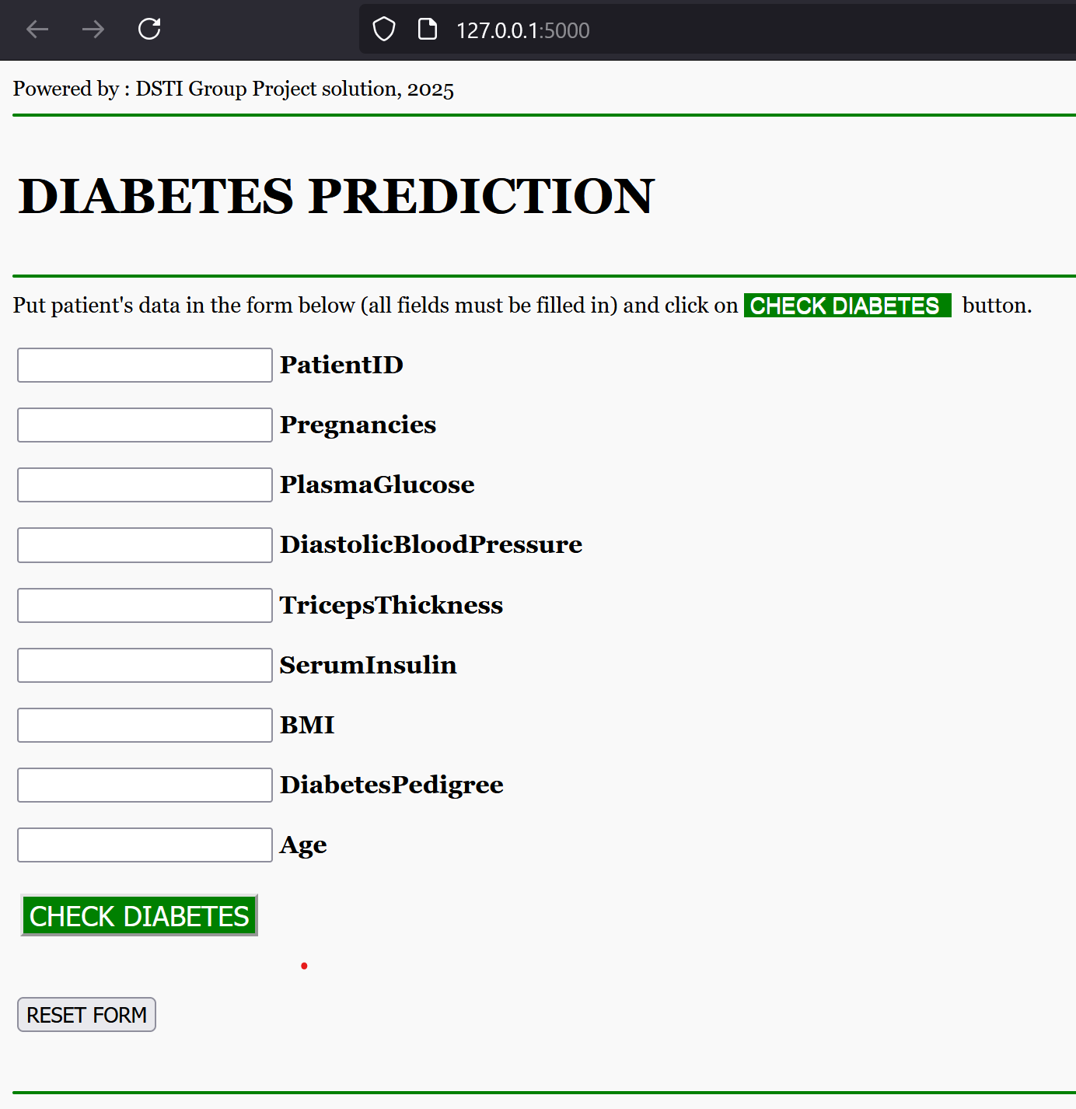
Picture 2. Web application main page.

The small video of running web application is available on the project’s GitHub.

Software and tools
The software tools necessary to deploy include :
- Python 3.8 or higher: Download and install Python from python.org.
- PyCharm IDE: Download and install PyCharm from JetBrains.
- Flask: a lightweight Python web framework.
- Pickle: a Python library for serializing and deserializing Python
- Required Python Libraries: Install the necessary libraries using pip.

Serializing Gradient Boost model
The Gradient Boosting (XGBoost) model demonstrated the best performance for diabetes prediction. By serializing the machine learning model, it can be integrated and reused in the web application.
The Jupiter notebook Encapsulate_XGBClassifier_Model.ipynb operates the serialization of the Gradient Boosting model. The notebook trains XGBoost model, tests it and creates a pickle archive Diabetes_Model.pkl reused in the Web Application.

Application code
The flask_ml_api_code project in the PyCHarm contains 1 folder and 4 files.
- requirements.txt
This file lists all the Python libraries and dependencies required to run the project. Install all required libraries by executing
pip install -r requirements.txt
command in PyCharm terminal.
- main.py
This is the main Python script that serves as the backend of the web application. The roles of the script are:
- Flask Application Setup: Initializes the Flask app and defines routes (@app.route) to handle HTTP requests.
- Machine Learning Integration: Loads the serialized machine learning model and uses it to make predictions.
- API Endpoint: Exposes an API endpoint to receive input data from the frontend and return predictions.

- index.html This file defines the frontend interface of the web application. The web page contains a form for user input and displays prediction results.

Web Application installation procedure
This chapter provides step-by-step instructions for setting up and deploying a web application.
Before starting, ensure the required software and tools are installed on your system.
Step 1: Set Up the Project in PyCharm
- Create a New Project
- Choose Flask for project type
- A new project containing a new virtual environment will be created

Step 2: Project structure
The PyCharm project structure is :
flask-ml-api-code/
├── templates/
│ └── index.html
├── Diabetes_Model.pkl
├── main.py
└── requirements.txt

Add all listed files to the project according project structure.

Step 3: Install Required Libraries
Install all required libraries, execute pip install -r requirements.txt command in the PyCharm terminal.

Step 4: Launch web application in PyCharm by executing python.exe .\main.py
or by clicking on Run button (from the main.py file).

Step 5: Consult and test the web application available on the http://127.0.0.1:5000 .

Conclusion
The project successfully developed a machine learning model to predict diabetes based on health metrics.
After comprehensive Exploratory Data Analysis (EDA), rigorous Feature Engineering, and Model Selection, the Gradient Boosting XGBoost model was identified as the best-performing model, demonstrating high accuracy and reliability.
The model was serialized using Python's Pickle module, enabling easy integration into the web application.
The application was developed in the PyCharm environment, providing a user-friendly interface for real-time predictions.

P.S. It was really great training project and great course !

