// SketchAr30BlinkOnOnOnOff.ino (2020.04.10)

// The LED on the Arduino plate is switched on for 3 sec.

// And the voltage of 5V between the GND port and the Pin13 is set.

// Thereafter the LED turns out for the short time.

// At this short time no voltage is set to Pin13.

// This sketch could be used to check the ports voltage

int Led = 13; // declare and set the variable Led

void setup(){

pinMode(Led, OUTPUT); // Set the variable Led to the OUTPUT

}

int TimeSlot=1000;

void loop()

{ int DurationOn=TimeSlot*0.5;

int DurationOff=TimeSlot-DurationOn;

digitalWrite(Led, HIGH); // the voltage is applied to the pin 13

delay(DurationOn); // wait 0.5 seconds

digitalWrite(Led, HIGH); // the voltage is applied to the pin 13

delay(DurationOn); // wait 0.5 seconds

digitalWrite(Led, HIGH); // the voltage is applied to the pin 13

delay(DurationOn); // wait 0.5 seconds

digitalWrite(Led, HIGH); // the voltage is applied to the pin 13

delay(DurationOn); // wait 0.5 seconds

digitalWrite(Led, HIGH); // the voltage is applied to the pin 13

delay(DurationOn); // wait 0.5 seconds

digitalWrite(Led, LOW); // no voltage applied to the pin 13

delay(DurationOff); // wait 0.5 seconds

}

**The wires used for the check the applied voltage**

Black wire – the GND port (POWER, 2nd from right)

Red wire – the port 13 (DIGITAL PWM, 5th from left)

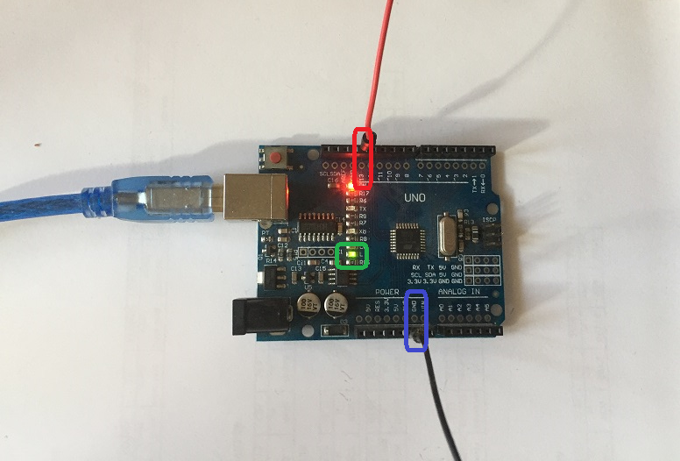

The LED on the Arduino plate is switched on for 3 sec.

And the voltage of 5V between the GND port and the Pin13 is set.

Thereafter the LED turns out for the short time.

At this short time no voltage is set to Pin13.

This sketch could be used to check the ports voltage

The voltage between GND and Pin13 could be measured by a multimeter