// SketchAr30BlinkOnOnOnOnOff.ino (2020.04.10)

// This sketch could be used to check the ports voltage

int Led = 13; // declare and set the variable Led

void setup(){

pinMode(Led, OUTPUT); // Set the variable Led to the OUTPUT

}

int TimeSlot=1000;

void loop()

{ int DurationOn=TimeSlot*0.5;

int DurationOff=TimeSlot-DurationOn;

digitalWrite(Led, HIGH); // the voltage is applied to the pin 13

delay(DurationOn); // wait 0.5 seconds

digitalWrite(Led, HIGH); // the voltage is applied to the pin 13

delay(DurationOn); // wait 0.5 seconds

digitalWrite(Led, HIGH); // the voltage is applied to the pin 13

delay(DurationOn); // wait 0.5 seconds

digitalWrite(Led, HIGH); // the voltage is applied to the pin 13

delay(DurationOn); // wait 0.5 seconds

digitalWrite(Led, HIGH); // the voltage is applied to the pin 13

delay(DurationOn); // wait 0.5 seconds

digitalWrite(Led, LOW); // no voltage applied to the pin 13

delay(DurationOff); // wait 0.5 seconds

}

**The wires used for the check the applied voltage**

Black wire – the GND port (POWER, 2nd from right)

Red wire – the port 13 (DIGITAL PWM, 5th from left)

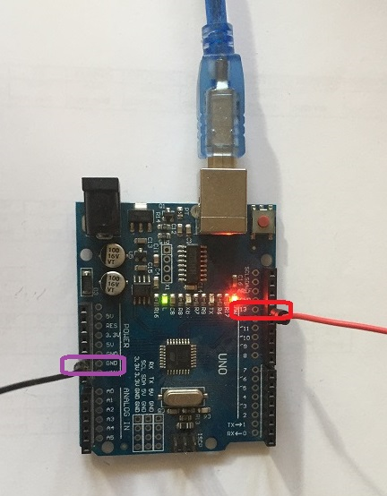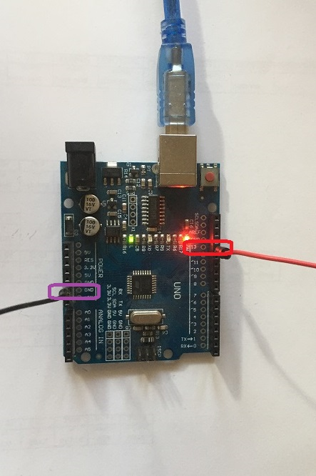

Execution: The LED on the Arduino plate is switched on and the voltage of 5V between the GND port and the Pin13 is set to 3 seconds. Thereafter the LED turns out for the short time. For this short time no voltage 0 V is set between the GND port and Pin13.

The voltage between GND and Pin13 could be measured by a multimeter