//SketchAr040FlashLEDpin8OnOnOff

The sketch makes a LED connected to the Arduino plate blinking.

//The LED on the plate, connected to Arduino,

// turns on for the 3 seconds.

//The voltage of 5V between GND and the Pin8 is set these 3 seconds.

//Thereafter the LED turns off for the short time.

//For this short time no voltage is set to Pin8.

int Led = 8;

// The declaration of a integer variable 'Led'

// that contains the number of the port

// to which the voltage is applied.

int delay3000=3000,delay500=500;

// This sketch makes the LED Flash

void setup()

// The mandatory procedure 'setup()' is executed once at the programm start.

{

pinMode(Led, OUTPUT);

// The function 'PinMode(PortNumber,State)'

// sets the type 'State' ('OUTPUT' or 'INPUT') to the digital port 'PortNumber'

}

void loop()

// The mandatory procedure 'loop()' is execuded cyclically after the procedure 'setup()' execution

{

digitalWrite(Led, HIGH); // the state 'switched on' is set 0n the digital port 'Led'

// The command digitalWrite(PortNumber,State) is used

// to 'switch on' or to 'switch off' the voltage on a didital port

// The first argument('PortNumber') is the number of the digital port,

// the second argument('State') is the state ('switched on' (HIGH) or 'switched off' (LOW)),

// to which the digital port should be set.

delay(delay3000);

// The command delay(time) is used for the waiting between the actions.

// The argument ('time') is the time (in milliseconds) of the waiting

digitalWrite(Led, LOW); // the state 'switched off' is set 0n the digital port 'Led'

delay(delay500);

}

**The wires used for the check the applied voltage**

Black wire – the GND (POWER, 2nd from right)

Red wire – the port 8 (DIGITAL PWM, 9th from right)

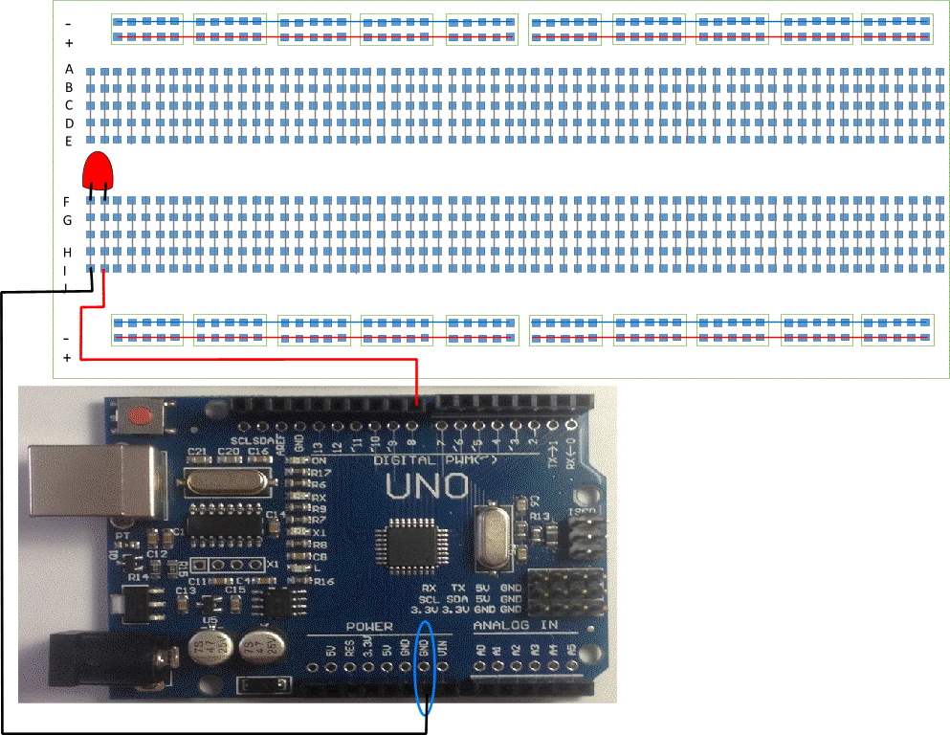

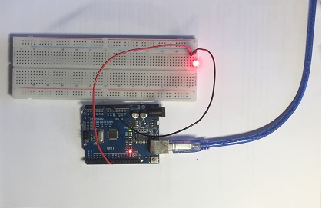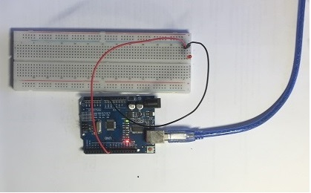

The LED on the plate, connected to Arduino, turns on for the 3 seconds.

The voltage of 5V between GND and the Pin8 is set these 3 seconds.

Thereafter the LED turns off for the short time.

For this short time no voltage is set to Pin8.

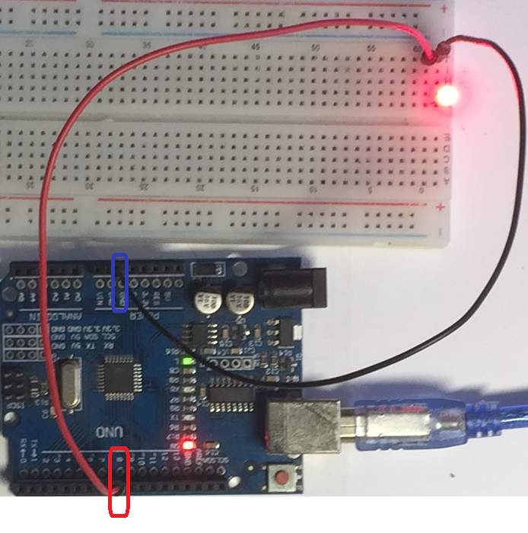

The voltage between GND and Pin8 could be measured by a multimeter.