Laboratoarele 1 & 2

1. **Cu ce aminoacid incep toate proteinele de mai sus?**

Proteinele incep cu Metionina

1. **Accesati GenBank la adresa https://www.ncbi.nlm.nih.gov/genbank/ si cautati inregistrarea cu codul de mai sus (cel cu galben).**

<https://www.ncbi.nlm.nih.gov/nuccore/AF213260.1>

1. **Se acceseaza adresa de mai sus. Se poate face click pe orice link din inregistrarea model de mai sus pentru a vedea o descriere detaliata a semnificatiei acelui camp.**

U49845



1. **Cate nucleotide compun gena de mai sus? Dar gena de la Drosophila melanogaster din grupul celor trei de mai sus?**

1. **Cu ce aminoacid se incheie aceasta secventa de aminoacizi?**

Secventa se incheie cu aminoacidul K (Lizina)

1. **Gasiti alte doua interfete web pentru conversia intre formate. Convertiti secventa GenBank de mai sus (U49845.1) in format FASTA, folosind una dintre uneltele de conversie gasite anterior.**

<https://sequenceconversion.bugaco.com/converter/biology/sequences/>

<https://www.hiv.lanl.gov/content/sequence/FORMAT_CONVERSION/form.html>

1. **Rulati exemplele furnizate in pagina de documentatie a functiei aminolookup.**

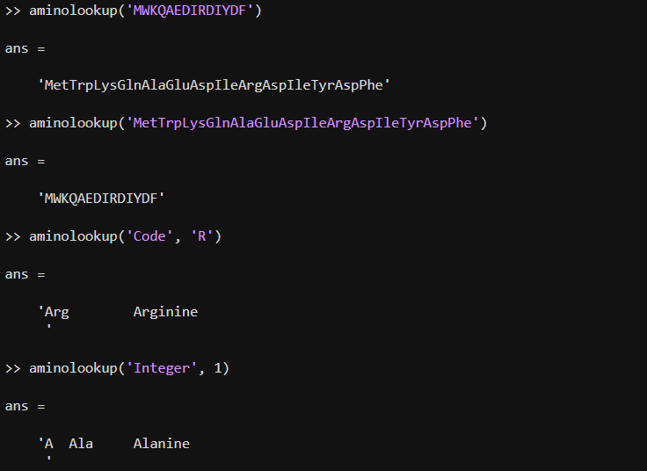

1. **Rulati exemplele furnizate in documentatia functiei baselookup**

1. **Rulati exemplul furnizat in documentatia functiei fastainfo**

**10. Rulati exemplele furnizate in documentatia functiei fastaread.**

**11. Rulati exemplele 7 si 8 furnizate in documentatia functiei fastawrite.**

**12. Convertiti secventa de aminoacizi a proteinei TP53 in secventa de coduri cu trei litere pentru fiecare aminoacid. Fisierul FASTA corespunzator este 'p53aa.txt'**

**13. Convertiti secventa de nucleotide a genei care codifica proteina TP53 in complementul sau. Fisierul FASTA corespunzator este 'p53nn.txt'.**



**14. Afisati denumirea fiecarei nucleotide care intra in componenta genei care codifica proteina TP53.**

**15. Rulati exemplele 1 si 2 furnizate in documentatia functiei genbankread**.

**16. Investigati modul de utilizare a celor patru functii mentionate mai sus. Rulati cel putin un exemplu pentru fiecare dintre ele.**

**17. Convertiti fisierul FASTA descarcat in format EMBL si in format GenBank**

