## Mindmap

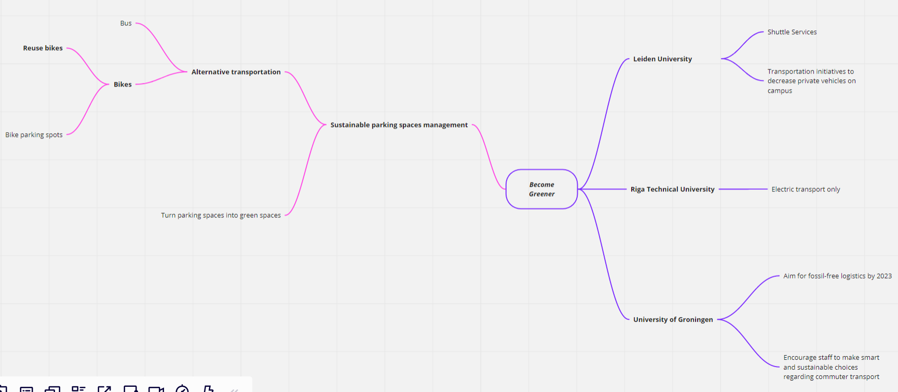

## Problem Statement

UBB conducts campaigns to promote bike sharing/reuse. The scenario is that students that graduate might move away from Cluj and they would rather donate their bikes than transport them.

**Actors**

* UBB Used Bikes Center (UBBUsedBikes)
* Student (S)

**Signals**

* UBBUsedBikes -> S: **receivingOldBikes** (used bikes collection campaign started)
* S -> UBBUsedBikes: **donateUsedBike** (student donates his/her used bike)