Semester Project

Name: Trașcă Andrei-Sabin

Group: 412G

1. Description of the program in natural language

The program asks us to introduce a number “n” from the keyboard which is the number of rows and columns of a 2D array and then to introduce its elements.

After that the program asks us to introduce a number of degrees (90,180,270) by which the matrix will be rotated

At the end, the program prints in the console the rotated matrix

2. As function, I used a function for each degree of rotation (1 for 90, 1 for 180 and 1 for 270) and the main function

In the main function , the program is reading a matrix from the keyboard and a rotation degree, then using a switch...case function we evaluate the introduced degree and print the desired matrix

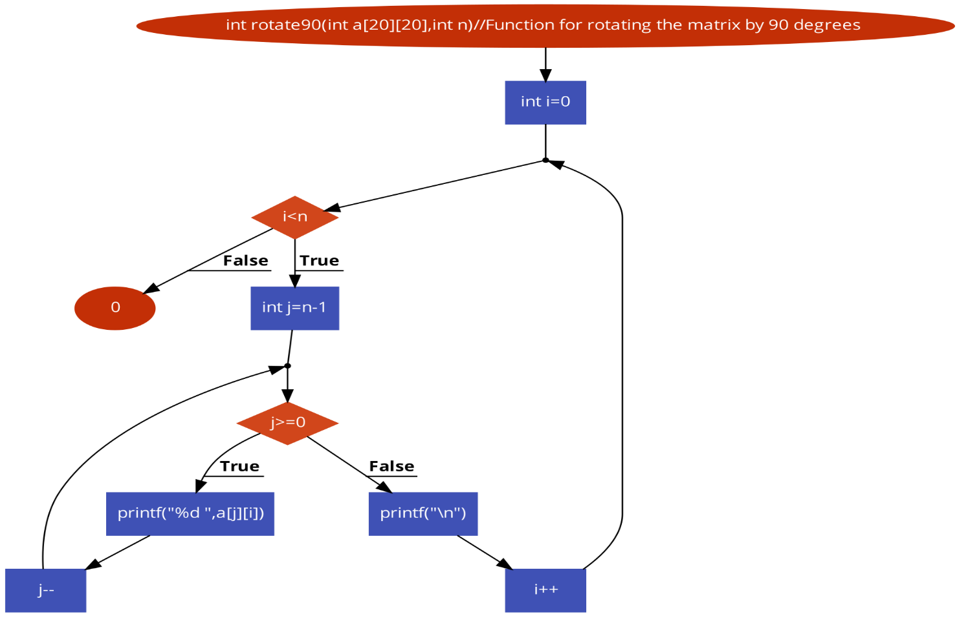

Flowchart for the 90 degree rotation function

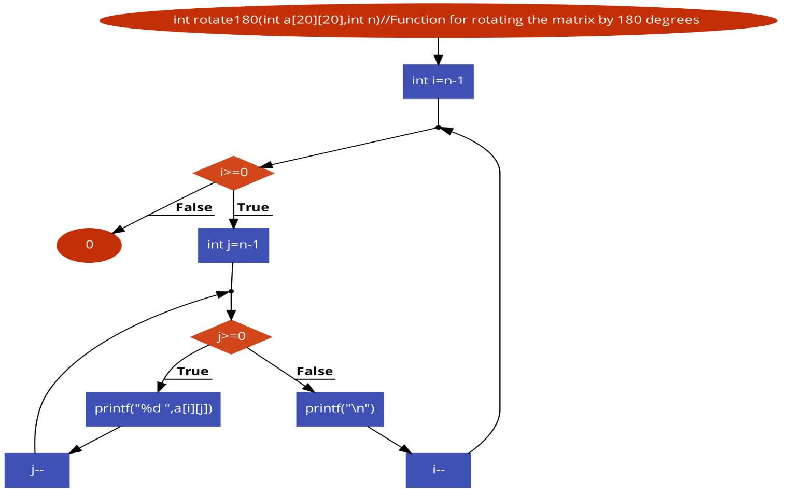

Flowchart for the 180 degree rotation function

Flowchart for the main function

3. The listing for entire program with comments

/\*The program will have us introduce a matrix from the keyboard  
 And will rotate it by a chosen degree,  
 Then it will print the final matrix\*/  
  
  
#include <stdio.h>  
int rotate90(int a[20][20],int n);  
int rotate270(int a[20][20],int n);  
int rotate180(int a[20][20],int n);  
int main() {  
 int a[20][20], i, j, n, degree;  
  
  
 printf("\n\nRead a 2D array of size nxn and print the matrix :\n");  
 printf("------------------------------------------------------\n");  
  
 //Introducing the matrix size and elements from the keyboard//  
  
 printf("Input number of lines and columns in the matrix :", n);  
 scanf("%d", &n);  
 for (i = 0; i < n; i++) {  
 for (j = 0; j < n; j++) {  
 printf("element - [%d],[%d] :", i, j);  
 scanf("%d", &a[i][j]);  
 }  
 }  
 //Introducing the rotation degree from the keyboard//  
  
 printf("\n Choose the rotation degree(90,180,270):", degree);  
 scanf("%d", &degree);  
 //We will use the switch...case function to evaluate the degree input//  
 printf("\n");  
 printf("------------------------------------------------------\n");  
 printf("The final matrix is:\n");  
  
 // Using a switch...case function to evaluate the degree input and printing the correct final matrix  
   
 switch (degree) {  
 case 90:  
 rotate90(a, n);  
 break;  
 case 180:  
 rotate180(a, n);  
 break;  
 case 270:  
 rotate270(a, n);  
 break;  
 default:  
 printf("Choose a compatible operator");  
  
 }  
}

//Function for rotating the matrix by 90 degree

int rotate90(int a[20][20], int n)  
{for(int i=0 ;i<n; i++)  
{  
for(int j=n-1;j>=0;j--)  
printf("%d ",a[j][i]);  
printf("\n");  
}  
return 0;  
}

//Function for rotating the matrix by 270 degrees

int rotate270(int a[20][20],int n)  
{for(int i=n-1;i>=0;i--)  
 {  
 for(int j=0;j<=n-1;j++)  
 {  
 printf("%d ",a[j][i]);  
 }  
 printf("\n");  
 }  
 return 0;  
}

//Function for rotating the matrix by 180 degrees

int rotate180(int a[20][20],int n)  
{for(int i=n-1;i>=0;i--)  
 {for(int j=n-1;j>=0;j--){  
 printf("%d ",a[i][j]);  
 }  
 printf("\n");}  
 return 0;  
}

4. Screenshots of the running program

