Profession : Junior Software Developer

**Calculations in python**

NOTEBOOK

THING: BASICS PROGRAMMING

Name : Aleksei Kromski

Group : JPTVR1

Multiple Choice Quiz 3

Chapter 01 Worksheet 4

Chapter 01 Worksheet 8

Part A 8

Part B 9

Part C 9

# Multiple Choice Quiz

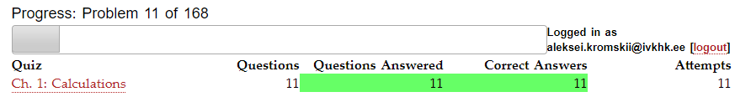

# Chapter 01 Worksheet

When writing answers to questions, please use proper grammar, capitalization, and punctuation. Please limit the length of each line to 80 characters.

1. Write a line of code that will print your name.

Print(‘Aleksei’)

1. How do you enter a comment in a program?

# Print(‘Aleksei’)

1. What do the following lines of code output? ALSO: Why do they give a different answer?

|  |
| --- |
| print(2 / 3)  0.6…  print(2 // 3)  0  the first is the usual division and the second this desire shows how many times one number enters another |
|  |
|  |

1. Write a line of code that creates a variable called **pi** and sets it to an appropriate value.



1. Why does this code not work?

|  |
| --- |
| A = 22  print(a)  variables have different uppercase |

1. All of the variable names below can be used. But which ONE of these is the *better* variable name to use?

|  |
| --- |
| a  A  Area  AREA  area  area_of_rectangle  Area_Of_Rectangle  best used a or area |

1. Which of these variables names are not allowed in Python? (More than one might be wrong. Also, this question is not asking about improper names, just names that aren't allowed. Test them if you aren't sure.)

|  |
| --- |
| apple  Apple  APPLE  Apple2  1Apple  account number  account_number  account.number  accountNumber  account#  pi  PI  fred  Fred  GreatBigVariable  greatBigVariable  great_big_variable  great.big.variable  2x  x2x  total%  r65#left |

1. Why does this code not work?

|  |
| --- |
| print(a)  a = 45  variable is printed first, but it is not set |

1. Explain the mistake in this code:

|  |
| --- |
| pi = float(3.14)  no error |

1. This program runs, but the code still could be better. Explain what is wrong with the code.

|  |
| --- |
| radius = float(input("Radius:"))  x = 3.14  pi = x  area = pi * radius ** 2  print(area) |

1. Explain the mistake in the following code:

|  |
| --- |
| x = 4  y = 5  a = ((x) * (y))  print(a) |

1. Explain the mistake in the following code:

|  |
| --- |
| x = 4  y = 5  a = 3(x + y)  print(a) |

1. Explain the mistake in the following code:

|  |
| --- |
| radius = input(float("Enter the radius:")) |

1. Do all these print the same value? Which one is better to use and why?

|  |
| --- |
| print(2/3+4)  print(2 / 3 + 4)  print( 2 / 3+ 4 ) |

1. What is a *constant*?

This is a value that does not change its value during the process.

1. What is a single quote and what is a double quote? Give and label an example of both?

don't care how you write single or double quotes, but if you want write word in quotes, that you can use single quotes

print("Hello, world!")# Hello, world!

print('Hello, "world"!')# Hello, "world"!

1. Write a Python program that will use escape codes to print a double-quote and a new line using the Window's standard. (Note: I'm asking for the Window's standard here. Look it up out of Chapter 1.)

Print(“hellow\n,world!”)

1. Can a Python program print text to the screen using single quotes instead of double quotes?

yes

1. Why does this code not calculate the average?

|  |
| --- |
| print(3 + 4 + 5 / 3)  first goes the division |

1. What is an ``operator'' in Python?

Aperator is we can do something

1. What does the following program print out?

|  |
| --- |
| x = 3  x + 1  print(x)  3 |

1. Correct the following code:

|  |
| --- |
| user_name = input("Enter your name: )"  user_name = input("Enter your name: “) |

1. Correct the following code:

|  |
| --- |
| value = int(input(print("Enter your age")))  value = int(input("Enter your age")) Chapter 01 WorksheetPart A Fahrenheit in celsium |

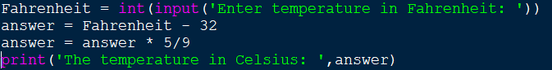

## Part B

Area of circle trapezoid

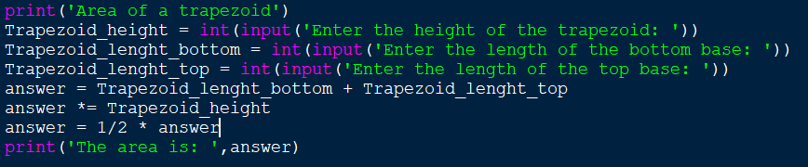

## Part C

Area of circle

