**FLAW**

**(fear loves another war)**

# Overview

The game is about Nick, a private placed in a task force required to extract an object from an unknown place, full of strange beings. He is together with 5 other people, but the helicopter he is on crashes due to an unknown explosion to one of the engines. He wakes up and tries to look for his team, only to find them being eaten by what look like zombies. Nick has to go through the mystified path to look for his commander and best friend, Rodge, and Amy, his girlfriend who are not among the dead, and also look for a way out of this hellish place. He must collect better weapons, as the enemies get harder to defeat.

Find out the truth about why you were sent there, the conspiracies behind the veil and the justified selfishness of the higher ups who sent you there in the name of salvation and extinction. The secrets you find hidden along this place might not lead to what you really wish for. As the light dims and the path darkens, the only option left is the most obvious one.

# Gameplay

The main components of my game are the shooting, looting and the enemies. There are some specific interactions between the enemies and the player, such as some enemies can only be heard when coming from a certain spot (behind), or some enemies that don`t move until a certain point is reached by the player. Some enemies are bound to certain objects such as trees or walls. There are multiple roads for the player to take, though most of them lead to the same result.

Enemies have a health bar that the player has to deplete in different ways as some enemies can`t be shot (or can they). The player collects different weapons that shoot projectiles, some made of different materials that harm specific targets. Weapons have different types of ammunition, which can be found on the ground in specific areas or dropped by some enemies at random.

Enemies evolve as the game progresses, becoming harder to defeat. Their health bar gets bigger (it looks the same but takes less damage) and they deal more damage. Some enemies turn into instant death enemies.

The player can also pass the level if specific actions are taken, defeating all the enemies is one of those actions. Other levels may require to transport an object from one place to another, while others have only one target that has to die for the player to move to the next stage.

# Interface

The controls are w, a for forwards and backwards movement, and a, d for rotating left and right while moving or being stationary. Spacebar will be used to jump, i will open the inventory and escape will open the menu. E and f are utility keys, such as interacting with other objects and picking up guns, opening doors. R is used to reload (also done by emptying the clip). Left mouse button will be used for shooting.

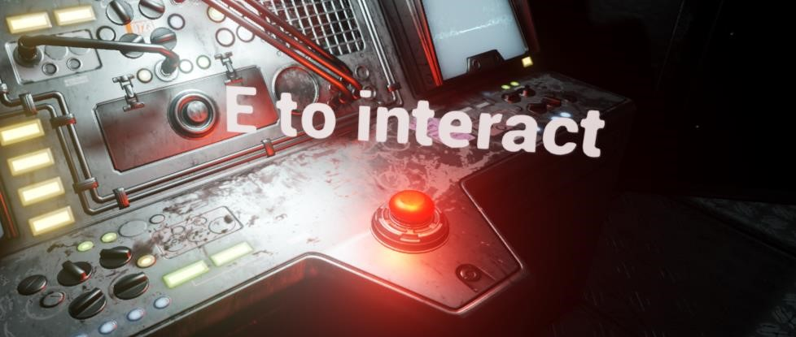

An example of pop up interactions (it appears only when the character is close to the object)

The GUI is similar to other games, a health bar for the player at the bottom of the screen and a corner that shows the equipped weapon. A health bar for enemies. Also pop ups for item interactions (pick-ups, doors etc). the inventory window will be accessible through keyboard input similar to old resident evil games (with no mouse input).

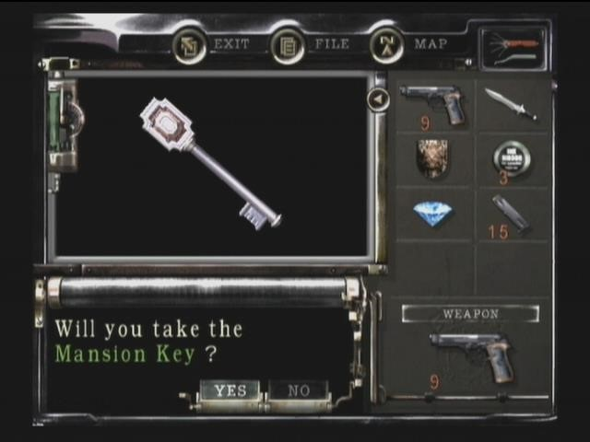

# Objectives

The main quest is to go through all the levels and escape. This is a fairly linear game, so most of the main objectives, such as finding his friend and girlfriend will be done at some point in the game.

For the first level, the player simply has to defeat all the enemies. This is also an introduction and a tutorial for the game.

For the second stage, the player has to find the hidden switch that displaces the rocks at the entrance to the next level. (This is where I`ll probably stop programming the game though I plan to finish it myself after I am done with university)

For the third level, the player moves towards the first looting spot, where he finds a mossy helicopter relic, with some weapons. There the quest is given, to “kill the one that did this”, out of duty to his mates. He sees a silhouette slithering away, later finds a combination of limbs attached to it and must kill it.

In the forth level, the player finds part of his best friend and has to follow a road to a dead end, where he finds a mesh of his girlfriend and best friend, organs hanging around them and other gory things. He can run or kill it.

The fifth level is about not being detected by the multi-eyed enemy, a blob with eyes all over its body who can scan in different ranges. This can be achieved by baiting enemies to come close and have them block the visual range of the enemy.

Sixth level is the last level, where the player finds the exit and the artefact that he is supposed to find. The exit is a boat for which the player must find the key. The artefact transports him back to his world, but he must get one item from a specific place to use it.

An optional level would be finding the weeping ghost, where he goes to a hidden room and finds the ghost. The only way to get through the level is to shine the light on the ghost and make it vanish in the air. The light is hidden in the level, though the player can`t die here and he gains a special weapon from this room. This stage appears on fourth level.

# Look and feel

The game that I am planning on making is a 3D top down horror shooter playable on PC with a mouse and keyboard. The game is placed in an unknown world, with strange plants, terrains and caves, foggy areas and many other effects. Every stage brings a new experience to the player, as enemies are layerd on stages, each enemy with it`s own trick.

The game has multiple sources, one of them being Darkwoods, a horror game with a dark theme where the player has to fight and colect resources to survive and get to the end of the game. This game has given me the idea for the top down shooter, though there are a lot of other games that have influenced me.

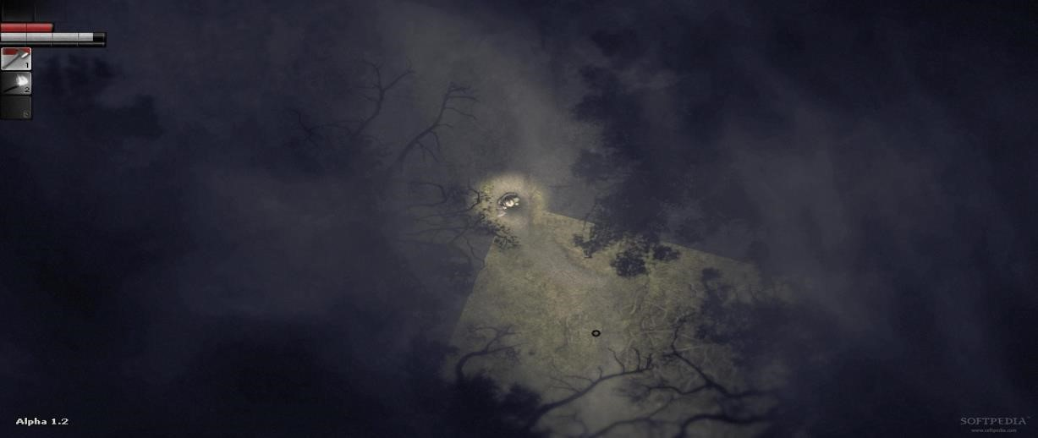

Immage from Darkwoods

The game will be a combination of a game called Cry of fear and a stickman series called Castle [1]. This series depicts the adventures a squad trying to find a new energy source for their planet that is dying. They encounter different threats and have to run away. The game Cry of fear is about a man who goes through the struggles of mental ilness and sees the world in a different way. Most of my inspiration for the story comes from this series and the game.

The sound consists of gunshots and different enemy sounds such as zombies, rough voices, high pitch voices. The music will consist of a combination of fast paced action songs [2][3] to enhance the action scenes and slow songs that would send chills down your spine [4][5].

# Story

Nick is a military who served in a lot of wars. He has joined the army together with Rodge, and they have both gone through different situations, saving each other. They have known each other since childhood and have stayed together through good and bad times.

Nick has lost his mother at an early age and his father has become obsessed of controlling him and abusive. He has decided to get away from home, with the military as his only option. A couple years back, while on a cooperative mission, he has met Amy, and they have stayed together ever since. They had this one last skit before they would retire. Sadly, this mission is their last together.

Through the whole game, all the enemies that he defeats is a representation of his life. The first stage is the easiest part of his life. The second stage represents him entering the army, where he used to train with his mates. The third stage represents the horror that he had gone through, and has changed him, killing people, having friends die.

The fourth stage is about the betrayal he sees from his best friend and girlfriend, and the way to deal with it based on the player`s choice. This betrayal is only in his head, with no proof from him. They both try to help him get through his problems but don`t succeed.

The fifth stage is returning home, to his father. This stage is about how his father behaves towards him, how he has to hide behind the little fears to dodge the bigger menace. He is responsible for his mother’s death, and his father is aware of that and tries to hold him back from harming other people.

The last stage represents his resolution to all of this, either by walking away and dying (the boat), or by taking a grip on reality through pills and getting into a mental hospital (the artefact). The enemies are representative to his struggle against the people around him and the asylum`s doctors and guards. The other patients are his imaginary friends. The special room is the recollection of his mother’s death and how it was his fault.

# References

1. <http://www.stickpage.com/castleseries.shtml>
2. <https://www.youtube.com/watch?v=HrlXjTtQEec>
3. <https://www.youtube.com/watch?v=ASj81daun5Q>[4]<https://www.youtube.com/watch?v=jLUaYqH-1hw>

[5]<https://www.youtube.com/watch?v=R1jG99z7lVY>