Online Energy Utility Platform

# Backend Dependency Diagram:

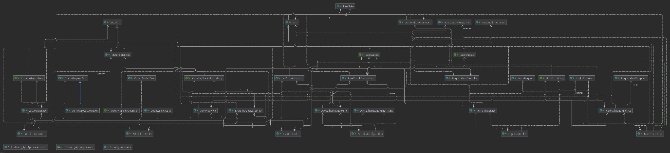

# Database Diagram:

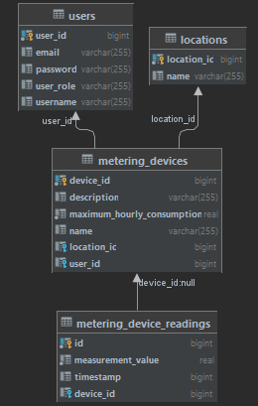

# Conceptual Diagram:

# Deployment Diagram:

