# Republic of the Philippines

**BATANGAS STATE UNIVERSITY**

**The National Engineering University**

**Alangilan Campus**

**COLLEGE OF INFORMATICS AND COMPUTING SCIENCES**

**IoT-BASED RFID ATTENDANCE SYSTEM**

A Project Study Presented to the

College of Informatics and Computing Sciences

Batangas State University

Batangas City

In Partial Fulfillment of the Requirements for the Courses:

IT311: Systems Administration and Maintenance

IT312: System Integration and Architecture

IT313: System Analysis and Design

IT314: Web Systems and Technologies

By:

Espino, John Jeric Z.

Camasis, Jane B.

Ramirez, Ralph Rosyl

Clanor, John Rys

Cueto, Mark Andrei

Alea, Allen

DECEMBER 2022

**CHAPTER I**

**Introduction**

**I.1 Project Context**

Attendance is a must. It is the important thing that is needed in school. Nowadays, Teachers use the common way of tracking the student attendance which is manual attendance. There are some disadvantages of using this system. For instance, the teacher with a large class may find the hassle of having the attendance sheet being passed around the class and the manual signing of attendance by students are burdensome and most likely distract them from teaching and getting the full attention from the students. Besides the attendance sheet being passed around the class, some students accidentally purposely sign another student's name. The first case led to a student missing out on their name. While the latter leads to a false attendance record. The other issue of having the attendance record in hardcopy form is that a teacher may lose the attendance sheet. As a consequence of that, the teacher can no longer trace the student's overall attendance. Apart from that, the teacher also has limited access to the single copy record, only at the workplace. In terms of attendance analysis, the teacher also has to perform manual computation of the student attendance and it normally consumes a lot of time.

Having said the limitation imposed by the common ways on tracking the student attendance. The researchers propose a solution in the form of an attendance tracking system based on RFID technology. The main idea behind the system is to capture student attendance in a way where the student can tap their RFID tag at the RFID scanner upon entering the classroom. This way, the RFID tag is instantly captured by the scanner after the data is sent to the online server for recording purposes. The system also helps to automatically compute the percentage of attendance for each individual student. It is reliable and less time consuming in monitoring the attendance. This can help the teachers to maximize their teaching time. It can notify the parents of the student, if the student is attending or not attending the class. This work was taken as guidance in developing a web-based student attendance system by using the RFID technology.

**I.2 Purpose and Description**

The purpose of this study is to lessen the hassle of getting all the attendance of every student manually in primary and secondary level in education. For that purpose, a IoT-Based RFID Attendance System will be created to ensure the efficiency of getting the attendance of every student and is not time consuming. The proposed system project consists of a website, RFID tag, and the RC522 RFID as the card reader. The study will be conducted by the researchers.

The attendance system that is currently in use now is recorded by signing their signature on a piece of paper, which makes tracking and processing troublesome. The recording of attendance in classrooms is done at the expense of the teaching-learning time. Therefore, the article at hand seeks to investigate an effective means to record attendance in a way which doesn’t hinder learning. It will need to be digitalized by using various sensors and modules on it. The attendance that was taken from the student matric card will be digitalized and sent to the server to be processed, and then the attendance records are able to be viewed via a website.

Radio Frequency Identification (RFID) based attendance system provides us with a solution that caters to issues like proxy attendance. This paper describes the design of an RFID based attendance monitoring system which uniquely identifies each student based on their RFID tag which is attached to their ID card. An RFID tag is an object that can be applied to or inserted into a product, person, or animal for the purpose of identification and tracking using radio waves. Some tags can be read from several centimeters or meters away and beyond the line of sight of the reader.

This makes the mechanism of recording the attendance effortless, quicker and protected as compared to conventional methods. This system is designed to be used at primary and secondary educational institutions. The proposed system consists of both hardware and software components based on IoT Technology. The software component consists of the Web-based GUI for viewing the student's attendance, which is hosted on a web server and which stores the data in a database server.

The students just need to place their RFID card or tag on the reader and their attendance will be recorded for the day. Also, the attendance recorded will be more accurate as the system is synced with a real-time clock. Radio Frequency Identification (RFID) technology is an automation technology that is beneficial in improving the current traditional way of monitoring. As every tag has its own unique ID, it is easy to differentiate every tag holder.

**I.3 Objectives of the Study**

The researchers aim to have an “IoT-Based RFID Attendance System” to have a proper, organized, and well monitored attendance system for students in primary and secondary education. This is an effective way to overcome the existing issues with the old and traditional way of monitoring attendance records.

1. To develop a web-based RFID attendance system;
2. To develop an attendance monitoring website;
3. To provide a web-based RFID attendance management plan. Tracking and monitoring of attendance records; and
4. To perform attendance system testing the following restrictions:

4.1 Efficiency

4.2 Effectiveness; and

* 1. Safety

**I.4 Scope and Limitations**

The objective of this study is to construct a Web-Based RFID Attendance System and use it for schools with primary and secondary education. The respondents who will participate in this study are the people (faculties & teachers, parents and students) who are present and are constituted in that specific school. The researchers decided to select primary and secondary school as major beneficiaries and main respondents of this study because unlike in tertiary school, they don’t change room assignments per subjects from time to time. Since, the old and traditional way of monitoring attendance records of students is non-maturing and lacks the technology that we have and use nowadays, it is eventually becoming unreliable and tricky.

Meanwhile, it will be practical to replace the traditional way of monitoring attendance by adopting radio frequency identification (RFID), a type of wireless communication that uses radio waves to identify and track items and objects. RFID can be used to record attendance for students. The system also allows administrators to view and track students' attendance, which is also saved on the web. Overall, this system enables the management of daily attendance data via comprehensive reports stored on the web.

The researchers selected RC522 RFID as the card reader module since it is the best option because it meets the needs of the current study, it is easy to use, and it is also cheap as well. RC522 is a highly integrated RFID card reader which works on non-contact 13.56mhz communication, is designed by NXP as low power consumption, low cost and compact size read and write chip, is the best choice in the development of smart meters and portable hand-held devices. The data that will be gathered will be easy to store and transfer with the use of this technology and its parameters.

The microcontroller (Node MCU ESP8266) will make everything automated. Node MCU is an open-source platform based on ESP8266 which can connect objects and let data transfer using the Wi-Fi protocol. In addition, by providing some of the most important features of microcontrollers such as GPIO, PWM, ADC, etc., it can solve many of the project’s needs alone. The researchers selected this type of microcontroller since data transfer and storing will be web-based using Wi-Fi protocol as the medium.

The study will be conducted with the help of technology specifically, programming of the certain materials that are mentioned, which will be done by the Information Technology students and the researchers.

**CHAPTER II**

**System Analysis**

**II.1 Development Model**

A software development methodology enabled a well-structured plan and total control of the processes throughout the entire project. The researchers chose the Agile Development Methodology as guidance in developing the system to achieve the objectives of the study.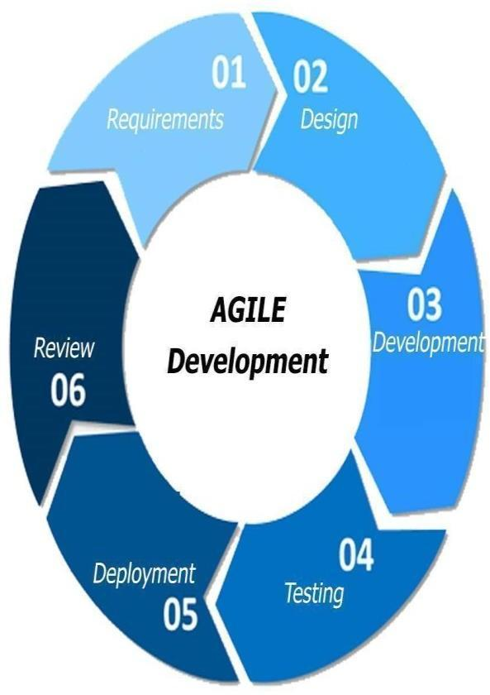

**Figure 1. Agile Development**

Figure 1 illustrated the Agile Model and included phases like the requirements, design, development, testing, deployment, and review. The researchers used such a model mainly because of its flexibility. This model allows changes within a short period and adjustments to changing demands. The agile methodology provided a better and stable system, made the client more involved, and distinguished what works and not. Because of that, the researchers had focused on a specific set of tasks while considering the task's importance.

**II.2 Development Approach**

**Fish Bone Analysis**

The researchers carefully checked the essential criteria to create a new method of attendance to help the students and teachers and developed a functional system that is efficient and effective. As shown in Figure 2, the fishbone diagram, were the causes of time consuming and inefficient attendance school system.

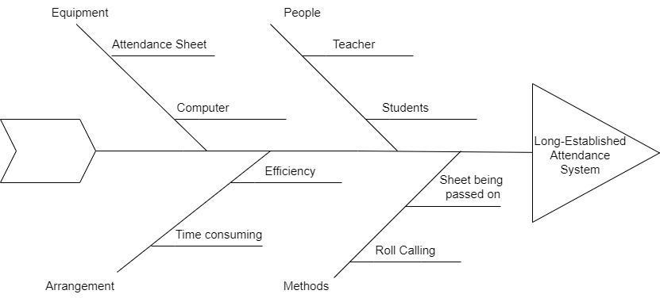

**Figure 2. Fishbone Analysis**

The users believed that the developed web-based system was a solution to this kind of problem. Moreover, it showed that four roots were the problem in the long-established attendance system.

The first reason dealt with the equipment, which was composed of the attendance sheet and the computer. The schools that we're trying to implement the project may have the problems in equipment, it's much more efficient to do the attendance in automated form than waste some attendance sheets every day when doing attendance manually, and they also need to manually type it to the computer were is also too much time consuming and not so efficient.

Other things that were considered were the people, teachers usually check the attendance of students before the class starts, more time will be consume instead of starting the class early to discuss important lessons.

Additionally, having the arrangement is less time consuming. The information will go directly to data base from then the teachers can export it into Microsoft excel sheet and when it comes to efficiency the long-established attendance system is lack of it, making it inefficient because it takes some time and mostly inaccurate.

Furthermore, it also showed that the methods in doing the roll calling or passing on the sheet to every student is very time consuming, as it is done during the time of the official start of class schedule.

**II.3 Schedule and Timeline**

To be able to create the web system to its set deadline, Gantt chart is used to track the activities to be done and should be done in that week.

|  |  |  |  |  |  |  |  |  |  |  |  |  |  |  |  |  |  |  |  |  |  |  |  |  |  |  |  |  |  |  |  |  |  |  |  |  |  |  |
| --- | --- | --- | --- | --- | --- | --- | --- | --- | --- | --- | --- | --- | --- | --- | --- | --- | --- | --- | --- | --- | --- | --- | --- | --- | --- | --- | --- | --- | --- | --- | --- | --- | --- | --- | --- | --- | --- | --- |
| **Activity** | *Week 1* | | | | | | | *Week 2* | | | | | | | | | *Week 3* | | | | | | | *Week 4* | | | | | | | *Week 5* | | | | | | | |
| Topic Planning |  |  |  |  |  |  |  | |  |  |  |  |  |  |  |  | |  |  |  |  |  |  | |  |  |  |  |  |  | |  |  |  |  |  |  |  |
| Topic Proposal |  |  |  |  |  |  |  | |  |  |  |  |  |  |  |  | |  |  |  |  |  |  | |  |  |  |  |  |  | |  |  |  |  |  |  |  |
| Topic Approval |  |  |  |  |  |  |  | |  |  |  |  |  |  |  |  | |  |  |  |  |  |  | |  |  |  |  |  |  | |  |  |  |  |  |  |  |
| Web Construction |  |  |  |  |  |  |  | |  |  |  |  |  |  |  |  | |  |  |  |  |  |  | |  |  |  |  |  |  | |  |  |  |  |  |  |  |
| Prototyping |  |  |  |  |  |  |  | |  |  |  |  |  |  |  |  | |  |  |  |  |  |  | |  |  |  |  |  |  | |  |  |  |  |  |  |  |
| Documentation |  |  |  |  |  |  |  | |  |  |  |  |  |  |  |  | |  |  |  |  |  |  | |  |  |  |  |  |  | |  |  |  |  |  |  |  |
| Final Defense |  |  |  |  |  |  |  | |  |  |  |  |  |  |  |  | |  |  |  |  |  |  | |  |  |  |  |  |  | |  |  |  |  |  |  |  |
|  | | | | | | | | | | | | | | | | | | | | | | | | | | | | | | | | | | | | | | |

**II.4 Project Team and Responsibilities**

Any project's robust Any project's robust and efficient execution depends on assembling an interdisciplinary team with the correct balance of skillset. The level of expertise team members possesses, the scope of the project, and the available budget all influence how resources are allocated. Team members may be able to perform multiple roles or there may be a sub-team focusing on a specific area. m A

|  |  |  |
| --- | --- | --- |
| **Members** | **Role** | **Responsibilities** |
| Alea, Allen | Documentation | Responsible for creating diagrams. |
| Camasis, Jane B. | Software Tester | Responsible for determining any flaws or defects that could negatively impact a software's performance or hurt user experience. They are an essential part of a software development team as they give insight to developers on how to improve and enhance the final product and overall user experience. |
| Cueto, Mark Andrei | Documentation | Helps create diagrams. |
| Clanor, John Rys B. | Design | Responsible for designing and documenting methods procedures in software. |
| Espino, John Jeric Z. | Lead Developer/Programmer | Responsible for writing, modifying, and testing scripts and code, enabling computer programs and applications to run correctly and guides projects and manages development teams. |
| Ramirez, Ralph Rosyl | Analysts | Responsible for pinpointing the requisite organizational improvements and build the mechanisms to put those changes into practice. |

**CHAPTER III**

**III.1 System Analysis and Design**

In the system analysis, the system will be presented and described, also, the equipment used for developing and designing the electronic circuit that includes software and hardware requirements as well, methods and implementation steps to conduct and monitor the student attendance and information system. The proposed circuit aims to investigate student’s services that provide presence and information services based on the internet of things applications and technologies by literature review that gives an overview of what has been done. To implement the presented system, hardware and software components are required to establish the implementation process that has been chosen based on three criteria and metrics such as cost, availability, and easy programming. The RFID reader is connected to a Node Mcu 8266 device which is an open circuit system by pins. The Node Mcu 8266 circuit sends the signal to a server-based via using Wi-Fi connection as well using Wamp server, PHP and MySQL for the server to archive the student information attendance records and present student records via a using web-based application like a computer at the front end of the attendance records and information management end to present students attendance records and to student registration via the staff in a faculty. Upon student’s entering their tag their parents will be notified instantly that they reach the school their attending to. Besides, the proposed system provides information service for students by displaying their information such as daily timetable attendance, lecture time, section, and other related instructions in the created web-application.

The system design gives a clear description of all processes of the system. In this stage, all steps and procedures for conducting the student attendance management part of the current system are described and presented in Fig. 2. The student scans (RFID Tag) into (RFID Reader) where (RFID Reader) reads the (ID) for the student in particularly via student ID (Reading Process) and then transfer information via Node Mcu 8266 through Wi-Fi access to send data to the Wamp server (MySQL and PHP) to record, manage, and display student attendance records by a web-based application.

**III.1.1 Functional Requirements**

* Admin Login/Logout System
* Forgot Password
* Edit and Update admin Profile
* Manage Students
* View Students
* Add New Students
* Edit and update the existing users
* Remove Students
* Manage Section
* Add new Section
* Update existing Section
* Update New token to the device
* Change the device mode (Enrollment mode: to register new students to the system, Attendance Mode: To record attendance of registered students)
* View Students Attendance Log

**III.1.2 Non-Functional Requirements**

* The students just need to place their RFID card or tag on the reader and their attendance will be recorded for the day.
* The microcontroller along with the database should always be on so that the system could work fully.
* Only the system administrator knows all passwords access to the system.
* The administrator has the responsibility to set up fob/card ID’s in the database so that the system can operate as intended.
* every tag has its own unique ID so that it is easy to differentiate every tag holder.
* Consists of the Web-based GUI for viewing the student's attendance, which is hosted on a web server and which stores the data in a database server.

**III.2 Data Flow Diagram TITIKMAN**

Data Flow Diagram (DFD) is a technique that represents the flow of data through a process or a system. The figure above is a DFD Level 0 diagram that illustrates how the data flows and connects with different entities and processmainly focuses on how appointments are being processed and approved, as well as stored in the database.

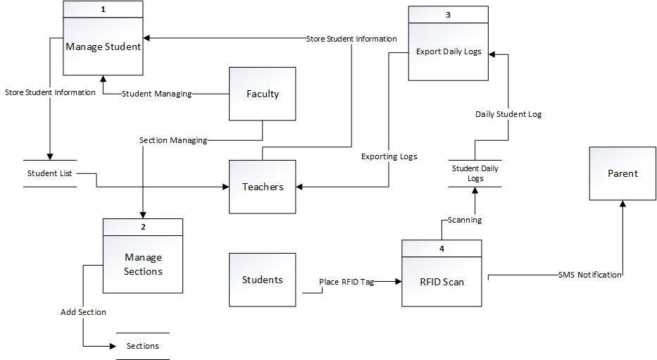

**Figure 3. Level 0 Diagram**

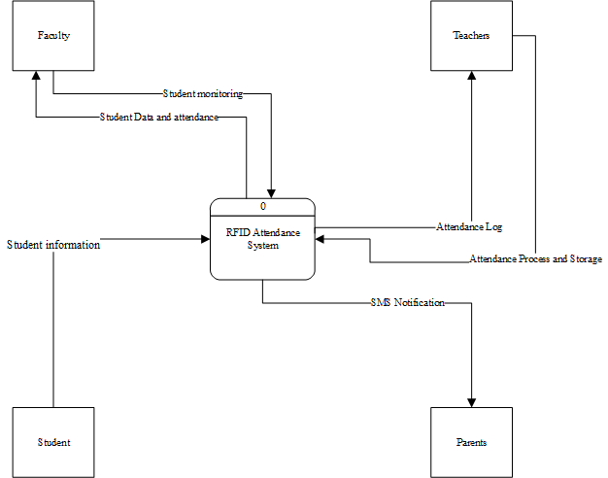

**Figure 3.2 Context Diagram**

Shown in figure 3.2 shows the whole process of the system modelled through context diagram. Context diagram define how the business or computer system interacts with its environment. Context diagrams are used early in a project to describe the entities of the system. It shows the external entities and data flows into and out of the system. As shown in the figure, four external entities were defined. Faculty who can monitor the system and will get the student data. Teacher who can manage student and access the attendance that gathered by the system. The student that will provide the information and attendance that will circulate in the system. Lastly, the parents that will get notified everytime the students go through the system.

**III.3 Graphical User Interface** 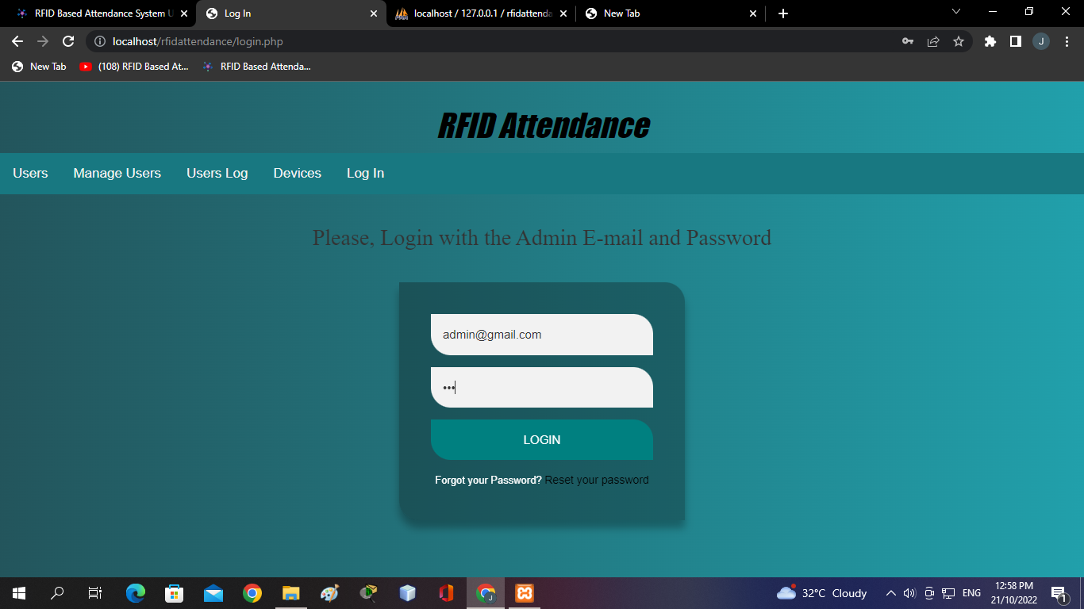

The following screenshots are the actual interface of the web system.

**Figure 6. Login Page**

Shown in Figure 6, that will be the login page for this system. And it is accessible only for the faculty and teachers.

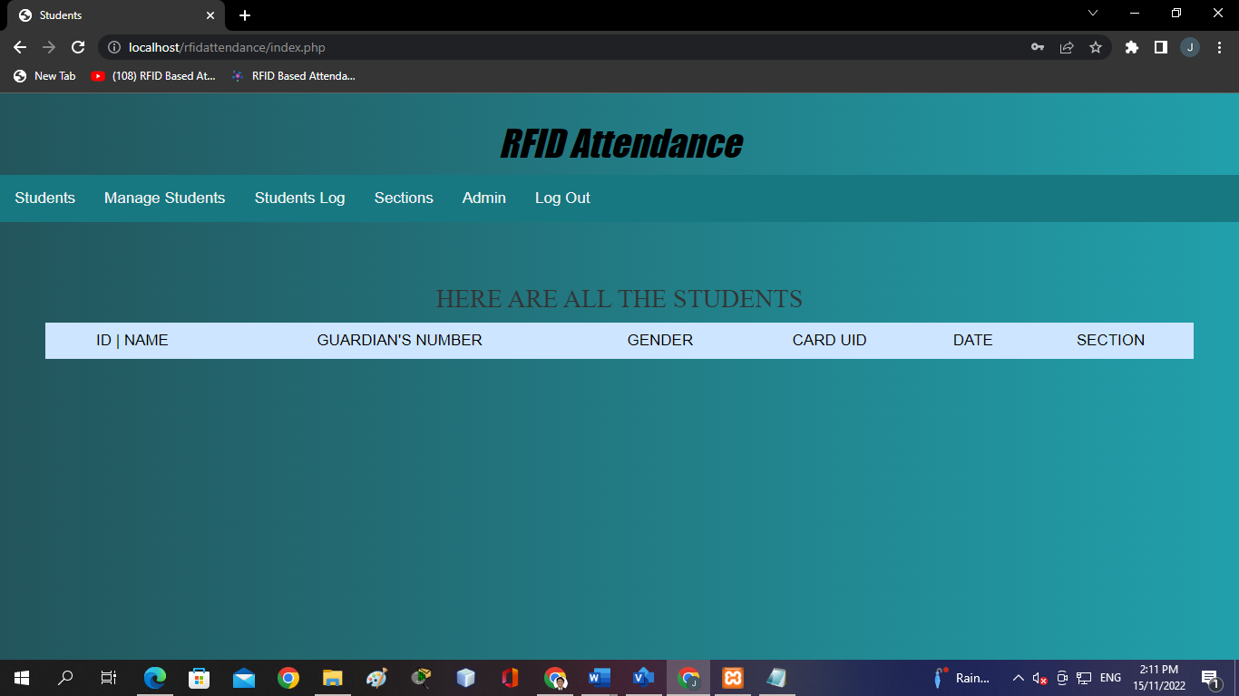

**Figure 7. Students List**

Displayed in Figure 7, the data or the students name and info will be stored in this section. It will consist of names, guardian’s number, gender, card uid and section.

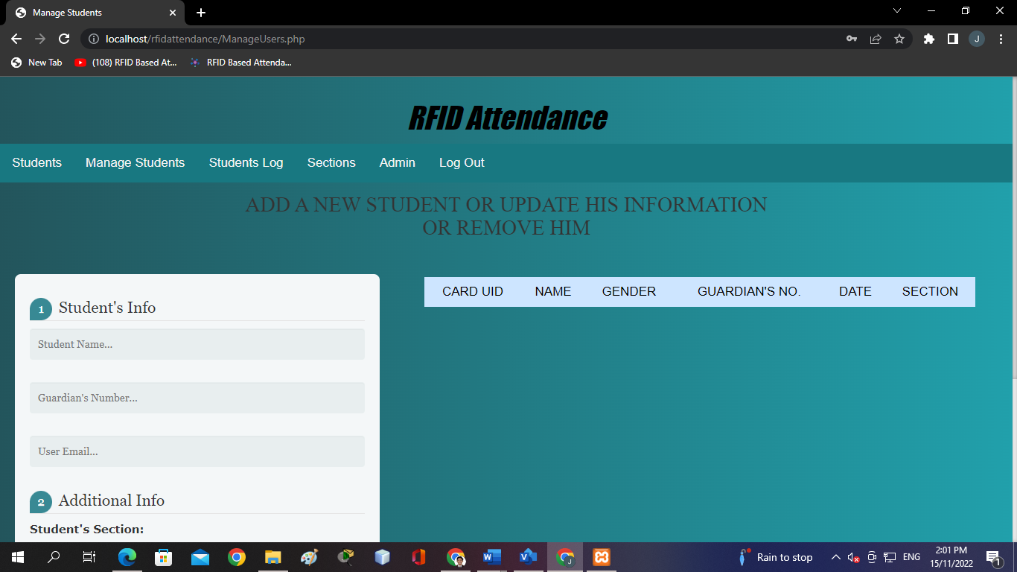

**Figure 8. Manage Students Page**

In figure 8, this will be the page that will update or add another user/student. The names, guardian’s number, email address and the student’s section.

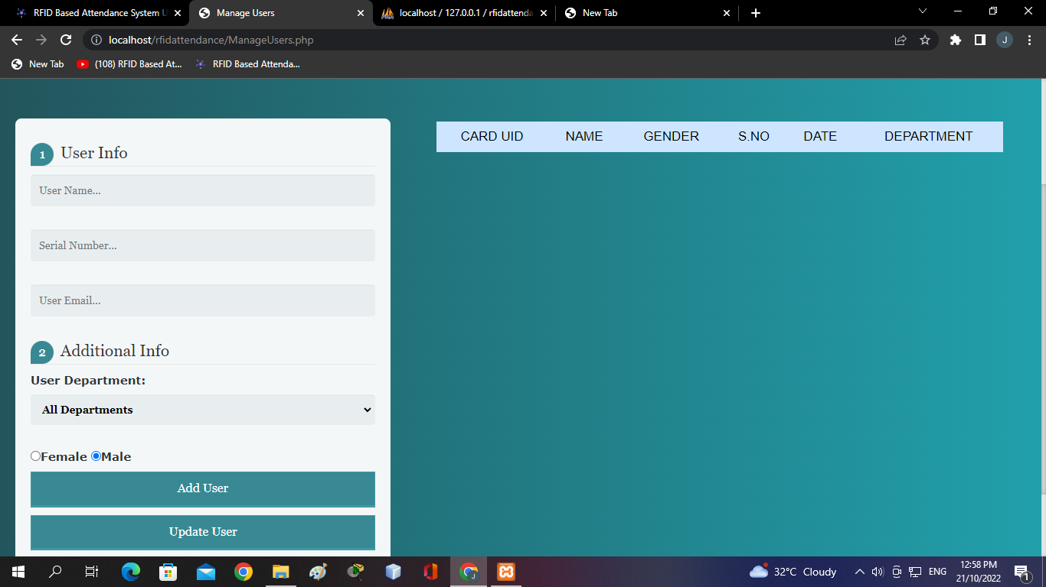

**Figure 9. Students Log**

In figure 9, this will be the page where the attendance will be stored. The teachers/professors can export the attendance to Microsoft Excel.

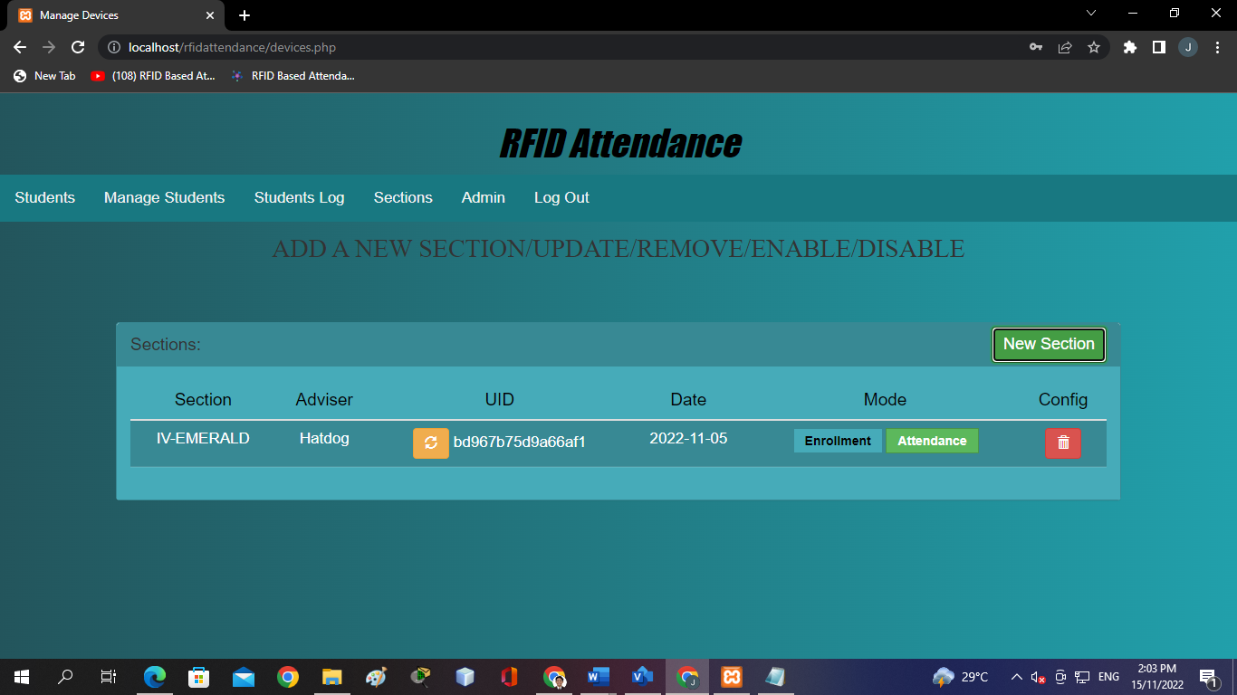

**Figure 10. Manage Sections Page**

Show in figure 9, the list and the managing page of the section in the system. It consists of section, advise, uid the data and the mode. There will two rfid scanner modes. It will be the Enrollment where the faculty can add new students and there will be the attendance mode where every tap to the scanner will automatically goes to the attendance or the students log.

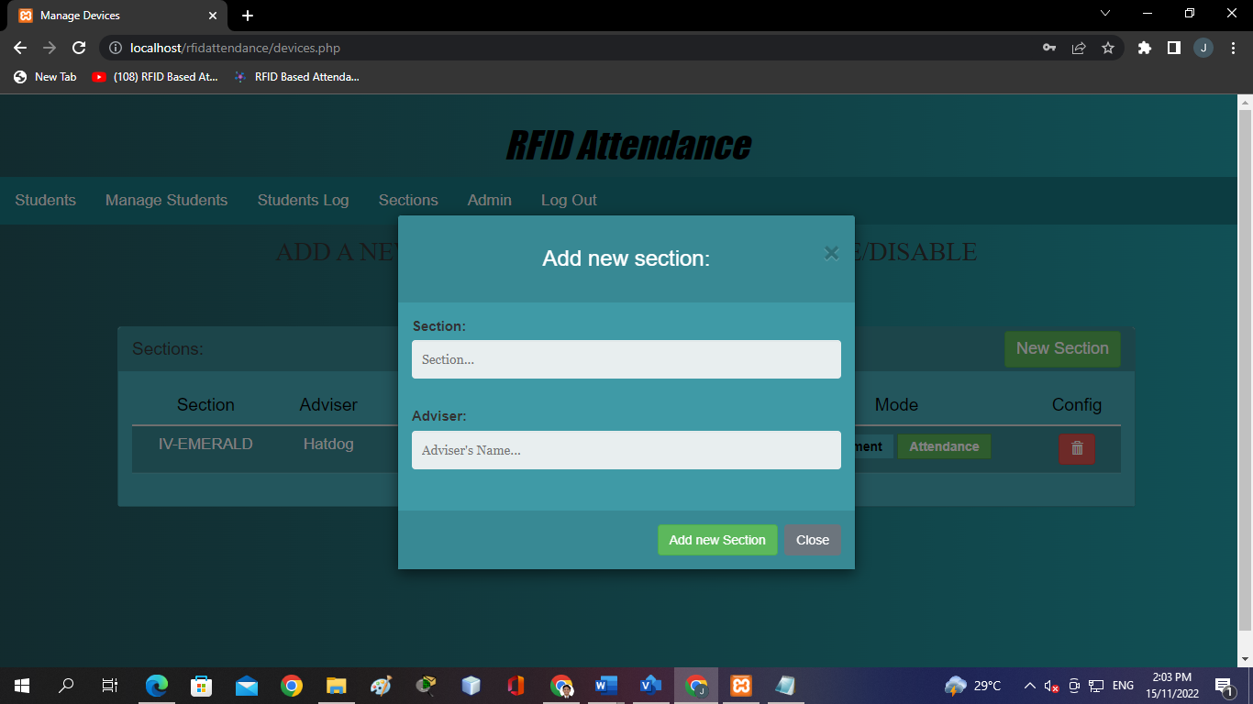

**Figure 11. Adding new section**

In figure 11, the function is to add an additional section in the system for the upcoming students

**CHAPTER IV**

**System Integration**

**IV. INTEGRATION SUPPORT**

This section will give descriptions to the materials, equipment, and facilities and software support required for integration as well as the training and personnel equipment necessary for the integration.

**IV.1.1Resources and their Allocation**

In this section, the table shows the facility, equipment, and support software required for the project development and system integration. It also indicates the personnel needed and their estimated cost and wages.

|  |  |  |  |
| --- | --- | --- | --- |
| **Facility** | **Address** | **Monthly Rent** | **Total Rent** |
| Espino’s Residence | Lmi Site Kumintang Ibaba Batangas City | FREE | FREE |
| Ramirez’s Residence | Sitio Roadside, Banaba West | FREE | FREE |

**Table#. Facility Used**

Table# show the facility that the development of the system takes place. Located in Kumintang Ibaba and Banaba West Batangas City Batangas for free.

|  |  |  |  |  |
| --- | --- | --- | --- | --- |
| **Equipment** | **Description of use** | **Number of units** | **Cost per units** | **Total Cost** |
| Desktop Computer | System designing, development and testing | 2 | Php 15,000 | Php 30,000 |
| Laptop | Documentation | 2 | Php 22,000 | Php 44,000 |
| Printer | Printing Documents | 2 | Php 5,000 | Php 10,000 |
| Router | Internet Connection | 2 | Php 1,299 | Php 2,598 |
| Bond Paper | Documentation | 1 | Php 200 | Php 200 |
| Node Mcu 8266 | System Device | 1 | Php 500 | Php 500 |
| RFID module kit | System Device | 1 | Php 200 | Php 200 |
| GSM Module | System Device | 1 | Php 900 | Php 900 |
|  |  |  |  |  |

**Table#. Equipment used in project development**

Table# shows all the equipment used for system development and integration.

The equipment used in facilities are desktop computers, laptop, printer, router, bond paper.

|  |  |  |  |  |
| --- | --- | --- | --- | --- |
| **Software** | **Description of use** | **Number of units** | **Cost per unit** | **Total Cost** |
| Visual Studio Code | Text Editor | 2 | FREE | ------ |
| PHPMYADMIN | Mysql, Database Server | 2 | FREE | ------ |
| Microsoft Office | Documentation | 2 | FREE | ------ |
| Youtube | System Design | 1 | FREE | ------ |

**Table # Software used in project development**

Table# shows all the software used for the system development and integration. For the development phase, the researchers used visual studio as text editor, Phpmyadmin for the database server, Microsoft office which free since the desktop and laptop have it since it was bought and Youtube for the codes and system designing.

|  |  |  |  |
| --- | --- | --- | --- |
| **Personnel** | **Designation** | **Monthly Wage** | **Total Wage** |
| Espino, John Jeric | Lead Developer/  Programmer | Php 55,000 | Php 55,000 |
| Ramirez, Ralph | System Analyst | Php 22,000 | Php 22,000 |
| Clanor, John Rys | UI Designer | Php 22,000 | Php 22,000 |
| Camasis, Jane B. | Software Tester | Php 22,000 | Php 22,000 |
| Cueto, Mark Andrei | Document Specialist | Php 15,000 | Php 15,000 |
| Alea, Allen | Document Specialist | Php 15,000 | Php 15,000 |

**Table#. Project team**

Table# shows persons involved in project development and integration their corresponding monthly and total wages. The project team consists of lead developer, programmer, system analyst, UI designer and document specialists.

**IV.1.2 Training**

Table# shows the table of contents of the sample manual for the client. The manual provides instruction for the client to use in training on how to use various features of the system. The training fee is charge and will be conducted by John Jeric Espino in Espino’s Residence.

|  |
| --- |
| RFID Attendance System Training Manual   1. Getting Started   System Walkthrough 1  System Components 2  Navigation 3     1. System   Managing Students 4  Export Student Attendance 5  Managing Sections 6  Update admin login account 7 |

**Table# Table of Contents of the Sample Training Manual**

**IV.1.3 Testing**

This section includes all the tests conducted after the system has been developed. The tables below include the following attributes: test case ID, test case description, test execution steps, inputs and outputs, test results and also the one who is responsible for the testing.

|  |  |  |  |  |  |  |
| --- | --- | --- | --- | --- | --- | --- |
| Test ID | 1 | Description | Evaluating page URLs | | | |
| Test Execution Steps | | | | | | |
| S.  No. | Tester | Action | Inputs | Expected  Output | Actual Output | Test  Result |
| 1 | Jane  Camasis | Click Students | rfidattendance/  index.php | Students Page | Students Page | Pass |
| 2 | Jane  Camasis | Click Manage Students | rfidattendance/  ManageUsers.php | Manage Students Page | Manage Students Page | Pass |
| 3 | Jane  Camasis | Click Students Log | rfidattendance/  UsersLog.php | Students Log Page | Students Log Page | Pass |
| 4 | Jane  Camasis | Click Sections | rfidattendance/  devices.php | Sections Page | Sections Page | Pass |
| 5 | Jane  Camasis | Click Admin | rfidattendance/  devices.php | Login Account | Login Account | Pass |
| 6 | Jane  Camasis |  |  |  |  | Pass |

**Table Evaluating web app**

Table 4.6 shows the test results on evaluating page URLs. The system is expected to display correct templates on different endpoints. The inputs for this particular test are different endpoints. The system passed all the test conducted by Arra Manalo.

|  |  |  |  |  |  |  |
| --- | --- | --- | --- | --- | --- | --- |
| Test ID | 2 | Description | Evaluating rfid attendance functionalities | | | |
| Test Execution Steps | | | | | | |
| S.  No. | Tester | Action | Inputs | Expected  Output | Actual Output | Test  Result |
| 1 | Jane  Camasis | Fill up the login form | Email: admin  Password: *** | Log in | Log in | Pass |
| 2 | Jane  Camasis | Fill up Student’s Info and Additional Info | Student Name: ralph  Guardian’s Number: 09375345377  User Email: user@gmail.com | Successfully added | Successfully added | Pass |
| 3 | Jane  Camasis | Fill up the Add new section form | Adviser: Adviser’s name  Section: section | A new device has been added successfully | A new device has been added successfully | Pass |

**Change procedures and history**

**CHAPTER V**

**V.1 Identifying the Risk**

Every system faces threats and risks that may take devices down. In order to prevent or take control of what is coming, the researchers identify all the possible threats or risks that may occur.

Show in table 1, the three threats in the system. First, eavesdropping is an attack that is known as sniffing or snooping. Attackers can steal information when the system is transmitting data in the database server. Scanner and Tag Degradations repeated and not properly used of tag and scanner over time will lead to degradation of the device. Lastly, the Internet Outage. Complete or partial failure of the connection will cause an interruption in data transmitting.

**Table 1. Identified Risks**

|  |  |  |
| --- | --- | --- |
| **Category of Risk** | | |
| RID | Type of Risk | Description |
| RID 001 | Eavesdropping | Eavesdropping, like it sounds, occurs when an unauthorized RFID reader listens to conversations between a tag and reader then obtains important data. It is still necessary for the hacker to know the specific protocols and tag and reader information for this technique to work Purpose: Steal Information and/or Gain Access |
| RID 002 | Scanner and Tag Degradation | Physical degradation of tag and scanner over time. |
| RID 003 | Internet/Connection Outage | Loss of internet connection within the school premises. |

**V.2 Analyzing the Risk**

In order to analyze the present risks, the researchers used the Risk Assessment Matrix as legend to identify the degree of hostility of each threat. Shown in Table no. 2, RID 001 (Eavesdropping) at High Risk. This risk has a probability of "Possible", a severity of 15 and a likelihood of 3 that sums up to a risk score of 45. On the other hand, RID 002 (Scanner and Tag Degradation) at Med Risk. This risk has a probability of "Rarely Occur" a severity of 6 and a likelihood of 2 that sums up to a risk score of 12. While the RID 003 (Internet Outage) at Low Risk. This risk has a probability of "Very Unlikely" a severity of 2 and a likelihood of 1 that sums up to a risk score of 2.

**Table 2. Risk Assessment Control Measure**

|  |  |
| --- | --- |
| RID | Risk Assessment Control Measure |
| RID 001 | High Risk |
| RID 002 | Med Risk |
| RID 003 | Low Risk |

**V.3 Evaluating the Risk**

Evaluating the risk and making a decision about its severity. The researchers identify the existing risk and possible threats that the system may face.

The first threat easily is in the extreme category in impact because it will cause data leakage and it is possible to happen. The second threat is in the moderate category in impact because the device is easy to replace. The third threat is in the minor category in impact because connection outage will rarely occur and it is easy to fix.

**Table 3. Summary of Risk Evaluation**

|  |  |  |  |  |  |
| --- | --- | --- | --- | --- | --- |
| **RID** | **Impact** | **Likelihood** | **Impact** | **Likelihood** | **Risk Score** |
| RID 001 | Extreme | Possible | 5 | 3 | 15 |
| RID 002 | Moderate | Rarely Occur | 6 | 2 | 12 |
| RID 003 | Minor | Very Unlikely | 2 | 1 | 2 |

**V.4 Treating the Risk**

After risk has been analyzed and prioritized, it is time to put actions to it. All of the risks and threats should be contained, controlled and eliminated.

|  |  |  |
| --- | --- | --- |
| **ID** | **Risk** | **Control** |
| RID 001 | Eavesdropping | Update antivirus and use virtual private network or VPN. |
| RID 002 | Scanner and Card Degradation | Encase the scanner within a waterproof and vandal resistant case and as for the cards, it is wise to put them in a protective cover. |
| RID 003 | Internet/Connection Outage | Regular monitoring of internet availability and accessibility. |

**Table Treating the Risks**

**V.5 Monitoring and Checking the Risk**

**Table. Review of Risks and Issues**

|  |
| --- |
| **REVIEW FREQUENCY** |
| Analyzing risks and issues is important. A successful system will always go through issues and that will lead them to make improvements. The researchers put enough effort on identifying the risk and issues that may occur in the system to make it a smooth process. |
| **PARTIES RESPONSIBLE FOR REVIEWING** |
| Cueto, Mark Andrei E.  Ramirez, Ralph Rosyl M. |

**Table. Monitoring**

|  |
| --- |
| **REVIEW FREQUENCY** |
| The assigned researcher will monitor the system and the website at least 3 times a week. In that manner the system will operate smoothly and any upcoming issues will be resolved as soon as it is discovered. |
| **PARTIES RESPONSIBLE FOR REVIEWING** |
| Alea, Allen  Clanor, John Rys |

**Table. Reporting**

|  |
| --- |
| **REVIEW FREQUENCY** |
| The researchers seek advice to the mentors in every part of the system developing and web developing. Putting great effort and work in the system for better result but its only possible with the help of the mentors. |
| **PARTIES RESPONSIBLE FOR REVIEWING** |
| Espino, John Jeric Z.  Camasis, Jane B. |