AUTONOMOUS NON-PROFIT ORGANIZATION
PROFESSIONAL EDUCATIONAL ORGANIZATION
MOSCOW INTERNATIONAL COLLEGE OF DIGITAL TECHNOLOGIES “TOP ACADEMY”

GRADUATION QUALIFICATION WORK

Level of professional education:
Secondary vocational education

Field of study (specialty):
09.02.07 Information Systems and Programming

Development of an Online Store Using the Django Framework

Explanatory Note
ANO PEO MICDT “TOP ACADEMY” 09.02.07. 1. 22. 234

Academic supervisor __________________ _________________
signature date initials surname

Quality control officer __________________ _________________
signature date initials surname

Student __________________ _________________
signature date initials surname

Moscow 2025

Contents
Contents 2
Introduction 4
Goal 5
1. Technical Specification 8
1.1. Introduction to the Technical Specification 8
1.2. Purpose of the Development 9
1.3. Program or Software Product Requirements 10
2. Software Design and Development 13
2.1. Software Design Methodology and Business Process Analysis 13
2.2. Software Development Tools and Technologies 14
2.3. Infological Data Model 15
3. Software Testing 18
3.1. Basic Terms and Their Relationship 18
3.2. Error Detection and Debugging Methods 19
3.3. Functional Testing 21
3.4. Structural Testing 27
4. System Programmer's Guide 28
4.1. General Program Information 28
4.2. Program Structure 28
4.3. Program Configuration 30
4.3.2. Changing the Configuration File 31
4.4. Program Verification 34
4.5. Messages for the System Programmer 35
5. Program Operation 37
5.1.1. Main Page 37
5.1.2. Registration and Authorization 37
5.1.3. Personal Account 38
5.1.4. Adding a New Listing 38
5.1.5. Viewing a Listing and Contact Form 39
5.1.6. Logging Out 39
5.2. Messages to the Operator 40
6. Occupational Safety and Life Safety 41
6.1. Organization of the Developer's Workplace 41
6.2. Work Schedule and Fatigue Prevention 42
6.3. Electrical Safety 42
6.4. Software Safety 43
6.5. General Conclusions on Safety 43
7. Development Prospects and Opportunities for Project Improvement 44
Conclusion 47
References 50
Appendices 52

Introduction
Over the past decades, internet technologies have developed rapidly and penetrated all areas of human activity. E-commerce plays a particularly important role in this transformation, providing convenient and accessible ways to purchase goods and services online. Developing web applications that ensure the stable and secure operation of online stores has become one of the most in-demand tasks in information technology.
Against the background of the growing number of online shoppers, there is also an increasing need for modern, functional, scalable, and convenient e-commerce systems. Online stores have become an integral part of small and medium-sized businesses, as well as a tool for self-employed individuals. This requires not only a platform for selling goods, but also a wide range of features: catalog management, order processing, customer interaction, and analytics.
As part of this graduation project, the OnlineShop2 e-commerce system was developed using the modern Django framework. The project implements the main modules required for e-commerce: user registration and authentication, a product catalog with filtering by various criteria, and order processing. The administrative part of the system provides convenient management of users and products.

Goal
The goal of this graduation project is to design, develop, and test an online store that meets modern requirements for functionality, reliability, and security. To achieve this goal, the following tasks were defined:
- Study the subject area and requirements for typical e-commerce systems;
- Formulate a technical specification for the software product;
- Develop the infological and logical models of the system;
- Implement the functional modules of the online store using the Django framework;
- Test the developed system and evaluate its stability;
- Prepare documentation and instructions for users and system administrators.
The object of the study is software for electronic commerce, while the subject is the design and implementation of its functional components on the Django platform.
The methodological basis of the graduation project consisted of object-oriented design principles, the MVC (Model–View–Controller) pattern implemented in Django as MTV (Model–Template–View), as well as REST-oriented approaches used for interaction between components. Git was used for version control, and testing was performed using the built-in Django testing framework.
From a technical perspective, the project is a web application implemented in Python using the Django framework. It provides a strict separation of application logic, routing support, database interaction, a template system, and numerous built-in security features. The application follows a modular structure: each functional area is placed in a separate Django application (for example, product catalog, users, and contact form), which simplifies maintenance and further development.
During development, the relational SQLite database was used at the prototyping stage, which simplified deployment and debugging. In the future, PostgreSQL can be used as a more performant and scalable solution. All project components are configured through standard Django mechanisms, making the system portable and independent of a specific operating environment.
The project takes user experience (UX) principles into account: simple and clear navigation is implemented, along with a minimal number of steps required to publish a listing. The system is intended for end users without specialized IT knowledge and allows them to easily browse the product catalog and contact the seller.
From a security perspective, the project implements the following mechanisms:
- Protection of forms against cross-site request forgery (CSRF);
- User password hashing using the built-in authentication manager;
- User input validation;
- Restricted access to the administrative interface.
The project also contains an administrative section — Django Admin — through which an administrator can manage listings and users. Thanks to Django's built-in capabilities, the administration panel does not require a separate implementation and is automatically generated based on the registered models.
Tests were implemented for the key components of the project, making it possible to identify and eliminate errors at an early stage. Typical user scenarios were also tested: registration, order processing, and submission of the contact form.
In conclusion, the developed software can be easily adapted to the needs of a real business: it is sufficient to connect payment services, configure a dedicated SMTP server for sending emails, and move the system to a full-fledged server (for example, using Nginx and Gunicorn or Docker containerization).
Thus, the graduation project demonstrates all stages of the modern software product life cycle — from defining the task and analyzing requirements to architectural design, implementation, testing, and preparation of technical documentation. It can serve as a template for the subsequent development of larger and commercially significant solutions.

1. Technical Specification

1.1. Introduction to the Technical Specification
This technical specification defines the development process, the main functional and non-functional requirements, and the technical conditions for creating the software product — the OnlineShop2 web application. The goal of the development is to create an online store with user registration and authorization, product catalog management, order processing, and message sending through a contact form.
The developed software is intended for use by both end users (buyers) and administrators (store owners or operators), with the possibility of further expansion.

1.2. Purpose of the Development
The purpose of the system is to automate the process of selling goods online. The system provides:
- convenient navigation through the product catalog with filtering;
- user registration, login, and logout;
- submission of inquiries through the contact form;
- management of website content through the administration panel.
The system should provide fast operation, high availability, and ease of scaling. It is intended for deployment on standard web hosting or VPS servers with support for Python and a database (PostgreSQL in the future).

1.3. Program or Software Product Requirements
The developed web application must have a set of functional and technical characteristics that ensure stable operation under real-world conditions. The core functionality allows users to browse the product catalog, register and log in, and contact sellers through the contact form. In addition, a personal account is provided with a list of posted products and a built-in search by name.
To ensure reliability and security, special attention is paid to handling user errors and validating data. All forms are protected against CSRF attacks, and user passwords are stored in encrypted form using the standard hashing mechanism built into Django.
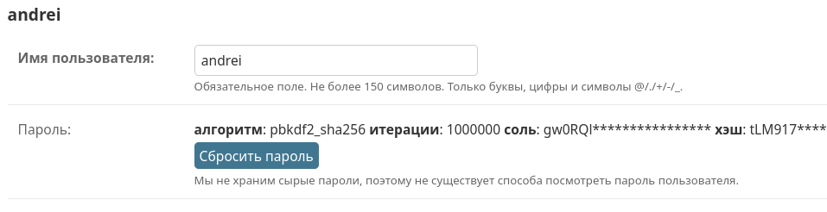
Figure 1 - Password stored only in hashed form

Access to the administrative section of the website is allowed only to authorized administrators, preventing external interference and unauthorized management of the content.
Figure 2 - User access permissions

The system is developed with compatibility across a wide range of client devices and browsers in mind. The application displays and operates correctly in current versions of Chrome, Firefox, Microsoft Edge, and other modern browsers. At the prototype stage, the built-in Django SQLite database is used, providing sufficient performance and ease of configuration. However, the application architecture was initially designed with the possibility of migrating to PostgreSQL, which is important for scaling in a production environment.
The application can be deployed both on local machines for development and testing and on server platforms supporting Python and the WSGI interface. The project does not require specialized hardware and can operate on most virtual servers with a basic configuration: at least 4 GB of RAM, Python 3.10+, and the ability to install the required dependencies.
One of the supporting components of the system is an email-sending module. In the current implementation, it works through an external SMTP server, allowing the contact form and notification functionality to be tested. For commercial use, connecting a dedicated corporate mail server is planned, providing control over outgoing messages and compliance with the organization's security policy.
Thus, the system is developed with a focus on stability, extensibility, cross-browser compatibility, and the ability to quickly adapt to real-world operating conditions.
Figure 3 - Mail server parameters

2. Software Design and Development

2.1. Software Design Methodology and Business Process Analysis
The project was developed using an iterative development model in which the entire process was divided into logical stages: requirements formalization, architectural design, feature implementation, testing, and refinement. This made it possible to gradually adapt the application to real needs and adjust the business logic based on intermediate results.
The business process analysis showed that users need a platform through which they can independently post advertisements for goods, view other users' listings, and communicate directly with one another. Within this interaction model, the seller and buyer exchange contact information (for example, through a contact form), while the transaction itself takes place outside the platform by personal agreement.
This business model reduces the technical load on the system because there is no need to implement complex payment processing, logistics, and return mechanisms. The main focus shifts to convenient listing publication and browsing, reliable user registration, and proper notification of sellers about new messages.

2.2. Software Development Tools and Technologies
Django version 5.1 was selected as the main framework because it provides built-in solutions for authentication, routing, ORM-based database interaction, the administration panel, and templating. This made it possible to focus on application logic without spending time implementing basic infrastructure. HTML and CSS were used for the client side.
The server side runs on Python 3.10+. SQLite is used for data storage, which simplified local deployment and initial testing. If necessary, the system can be migrated to PostgreSQL without changing the application logic.
VS Code and plugins for Django, Python, HTML, and CSS development were used as the development environment, while version control was managed with Git. The built-in Django server was used for running and testing the application, together with manage.py utilities for migrations, creating a superuser, and loading initial data.
In the test version, email sending is implemented through an external SMTP server, which made it possible to test communication between users. The settings are stored in configuration variables, allowing the mail provider to be replaced quickly when moving to production use (Figure 3).

2.3. Infological Data Model
The infological model is based on the main entities: User, Listing, and Message. The relationships between them make it possible to implement all necessary interaction scenarios between platform participants.
- User — a registered system participant who can post listings. The standard Django user model is used, with extensions that allow fields such as email address and phone number to be stored.
- Listing — the main object of the platform. It contains information about a product or service, description, price, images, publication date, and a link to the author.
- Message — an object that provides communication between a potential buyer and the listing author. It contains the sender's contact information, subject, message text, and timestamp.
Relationships between the models:
- One user can create multiple listings.
- Each message is associated with a specific listing and is addressed to its author.
Figure 4 - Relationship between users and listings

The data model is implemented using Django's built-in Object-Relational Mapping (ORM). This provides a high-level abstraction for database interaction: each table is described as a Python class, while table fields are represented as attributes of that class. As a result, development becomes more intuitive, code maintenance is simplified, and the likelihood of errors related to SQL syntax is reduced.
Django ORM automatically generates the SQL queries required to create, modify, delete, and retrieve data. This is especially important when implementing complex queries with filtering, sorting, and relationships between tables — all of these can be expressed using Python methods without manually writing SQL.
Another advantage of using ORM is automatic database schema migration. This simplifies the evolution of the data structure as the project grows and develops.

3. Software Testing

3.1. Basic Terms and Their Relationship
Software testing is the process of verifying that the system operates in accordance with the stated requirements. The goal of testing is to identify possible errors in logic, the interface, security, and component interaction, as well as to ensure that the application operates reliably under different scenarios.
Two levels of testing were used within this project:
- Unit testing — checking individual functions and methods, primarily models, forms, and views.
- Integration and functional testing — checking application behavior under conditions close to real-world operation: user registration, message sending, and listing publication and viewing.
Manual interface testing was also performed using several test accounts to emulate user behavior.

3.2. Error Detection and Debugging Methods
During development, basic debugging methods were used, primarily error logging and analysis of tracebacks in the Django development console.
Figure 5 - Example of an error and its traceback

Errors were grouped into categories:
- Syntax errors, such as errors in Python code, templates, forms, or routes;
- Logical errors, such as the absence of authorization checks when accessing listing editing;
- Data validation errors, most often incorrect input in the contact form or missing required fields.
Each error was recorded, reproduced in a minimal test configuration, and then fixed, followed by a mandatory recheck.
Manual analysis of mail server logs was also performed when sending emails. This was used to verify correct SMTP integration and handling of network errors, such as an unavailable mail server or incorrect addresses.
Figure 6 - Example of a message-sending error

3.3. Functional Testing
Functional testing was performed according to key user scenarios:
- User registration and login: checking the registration form, user creation in the database, automatic authorization, and login with both valid and invalid credentials.
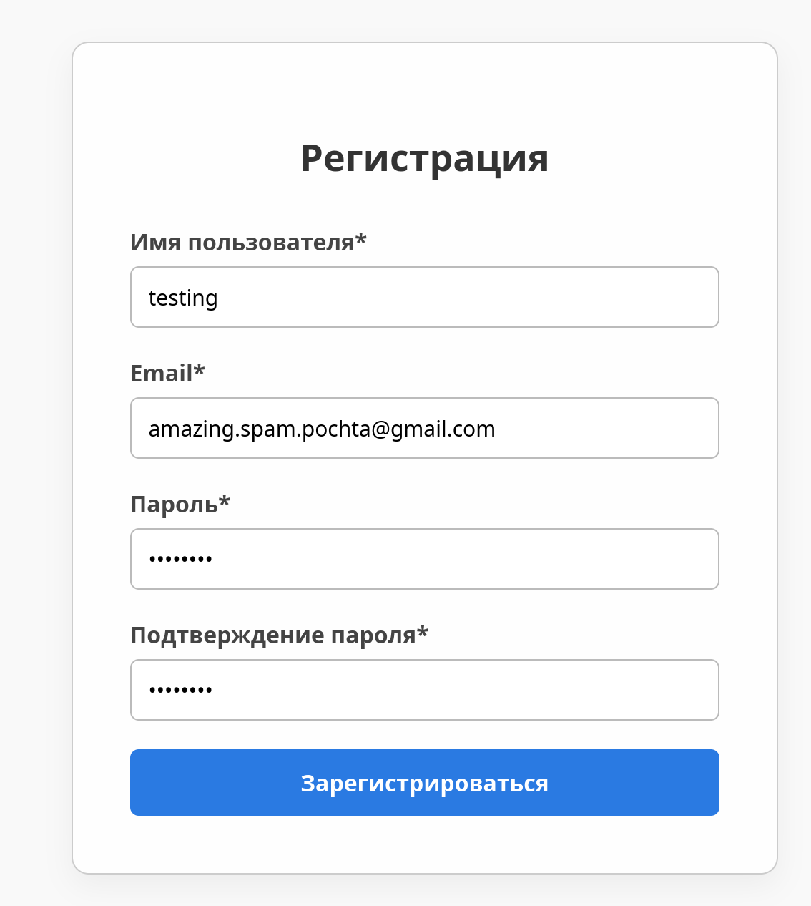
Figure 7 - User registration form
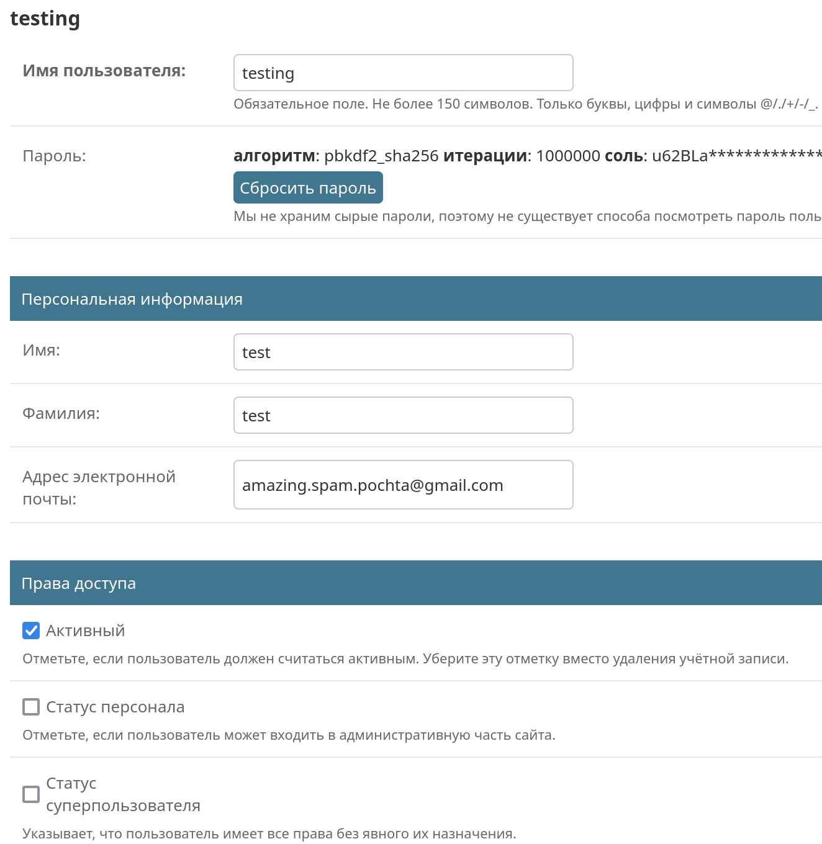
Figure 8 - Successful user creation with correct access permissions

- Listing publication: checking the listing creation form, image upload, display of the listing in the list, editing, and deletion.
Figure 9 - Example of creating a listing

Figure 10 - Successful listing creation check

- Viewing other users' listings: checking access to other users' pages and displaying descriptions and photographs.

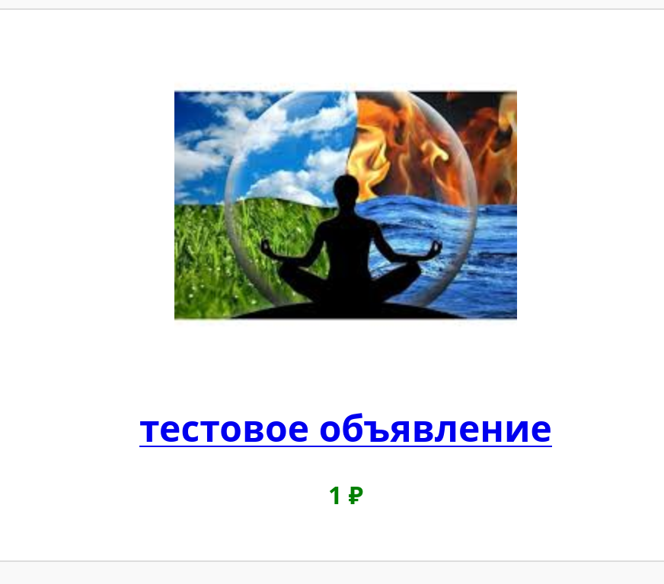
Figure 11 - Viewing a listing on the main page

- Sending a message through the contact form: testing form completion, required-field validation, successful sending, and exception handling in case of SMTP errors.

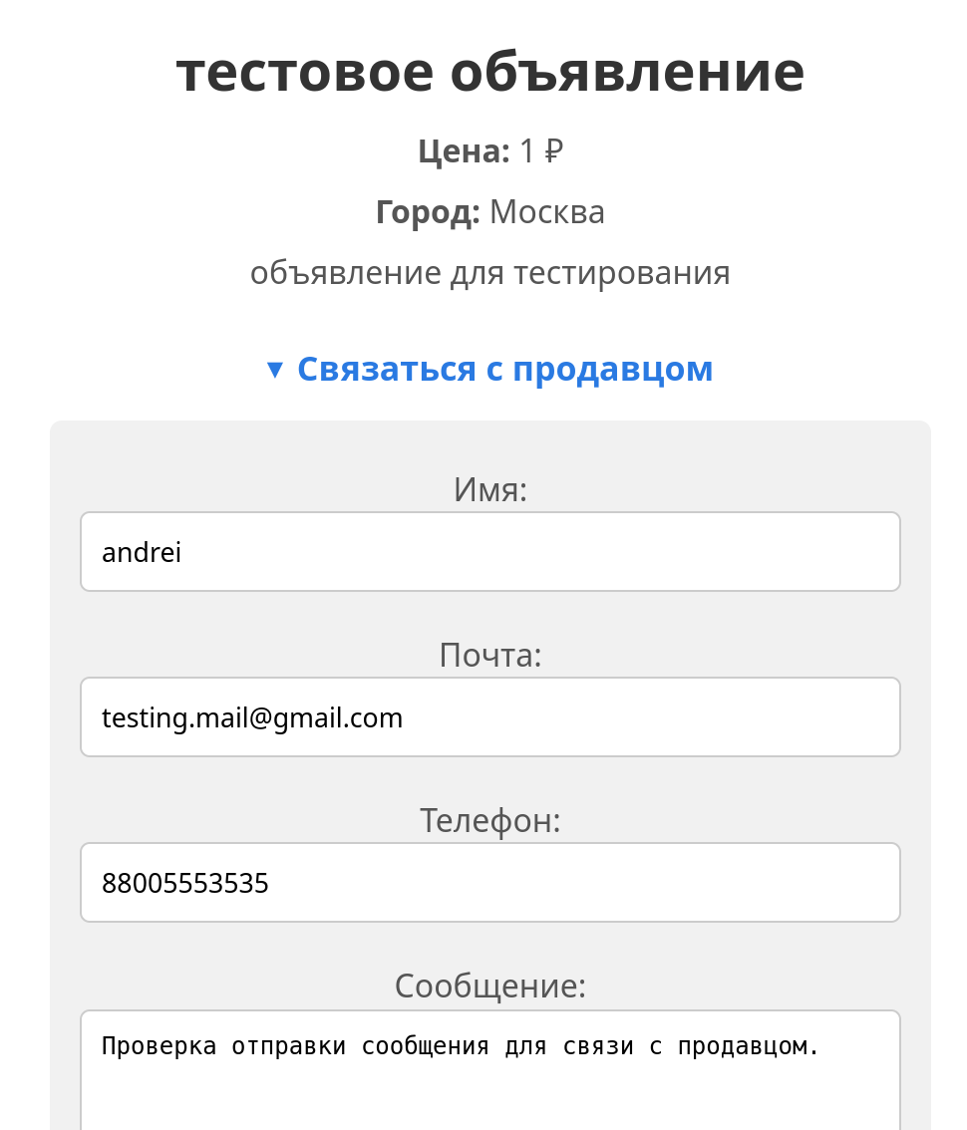
Figure 12 - Completed contact form for the seller

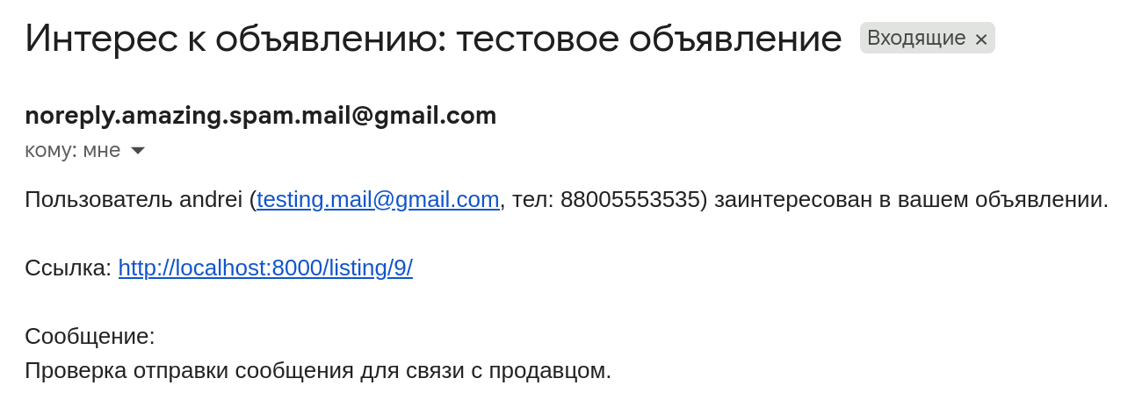
Figure 13 - Confirmation of successful message delivery to the seller

- Access to the administration panel: checking access control, model display, and the ability to edit and delete through the admin interface.
Figure 14 - Administration panel

Each of these scenarios had a set of test cases that were manually run in different browsers and under different accounts.

3.4. Structural Testing
Unlike functional testing, structural testing is aimed at checking the internal logic of the application and the correctness of its individual components from the perspective of the source code. The goal of this stage was to confirm the correctness of architectural decisions and to verify the interaction logic of models, routes, templates, and views.
At the model level, the correctness of relationships between entities was checked. Particular attention was paid to the relationships between listings and users, where each publication must correspond to exactly one registered author.
For routes and views, the URL configuration was reviewed to eliminate conflicts, and clear navigation throughout the site was ensured. Routing was checked both for the main pages (listing list, registration, login) and for dynamic paths containing identifiers of specific listings. The access-control logic was separately checked for all views — in particular, unauthenticated users were prevented from viewing restricted sections.
Another important aspect of structural testing was checking the resilience of templates to missing or invalid data. The project interfaces should not produce broken displays or critical errors even when certain database fields are empty. Attention was also paid to form validation: it was checked that users receive understandable error messages when entering invalid data and that CSRF protection works reliably on all input forms.

4. System Programmer's Guide

4.1. General Program Information
The developed software is a web application created using the Django framework. Its primary purpose is to provide a platform for posting and viewing private listings with the ability for users to contact one another. The application uses a client-server architecture and follows the MVC (Model–View–Controller) pattern as implemented through Django: models (models.py) define the data structure, views (views.py) contain the business logic, and templates provide the user interface.

4.2. Program Structure
The software is built using a modular architecture and consists of three main applications within a single Django project. Each application performs a separate functional task, making the system easier to maintain and extend in the future.
The first application — users — is responsible for user management. It implements registration, login, logout, profile editing, and display of a specific user's active listings. The authentication system uses Django's built-in mechanisms, providing secure and stable operation.
The second application — listings — is responsible for working with listings. It implements the logic for creating, editing, deleting, and displaying publications. Each listing is linked to a specific user. Image uploads are supported, as well as categorization and sorting of the listing list.
The third application — contact — is intended to provide communication between a potential buyer and seller. It contains a message form that sends an email with the sender's contact information and message text. This allows users to quickly contact one another without registering an additional messenger or using a third-party service.
Together, these modules form a complete and self-contained system in which a user can register, post a listing, and contact interested parties.
The main project module — onlineshop2 — serves as the configuration core of the entire Django application. It contains the main settings that determine the overall behavior of the website. In particular, settings.py contains database parameters, paths to static and media files, security settings, mail server configuration, and the list of connected applications. This file provides centralized management of project components.
This module also contains urls.py, where top-level routes are defined. It serves as the entry point from which navigation proceeds to the routes of internal applications such as users, listings, and contact.
Thus, onlineshop2 does not contain application-specific logic, but serves as the central point from which the structure and behavior of the entire system are managed. It acts as a link between individual applications and the external environment in which the application operates.
The project does not require external payment or delivery services — all transactions take place outside the platform, while contact information is exchanged manually through the contact form.

4.3. Program Configuration
Before starting the project, the environment must be configured. First, install all dependencies listed in requirements.txt. The following command is executed in the terminal: pip install -r requirements.txt. This command installs all libraries required by the project, including Django and related modules.
The next step is to initialize the database. The project uses SQLite, so no additional DBMS installation is required. To create the tables and apply migrations, run: python manage.py migrate.
After the migration is successfully completed, create a superuser who will have access to the Django administration panel. The command is: python manage.py createsuperuser. During execution, you will be asked to enter a username, email address, and password. These credentials can then be used to log in to the administration interface.
To make the contact form work, the mail server must be configured (Figure 3). SMTP parameters are entered in settings.py in the following lines:
EMAIL_HOST = 'smtp.example.com'
EMAIL_PORT = 587
EMAIL_USE_TLS = True
EMAIL_HOST_USER = 'your_email@example.com'
EMAIL_HOST_PASSWORD = 'your_password'

If the project is intended to be publicly accessible, it is recommended to move these values to a .env file and load them through os.environ to improve security.

4.3.2. Changing the Configuration File
The settings.py file contains configuration parameters that determine the behavior and environment of the Django project. Some fields require mandatory adjustment when moving the project to a server or performing the final configuration.
1. SITE URL and ALLOWED_HOSTS / The ALLOWED_HOSTS parameter defines the list of domain names from which access to the site is permitted. By default during development it may be empty or contain 'localhost'. In production, real domains or IP addresses should be specified: ALLOWED_HOSTS = ['example.com', 'www.example.com']
If you are testing the project locally, you can temporarily use ['*'], but this is insecure and is not recommended for the final version.
2. MEDIA_URL and MEDIA_ROOT / These parameters define how Django handles files uploaded by users (for example, listing images): MEDIA_URL = '/media/', MEDIA_ROOT = BASE_DIR / 'media'.
After this, make sure that the development server or web server (for example, Nginx) serves the media folder.
3. STATIC_URL and STATICFILES_DIRS / To connect CSS, JavaScript, and other static resources:
STATIC_URL = '/static/'
STATICFILES_DIRS = [BASE_DIR / 'static']

Figure 15 - Parameters required for individual configuration

4. LOGIN_REDIRECT_URL / This parameter specifies where the user is redirected after a successful login: LOGIN_REDIRECT_URL = '/'.
Another page can be specified, such as /profile/ or /dashboard/, depending on the site logic.
5. Language and time zone / To correctly display time and translate the interface, specify the required parameters:
LANGUAGE_CODE = 'ru-ru'
TIME_ZONE = 'Europe/Moscow'
USE_I18N = True
USE_L10N = True
USE_TZ = True
This provides Russian localization and correct time display for the selected time zone.
6. SECRET_KEY / The SECRET_KEY is required for Django cryptographic operations. It must not be published or left unchanged: SECRET_KEY = 'your_unique_secret_key'.
In production, it should be stored in environment variables rather than in plain text in the code.

7. DEBUG / The DEBUG flag controls debug mode. During development it should be enabled (True), but before launching the project in production it must be set to: DEBUG = False.
Otherwise, users may see full error messages and stack traces, which is a security risk.
Configuring these parameters allows the project to be adapted to a specific server environment and security requirements, ensuring stable and correct operation.

4.4. Program Verification
After installing the dependencies, running migrations, and creating the superuser, the initial system check can be performed. Start the built-in Django development server with: python manage.py runserver.
After startup, the terminal will display a message indicating that the server is running successfully and the address at which the site can be opened in a browser. Usually this is http://127.0.0.1:8000/.
At this stage, the following actions are performed:
- Checking the main page — opening the website's start page and verifying that there are no loading errors.
- Checking registration and authorization — creating a new user, logging in, and accessing the personal account.
- Publishing a listing — creating a new listing through the interface: completing the form, uploading an image, and checking its display on the main page.
- Testing the contact form — opening the contact form for a seller, sending a message, and checking email delivery.
- Accessing the administration panel — navigating to http://127.0.0.1:8000/admin/, logging in with the superuser credentials, and checking the ability to manage the User, Listing, and Message models.
These actions make it possible to verify that the project works as expected, its main components operate correctly, and data is stored and processed properly. If an error occurs at any stage, it can be resolved using Django's built-in debugging mechanisms and server logs.

4.5. Messages for the System Programmer
Various system messages and errors may occur during the configuration and operation of the Django application. The following are the most common situations a system programmer may encounter, together with possible solutions:
1. Error when starting the development server / If an error message such as ModuleNotFoundError appears when running python manage.py runserver, this indicates that a library is missing. Make sure all dependencies are installed by running: pip install -r requirements.txt.
If requirements.txt is missing, the dependencies must be installed manually as described earlier.
2. Database migration errors / When running python manage.py migrate, messages about a missing model or database mismatch may appear. In this case, run: python manage.py makemigrations and python manage.py migrate.
If the errors continue, it may be necessary to delete the db.sqlite3 file and the __pycache__ directory and then repeat the migrations.
3. SMTP server problems / If the contact form produces an error when sending email, the SMTP parameters in settings.py are probably incorrect. Recheck the fields in settings.py specified in section 4.3. Also make sure that the mail server allows SMTP access and does not block the connection.

4. CSRF or 403 Forbidden errors when submitting forms / If a 403 Forbidden error occurs when attempting to submit a form, this may indicate incorrect operation of the CSRF protection mechanism. Make sure that all form templates contain the tag: {% csrf_token %}.
5. Static files are not displayed / If images or styles are not loading, make sure that STATIC_URL, MEDIA_URL, STATICFILES_DIRS, and MEDIA_ROOT are configured correctly in settings.py and that they are served by the development server. During testing, you can also run:
python manage.py collectstatic.
These messages and recommendations make it possible to quickly diagnose and resolve errors, ensuring stable operation of the project in both educational and production environments.

5. Program Operation
For the operator (system user), working with the web application begins by opening the website's main page. During local development, this is usually http://127.0.0.1:8000/, while when deployed to a server it is the project's domain name or IP address. Program operation from the operator's perspective means full interaction with the web application through the user interface. This includes browsing listings, registration, authorization, adding and managing one's own listings, and communicating with other users through the contact form.

5.1.1. Main Page
After the site is launched, the user is taken to the main page. Here, all active listings published by other users are displayed. Listings are presented as cards with an image, short description, price, and a link to the full description. The main page is available without registration or login.

5.1.2. Registration and Authorization
To post listings, a user must create a personal account. Registration takes place on a dedicated page where the username, email address, and password are requested. After successful registration, the user can log in using the username and password.
After logging in, the user is redirected to the main page or personal profile. The user can also log out through a link in the navigation menu.

5.1.3. Personal Account
A registered user receives access to a personal account where they can:
- View a list of their own active listings;
- Open any of them for editing;
- Delete unnecessary listings;
- Add new listings.

Each listing is accompanied by “Details” and “Delete” buttons, allowing the user to quickly make changes or remove outdated information.

5.1.4. Adding a New Listing
By clicking the “Create Listing” button, the user is taken to a page containing a form. In this form, the user specifies:
- Title;
- Short description;
- Price in rubles;
- City;
- Image;
- PDF document with a detailed description and additional information;
After all required fields are completed and the “Publish” button is pressed, the listing becomes available on the main page. The photograph is saved in the media/ folder, and its path is automatically inserted into the template.

5.1.5. Viewing a Listing and Contact Form
By opening a specific listing page, another user can study detailed information, view the image, read the description, and use the built-in contact form. This form allows a message to be sent to the listing owner. When SMTP email is configured, the message is sent to the seller's email address.
This is a key feature of the site: communication between the seller and buyer takes place directly, without an internal order system or shopping cart.

5.1.6. Logging Out
The user can log out of the system at any time by clicking the “Log Out” button. After that, access to the profile and listing-management functionality is lost until the next login.
Thus, an ordinary site user interacts with the application through a simple, logical, and intuitive structure of pages and forms. The site provides all the basic functions for creating, displaying, and managing listings without unnecessary complexity.

5.2. Messages to the Operator
During interaction with the web application, various system messages are displayed to the user (operator), informing them about the result of their actions. These messages improve usability and reduce the number of errors.
- If an incorrect username or password is entered:
“Invalid username or password.”
- When attempting to register a user with an existing username: “A user with this username already exists.”
- If a required form field is not filled in, the system reports: “Please fill in all required fields.”
Contact form messages
- After sending a message through the seller contact form: “Your message has been successfully sent to the seller.”
Figure 17 - Example of a message to the user

- In case of a sending error (for example, if the SMTP server is unavailable).
All messages are displayed using Django's standard messages system, usually at the top of the page. Their appearance is implemented through templates, where each message type has a specific color or style, for example, green for success and red for errors. This makes the interface easier to understand and more responsive.

6. Occupational Safety and Life Safety
During software development, it is important to consider not only the technical and functional aspects of the project, but also occupational safety and life-safety issues for developers and future system users. Following the relevant standards helps preserve health, reduce fatigue, and lower the risk of occupational illnesses.

6.1. Organization of the Developer's Workplace
Development was carried out using a personal computer. To ensure safe working conditions, the following requirements were observed:
- The workplace was located in a well-lit room with both natural and artificial lighting.
- Ergonomic furniture meeting sanitary standards was used.
- The monitor was positioned 50–70 cm from the user's eyes, at a right angle to the line of sight.
- The work area was regularly ventilated to provide fresh air.

6.2. Work Schedule and Fatigue Prevention
Working with a computer requires regular breaks. According to sanitary standards, after every hour of continuous work, a 5–10 minute break should be taken. During this time, simple physical exercises and hand and eye exercises are recommended, reducing fatigue and the risk of visual strain.

6.3. Electrical Safety
All devices used were connected through a functioning electrical network with grounding. Damaged cables or unstable power sources were not permitted. The following basic electrical safety measures were observed:
- Contact with wires having damaged insulation is not permitted.
- All devices were disconnected from the power supply during maintenance or relocation.
- Functional extension cords with automatic protection were used.

6.4. Software Safety
The site does not store confidential user data, and all authentication and message transmission are implemented using reliable security mechanisms. The following additional information-security measures were taken into account:
- Use of a unique SECRET_KEY.
- Protection against CSRF attacks using Django's built-in mechanisms.
- Access restriction through ALLOWED_HOSTS.
- In the future, an HTTPS certificate can be added to protect the connection.

6.5. General Conclusions on Safety
The project was developed under conditions that comply with occupational safety requirements for working with personal computers. All potentially harmful factors were minimized, providing a comfortable and safe working environment. The software product also complies with user information-security requirements because it does not collect, store, or process critical personal information.

7. Development Prospects and Opportunities for Project Improvement
The web service created as part of the graduation project is a minimum viable product (MVP) providing basic functions for posting and viewing listings with the ability to contact a seller or potential buyer. Despite the completeness of the current implementation, the project has significant potential for development and technical expansion, both in terms of improving user experience and expanding architectural and administrative capabilities.
One obvious area for development is the introduction of a listing classification system with categories and subcategories. This would structure the presented content, simplify search, and add support for advanced filtering by parameters such as price, publication date, location, and other characteristics. Improving search convenience becomes especially important as the number of users and published listings grows.
Another significant improvement could be the introduction of a private messaging system between users. The current implementation uses an email contact form, but as the project develops, a logical next step would be to move to an internal chat that allows users to communicate within the platform without leaving the site. This would provide safer and more convenient interaction between the parties to a transaction.
The image-upload mechanism could also be improved. Adding drag-and-drop support, previews of uploaded files, and automatic size optimization would significantly simplify listing creation and improve the visual presentation of the interface.
From an administrative perspective, an important task would be implementing a moderation panel. It would allow administrators to monitor and remove unwanted or prohibited content, manage users, and prevent abuse. This would improve the reliability and security of the platform. In addition, a review and rating system could be introduced to help build trust between users, especially when interacting with unfamiliar sellers.
If the project develops into a full commercial resource, payment systems such as Stripe, YooKassa, or PayPal could be integrated. This would move interaction between sellers and buyers into the platform itself, opening opportunities for automated transactions and transaction accounting.
Another possible development direction is internationalization — adding support for multiple languages and localization of date, currency, and time formats. This would open the way for using the system outside a single region. At the same time, as the database and user base grow, it would be desirable to move from SQLite to a more performant and scalable database management system such as PostgreSQL.
To increase deployment flexibility, containerization using Docker could be used. This would provide convenient and fast installation of the application on different servers and environments. An analytics module could also be implemented to collect data on views, user activity, and responses to listings. Such information would be useful both to site administrators and listing authors.
Thus, the developed service can serve not only as an educational example but also as a solid technical foundation for a scalable project that can be developed further. The application architecture, use of Django, and modular structure allow new features to be added, logic to be expanded, and the system to be adapted to different needs without major changes.

Conclusion
The development of the graduation project based on the Django framework demonstrated the relevance of modern web technologies for solving practical tasks related to publishing and managing user listings. As a result, a universal and functionally complete system was created that supports listing publication, user registration, and communication between interested parties through a built-in contact form.
The main goal of the project was to create a web application focused on end-user convenience and ease of interaction. It was decided to avoid excessive functionality such as a shopping cart, payment system, or complex rating system and instead focus on a basic but stable architecture. This made it possible to keep the business logic transparent, simplify testing, and retain the possibility of further scaling.
The project structure includes three main applications, each responsible for a separate area of web-service functionality. The first application, users, implements registration, authorization, and logout, and also allows users to manage their profiles. It provides access control and stores user data, including account parameters. The second application, listings, is responsible for the main business logic of listing management. It implements creation, editing, display, and deletion of listings, as well as their presentation on the main page and in the user profile. Finally, the contact application provides communication between potential buyers and sellers. It implements email message sending through the built-in SMTP server, allowing users to contact the author of an interesting listing directly and discuss transaction details outside the platform.
Additionally, the project includes the basic onlineshop2 module, which contains global configurations, routes, template settings, media storage, language and time-zone settings, security parameters, and other key elements.
The project was developed in stages, beginning with requirements analysis, during which the system goals, key tasks, and both functional and non-functional characteristics of the future web application were defined. At the next stage, during design, an infological database model was developed to represent the structure of stored information, and the architecture of interaction between project components was defined. This was followed by the development stage, during which the main server-side functionality was implemented, user-interface templates were prepared, URL routes were configured, and data transfer through forms with subsequent validation was provided. After the software part was completed, various types of testing were performed: functional testing to verify compliance with the stated behavior, and structural testing aimed at identifying possible logical errors in the system. The final stage was preparation of documentation, including a detailed guide for the system programmer and operator, as well as instructions for installing, configuring, and operating the developed software.
Particular attention during development was paid to user experience. The interface is minimalist, clear, and does not require lengthy training. A user can quickly register, add a listing, edit or delete it, and contact other platform participants through the built-in form. The functionality is adapted to the realities of the local market and can be easily expanded for the needs of a particular business (for example, by replacing the SMTP server with a corporate one or connecting an external API).
From the perspective of operational stability, the project is stable, does not require high system resources, and can be deployed on any server supporting Python and the WSGI interface. Using SQLite at the prototyping stage simplifies debugging, while in the future the database can be replaced with PostgreSQL or MySQL without significant modifications.
The development took into account basic information-security principles as well as occupational safety requirements: work was carried out in compliance with hygiene standards, with breaks and the use of ergonomic equipment.
Thus, it can be concluded that the stated tasks were completed in full. The created software meets modern requirements for web-application architecture, has development potential, and can be used for both educational and practical purposes. The knowledge and skills acquired during the project will provide a strong foundation for further professional growth in web development and information-system architecture.

References

1 Django Girls. Django Tutorial — Django Girls Tutorial. — URL: https://tutorial.djangogirls.org/en/ (accessed: 15.06.2025) https://tutorial.djangogirls.org/en/
2 Django Girls. Resources: introduction to the command line, Python, HTML, CSS, and Django. — URL: https://djangogirls.org/resources/ (accessed: 15.06.2025) https://djangogirls.org/resources/
3 Python Software Foundation. The Python Tutorial — Python 3.13.5 documentation. — URL: https://docs.python.org/3/tutorial/index.html (accessed: 16.06.2025) https://docs.python.org/3/tutorial/index.html
4 Python Software Foundation. Python: Getting Started Guide. — URL: https://www.python.org/about/gettingstarted/ (accessed: 16.06.2025) https://www.python.org/about/gettingstarted/
5 MDN Web Docs. CSS Styling Basics. — URL: https://developer.mozilla.org/en-US/docs/Learn_web_development/Core/Styling_basics (accessed: 17.06.2025) https://developer.mozilla.org/en-US/docs/Learn_web_development/Core/Styling_basics
6 MDN Web Docs. HTML: HyperText Markup Language. — URL: https://developer.mozilla.org/en-US/docs/Web/HTML (accessed: 17.06.2025) https://developer.mozilla.org/en-US/docs/Web/HTML
7 MDN Web Docs. Structuring HTML Content. — URL: https://developer.mozilla.org/en-US/docs/Learn_web_development/Core/Structuring_content (accessed: 18.06.2025) https://developer.mozilla.org/en-US/docs/Learn_web_development/Core/Structuring_content
8 MDN Web Docs. Getting Started with CSS. — URL: https://developer.mozilla.org/en-US/docs/Learn_web_development/Core/Styling_basics/Getting_started (accessed: 25.06.2025) https://developer.mozilla.org/en-US/docs/Learn_web_development/Core/Styling_basics/Getting_started
9 Ubuntu. Linux Command Line for Beginners. — URL: https://ubuntu.com/tutorials/command-line-for-beginners (accessed: 18.06.2025) https://ubuntu.com/tutorials/command-line-for-beginners
10 LinuxCommand.org. Linux Command Line Tutorial. — URL: https://linuxcommand.org/ (accessed: 19.06.2025) https://linuxcommand.org/
11 Ryan’s Tutorials. Learn Linux and the Bash Command Line. — URL: https://ryanstutorials.net/linuxtutorial/ (accessed: 25.06.2025) https://ryanstutorials.net/linuxtutorial/
12 MDN Web Docs. CSS: Cascading Style Sheets. — URL: https://developer.mozilla.org/en-US/docs/Web/CSS (accessed: 25.06.2025) https://developer.mozilla.org/en-US/docs/Web/CSS
13 W3Schools. Python Tutorial. — URL: https://www.w3schools.com/python/ (accessed: 25.06.2025) https://www.w3schools.com/python/

Appendices
