Operational Manual — BioCap Sensor Control Module
Project: RAP_126 — Development of a prototype sensor control module for monitoring operator physiological state during simulated work scenarios Document version: 1.1 Date: 2026-08-11 Intended for: The measurement operator (device operator during a test session)

Contents
- System and device overview
- Preparation before measurement
- Launching the app and initial setup
- Connecting the sensors
- Creating a participant and starting a session
- Pairing the second device (screen mirroring)
- Running the measurement — scenarios A–E
- Ending the session and exporting data
- Troubleshooting common problems

1. System and device overview
See diagram 01 — System architecture: diagrams/png/01_system_architecture_en.png
The BioCap system consists of the following devices the operator prepares and controls:
Device | Role during measurement
Android tablet/phone (Client) | Runs the BioCap app; connects the sensors; records and uploads the session
eSense Pulse (chest strap) | Measures heart rate and R-R intervals over BLE
eSense Respiration (chest strap) | Measures respiration amplitude over the tablet’s audio jack
Galaxy Watch 8 | Measures EDA, heart rate and IBI; worn by the participant
Second Android device (Server, optional) | Watches the Client’s live screen over the local Wi-Fi link — useful when the operator is not next to the participant
Important: each tablet is set to exactly one role for the device-to-device link — Client (runs the full app: sensors, sessions, scenarios) or Server (hosts the link and only watches the Client’s screen). Most sessions only need the Client; the Server device is optional and only relevant when a second operator wants to monitor remotely.

2. Preparation before measurement

2.1 Checklist before every session
- Tablet/phone charged (recommended ≥ 80 %)
- Galaxy Watch charged (recommended ≥ 50 %; the app warns at ≤ 20 % and warns critically at ≤ 10 %, where the watch may enter power saving and stop sampling with the screen off)
- eSense Pulse charged and working (indicator lit)
- eSense Respiration plugged into the tablet’s audio jack
- Bluetooth on the tablet is on (required for both the eSense Pulse BLE link and the Galaxy Watch Data Layer)
- Location services on the tablet are on (required by Android for BLE scanning)
- Notification permission granted (needed for the foreground service that keeps the session alive)
- If using the second device for screen mirroring: both devices on the same Wi-Fi network

2.2 Fitting the sensors on the participant
- eSense Pulse — fit the chest strap with the electrodes in the correct position; wait at least a few seconds after the BLE connection before recording begins so the signal stabilizes.
- eSense Respiration — fit the chest strap; plug the cable into the tablet’s audio jack.
- Galaxy Watch 8 — fit it on the participant’s wrist; check that the Wear companion app is running (it shows as a foreground “health” service on the watch).

3. Launching the app and initial setup

3.1 First launch — choosing the device mode
On first launch the app asks whether this device is Server or Client. Pick Client for the device that runs the measurement (sensors, sessions, scenarios); pick Server only for a second device that will watch the Client’s screen remotely. The choice is remembered — later launches go straight to Home. It can be changed any time in Settings.

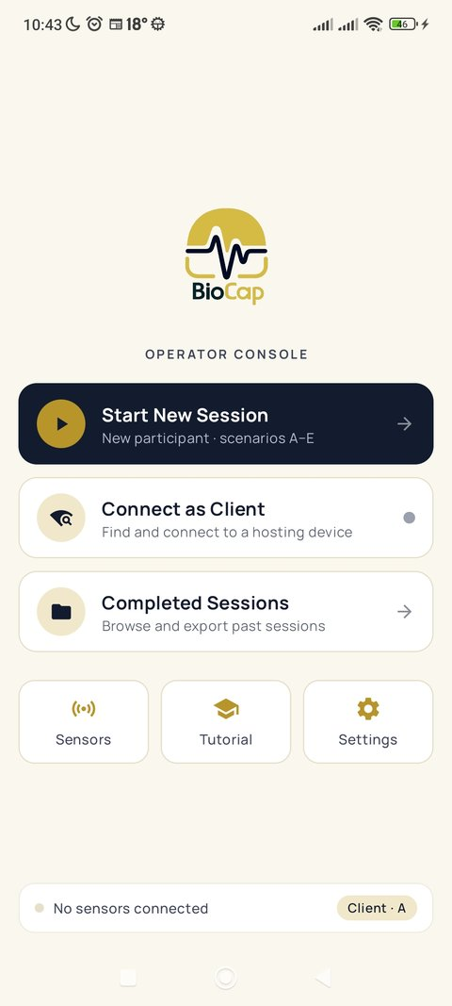
3.2 Home screen (Client mode)
Screenshot: Home screen, Client mode
Element | Purpose
Start New Session | Creates a new participant and starts a session — the main working action
Connect as Client | Opens the device-to-device link so a Server device can watch this screen
Completed Sessions | Review, export and upload of finished sessions
Sensors (bottom) | Connection and live status of sensors — used before a session or for diagnostics
Tutorial (bottom) | Introductory guide — one-time reading
Settings (bottom) | Device prefix and device mode
Status card (bottom) | At-a-glance readiness: sensors connected, active session, or setup warnings
During normal operation the operator mainly uses Start New Session and Completed Sessions. The other items are for one-time setup or diagnostics.

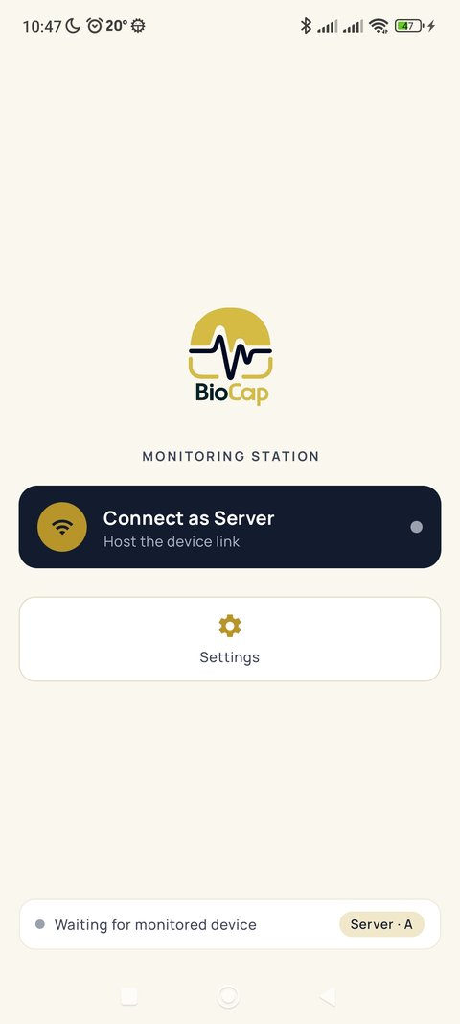
3.3 Home screen (Server mode)
Screenshot: Home screen, Server mode
A device in Server mode shows only Connect as Server and Settings — hosting the link and watching the paired device’s screen is its only job; it does not run sessions or sensors itself.

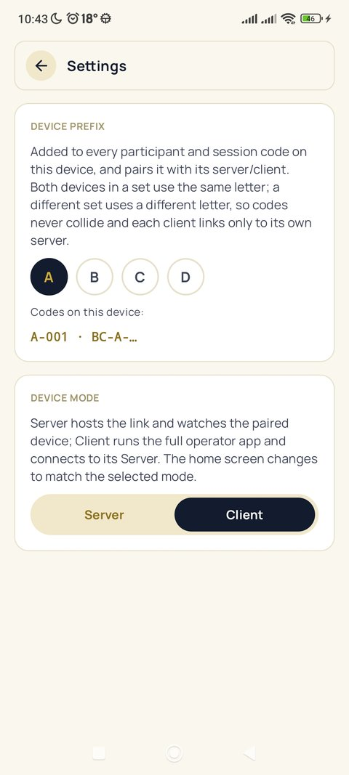
3.4 One-time setup — device prefix and mode
Screenshot: Settings — device prefix and device mode
Before the first session, open Settings and pick this device’s prefix: A, B, C or D. The prefix is added to every participant code (e.g. A-001) and session code (BC-A-yyMMdd-HHmmss) generated on this device, and it also scopes the device-to-device link to one pair.
Rule: both devices of a pair (Client + its Server) use the same letter; a different pair uses a different letter. That way each Server only links to its own Client and codes never collide when several tablets test in parallel. Agree beforehand which letter each pair owns, and do not change it mid-study.
The same screen also holds the Device mode switch (Server/Client) described in §3.1 — changing it here re-shapes the Home screen immediately on return.

4. Connecting the sensors

4.1 eSense Pulse (BLE)
- On the sensor-setup screen (see §5), tap the Heart Rate card (or go to Sensors → eSense Pulse).
- The app scans for BLE devices — select the one whose name starts with eSense from the list.
- Once connected, the live heart-rate value (BPM) and R-R intervals are shown.
If the device is not found: check that Bluetooth and Location Services are enabled on the tablet.

4.2 eSense Respiration (audio jack)
The sensor activates automatically once plugged into the audio jack. Check on the sensor-setup screen that the Respiration card shows a live value (unit: RA, raw respiration amplitude — not breaths per minute). A breathing-rate estimate (br/min) appears after roughly 15 seconds of clean signal; until then the display shows --.
The app watches the signal quality continuously and shows a warning banner when something is wrong:
- Respiration signal lost — the strap has slipped off the chest (the RA value collapses). Re-seat the chest strap.
- No breathing detected — the strap is on but is not tracking breathing (e.g. worn too loose). Tighten and reposition the strap.

4.3 Galaxy Watch 8
- Make sure Bluetooth is on — the watch link runs over direct Bluetooth, not Wi-Fi.
- Check the Galaxy Watch 8 card status: Connected (live data), Watch dozing — buffering (the watch screen is off — data is being stored on the watch, not lost), or Disconnected.
- The dozing state is normal whenever the watch screen is off — the buffered data is sent back to the tablet automatically at the end-of-session flush (see §8.1).
If the status stays Disconnected: check that Bluetooth on the tablet is on and that the watch’s companion app is running.
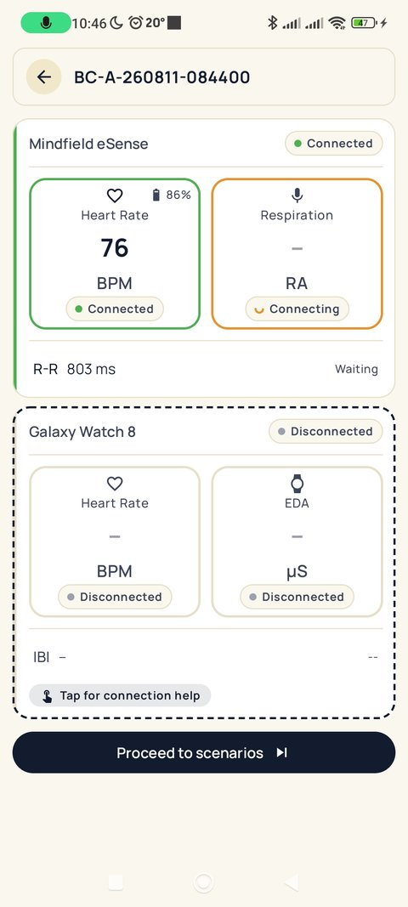
Screenshot: Sensor-setup screen — Mindfield eSense (connecting) and Galaxy Watch 8 (disconnected)

5. Creating a participant and starting a session
- On the Home screen, tap Start New Session.
- If the button is grayed out with the note “Fix the warnings above to start”, the tablet is missing a setting the session cannot safely run without — the battery-optimization exemption or the notification permission (without them, the system can silently kill the recording while the screen is off and the whole session would be lost). Use the Fix buttons in the warning card at the top of the Home screen; the button unlocks as soon as both are granted. Resuming an already-running session is never blocked.
- The New Participant form appears:
  - Participant code — automatically generated (e.g. A-004-260722-115828). Read-only — do not try to edit it.
  - Age — the participant’s age (18–80 years); use the − / + buttons to set it.
  - Gender — Male / Female / Other / N/A.
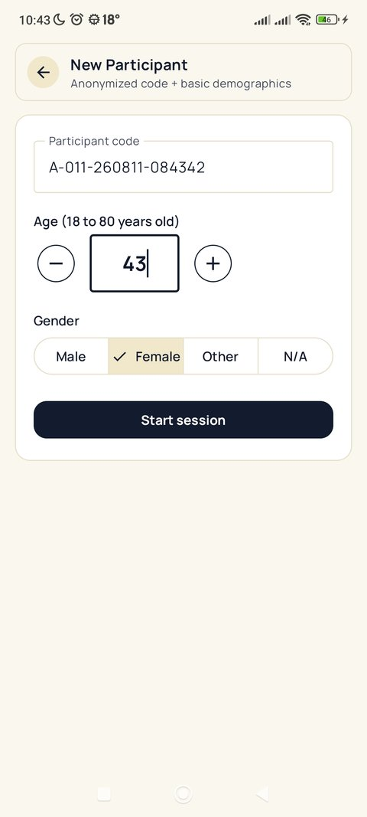
- Tap Start session.
Screenshot: New Participant form
- The app opens the sensor-setup screen — a one-time check to confirm sensors before recording starts (see §4 and the screenshot above). Tap Proceed to scenarios once the sensors you need are connected. The button stays disabled (with the hint “Connect at least one sensor to continue.”) until at least one sensor is connected — this prevents starting a scenario that would record no data. Disconnected sensors show a dashed border with a Tap to connect pill; tapping anywhere on such a card starts its connection flow.
A foreground service keeps the sensors and (if enabled) the device link alive even while the tablet screen is off, so the operator does not have to hold the tablet continuously.

6. Pairing the second device (screen mirroring)
This step is optional — only needed if a second operator wants to watch the Client’s screen remotely. Skip this section for a single-tablet session.

6.1 Pairing procedure
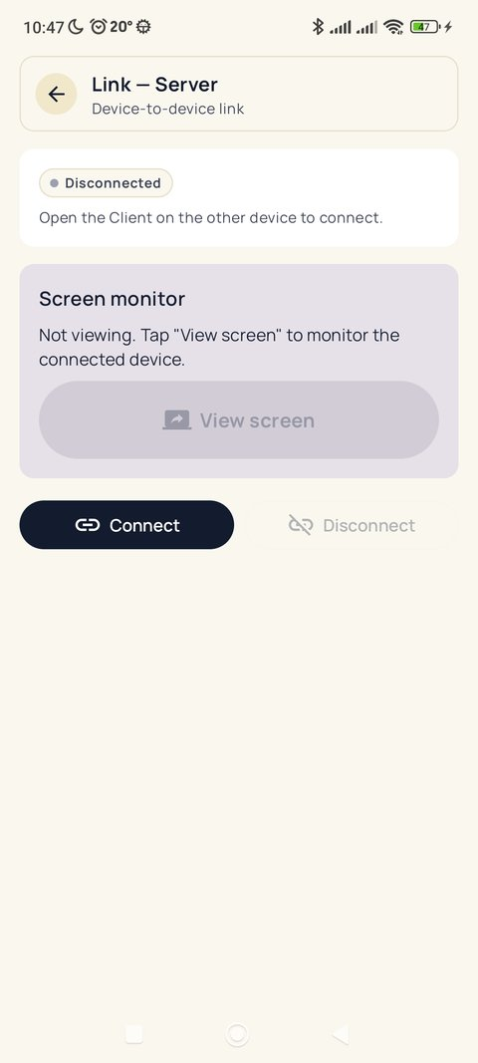
- On the Server device, tap Connect as Server, then Connect. The status shows Waiting for monitored device.
- Screenshot: Link — Server, before connecting
- On the Client device, tap Connect as Client. It scans for the Server over mDNS.
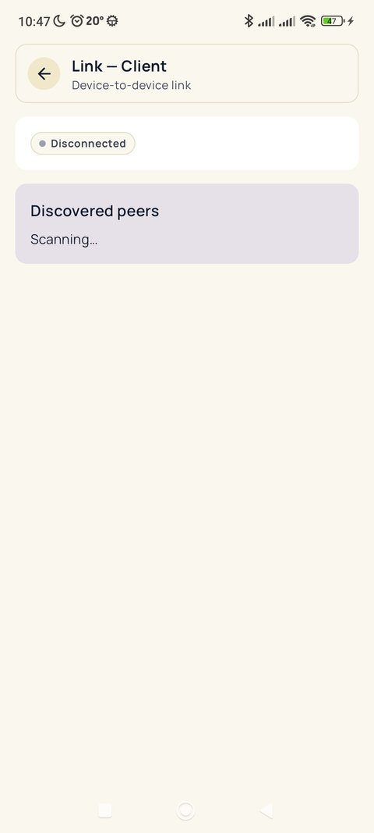
- Screenshot: Link — Client, scanning
- On the Client, tap the discovered device in Discovered peers, then tap Connect. Both screens turn to a green Connected status once the WebSocket link is up.
- On the Server, tap View screen — the Client device shows Android’s screen-capture consent dialog. Once accepted, the Client’s screen streams live to the Server, peer-to-peer over Wi-Fi (WebRTC) — no data leaves the local network.

6.2 Recovering the connection after a dropout
If the Wi-Fi link drops, reconnect using the same steps as above — Connect on the Server, then select the discovered device on the Client. A dropout does not affect the session or sensor recording on the Client — screen mirroring is a monitoring aid, not part of the measurement itself.

7. Running the measurement — scenarios A–E

7.1 The scenario hub
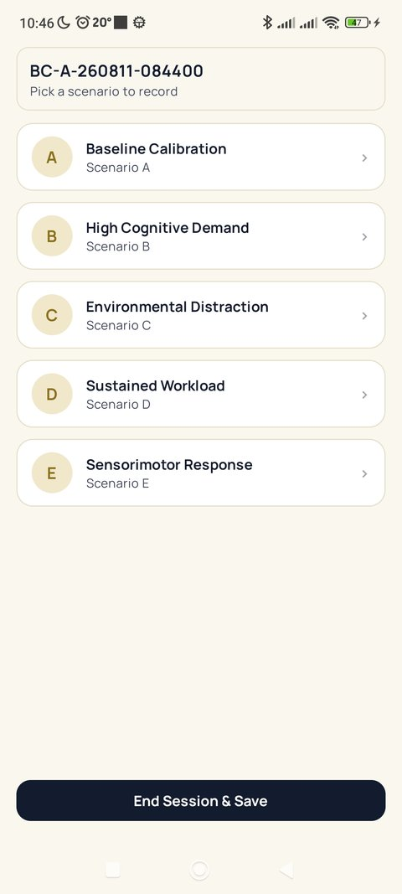
After the sensor-setup screen, the scenario hub is shown — one card per scenario, plus End Session & Save at the bottom.
Screenshot: Scenario hub
Scenario | Duration | Purpose
A — Baseline Calibration | 10 min | Baseline measurement, no induced load
B — High Cognitive Demand | 20 min | Mental workload condition
C — Environmental Distraction | 20 min | Environmental distraction condition
D — Sustained Workload | 30 min | Extended-duration load and fatigue condition
E — Sensorimotor Response | 10 min | Reaction-based task condition
The duration is fixed per scenario and drives the countdown; the app stops and finalizes the recording on its own when it reaches zero.

7.2 Running one scenario
- Tap a scenario card. Recording starts automatically — no separate Start button.
- A countdown ring shows the time remaining; the top bar turns red with a pulsing REC badge and the elapsed time. The app also locks touch input and hides the system bars, so it is safe to set down or pocket the tablet during the run.
- When the countdown reaches zero, the scenario stops and finalizes automatically and the app returns to the scenario hub. A finished scenario shows a green check and its letter badge turns green.
- Repeat for each scenario the protocol requires. Scenarios can be run in any order and each can be re-run if needed — the hub always shows which ones already have a recorded run.
If a sensor disconnects mid-scenario, a banner appears (“… disconnected — Recording continues — reconnect to resume data capture”). The scenario keeps its timer running; reconnect the sensor as soon as possible to minimize the gap in that scenario’s data.
If a scenario is opened with no sensor connected at all (for example, a sensor dropped between setup and the scenario), a “No sensor connected” banner appears and neither the recording nor the countdown starts. Nothing is lost — connect a sensor and the scenario begins normally.

8. Ending the session and exporting data

8.1 Ending the session
- From the scenario hub, tap End Session & Save, then confirm.
- If the Galaxy Watch has buffered data, the app asks the operator to wake the watch (tap its screen) so it can send back everything it stored during the session.
- Once the transfer completes, a green check confirms Watch data saved, and the app continues automatically to the session review screen.
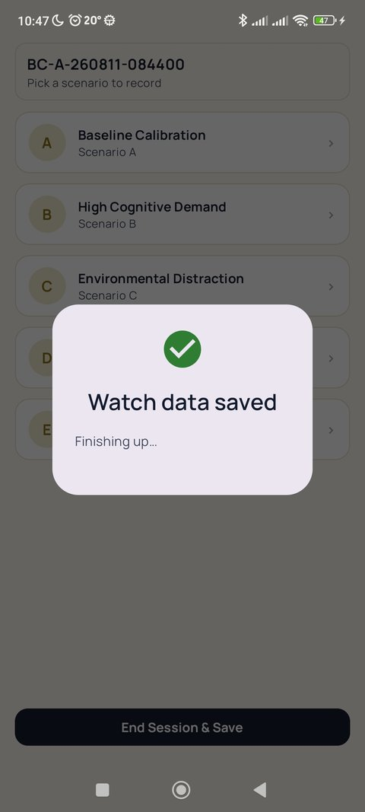
- Screenshot: End-session confirmation
- If the watch does not respond, End without watch data is available — the watch keeps its stored data safely and it can be recovered on a later session; no data is lost, only delayed.

8.2 Review, export and upload
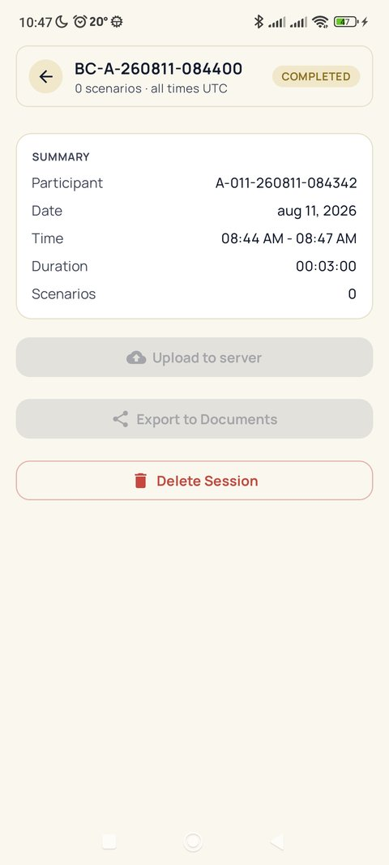
The app opens the session review screen automatically.
Screenshot: Session review
Action | Effect
Upload to server | Sends the full session (participant + scenarios + samples) to the BioCap server. Safe to repeat — repeating it does not duplicate data (the server recognizes the session by its code).
Export to Documents | Writes a local JSON + CSV copy to the tablet’s Documents folder. Independent of upload status.
Delete Session | Permanently removes the session — only after it has been exported or uploaded.
If the upload fails (e.g. no network), tap Upload to server again once connectivity is restored.

9. Troubleshooting common problems
Problem | Possible cause | Solution
eSense Pulse is not found | Bluetooth off, Location Services off | Turn on Bluetooth and Location Services
eSense Respiration shows no data | Cable not plugged in correctly | Unplug and re-plug the audio jack
“Respiration signal lost” banner | Chest strap slipped off the chest | Re-seat the chest strap; the banner clears once the signal returns
“No breathing detected” banner | Strap worn too loose — not tracking chest movement | Tighten and reposition the strap
Galaxy Watch shows Disconnected | Bluetooth on the tablet is off, or the watch’s companion app is not running | Turn on Bluetooth; restart the app on the watch
Galaxy Watch shows “dozing — buffering” | The watch screen is off (normal state) | No action needed — data is being stored; the end-session flush retrieves it
Device link — Client can’t find the Server | Devices not on the same Wi-Fi network, or Server not started | Confirm both are on the same Wi-Fi; tap Connect on the Server first
Screen mirroring shows nothing | Screen-capture consent was denied on the Client | On the Server, tap View screen again; on the Client, accept the system consent dialog
Upload to server failed | No Wi-Fi / weak connection | Retry once connectivity is restored; the upload is safe to repeat
Tablet disconnects sensors after a while | Battery optimization killing the background service | In system Settings, exempt BioCap from battery optimization

This document is part of the formal output of project RAP_126, Activity 2 (modelling / simulation). The full session workflow is shown in diagram 02: doc/grant_RAP_126/diagrams/png/02_operator_session_workflow_en.png

