OperatorSense Live — EDA Ring: Technical Documentation
Technical description of the EDA measurement kit (sensor ring + USB dongle) and of operatorsense_live.html, the browser application used to read, record and export its data.

1. What the system is
Part | Function
EDA ring | Finger-worn sensor. Measures skin resistance and transmits it by 2.4 GHz radio.
USB dongle | Receives the radio packets and outputs them as ASCII lines on a USB virtual COM port.
operatorsense_live.html | Reads that COM port in Chrome/Edge, displays the signal live, records it, exports CSV, and can POST the capture to a server.
CALIBRATION.xlsx | Measured ADC-code → resistance table for both rings (implemented in the app, see §5).
foto/ | Photographs of the ring and the dongle.

Signal chain
┌──────────────┐ 2.4 GHz radio ┌────────────────────────┐ USB (virtual COM) ┌───────────────────┐
│ EDA ring │ ─────────────────► │ USB dongle │ ────────────────────► │ Chrome / Edge │
│ │ IEEE 802.15.4 │ │ 38400 baud, 8/N/1 │ │
│ ATMEGA128RFA1│ proprietary │ ATMEGA128RFA1 receiver │ ASCII text lines │ operatorsense_live│
│ skin-resist. │ packet format │ + FTDI FT232RQ │ │ .html (Web Serial)│
│ measurement │ (undocumented) │ USB-serial bridge │ │ │
└──────────────┘ └────────────────────────┘ └───────────────────┘
│
CSV file ◄────────┼────────► HTTP POST
(local) │ (JSON, optional)
The dongle is required. Android cannot read the ring directly — see §3.

2. Hardware

2.1 Chips
Device | Chips
Ring | ATMEGA128RFA1 — 8-bit AVR microcontroller with an integrated 2.4 GHz IEEE 802.15.4 transceiver.
Dongle | ATMEGA128RFA1 (radio receiver) + FTDI FT232RQ (USB-to-serial converter).

The FTDI chip enumerates as a standard virtual COM port, so no vendor driver is needed on current Windows/macOS/Linux, and the browser can open it via the Web Serial API.
- USB vendor ID: 0x0403 (FTDI) — used by the app to filter the port chooser.
- Serial settings: 38400 baud, 8 data bits, no parity, 1 stop bit, no flow control.
The kit is an uncertified prototype: no FCC ID or equivalent approval exists.

2.2 Ring
A small potted PCB carried on a black elastic strap with a hook-and-loop closure; the strap is what holds it on the finger and lets one unit fit different finger sizes.
Worn
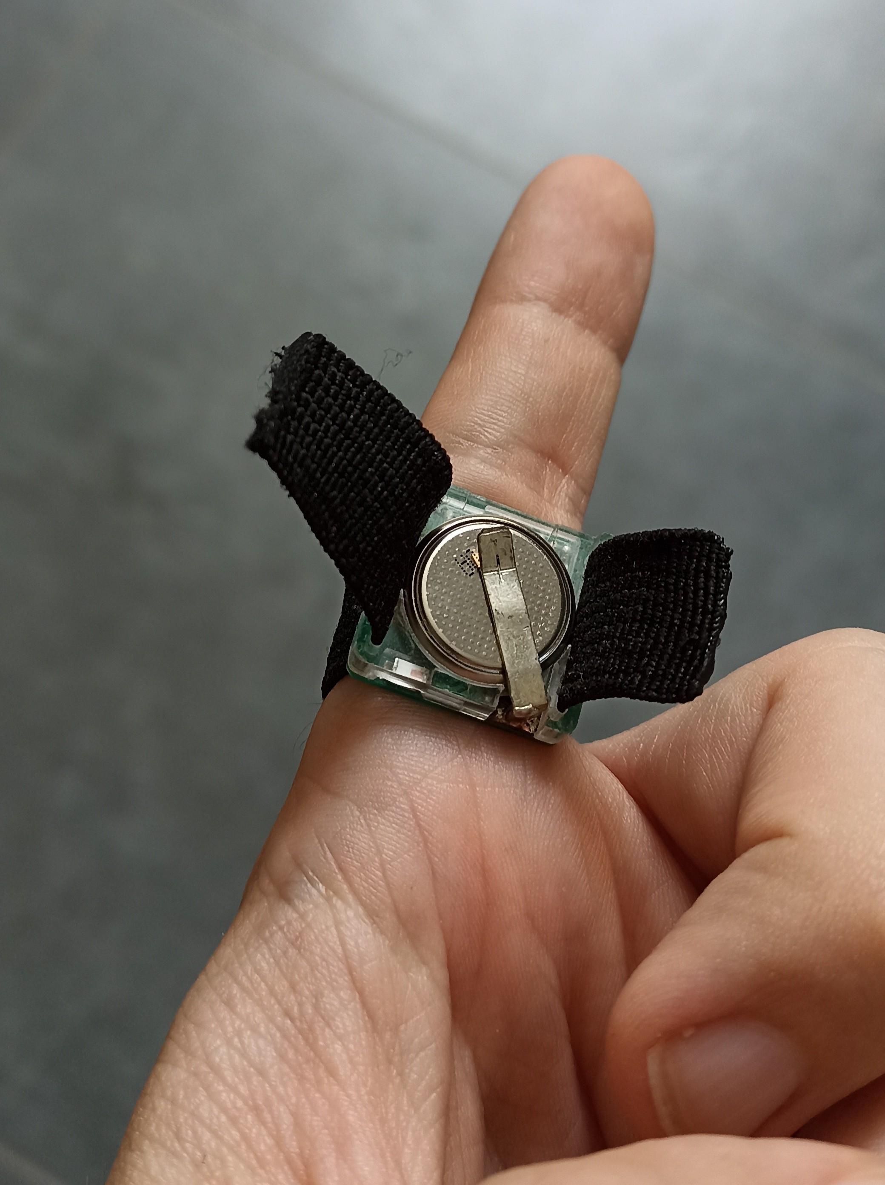
The ring on a finger, coin cell and retaining clip facing outward
Opened, cell removed
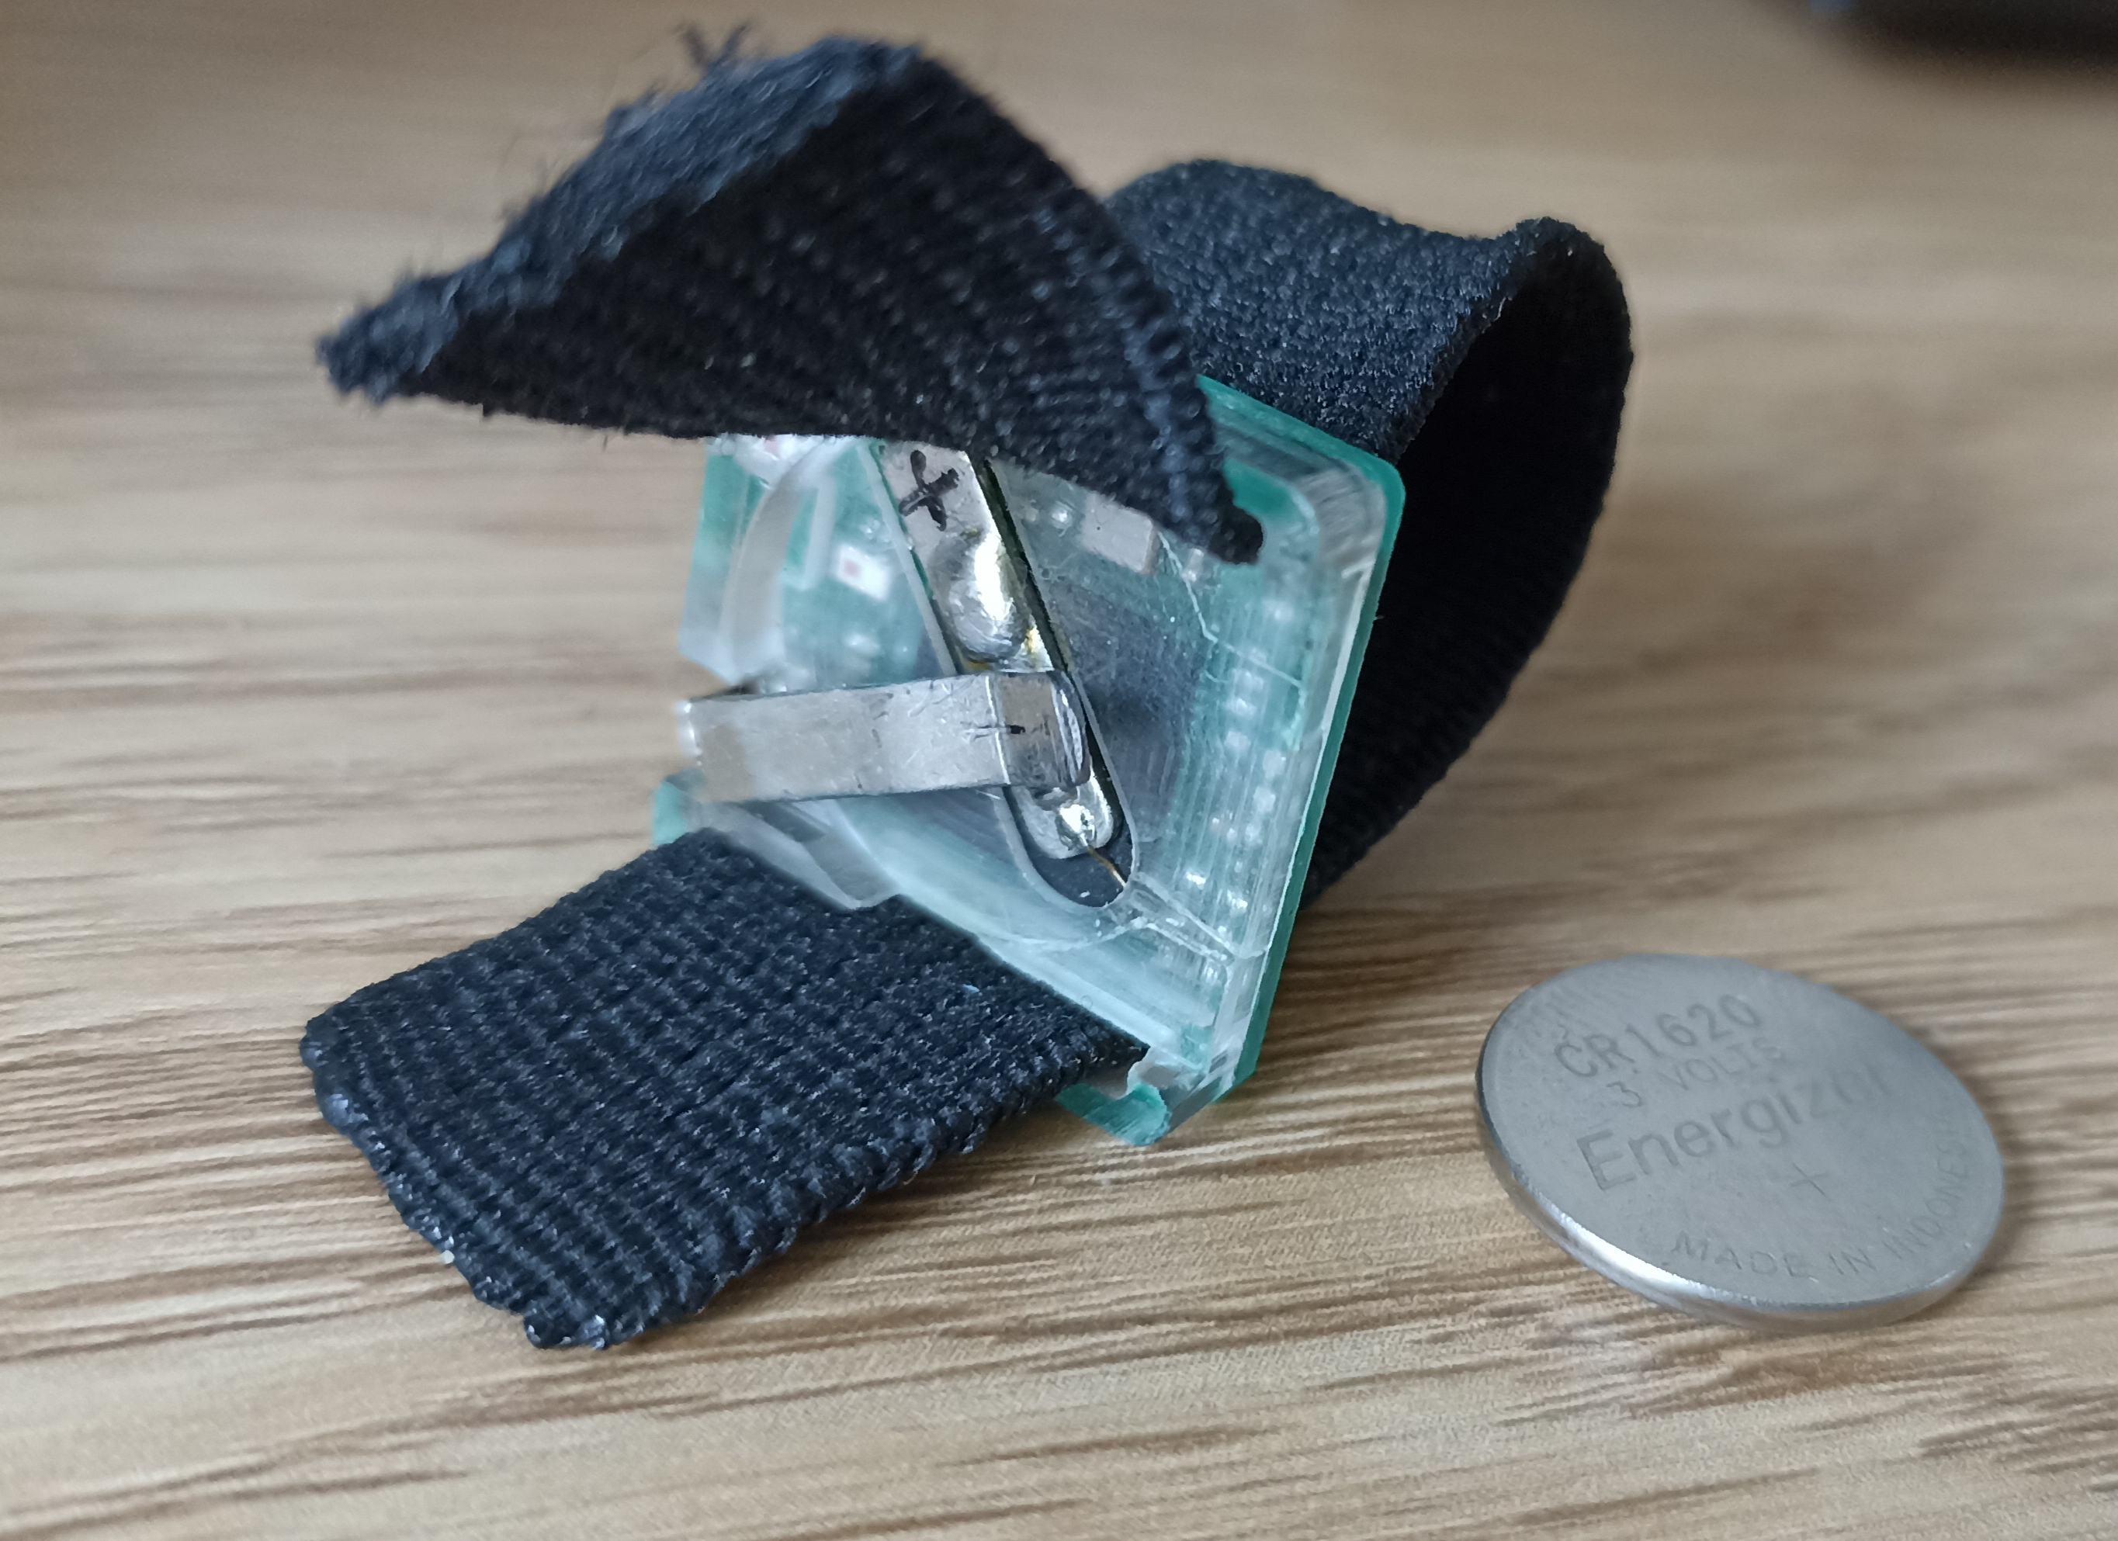
The ring with the strap opened and the CR1620 cell taken out, showing the clear-potted PCB and the battery clip
- The electronics are encapsulated in a clear potting compound, so the board is sealed but its components stay visible. The strap is threaded through slots at both ends of the module.
- Power: one CR1620 3 V lithium coin cell, held by a soldered metal spring clip. The cell is user-replaceable and sits on the outward-facing side of the module.
- There is no charging connector and no power switch — the ring runs whenever a cell is fitted, and pulling the cell out of the clip is the only way to switch it off. Battery life is undocumented (see §9).
- The skin-contact electrodes are on the underside, against the finger; they are not visible in these photographs. (Assumed from the placement of the cell on the opposite face.)
Handling
- Slide the cell out of the clip when the kit is stored, otherwise the ring keeps transmitting and drains the battery.
- Seat the module against the skin firmly but without over-tightening the strap — a ring that loses skin contact shows up as a frozen reading (see §6.6).

2.3 Dongle board
Unenclosed PCB with a USB-A plug soldered directly onto it.
Top side — radio
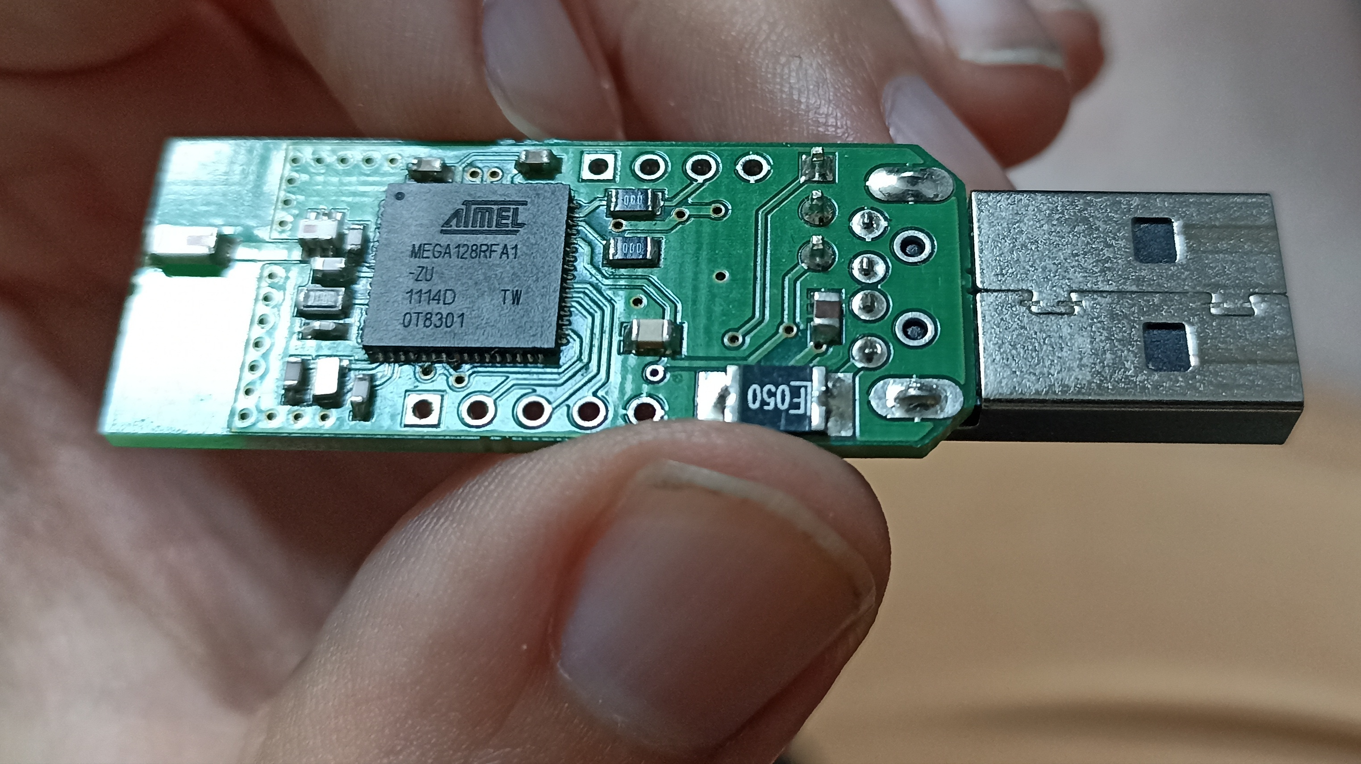
Dongle, top side: ATMEGA128RFA1 and the PCB antenna
- QFN chip marked ATMEL MEGA128RFA1-ZU, additional markings 1114D TW / 0T8301 (1114 read as a date code = about week 11 of 2011).
- The end opposite the USB plug carries a PCB trace antenna etched into the copper; there is no external aerial.
Bottom side — USB interface
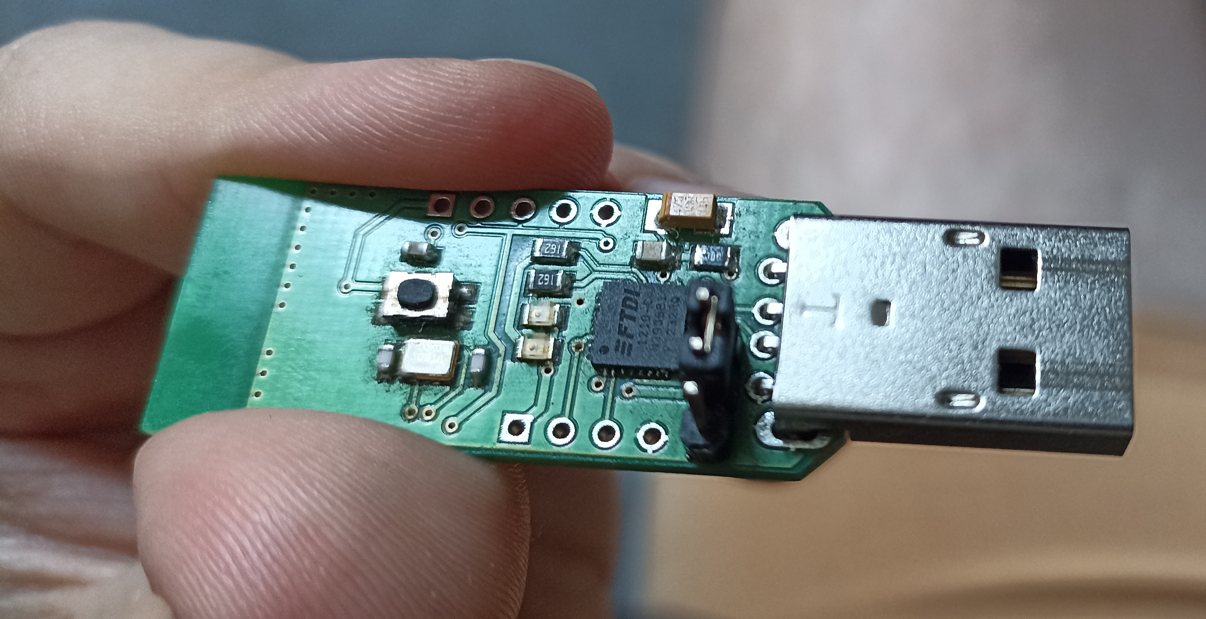
Dongle, bottom side: FTDI converter, push button, unpopulated header
- FTDI USB-to-serial converter, a crystal and passives.
- A tactile push button — it does not reset the microcontroller. Verified by holding it for 8 seconds three times with the serial port open: the packet stream continued undisturbed at its 3.1 s cadence, without a single gap and without any change to the line contents. Either it is not connected, or the firmware ignores it. It is not needed in operation and is harmless.
- A row of unpopulated through-holes, most likely a programming/debug header (ISP or JTAG) — the only route to the chip's memory, see §8.
- The FTDI converter's DTR and RTS lines are not wired to reset. Verified by pulsing both: the data stream did not break. This means the computer has no way to reset or disturb the dongle — no software can reach the microcontroller over USB.
Handling
- The board is exposed: hold it by the USB connector, treat it as ESD-sensitive.
- Keep the antenna end clear of fingers, laptop chassis and metal surfaces. A short USB extension cable that moves the dongle away from the computer is the simplest way to improve range and link stability.

3. Radio link between ring and dongle
Property | State
Protocol | Proprietary 2.4 GHz protocol on the IEEE 802.15.4 physical layer, possibly Thread/ZigBee-derived. Not Bluetooth, BLE or ANT. (Developer's assessment, unconfirmed.)
Frequency band | 2.4 GHz.
Pairing | None — measured. The dongle was unplugged five times during testing and the link came back by itself every time, immediately and without intervention. Ring and dongle have fixed addresses (see §4.2).
GATT services / UUIDs | Not applicable — no BLE layer exists.
SDK / API | None. The dongle's serial output is the only interface.
Encryption | Unknown. Determinable only by capturing a radio frame with an 802.15.4 receiver, which we do not have. Not material to describing what the device currently does.

Reading from Android is not possible. Neither a phone nor a tablet has an 802.15.4 radio, and the ring exposes no BLE profile, so the only route to the data is through the dongle attached to a computer.

4. Serial output format
The dongle emits plain ASCII text, one line per received measurement.

4.1 Example line
D8730:01[CEE3];CAFE;1068

4.2 Fields
Field | Example | Meaning | Confidence
Packet identifier | D8730 | Constant, not a counter | Measured
Channel | 01 | Radio channel, constant | Measured (meaning assumed)
Dongle address | CEE3 | Receiver address, constant | Measured (meaning assumed)
Ring address | CAFE | Sender address, constant | Measured (meaning assumed)
Value | 1068 | ADC code of the measured resistance | Confirmed

The first four fields are static identifiers. Across a 1,054-sample capture spanning 67 minutes, and in every later measurement, not one of them changed. The developer's original assumption that D8730 changes from packet to packet was not borne out by measurement — packet loss therefore cannot be detected from these fields.
Every line has a fixed length of 24 bytes (23 characters + terminator).
The application reads the integer after the last ; as the value, so it keeps working even if the leading fields are later interpreted differently.

4.3 Line terminator and sampling rate
- Terminator: a bare LF (0x0A), no CR. Measured on the raw bytes from the serial port; not a single invalid byte occurred in the whole capture. The app nevertheless accepts \r\n, \r and \n and buffers any incomplete tail until the rest of the line arrives.
- Sampling period: 3.101 s (≈ 0.32 Hz). Measured over 965 intervals; standard deviation 20 ms. The period is immovable — it holds both with the contacts shorted and with the circuit open. The app also measures the rate live from the last 50 packets and displays it as Hz and s/sample.
The phase re-anchors after every dropout. If transmission drops out briefly, the packets that follow do not resume on the original grid but on a new one — most often shifted by ±1.03 s, exactly one third of the period. In the 67-minute capture the phase shifted at 24 of 34 dropouts.
> Consequence for data processing: samples cannot be placed on a regular time grid. Always work > with the actual timestamps from the export.

4.4 Value range and the meaning of 65535
The converter is 16-bit; the verified range of observed values is 2 to 65535.
The value 65535 (0xFFFF) means an open circuit — i.e. no valid measurement. It is not a special code from the firmware but converter saturation: the resistance exceeded the measurable range. Confirmed by the trace recorded after taking the ring off the finger, where the value climbed smoothly to the ceiling as moisture dried off the electrodes:
615 → 1945 → 5144 → 9121 → 13994 → 20321 → 28050 → 36903 → 46515 → 55097 → 65535
> Consequence for data processing: samples with the value 65535 must be filtered out before > analysis. The 67-minute capture contained 312 of 1,054, i.e. 29.6%, and in long contiguous runs > (98, 61, 52, 42, 25 and 24 samples back to back). The median comes out at 3,140 with the sentinels > included and 2,146 without them. The stretch just before saturation has to be cut too — about 100 > seconds pass between the loss of contact and the ceiling being reached, and during them the values > look like a valid measurement.

5. Calibration: ADC code → resistance → conductance
The transmitted value is a raw ADC code, not ohms. Reference resistors were connected to each ring and the reported code recorded; the result is CALIBRATION.xlsx:
R [kΩ] | ADC code — ring CAFE (band) | ADC code — ring CAD1 (no band)
0.55 | – | –
1 | 3 | 3
2.2 | 9 | 10
5.55 | 27 | 28
8.19 | 40 | 42
17.9 | 93 | 96
38.9 | 212 | 212
68.3 | 361 | 377
100.2 | 554 | 550

Two rings, two columns — they calibrate slightly differently. The ring address is present in every packet, so the app selects the matching column automatically; an unknown address falls back to CAFE and is marked as a fallback in the upload payload.
How the app converts (code at the top of operatorsense_live.html):
- Between table points: linear interpolation. The response is close to but not exactly linear (the code-per-kΩ ratio drifts from 3.0 to 5.5), so the piecewise table is more accurate than a single fitted line.
- Outside 1–100.2 kΩ: linear extrapolation from the nearest segment. Such values are estimates and are flagged everywhere: (extrapolated) in the live readout, in_calibrated_range in the CSV, inCalibratedRange in the JSON. Skin readings usually land above the calibrated span (code 1068 ≈ 185 kΩ), so the flag appears often — it marks calibration coverage, not an error.
- Below the calibrated span: the 0.55 kΩ row reads – in the table. That does not mean the device reports nothing — values as low as 2 have been measured in operation, far below the first calibration point. The dash evidently means the developer could not get a stable reading there, not that the output is missing.
- Conductance: µS = 1 000 000 / Ω. Microsiemens is the standard unit for EDA analysis and the unit the VitalWork Android app uses for its Galaxy Watch EDA channel, so the two are directly comparable.
The raw ADC code is kept in every export next to the converted values, so data can be re-converted if the calibration is revised.
Adding another ring: append its address and measured pairs to CALIBRATION_TABLES in operatorsense_live.html. Nothing else changes.

6. The operatorsense_live.html application
A single self-contained HTML file — no installation, no server, no dependencies. It reads the dongle through the browser's Web Serial API.

6.1 Requirements
- Desktop Chrome or Edge. Firefox, Safari and mobile browsers do not implement Web Serial; the page shows a warning banner if unsupported.
- The dongle plugged in.

6.2 Screen layout
Section | Contents
Top bar | Connect / Disconnect, baud selector (default 38400), 8/N/1 note, connection status.
Stat cards | Current raw ADC value, converted kΩ and µS, min / max / average, sample rate (Hz, s/sample), duration, recorded samples, event count.
Live signal | Rolling chart of the last 600 samples with event markers, plus a decoded view of the last packet.
Recording & export | Start/Stop recording, Mark event, Download CSV, Send to server, Clear recording, and the server settings.
Raw serial log | Last 200 lines exactly as received — the first place to look when something behaves oddly.

6.3 Workflow
1. Connect dongle — the browser shows a port chooser filtered to FTDI devices (cancelling it opens an unfiltered chooser). Live graph and statistics start immediately.
2. Start recording — every sample is stored with a timestamp from here on. Watching the live graph does not require recording.
3. Mark event (optional, while recording) — prompts for a label (e.g. touch, stimulus) and places a marker on the chart and into the export, attached to the nearest sample in time.
4. Stop recording — captured data stays in memory.
5. Download CSV and/or Send to server.
6. Clear recording before the next run.
Buffer behaviour: downloading the CSV does not empty the buffer. Starting a second recording without pressing Clear recording puts both runs in one file. Disconnecting the dongle stops recording but keeps the data, so a capture can still be exported or uploaded afterwards.

6.4 CSV export
File name: operatorsense_capture_<timestamp>.csv.
timestamp_iso, epoch_ms, elapsed_ms, value_adc, resistance_ohm, conductance_us,
in_calibrated_range, packet_id, channel, dongle_addr, ring_addr, event, raw
Column | Meaning
elapsed_ms | Milliseconds since the first recorded sample.
value_adc | Raw code as transmitted, never modified.
resistance_ohm, conductance_us | Converted via the ring's calibration table (§5).
in_calibrated_range | 1 inside 1–100.2 kΩ, 0 when extrapolated.
event | Label of any marker falling on that sample.
raw | Original serial line, kept for re-parsing.

6.5 Server upload
The upload path is implemented but points at no server by default — nothing is transmitted until an endpoint is entered.
Configuration — open ⚙ Server settings in the Recording & export panel:
Field | Meaning
Endpoint URL | Target of the POST, e.g. https://api.example.org/v1/eda/captures.
Authentication | Bearer token (Authorization: Bearer …), API key header, or None.
API key / token | Credential issued by the server.
API key header name | Header used with the API-key scheme; default X-API-Key.
Session label | Optional text sent with every capture.

Save settings stores them; Test connection sends an empty payload with "test": true to verify URL and credentials without data; Forget credentials clears them. Settings live in that browser's localStorage (key operatorsense.upload.v1). To ship a pre-configured copy, fill in UPLOAD_DEFAULTS at the top of the script — saved settings still take precedence.
Payload — one JSON POST per capture:
{
"schemaVersion": "1.0",
"source": "OperatorSense Live (EDA ring, FTDI Web Serial)",
"sentAtIso": "2026-08-18T09:12:33.120Z",
"test": false,
"capture": {
"captureId": "os-20260818T091120-4f3a",
"label": "operator-07",
"startedAtIso": "2026-08-18T09:11:20.000Z",
"endedAtIso": "2026-08-18T09:12:21.234Z",
"durationMs": 61234,
"sampleCount": 612,
"eventCount": 3,
"baudRate": 38400
},
"device": { "dongleAddr": "CEE3", "ringAddr": "CAFE", "usbVendorId": "0x0403" },
"signal": {
"unit": "raw_adc",
"ohmsAvailable": true,
"calibration": {
"source": "CALIBRATION.xlsx (device developer)",
"ringTable": "CAFE",
"rangeKOhm": [1, 100.2]
}
},
"samples": [
{
"epochMs": 1755506380000, "elapsedMs": 0, "valueAdc": 1068,
"ohms": 185156.48, "microSiemens": 5.4008, "inCalibratedRange": false,
"packetId": "D8730", "channel": "01", "dongleAddr": "CEE3", "ringAddr": "CAFE",
"raw": "D8730:01[CEE3];CAFE;1068"
}
],
"events": [ { "epochMs": 1755506390000, "elapsedMs": 10000, "label": "touch" } ]
}
For the receiving endpoint:
- Any 2xx response counts as success. Requests time out after 30 s.
- captureId is stable for one recording — use it to de-duplicate retried uploads.
- Recorded data is kept after a failed upload, so it can be retried or exported to CSV.
- signal.calibration.ringTable names the calibration column used; a value ending in (fallback) means the ring address was not recognised.
- CORS: the server must allow the page's origin. A page opened as file:// sends Origin: null; serving the HTML over http:// avoids that.

6.6 Troubleshooting
Symptom | Cause / fix
"Browser doesn't support Web Serial" | Use desktop Chrome or Edge.
Port chooser empty | Dongle not plugged in, or the COM port is held by another program (PuTTY, terminal).
Connected but no data | Check the raw serial log. Lines arriving but unparsed → format changed. Nothing at all → wrong baud rate, or the ring is off/out of range.
Value stuck at 65535 | Open circuit — the ring has no skin contact, or it is off the finger (§4.4).
Values frozen | Ring likely not making skin contact.
Values falling right after fitting | Normal — settling takes about a minute (§7.1).
Readout shows "(extrapolated)" | Normal — value is outside the 1–100.2 kΩ calibrated span. Affects conversion accuracy only, not the recording.
Readout shows "—" | No packet parsed yet, or the value could not be converted.
Send to server greyed out | No endpoint configured, or nothing recorded.
Network/CORS error | Wrong or unreachable URL, or the server rejects this page's origin.

7. Measured operational behaviour
Measurements from 2026-08-18, obtained by passively listening on COM4 and by analysing the 67-minute capture from 2026-06-15. The device was not interfered with — nothing was sent to it and nothing was changed.

7.1 Settling after fitting
After the ring is fitted, the value falls smoothly from saturation and settles after about 55 seconds:
Time since fitting | Value
0 s | 65535 (no contact)
6 s | 23,460
18 s | 10,987
30 s | 8,218
43 s | 5,913
55 s | 3,332 (plateau)

After that it fluctuates around its mean by roughly ±29%.
> For the measurement protocol: after fitting the ring, wait at least a minute, preferably > two, and only then start recording. The first minute is unusable.

7.2 Transmission dropouts
Conditions | Result
67 minutes of measurement with handling | 34 dropouts longer than 4.5 s; the longest 7 minutes
200 seconds with the ring set down and untouched | not a single dropout, 64 packets at a steady cadence

Dropouts are therefore not a property of the radio link — they arise when the ring is handled. Suspicion falls on the cell moving in its spring clip, or possibly on a change in antenna position.
> For the measurement protocol: do not touch or move the ring during a recording. When checking > the data, expect gaps in the time series to be normal.

7.3 Start-up time after plugging in the dongle
Between inserting the dongle into USB and the first data, 5 to 7 seconds elapse — 1 to 3 seconds of that is Windows recognising the device, the rest is waiting for the next packet.

7.4 Corrupted lines
The serial line occasionally delivers a corrupted line — 2 out of 1,054, i.e. 0.2%, in the 67-minute capture. The app currently accepts them as valid samples, because all it checks is whether there is a number after the last ;. When processing the data it is therefore worth verifying that the line in the raw column matches the expected shape exactly.

8. Firmware
No firmware or source code was supplied with the device, and the author no longer has them. What follows is based on chip identification and on measured behaviour.

8.1 What the device runs on
Property | Finding
Platform | ATMEGA128RFA1 — 8-bit AVR, 128 kB Flash, 16 kB SRAM, integrated 2.4 GHz IEEE 802.15.4 transceiver and hardware AES-128
Same chip | in both the ring and the dongle
Age | the chip's date code points to 2011
Timing | fixed 3.101 s period → driven by a timer in the firmware
Output | UART 38400 8N1, fixed 23-character text format, LF terminator
USB | the firmware does not customise the FTDI descriptors — they report as generic (VID_0403/PID_6001), with no project name or version
Start-up | the firmware prints no banner at start-up

The radio stack is unknown. The 16-bit addresses and the channel field would fit the Atmel Lightweight Mesh library, which was the usual choice for this chip in 2011 — but that is an inference from indirect clues, not a verified fact.

8.2 How the device is programmed
The ATMEGA128RFA1 is programmed over ISP (the SPI interface), JTAG, or a bootloader over the serial line. The unpopulated header on the underside of the board (§2.3) is almost certainly one of the first two.

8.3 What was tried in order to obtain the firmware
Every route that does not require buying equipment was checked systematically:
Route | Result
Read-out over USB / the serial line | Impossible. The FTDI is only a converter; it has no access to the microcontroller's memory.
Reset via the DTR / RTS lines | Not connected. Pulsing both lines did not interrupt the data stream.
Serial bootloader | Unreachable, since no reset can be triggered from the computer.
Start-up banner after unplugging and replugging | Not captured. Windows needs 1–3 s to recognise the port; the banner would be gone before that.
Reset via the button on the board | The button does not reset — three 8-second holds, with no effect whatsoever.

8.4 What obtaining the firmware would require
The only remaining route is a programmer (e.g. USBasp or USBtinyISP, ~€15) attached to the unpopulated header, with the pinout traced out using a multimeter. The procedure would be read-only — first the lock and fuse bits, and only if they are unlocked, the Flash image.
Limitations to expect:
- If the lock bits are set to protect the memory, the read-out returns garbage and nothing further can be done.
- The result is a binary without source code; extracting the packet format from it means reverse engineering AVR code. The only quick win would be a string search, which may reveal the name and version of the stack in use.
- Only the dongle's firmware could be obtained. The ring is potted in resin and its programming header cannot be reached without destroying it — and the measurement logic is precisely what sits inside it.

9. Open technical questions
1. Calibration covers only 1–100.2 kΩ, while skin readings sit above that range almost always — in the 67-minute capture only 137 of 1,054 samples (13%) were inside the calibrated span. Extending the table with higher reference resistors (200 kΩ, 500 kΩ, 1 MΩ) would remove the extrapolation. This is the most useful thing the developer could supply.
2. What causes the dropouts during handling (§7.2) — the suspicion that the cell moves in its clip can be tested by deliberately moving the ring during a measurement.
3. Drift over long wear — settling after a minute is measured, but the behaviour after tens of minutes of wear (a possible moisture bridge between the electrodes) has not been checked.
4. Ring battery life — how long one CR1620 cell lasts in continuous transmission is undocumented; worth measuring before longer recording sessions.
5. "BAND" / "NO BAND" — the two calibration columns correspond to ring units CAFE and CAD1; what the band changes is not confirmed. The photographed unit (§2.2) does carry an elastic strap, so the label plausibly distinguishes a strapped from an unstrapped unit — but which address the photographed ring holds was not read off, so this stays unconfirmed.
6. Field meanings — that they are constant is measured; that 01 is a channel and CEE3/CAFE are addresses remains the developer's assumption, unverified against the firmware.
7. Encryption of the radio packets — determinable only with an 802.15.4 receiver. Not material to describing what the device currently does.

10. Documentation status
No firmware images, source code or protocol documentation exist for this device — the original firmware was not preserved (§8). Everything above comes from four sources:
1. Written information from the device's developer (hardware, radio, interpretation of the fields, firmware status).
2. The calibration measurements in CALIBRATION.xlsx.
3. Photographs of the ring and of the dongle board, from which the chip markings were read.
4. Our own measurements of 2026-08-18 — passive listening on the serial port and analysis of the 67-minute capture of 2026-06-15. These confirmed or corrected the figures for the period, the terminator, the value range, the meaning of 65535, the static identifiers, the absence of pairing, the behaviour of the button, and the operational behaviour in §7.
Figures marked measured in the text come from source 4 and are verifiable by repeating the measurement. Figures marked assumed come from the developer and have not been verified.

