AMS (Altech management system).

Altech is an IT company located in Galway. To simplify and organize working process company decide to design management system that can run online which allow you to access information from anywhere at any given time as long as you have internet access.

System users divided on 4 categories

* Employees;
* Office managers;
* Head managers;
* HR

Different categories have a different rights to access data. Thus employees can see only their working hours, but Office manager can see worked hours of all employees in the office including theirs own.

General features:

* Authorization
* Clocking in and out
* Holidays booking
* Records employee’s information

There is all features and rights that AMS provides:

|  |  |  |  |  |
| --- | --- | --- | --- | --- |
| Features | Employees | Office Manager | Head Manager | HR |
| Clock IN/OUT | Yes | No need | No need | No need |
| See worked hours | Only their own | All employees in the office | All Employees | All employees |
| See Booked Holidays | Only their own | All Employees in the office | All Employees | All employees |
| Book Holidays | Yes | Yes | No need | Yes |
| Confirm Holidays | No | Only employee’s in the office | Yes | No |
| See user’s details | No | Only employees in the office | Yes | Yes |
| Register new users | No | No | No | Yes |
| Remove users | No | No | No | Yes |
| Edit users | No | No | No | Yes |

Front end of AMS is the website that contain several pages such as:

* Home page
* Clock IN/OUT
* Payroll
* Holidays
* Users

To enter into the system, user must to enter his credentials. After successful authorization the system allows to user to see or write the information.

This is a screenshot of AMS Home page:

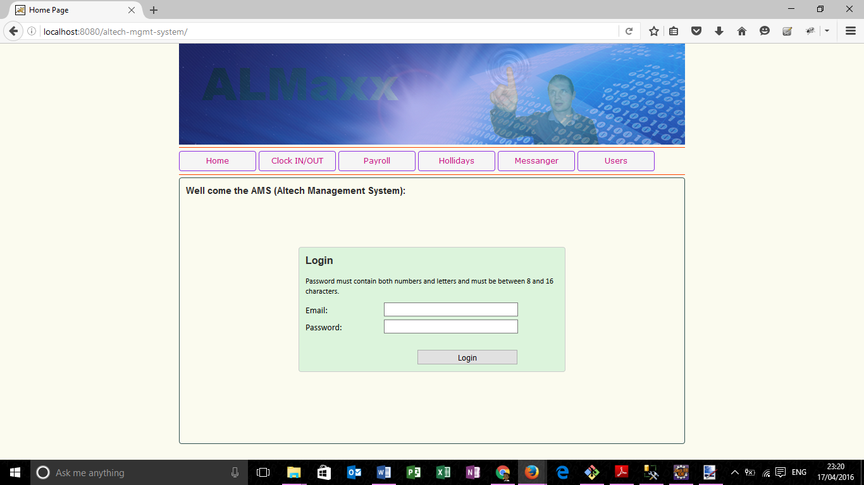

To implement the Altech Management System was decided to use Java Spring framework. It’s used for creating high performance, easily testable and reusable code. Basically Java Spring enables developers to develop enterprise class applications.

**1.1.0 Database**

***1.1.1 Database connector JDBC***

Spring JDBC Framework takes care of all the low-level details starting from opening the connection, prepare and executive the SQL statement, process exceptions, handle transactions and finally close the connection. Spring JDBC provides several approaches and correspondingly different classes to interface with the database. The JDBC Template class executes SQL queries, update statements and stores procedure calls, performs iteration over ResultSets and extraction of returned parameter values. It is also catches JDBC exception hierarchy defined in the org.springframework.dao package.

[www.tutorialspoint.com/spring_jdbc_framework.htm](http://www.tutorialspoint.com/spring_jdbc_framework.htm)

***1.1.2 Database pool DBCP***

In software engineering, a connection pool is a cache of database connections maintained so that the connections can be reused when future requests to the database are required.  Connection **pools** are used to enhance the performance of executing commands on a **database**.

<https://en.wikipedia.org/wiki/Connection_pool>

***1.1.3 Datasource***

Datasource is a name given to connection set up to a Database from a server. The name is commonly used when creating a query to the database. The database source name (DSN) does not have to be the same as the filename for the database. A data source is simply the source of the data. It can be a file, a particular database on a DBMS, or even a live data feed. The data might be located on the same computer as the program, or on another computer somewhere on a network.

https://en.wikipedia.org/wiki/Datasource

***1.1.4 Information about connection between DBCP, JDBC and datasource***

UCP for JDBC provides a connection pool implementation for caching JDBC connections. Java applications that are database-intensive use the connection pool to improve performance and better utilize system resources.

A UCP JDBC connection pool can use any JDBC driver to create physical connections that are then maintained by the pool. The pool can be configured and provides a full set of properties that are used to optimize pool behavior based on the performance and availability requirements of an application. For more advanced applications, UCP for JDBC provides a pool manager that can be used to manage a pool instance.

The pool also leverages many high availability and performance features available through an Oracle Real Application Clusters (RAC) database. These features include Fast Connection Failover (FCF), run-time connection load balancing, and connection 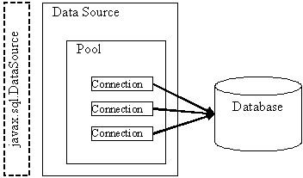affinity

DBCP

JDBC

JDBC

JDBC

MySQL

<https://docs.oracle.com/cd/B28359_01/java.111/e10788/intro.htm>

***1.1.5 DAO***

Data access object (DAO) is an object that provides an abstract interface to some type of database or other persistence mechanism. By mapping application calls to the persistence layer, DAO provide some specific data operations without exposing details of the database.

<https://en.wikipedia.org/wiki/Data_access_object>

**1.2.0 MVC**

***1.2.1 Dispatcher servlet***

The Dispatcher servlet is the bit that "knows" to call that method when a browser requests the page, and to combine its results with the matching JSP file to make an html document. The job of the Dispatcher Servlet is to take an incoming URI and find the right combination of handlers (generally methods on Controller classes) and views (generally JSPs) that combine to form the page or resource that is supposed to be found at that location. It is a **servlet** that takes the incoming request, and delegates processing of that request to one of a number of handlers, the mapping of which is specific in the **Dispatcher Servlet** configuration. In Spring MVC all incoming requests go through a single **servlet**.

<http://stackoverflow.com/questions/2769467/what-is-dispatcher-servlet-in-spring>

MVC is designed around a Dispatcher Servlet

DS handles all the HTTP requests and responses.

HTTP Request HTTP Response

WebApplicationContext

Handler Mapping

View

Controller

View Resolver

Dispatches Servlet