Belpro
Beleženje Prostovoljstva
Digital Volunteer Diary for Slovenian NGOs
AI-Powered | WhatsApp-Native | GDPR-Compliant | Self-Hosted

Architecture & Workflow Overview · 2025

What is Belpro?
Belpro is a smart, AI-powered digital assistant built specifically for Slovenian non-governmental organisations (NGOs). Its mission is simple: to make the legally required Volunteer Work Diary (Dnevnik prostovoljskega dela) as painless as possible for everyone involved.
Under Slovenian law, volunteers receiving the Work Activity Allowance (Dodatek za delovno aktivnost) must log their activities monthly and submit proof to their local Centre for Social Work (CSD). Traditionally this meant paper forms, manual entries, and administrative overhead for the NGO. Belpro automates the entire process — from the moment a volunteer picks up their phone to the moment a signed PDF lands on the CSD desk.

Voice-first | Volunteers speak naturally in Slovenian — any dialect. AI does the rest.
WhatsApp | No new app to install. Uses the messaging platform volunteers already have.
Sovereign | Every NGO runs its own instance. No shared cloud, no third-party data access.
Auto-reports | Monthly PDF summaries generated automatically, ready for CSD submission.
Manager control | Every entry is reviewed and approved by the NGO manager before it is saved.

System Architecture
Belpro is built on a modern, self-hosted microservices stack, containerised with Docker and orchestrated locally. Every component is open-source, battle-tested, and self-hostable — no vendor lock-in, no subscription fees, no data leaving the NGO's own infrastructure.
The diagram below shows the high-level data flow: volunteers communicate via WhatsApp → Evolution API routes messages to n8n → n8n calls Whisper for transcription and writes approved records to PostgreSQL → the manager acts via the web dashboard or WhatsApp → Gmail delivers monthly reports.
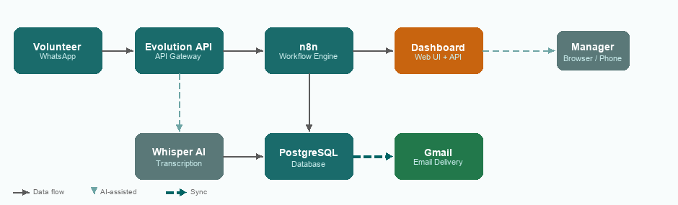

Core Components
Component | Technology | Role
Messaging layer | WhatsApp / Evolution API | Real-time two-way communication with volunteers
AI Transcription | Faster-Whisper | Converts voice notes to text, on-device, CPU-optimised
Workflow engine | n8n | Orchestrates all business logic — no custom glue code
Message cache | Redis 7 | Evolution API in-memory queue and cache (required dependency)
Database | PostgreSQL 18 | Persistent, auditable storage of all volunteer records
Web dashboard | FastAPI + HTML/JS | Manager interface for approvals, analytics and reports
PDF engine | WeasyPrint | Generates print-ready monthly summaries
Email delivery | Gmail | Sends reports and notifications to volunteers

How It Works — The Volunteer Journey
From the volunteer's perspective, Belpro feels like a simple WhatsApp chat. Behind the scenes, a sophisticated AI pipeline captures, cleans, validates, and stores every entry with a complete audit trail.


① Record
The volunteer opens WhatsApp and sends a voice note describing what they did — in plain, everyday Slovenian. Any dialect is welcome. They can optionally attach a photo of completed work (a cleaned room, a tended garden bed). No forms. No apps. No training required.

② AI Cleans
Belpro's built-in speech recognition engine (Faster-Whisper) transcribes the voice note in real time, entirely on the NGO's own hardware. The transcript is then processed by the n8n workflow engine, which extracts the key facts — date, hours worked, activity type, location — and structures them into a clean record.

③ Confirm
Within seconds, the volunteer receives a neat summary back in WhatsApp: "Date: 12 May · 3 hours · Assisted with lunch at Dom starejših Trnovo." They can confirm with one tap, correct the entry if something was misheard, or cancel entirely. The volunteer is always in control.

④ Manager Approval
Once the volunteer confirms, the NGO manager receives an instant WhatsApp notification with the full entry details. A single tap approves or rejects. The manager can also view and action all pending entries via the web dashboard from any device.

⑤ Saved & Closed
An approved entry is written to the secure database with a full timestamp. Any attached photo is stored locally with its EXIF metadata (time and GPS location) intact — creating a tamper-evident audit trail. The volunteer receives a friendly confirmation message.

Monthly Reporting
At the end of each month, Belpro automatically generates all the paperwork the NGO needs — with zero manual effort.
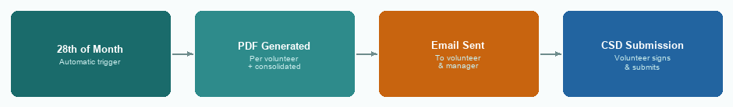

Volunteer PDF
Each volunteer receives a personalised, print-ready PDF summarising their month's activities. The document is formatted to match the CSD submission requirements — the volunteer only needs to add their signature and hand it in.

Manager Report
The NGO manager receives a consolidated report covering all volunteers: total hours, a breakdown per person, and flagged entries. One document, complete picture.

Flexible Delivery
Reports can be emailed automatically (with the volunteer's consent), downloaded from the dashboard, or printed at the NGO office. Whatever works best for the volunteer.

Privacy & Compliance
GDPR & ZVOP-2 | All data processing complies with Slovenian and EU data protection law.
Data sovereignty | All data stays on the NGO's own server. Nothing is sent to third parties.
Encryption | Sensitive personal data (EMŠO) is encrypted at rest using AES-256.
Photo privacy | Photos must show only work results — no faces or identifiable persons.
Retention | Data is kept only as long as required for CSD/IRSD inspections.
Audit trail | Every entry carries a complete, tamper-evident log of who approved what and when.

