General Notes:

When program has choice between Global and Local variable, it will pick the local
cout << ::x << endl; //will force to use the global variable with Scope operator (::)

Function overloading:
you can make two functions with same name but different datatype as parameter

Recursion:
A function calling it self. Without and endpoint it will be an infinite loop

Casting:
Temporary change of variable type. The variable gets castet into a different one. Useful when having equations with multiple data types. Its better to have them all one same datatype:

float x = 1.23:
int y =1;

sum = x * (float)y;

Arrays:

When passing an array into a function:
void printArray(int x[]){}
but when you call the function you write it without square brackets
printArray(arr);

const:
cannot change the variable
cannot dereference the pointer if its before the *
cannot change the pointer itself to something else if its after *

when its written after function name, it means the function cant change any

String:

Static:

static before a variable, is kinda like defining it private in that class
extern before variable means it refers to an external variable
same goes for a function

Stack/Heap

when we declare variables, arrays etc. they get stored in the top address. (top of the stack). Every time we do so, the stackpointer moves down by one. Every time when we reach the end of that scope where they are defined, the memory gets freed (poped) from the stack.
Heap is slower, and the space needs to be freed by the programmer. Stack gets freed automatically when a function is left.

Stack: int x = 5;
Heap: int* hx = new int;
*hx = 5;
delete hx;

Arrow Member Selection Operatoren: ->
Derefereces a pointer that is pointing to a class. Its just a shortcut of us not having to manually dereference it.

Player x; Player x;

Player* ptr = &x Player* ptr = &x
(*ptr).movePlayer(); ptr->movePlayer();

Member Initlializers
When using a constant member variable, you need to initialize them with the constructor differently.

Player(int a, int b) : regVar(a), constVar(b) {}

this keyword:
this is a pointer of the current object of the class it in in. Can only be called in a member function

Example: printing an int from a class
cout << x << endl;
cout << this→x << endl;
cout << (*this).x << endl;

new keyword:
allocate memory on the heap. The memory remains stored after end of sccope

Friend functions:
You declare a friend function inside a class as if you would prototype it.
But when you define the function outside of the class, it has access to its components because it is its friend.

Copy constructor:
Copy cconstructor is used when we pass an object into another object, which means to set those two objects as equal. When pointers are used inside we can two objects that are have same pointers, which can cause problems. Thats why you need to create copy constructor yourself, in order to allocate different memory space for that pointer with new keyword. Then you actually get two objects which are copies.

Mit ER modell wird geplannt wie die datenbank struktur aussehen soll
ER modell besteht aus entities

Relationales Datenmodell besteht mur aus tabellen

in diesen tabellen hat man spalten und zeilen
spalten = atributee
jede zeile ist eigenes object
wenn eine jeweilige zelle als not null definiert ist, darf sie nicht 0 sein, muss ein wert haben

jede entity wird durch eine tabelle abgebildet
es gibt keine 2 gleichen zeilen
eine zeile wird auch tupel genannt

DDL → sql befehle
primär schlüssel → einzigartige spalten, muss eindeutig sein und minimal zb ID
fremdschlüssel verweist auf einen primär schlüssel in einer anderen tabelle und verknüpft diese somit . Erkennbar duch strich oben

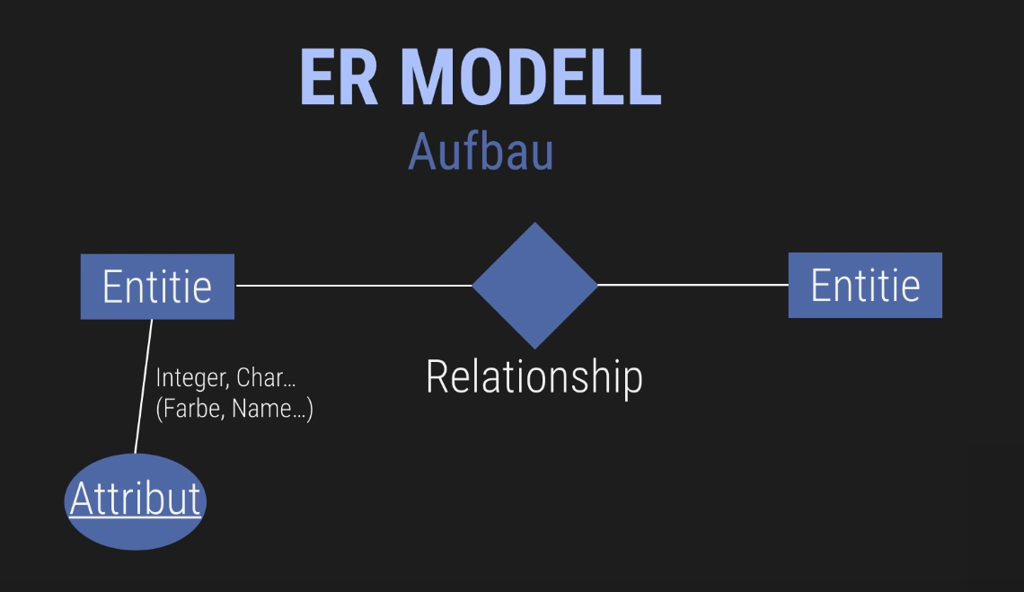

Unterschricchten wenn primär schlüssel
über relationships sieht man schon welcher fremdschlüssel enthalten ist

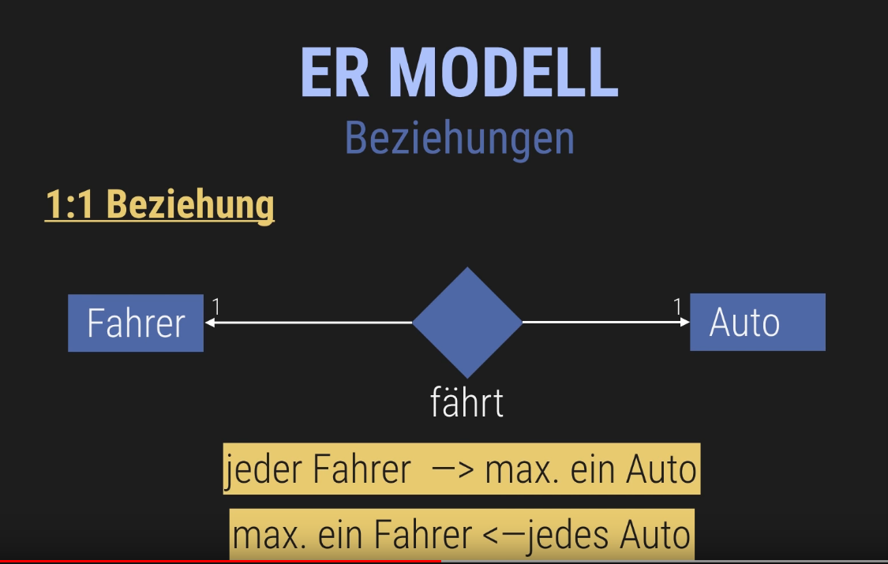
1 zu 1 beziehung heißt jedes entitiy hat max eine beziehung zum object einer anderer entity und umgekehrt
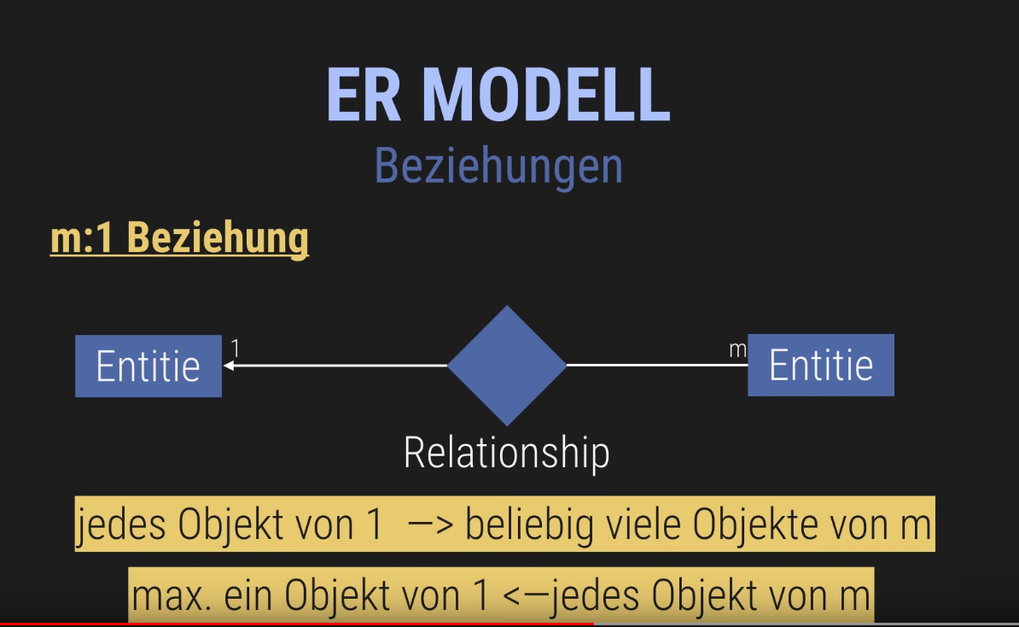

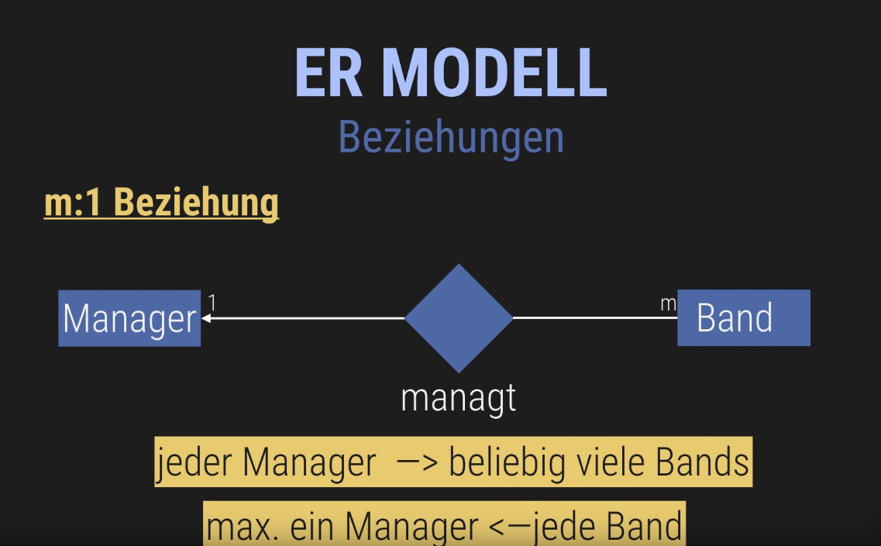
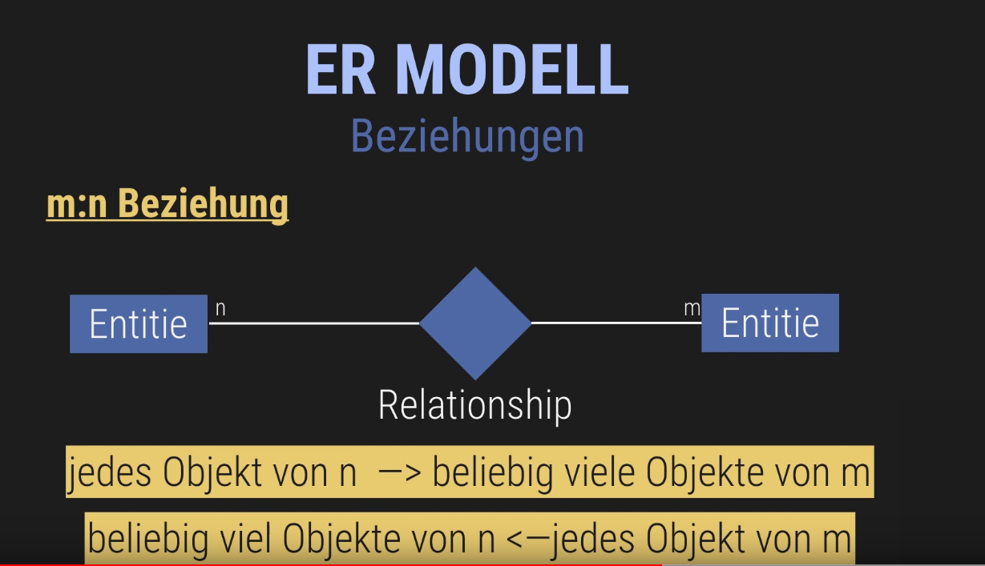
Beispiel:

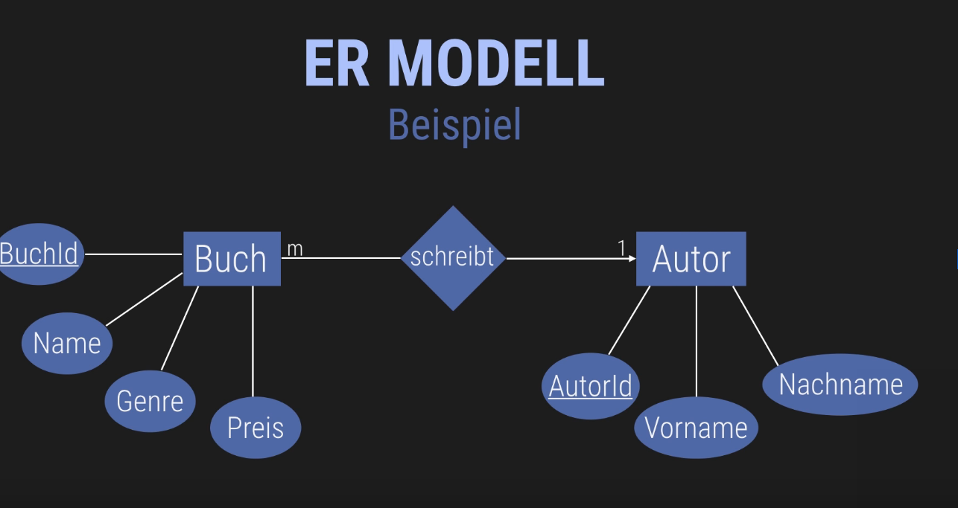
Es gibt also 3 beziehungen

Normalformen sind entwurfsregeln für eine gute relation (qualität steigern) um redzbdabzfreiheit und datenanimalien zu vermeiden

1NF
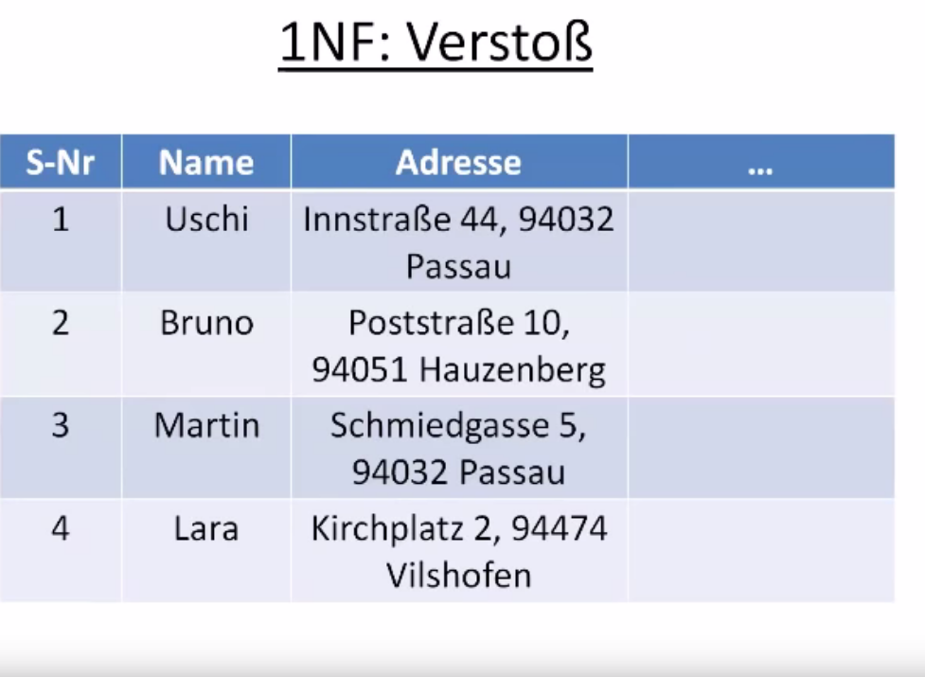
Verstoß weil die atribut werte von adresse nicht elementar (atomar) sind

jede weitere NF setzt die jeweils vorangegangene voraus

3NF ist wenn alle nicht-schlüsselatribute von einander unabhängig sind.

2NF alle nicht schlüsselatribute hängen vom gesamten primärschlüssel ab

