Inhaltsverzeichnis
1. Reading and writing a FILE to SDCARD 1
1.1. Ziele 1
1.2. Description 1
1.3. View 1
1.3.1. Project: Files-sdcard 2
1.4. Activity 3
1.4.1. Project: Files-sdcard 4
1.5. AndroidManifest.xml 5
1.6. Lab#1: read a textfile from sdcard for a hangman program 5

Reading and writing a FILE to SDCARD

Ziele
- Showing how to read and write a file to a sdcard.
- See:
  - http://www.java-samples.com/showtutorial.php?tutorialid=1523

Description
- This program shows how to WRITE and READ a FILE to/from SDCARD.
- The user can:
  - input some text, that will be written to the file called myfile.txt by pressing the write button.
  - Read the file myfile.txt by pressing the read button.

View
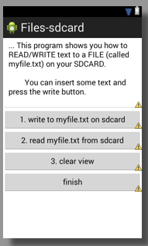
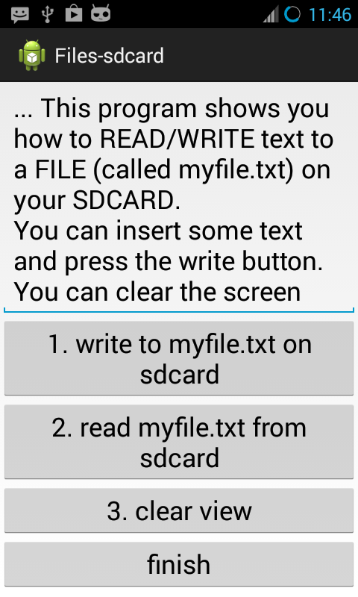
Fig.: app running Fig.: layout

The View consists of:
- 1 EditText
- 4 Buttons

Project: Files-sdcard
- Create a Android Project: Files-sdcard
- use the following layout:
activity_main.xml
<LinearLayout xmlns:android="http://schemas.android.com/apk/res/android"
xmlns:tools="http://schemas.android.com/tools"
android:id="@+id/container"
android:layout_width="match_parent"
android:layout_height="match_parent"
android:orientation="vertical"
tools:context="com.example.files_sdcard.MainActivity"
tools:ignore="MergeRootFrame" >

<EditText
android:id="@+id/editTextContent"
android:layout_width="match_parent"
android:layout_height="wrap_content"
android:ems="7"
android:fitsSystemWindows="true"
android:inputType="textMultiLine"
android:maxLines="7"
android:scrollHorizontally="true"
android:scrollbarAlwaysDrawVerticalTrack="true"
android:scrollbarStyle="insideOverlay"
android:scrollbars="vertical|horizontal"
android:text="... This program shows you how to READ/WRITE text to a FILE (called myfile.txt) on your SDCARD.

You can insert some text and press the write button.

You can clear the screen and press the read button to read the conent of the file (myfile.txt) into the EditView." >

</EditText>

<Button
android:id="@+id/buttonWrite"
android:layout_width="match_parent"
android:layout_height="wrap_content"
android:onClick="onWrite"
android:text="1. write to myfile.txt on sdcard" />

<Button
android:id="@+id/buttonRead"
android:layout_width="match_parent"
android:layout_height="wrap_content"
android:onClick="onRead"
android:text="2. read myfile.txt from sdcard" />

<Button
android:id="@+id/buttonClear"
android:layout_width="match_parent"
android:layout_height="wrap_content"
android:onClick="onClear"
android:text="3. clear view" />

<Button
android:id="@+id/buttonFinish"
android:layout_width="match_parent"
android:layout_height="wrap_content"
android:onClick="onFinish"
android:text="finish" />

</LinearLayout>

Activity
Android programmers can use the standard java classes for filehandling.
They are packaged within java.io.

Especially, you can use:
- File
- InputStreamReader
- BufferedReader

See chapter JAVA/07-java-streams on our subversion server.

Project: Files-sdcard
Complete the Project: Files-sdcard.

Here are some hints for MainActivity.java

Advice/Hint for Reading:
...
File myFile = new File("/sdcard/myfile.txt");
FileInputStream fIn = new FileInputStream(myFile);
BufferedReader myReader = new BufferedReader(
new InputStreamReader(fIn));

String aDataRow = "";
String aBuffer = "";
while ((aDataRow = myReader.readLine()) != null) {
aBuffer += aDataRow + "\n";
}
...

Advice/Hint for Writing:
...
EditText txtContent= (EditText) findViewById(R.id.editTextContent);

// write on SD card file data in the text box
...
PrintWriter fOut= new PrintWriter (
new BufferedWriter(
new FileWriter("/sdcard/myfile.txt")));

fOut.print(txtContent.getText());
fOut.close();
…

AndroidManifest.xml
To use your SDCARD you must assign the required persmissions.

...
<uses-permission android:name="android.permission.WRITE_EXTERNAL_STORAGE"/>
...

Lab#1: read a textfile from sdcard for a hangman program
Step 1: Create the project and class Hangman
Step 2: Define private members
private Vector<String> words;
...
Setp 3: program the constructor
Hangman(String filename)
reads data from the file into the private member words

Step 4: Test your App.

