Inhaltsverzeichnis
1. Android: Google Maps 1
1.1. Ziele 1
1.2. Location Based Services: Die APIs 1
1.3. Notwendige Permissions 1
1.4. Beispiel: Location Manager 2
1.5. OpenStreetMap 4
1.6. Location-Wechsel simulieren 6
1.7. Google Map API Key 7
1.8. Übung: Android99-google-maps-view1 7
1.9. Übung: Android99-google-maps-view2-controls 9
1.10. Übung: Android99-google-maps-view3-overlay 11

Android: Google Maps

Ziele
- Einführung in die Entwicklung von Software unter Android
- Quellen:
  - http://www.vogella.de/android.html
  - http://developer.android.com/guide/tutorials/views/hello-mapview.html

Location Based Services: Die APIs
- Location APIs:
zur Verarbeitung ortsgebundener Daten (GPS, WiFi, GSM)
  - android.location
  - LocationManager
  - Geocoder

- Mapping APIs:
zur Anzeige und Navigation von Karten
  - com.google.android.maps
  - MapView
  - MapActivity

Notwendige Permissions
Im AndroidManifest.xml

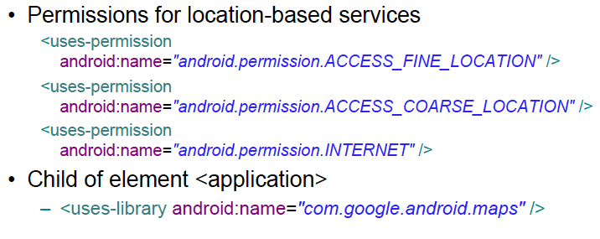
- Beispiel: http://developer.android.com/guide/tutorials/views/hello-mapview.html

Beispiel: Location Manager
- Siehe: 99-android-gps-sms.odt
- Bsp1:
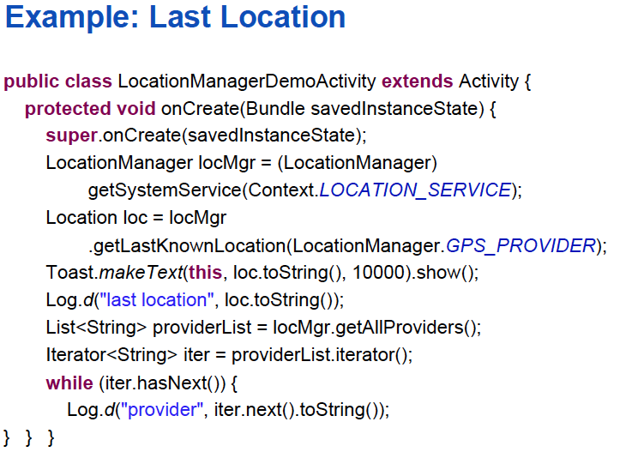

- Bsp2:
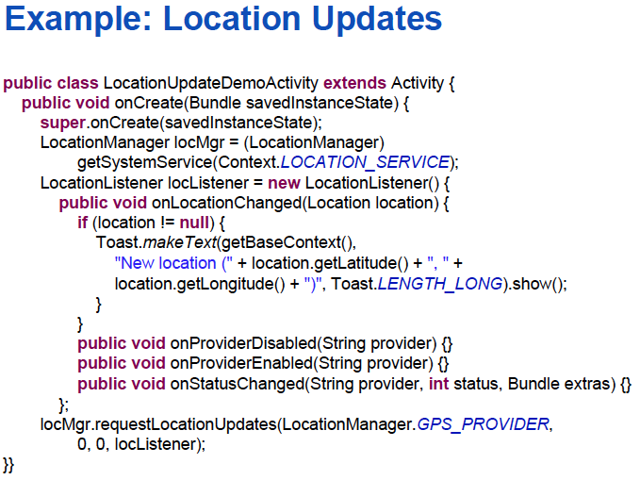

OpenStreetMap
[Ein Beitrag von Herbst Michael. 3DHELI 2012]
- Laden Sie osm-android-x.x.x.jar von http://code.google.com/p/osmdroid/downloads/list und slf4j-android-x.x.x von http://www.slf4j.org/android herunter.
- Erstellen Sie ein neues Projekt (Android_OSM).
- Erstellen Sie in ihrem Projektverzeichnis einen neuen Ordner "lib" und kopiern Sie die beiden *.JAR Files per Drag & Drop hinein.
- Rechte Maustaste auf das *JAR-File -> Build Path -> Add to Build Path.
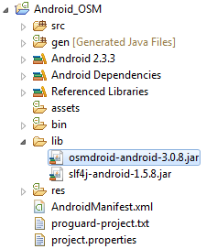
So sollte das Projektverzeichnis nun aussehen.

- Öffnen Sie das main.xml File und fügen Sie den folgenden Programmcode ein.

<?xml version="1.0" encoding="utf-8"?>
<LinearLayout xmlns:android="http://schemas.android.com/apk/res/android"
android:layout_width="fill_parent"
android:layout_height="fill_parent"
android:orientation="vertical" >
<org.osmdroid.views.MapView
android:id="@+id/osmmapview"
android:layout_width="fill_parent"
android:layout_height="fill_parent"/>
</LinearLayout>

- Öffnen Sie die Android_OSMActivity.java und fügen Sie folgeneden Programmcode ein.

package org.mherbst.osm;
//Imports
import org.osmdroid.util.GeoPoint;
import org.osmdroid.views.MapView;

import android.app.Activity;
import android.os.Bundle;

public class Android_OSMActivity extends Activity {
//Mapview definieren
private MapView mapView;
public void onCreate(Bundle savedInstanceState) {
super.onCreate(savedInstanceState);
setContentView(R.layout.main);

//MapView
mapView = (MapView)findViewById(R.id.osmmapview);
mapView.setClickable(true);

//Zoom-Buttons hinzufügen
mapView.setBuiltInZoomControls(true);

//Zoomfaktor festlegen
mapView.getController().setZoom(10);

//Ort festlegen
mapView.getController().setCenter(new GeoPoint(47.8465033,
13.0353415));//Latitude|Longitude
}
}

Location-Wechsel simulieren
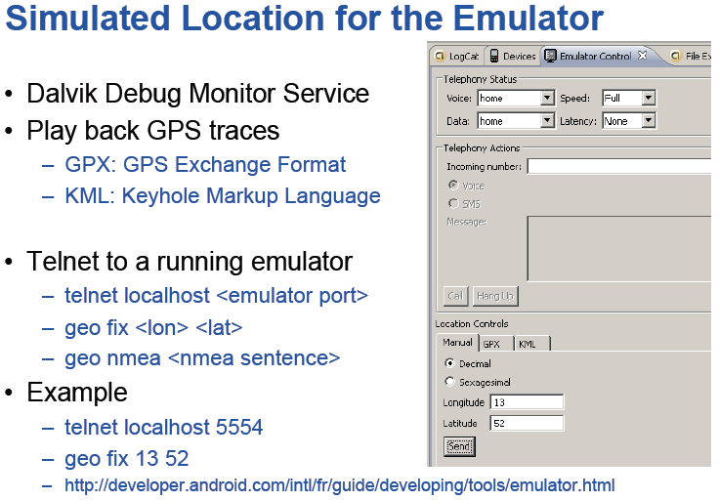

Google Map API Key
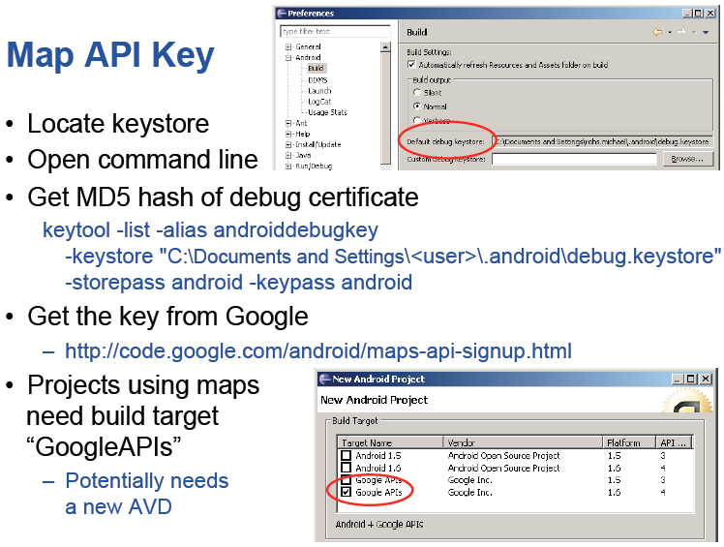

- Aufgabe: Besorgen Sie sich einen Map API Key von Google:

Zum Beispiel:
0m2XlLEG-Jmm374XbB_FtKF0xKM7wuJ9Tpt_tQQ

Übung: Android99-google-maps-view1
Wir wollen zuerst eine einfache Google-Maps-View zur Anezige von Karten erstellen.

- Projekt: Android99-google-maps-view1
- package: org.ht.android.googlemaps
- Activitiy: GoogleMapsView1Activity.java

- AndroidManifest.xml
<?xml version="1.0" encoding="utf-8"?>
<manifest xmlns:android="http://schemas.android.com/apk/res/android"
… >

…

<uses-permission android:name="android.permission.INTERNET" />

<application
….

<uses-library android:name="com.google.android.maps" />

….

</application>

</manifest>

- res/layout/mapview.xml
<?xml version="1.0" encoding="utf-8"?>
<LinearLayout xmlns:android="http://schemas.android.com/apk/res/android"
android:layout_width="fill_parent"
android:layout_height="fill_parent"
android:orientation="vertical" >

<com.google.android.maps.MapView
android:id="@+id/mapview"
android:orientation="vertical"
android:layout_width="fill_parent"
android:layout_height="fill_parent"
android:clickable="true"
android:apiKey="0m2XlLEG-Jmm374XbB_FtKF0xKM7wuJ9Tpt_tQQ"
/>

</LinearLayout>

- GoogleMapsView1Activity.java
package org.ht.android.googlemaps;

import com.google.android.maps.MapActivity;
import android.app.Activity;
import android.os.Bundle;

public class GoogleMapsView1Activity extends MapActivity {

@Override
public void onCreate(Bundle savedInstanceState) {
super.onCreate(savedInstanceState);
// setContentView(R.layout.main);
setContentView(R.layout.mapview);

}

protected boolean isRouteDisplayed() { return false; }
}

Übung: Android99-google-maps-view2-controls
Wir wollen nun
- einige Buttons zum Zoomen
- die Position und
- den Zoomwert einstellen.

TODO:
- Projekt: Android99-google-maps-view2-controls
- package: org.ht.android.googlemaps2
- Activitiy: GoogleMapsView2ControlsActivity.java

- AndroidManifest.xml
<?xml version="1.0" encoding="utf-8"?>
<manifest xmlns:android="http://schemas.android.com/apk/res/android"
… >

…

<uses-permission android:name="android.permission.INTERNET" />

<application
….

<uses-library android:name="com.google.android.maps" />

….

</application>

</manifest>

- res/layout/mapview.xml
<?xml version="1.0" encoding="utf-8"?>
<LinearLayout xmlns:android="http://schemas.android.com/apk/res/android"
android:layout_width="fill_parent"
android:layout_height="fill_parent"
android:orientation="vertical" >

<LinearLayout
android:id="@+id/linearLayout1"
android:layout_width="match_parent"
android:layout_height="wrap_content" >

<Button
android:id="@+id/buttonZoomIn"
android:layout_width="wrap_content"
android:layout_height="wrap_content"
android:onClick="onClick"
android:text=" + " />

<Button
android:id="@+id/buttonZoomOut"
android:layout_width="wrap_content"
android:layout_height="wrap_content"
android:onClick="onClick"
android:text=" - " />
</LinearLayout>

<com.google.android.maps.MapView
android:id="@+id/mapview"
android:layout_width="fill_parent"
android:layout_height="fill_parent"
android:apiKey="0m2XlLEG-Jmm374XbB_FtKF0xKM7wuJ9Tpt_tQQ"
android:clickable="true"
android:orientation="vertical" />

</LinearLayout>

- GoogleMapsView2ControlsActivity.java
package org.ht.android.googlemaps2;

import org.ht.android.googlemaps2.R;

import com.google.android.maps.GeoPoint;
import com.google.android.maps.MapActivity;
import com.google.android.maps.MapView;

import android.os.Bundle;
import android.view.View;
import android.widget.Button;

public class GoogleMapsView2ControlsActivity extends MapActivity {

private GeoPoint homePoi = new GeoPoint((int)(
47.800038 * 1000000), (int)(13.044499 * 1000000));

private MapView mapView;

@Override
public void onCreate(Bundle savedInstanceState) {
super.onCreate(savedInstanceState);

setContentView(R.layout.mapview);
mapView= (MapView) findViewById(R.id.mapview);

mapView.setBuiltInZoomControls(true);

mapView.getController().setCenter(homePoi);
mapView.getController().setZoom(14);
}

public void onClick(View v){
// Welcher Buttoon
Button btn= (Button) v;

switch(btn.getId()){
case R.id.buttonZoomIn:
mapView.getController().zoomIn();
break;

case R.id.buttonZoomOut:
mapView.getController().zoomOut();
break;
}
}

protected boolean isRouteDisplayed() { return false; }
}

Übung: Android99-google-maps-view3-overlay
Wir wollen nun noch einige Marker hinzufügen.
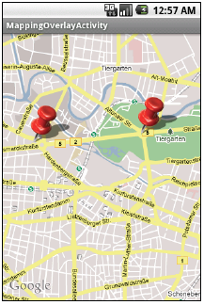

TODO:
- Projekt: Android99-google-maps-view3-overlay
- package: org.ht.android.googlemaps3
- Activitiy: GoogleMapsView3OverlaysActivity.java

- Datei: res/layout/mapviewoverlay.xml

<?xml version="1.0" encoding="utf-8"?>
<LinearLayout xmlns:android="http://schemas.android.com/apk/res/android"
android:layout_width="fill_parent"
android:layout_height="fill_parent"
android:orientation="vertical" >

<com.google.android.maps.MapView
android:id="@+id/mapviewoverlay"
android:orientation="vertical"
android:layout_width="fill_parent"
android:layout_height="fill_parent"
android:clickable="true"
android:apiKey="0m2XlLEG-Jmm374XbB_FtKF0xKM7wuJ9Tpt_tQQ"
/>

</LinearLayout>

- Datei: AndroidManifest.xml (wie oben)
- Datei: GoogleMapsView3ControlsActivity.java

package android.googlemaps3;

import java.util.ArrayList;
import java.util.List;

import com.google.android.maps.GeoPoint;
import com.google.android.maps.ItemizedOverlay;
import com.google.android.maps.MapActivity;
import com.google.android.maps.MapView;
import com.google.android.maps.OverlayItem;

import android.app.Activity;
import android.graphics.Canvas;
import android.graphics.drawable.Drawable;
import android.os.Bundle;

public class GoogleMapsView3OverlaysActivity extends MapActivity {
private MapView mapView;

private GeoPoint homePoi1 = new GeoPoint((int)(
47.800038 * 1000000), (int)(13.044499 * 1000000));

private GeoPoint homePoi2 = new GeoPoint((int)(
47.810038 * 1000000), (int)(13.054499 * 1000000));

@Override
public void onCreate(Bundle savedInstanceState) {
super.onCreate(savedInstanceState);

setContentView(R.layout.mapviewoverlay);

mapView = (MapView) findViewById(R.id.mapviewoverlay);
mapView.setBuiltInZoomControls(true);
mapView.setClickable(true);
mapView.getController().setCenter(homePoi1);
mapView.getController().setZoom(14);

Drawable marker =
getResources().getDrawable(R.drawable.ic_launcher);

mapView.getOverlays().add(new InterestingLocations(marker));

}

@Override
protected boolean isRouteDisplayed() {
return false;
}

class InterestingLocations extends ItemizedOverlay<OverlayItem> {

private List<OverlayItem> locations =
new ArrayList<OverlayItem>();
private Drawable marker;

public InterestingLocations(Drawable marker) {
super(marker);
this.marker = marker;

locations.add(new OverlayItem(
homePoi1, "Sbg Zentrum", "Sbg Zentrum"));

locations.add(new OverlayItem(
homePoi2, "Sbg Ziel", "Sbg Ziel"));

populate();
}

public void draw(Canvas canvas, MapView mapView,
boolean shadow) {
super.draw(canvas, mapView, shadow);
boundCenterBottom(marker);
}

protected OverlayItem createItem(int i) {
return locations.get(i);
}

public int size() {
return locations.size();
}
}

}

