Inhaltsverzeichnis
1. QWidgetNotepad 1

QWidgetNotepad
* Projekt: Qnotepad
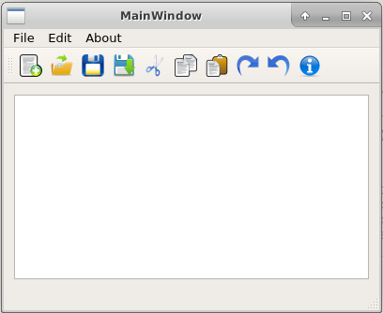
* Show Video:
https://www.youtube.com/watch?v=j4j1gbYJtUw&index=26&list=PLS1QulWo1RIZiBcTr5urECberTITj7gjA

* Inhalt:
- DESIGNER / MainWindow
- QMenue
- TextEdit (horiz. layout)
- QMenu (mit Icons)
File
New
Open
----
Save
Save As
Edit
Cut
Copy
Paste
-----
Redo
Undo
About
- ADD qrc (Qt Resource)für die Icons (02-ueben/icons)
- im Designer ->Action Editor (= links unten) -> Doppelklick auf actionNew
Icons auswählen
... auch alle anderen
- im Designer ->Action Editor-> drag actionNew zur Toolbar
... auch alle anderen
- im Designer ->Action Editor-> go to slot ...
... auch alle anderen
- EDIT: copy,cut,paste
void MainWindow::on_actionCut_triggered()
{
ui->textEdit->cut();
}

- FILE: new
class MainWindow
private:
QString file_path;
...

void MainWindow::on_actionNew_triggered()
{
file_path="";
ui->textEdit->clear();
}

* Wir werden folgendes brauchen/tun:
#include <QFile>
#include <QFileDialog>
#include <QTextStream>

* FILE: open:
* QFileDialog
* file_path setzen
* file_path= filename

* FILE: save
* file_path nutzen

* FILE: save as
* QFileDialog
* file_path setzen
* file_path= filename

void MainWindow::on_actionOpen_triggered()
{
QString filename= QFileDialog::getOpenFileName(this, "Open File");

if (!filename.isEmpty()){

QFile file(filename);

if (!file.open(QFile::ReadOnly|QFile::Text)){
QMessageBox::warning(this, "..", "file not open");
return;
}

// remember !!!
file_path= filename;

QTextStream fin(&file);
ui->textEdit->setText( fin.readAll());
file.close();
}
}

void MainWindow::on_actionSave_triggered()
{

QFile file(file_path);

if (!file.open(QFile::WriteOnly|QFile::Text)){
QMessageBox::warning(this, "..", "file not open");
return;
}

QTextStream fout(&file);

QString sout= ui->textEdit->toPlainText(); //!!

fout << sout;

file.flush();
file.close();

}

void MainWindow::on_actionSave_As_triggered()
{
QString filename= QFileDialog::getSaveFileName(this, "Save as File");
if (!filename.isEmpty()){
QFile file(filename);

if (!file.open(QFile::WriteOnly|QFile::Text)){
QMessageBox::warning(this, "..", "file not open");
return;
}

//remember
file_path= filename;

QTextStream fout(&file);
QString sout= ui->textEdit->toPlainText(); //!!
fout << sout;
file.flush();
file.close();
}
}

void MainWindow::on_actionAbout_triggered()
{
QString about_text="Notepad<br>";
about_text += "Author: A.Hofmann<br>";
about_text += "<a href='https://www.youtube.com/watch?v=j4j1gbYJtUw&index=26&list=PLS1QulWo1RIZiBcTr5urECberTITj7gjA'>Quelle: URL</a>";

QMessageBox msgBox(this);
msgBox.setWindowTitle("About");
msgBox.setTextFormat(Qt::RichText);
msgBox.setText(about_text);
msgBox.exec();
}

Quellen:
* Download Source:
http://www.codebind.com/cpp-tutorial/qt-tutorials-for-beginners-simple-notepad-application/

* Download Icons: http://www.iconarchive.com/search?q=about

