Inhaltsverzeichnis
1. QWidgetQRcode (QProcess) 1

QWidgetQRcode (QProcess)
* Projekt: QWidgetQRcode-process

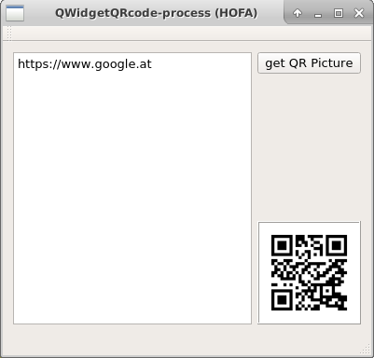
Aufgabe: install libCRENCODE
* Linux: sudo apt-get install libqrencode-dev
* Win: https://code.google.com/archive/p/qrencode-win32/

Aufgabe: Teste die Funktion
* qrencode -t PNG -o google.png http://www.google.at

void MainWindow::on_pushButtonGetPicture_clicked()
{
QString program = "/usr/bin/qrencode";
QStringList arguments;
arguments << "-t" << "PNG";
arguments << "-o" << "google.png";
arguments << ui->plainTextEdit->toPlainText();

QProcess *myProcess = new Qprocess(this);
myProcess->setWorkingDirectory("/tmp");
myProcess->start(program, arguments);
myProcess->waitForFinished();

QPixmap pix("/tmp/google.png");
ui->labelQRpicture->setPixmap(pix);
ui->labelQRpicture->update();
}

* siehe auch:
* git clone https://github.com/yoneal/qtqrencode.git

* https://ralgozino.wordpress.com/2011/05/29/introducing-qtqr-a-qr-code-generator-and-decoder/

