Inhaltsverzeichnis
1. OOP – SocialNetwork1 1
2. OOP – SocialNetwork2 3

OOP – SocialNetwork1
Part 1: Given is the following uml class diagram:
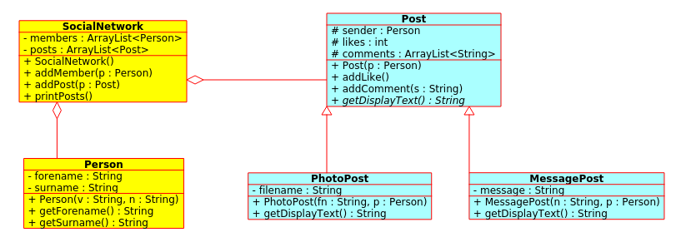
Part 2: Given is a small test program (here java):

public static void main(String[] args) {
SocialNetwork schoolBook = new SocialNetwork();

Person teacher1 = new Person("Max", "Teacher");
Person student1 = new Person("Susi", "Student");

schoolBook.addMember(teacher1);
schoolBook.addMember(student1);

MessagePost postTeacher1 = new MessagePost("What is the best coding language?", teacher1);
MessagePost postStudent1 = new MessagePost("I like to design software!", student1);
PhotoPost photoPostTeacher1 = new PhotoPost("teacher1.jpg", teacher1);
schoolBook.addPost(postTeacher1);
schoolBook.addPost(postStudent1);
schoolBook.addPost(photoPostTeacher1);

postTeacher1.addLike();
postTeacher1.addLike();
postTeacher1.addLike();

postStudent1.addLike();

postTeacher1.addComment("Java, java, java");
postTeacher1.addComment("I agree");
postStudent1.addComment("software testing is coooool?");

schoolBook.printPosts();
}

The above code gives this output:

MESSAGE-POST:
"What is the best coding language?" by Max Teacher, 3 likes
comment: Java, java, java
comment: I agree

MESSAGE-POST:
"I like to design software!" by Susi Student, 1 likes
comment: software testing is coooool?

PHOTO-POST:
"teacher1.jpg" by Max Teacher, 0 likes

Lab: SocialNetwork1
Write the classes shown in the above uml diagram and test your code.

OOP – SocialNetwork2
The above code has some constraints:
- members can not have friends
- we dont know who sended a comment
- we dont know who made a like
The uml-diagram:
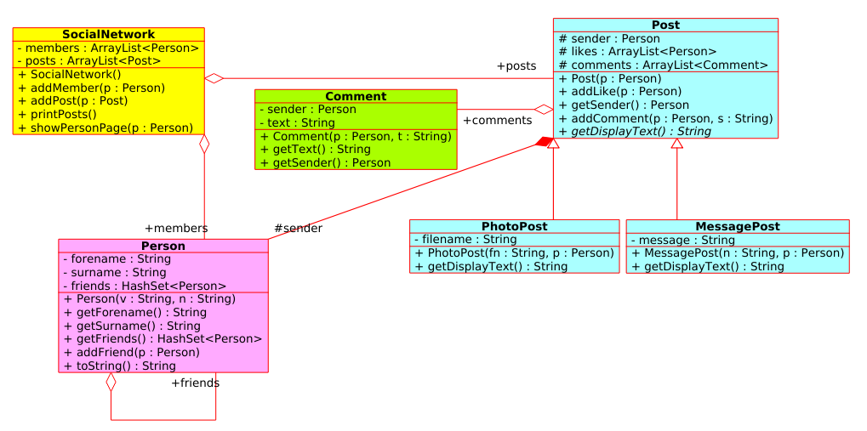
The main procedure:
public static void main(String[] args) {
// Person and friends
Person person1 = new Person("Max", "Smith the I");
Person person2 = new Person("Florin", "Smith the II");
Person person3 = new Person("Chris", "Smith the III");
Person person4 = new Person("Alex", "Smith the IV");

person1.addFriend(person2);
person1.addFriend(person3);

// Posts and likes and comments
MessagePost postPerson1 = new MessagePost("What is the best coding language?", person1);
postPerson1.addLike(person2);
postPerson1.addLike(person3);

postPerson1.addComment(person4, "Java,c++,c ...");
postPerson1.addComment(person2, "I agree");

MessagePost postPerson2 = new MessagePost("I like to design software!", person2);
postPerson2.addLike(person1);
postPerson2.addComment(person1, "Oh no, its hardware. Thats the best!");

PhotoPost photoPostPerson1 = new PhotoPost(person1.getSurname()+".jpg", person1);
// ...

// SocialNetwork
SocialNetwork schoolBook = new SocialNetwork();
schoolBook.addMember(person1);
schoolBook.addMember(person2);
schoolBook.addPost(postPerson1);
schoolBook.addPost(postPerson2);
schoolBook.addPost(photoPostPerson1);

// output
schoolBook.showPersonPage(person1);
System.out.println("\n");
schoolBook.showPersonPage(person2);
}
The output:
PAGE of Max Smith the I
=============================================================
Friends:
Chris Smith the III
Florin Smith the II
Posts:
MESSAGE-POST: "What is the best coding language?" by Max Smith the I, 2 likes
comment: Java,c++,c ... (Alex Smith the IV)
comment: I agree (Florin Smith the II)

PHOTO-POST: "Smith the I.jpg" by Max Smith the I, 0 likes

PAGE of Florin Smith the II
=============================================================
Friends:
Max Smith the I
Posts:
MESSAGE-POST: "I like to design software!" by Florin Smith the II, 1 likes
comment: Oh no, its hardware. Thats the best! (Max Smith the I)

Lab: SocialNetwork2
Write the classes shown in the above uml diagram and test your code intensive.

Tipp:
public void addFriend(Person p) {
friends.add(p);
p.friends.add(this); // we are friends! (both sides)
}

Tipp: create class Comment to hold the comment-text and who made the comment.

Tipp:
class Post: member likes becomes an ArrayList<Person> to store the Person, who likes that post. The size of the ArrayList likes holds the number of likes.

