General Notes:

When program has choice between Global and Local variable, it will pick the local
cout << ::x << endl; //will force to use the global variable with Scope operator (::)

int x{} means it gets initialized with 0. just int x; means it gets some random value.
Its the same as int x = 0;
That means: int x{42} -> int x = 42;

escape sequenz: \n, \t ….

Function overloading:
you can make two functions with same name but different datatype as parameter

Recursion:
A function calling it self. Without and endpoint it will be an infinite loop

Casting:
Temporary change of variable type. The variable gets castet into a different one. Useful when having equations with multiple data types. Its better to have them all one same datatype:

float x = 1.23:
int y =1;

sum = x * (float)y;

Arrays:

When passing an array into a function:
void printArray(int x[]){}
but when you call the function you write it without square brackets
printArray(arr);
There is no such thing as index out of bounds in C because its just a pointer. It will show some random value in your next memory address. Arrays themselves dont know how long they are, except char arrays that have a termination char at the end of the array. So when passing an array into a function that is not an char array, we also need to pass the actual length of the array as an integer so that we can iterate through it

const:
1. cannot change the variable
2. cannot dereference the pointer if its before the * and
cannot change the pointer itself to something else if its after *

3. when its written after method brackets and berfore curly brackets, it means the function cant change any of the class like its member variables (“read only method”). This makes sense with a getter method since we ain’t changing anything. Only works with methods btw.

This means, we can literally have 3 times const in our code if we have a member pointer in a method. “const int* const GetX() const {}. This means the method returns a pointer that cannot be changed, its value cannot be changed, and the method itself can’t change anything.

When I have a const method instance, only const methods of that object can be used. So always put const after method braces, if the method doesn’t change anything, otherwise I’m denying access to that method if I have an const object instance. Const objects need constant functions

String:
C style strings char* s; cannot be modified because they are in read only memory. Thats why we write const before it for the compiler to know. With const char* we have to use C functions like strlen(). Using char[] s; instead is also a pointer, just the name is a pointer to the fist element, so we can access the array also with s+1. The biggest difference is that char[] we can modify because it points to a space in memory we can edit. So if its only output we can use char* else always use string class. String is a class and takes in a constructor of char[]
We can create object like string s = “hello”; OR like this string s(“hello”); Both are same.

Static:

1. static before a global variable, is kinda like defining it private in that class. We can prevent double names error. Because global variables are typically avoided, the static keyword is not often used in this capacity.

2. If used in a function, the variable doesn’t get destroyed after the function. It only gets destroyed when the programm ends
Static variables offer some of the benefit of global variables (they don’t get destroyed until the end of the program) while limiting their visibility to block scope, so that they cant be accidently used somewhere else like an global variable would. So its the same as global variable, but only for the function.
Best practice is avoid static local variables unless the variable never needs to be reset. static local variables decrease reusability and make functions harder to reason about.

3. Static variable inside a class makes it so that every instance if the class uses the same variable, no copy is being made. It’s like having a global variable but for classes. Classic methods are the same, its like writing the method outside of the class. That means static methods can only use static variables.

extern keyword is the opposite of static. before variable means it refers to an external variable. This way we can also prevent double name error. Use as private in class, as much as possible otherwise they will be global
same goes for a function

int& x = y //address of x is the same as address of y. Both are the same. If one changes the other one does too
call by reference is using references in a function parameter. It has two consequences:
1. It saves memory since no copy is created for the function
2. It changes the variable itself. Change presists outside of the function
int swap(int& x, int& <) when passing into this function we are doing this: int& x = a
That means we are basically setting x and a to have the same address

Stack/Heap

when we declare variables, arrays etc. they get stored in the top address. (top of the stack). Every time we do so, the stackpointer moves down by one. Every time when we reach the end of that scope where they are defined, the memory gets freed (poped) from the stack.
Heap is slower, and the space needs to be freed by the programmer. Stack gets freed automatically when a function is left. Use heap when you need longer lifetime or when there is no enough space on stack, since the stack is smaller

Stack: int x = 5;
Heap: int* hx = new int;
*hx = 5;
delete hx;

Arrow Member Selection Operatoren: ->
Derefereces a pointer that is pointing to a class. Its just a shortcut of us not having to manually dereference it.

Player x; Player x;

Player* ptr = &x Player* ptr = &x
(*ptr).movePlayer(); ptr->movePlayer();

Member Initlializers
Different way if initializing private members in costructor. Always use it because its faster
Player(int a, int b) : m_Var1(a), m_Var2(b) {}

this keyword:
We can only use it in methods (member function)
this is a pointer of the current object of the class it in in. Usefull when the constructor has same name parameters as the members. So when using this->x=x, the this x is the global x, and right one is the local x. It’s because this is a pointer to that same object. So: Entity* e = this; so if we dereference this, we have access to ourself in that function. This way we can exactly tell this→x is the member x.

Example: printing an int from a class
cout << x << endl;
cout << this→x << endl;
cout << (*this).x << endl;

new keyword:
allocate memory on the heap. The memory remains stored after end of sccope . It returns a pointer to the free memory space

Friend functions:
You declare a friend function inside a class as if you would prototype it.
But when you define the function outside of the class, it has access to its components because it is its friend.

Copy constructor:
Copy cconstructor is used when we pass an object into another object, which means to set those two objects as equal. When pointers are used inside we can two objects that are have same pointers, which can cause problems. Thats why you need to create copy constructor yourself, in order to allocate different memory space for that pointer with new keyword. Then you actually get two objects which are copies.

Encapsulation –Verbergen von Daten oder Informationen vor dem Zugriff von außen. Der direkte Zugriff auf die interne Datenstruktur wird unterbunden und erfolgt stattdessen über definierte Schnittstellen (getter, setter). Diese Methoden erlauben das manipulieren der private member. So lokal wie möglich, so gliobal wie nötig

Abstraction is the concept of object-oriented programming that "shows" only essential attributes and "hides" unnecessary information. The main purpose of abstraction is hiding the unnecessary details from programmers that work on other classes. Just give details for others to know how to use the class. You can divide the code into bits

private (-) – can only be accessed in the class
protected (#) – can be accessed in the class AND in its subclasses

inheritance is a arrow triangle that points to baseclass from subclasses
abstract class names are shown when they are cursiv. Also known as IS-A
Aggregation is shown with a diamond. The class on which the diamond is, means that here are the object instances of the other class, but can still exist separately. Composition is the same but the two classes cant exists separately. This is shown with a filled diamond. Also known as a HAS-A

Polymorphism – same name methods can have different functions. We can define same name method in different classes. Depending which instance of class we use, the corresponding method will be called. We can also see polymorphism as function overloading. Where we can have same name methods but different parameters. Then it depends how we use the parameters which method will be called

Classes are practically data types, while objects are variables. That variable is also called object instance

Virtual Functions allow to override methods in subclases. It just tells c++, hey, watch out what type of object instance it is. Is it a subclass or the baseclass? Corresponding to what it is it takes the correct method. Bit more precise, virtual allows functions to be overriden by sub functions, but dont hhave to be. This is called polymorphism. One function can do multiple things

A pure virtual function means it NEEDS to be overriden, since it has no body, its defined by being set to 0. So its like an abstract method. We are forcing sub classes to implement it. That means the base class with the pure virtual function cannot be instanciated. Its also called an interface, because we have only a template of the function and other sub classes are implementing it

hashtags are preprocersor statements that are initialized before the compilation
#pragma once → prevents me from including multiple times. Include is basically take the file and paste into. This can easily happen when there are includes in includes.

Function pointers → assign a function to a varianble

Singletons is a single instance of a class

#pragma once is the same as #ifndef #endif. Its a header guard

Namespaces: When including a header file, and we want to program the method inside a class, we cant, because its not defines in a global namespace, its inside a class. Thats why we need to put int myClass::getX() const {} before so that the compiler knows that this method is inside the myClass class.

Mit ER modell wird geplannt wie die datenbank struktur aussehen soll
ER modell besteht aus entities

Relationales Datenmodell besteht mur aus tabellen

in diesen tabellen hat man spalten und zeilen
spalten = atributee
jede zeile ist eigenes object
wenn eine jeweilige zelle als not null definiert ist, darf sie nicht 0 sein, muss ein wert haben

jede entity wird durch eine tabelle abgebildet
es gibt keine 2 gleichen zeilen
eine zeile wird auch tupel genannt

DDL → sql befehle
primär schlüssel → einzigartige spalten, muss eindeutig sein und minimal zb ID
fremdschlüssel verweist auf einen primär schlüssel in einer anderen tabelle und verknüpft diese somit . Erkennbar duch strich oben

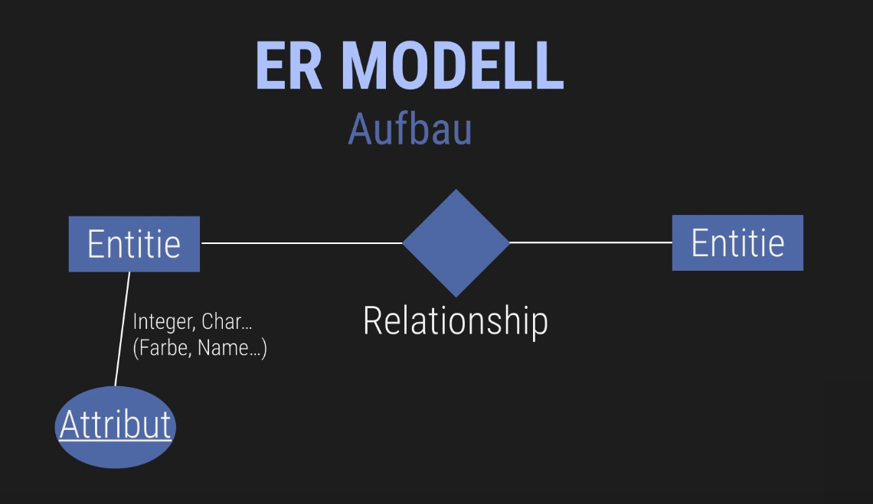

Unterschricchten wenn primär schlüssel
über relationships sieht man schon welcher fremdschlüssel enthalten ist

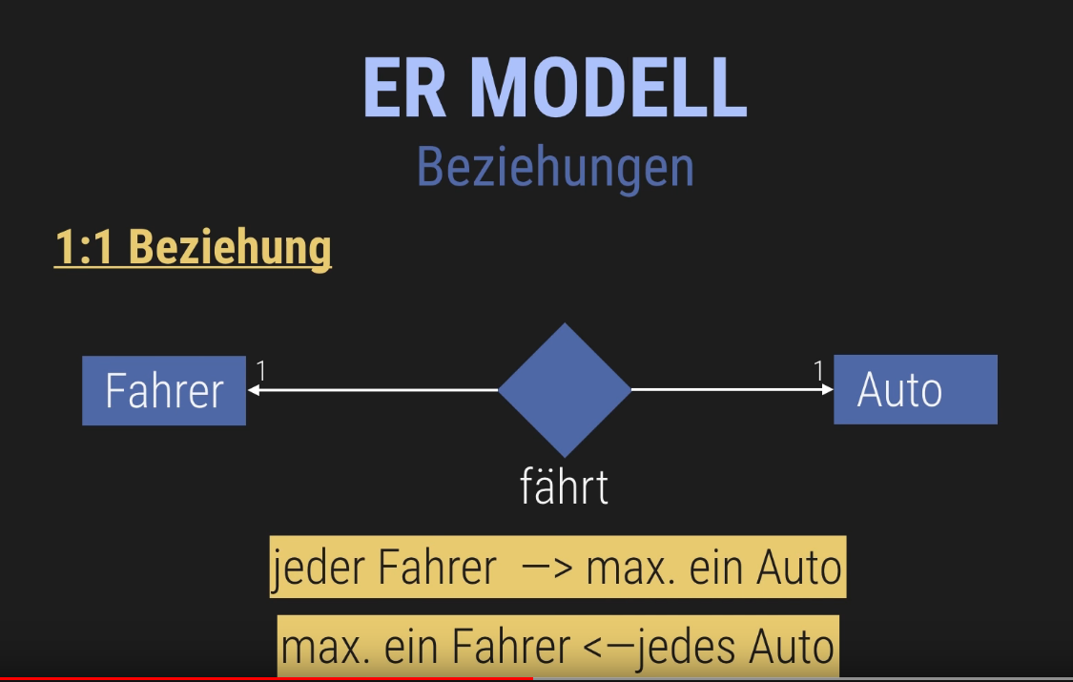
1 zu 1 beziehung heißt jedes entitiy hat max eine beziehung zum object einer anderer entity und umgekehrt
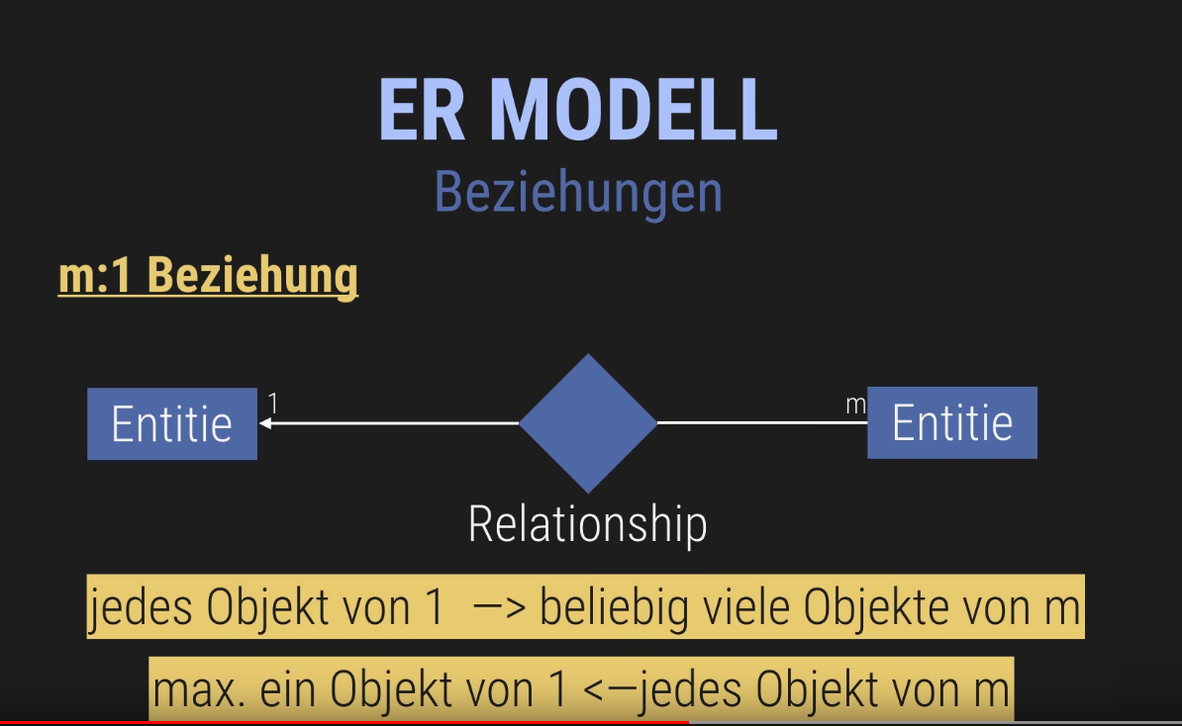

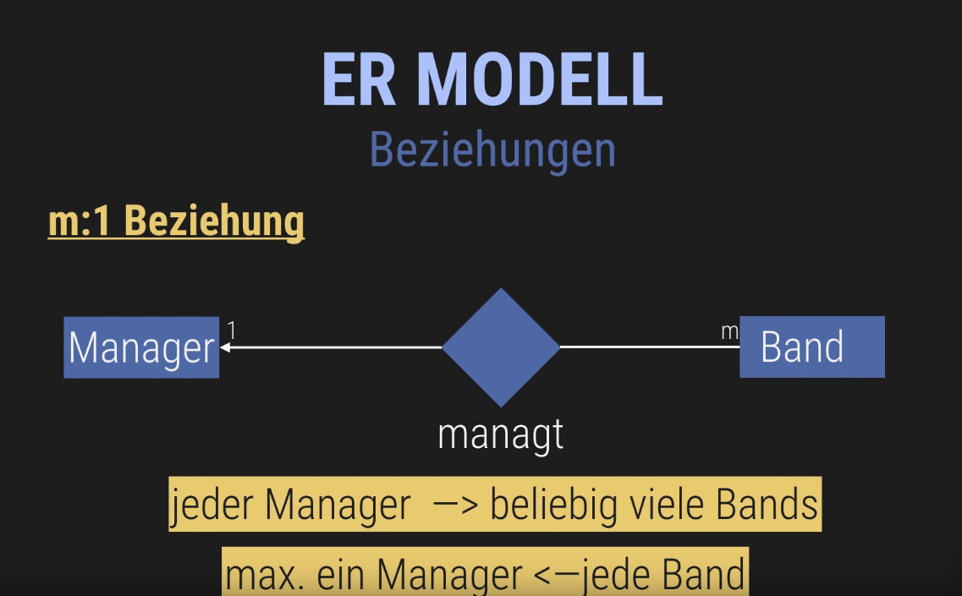
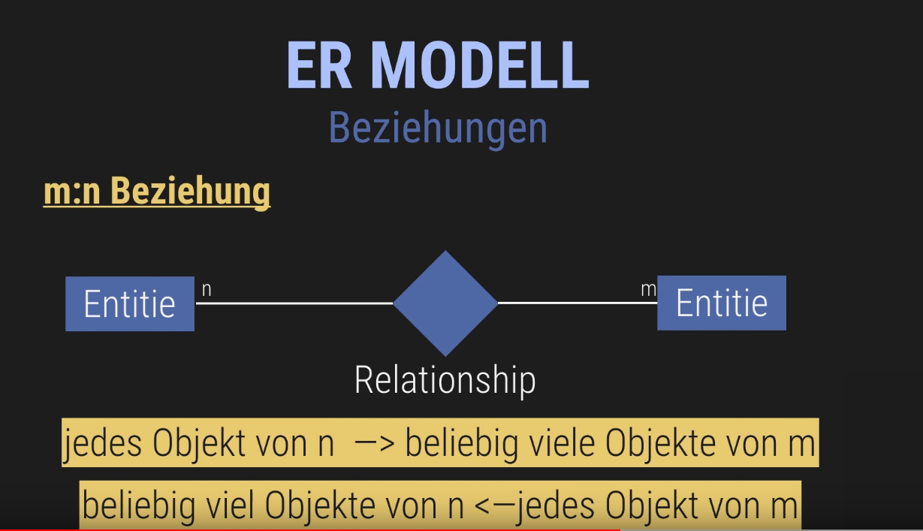
Beispiel:

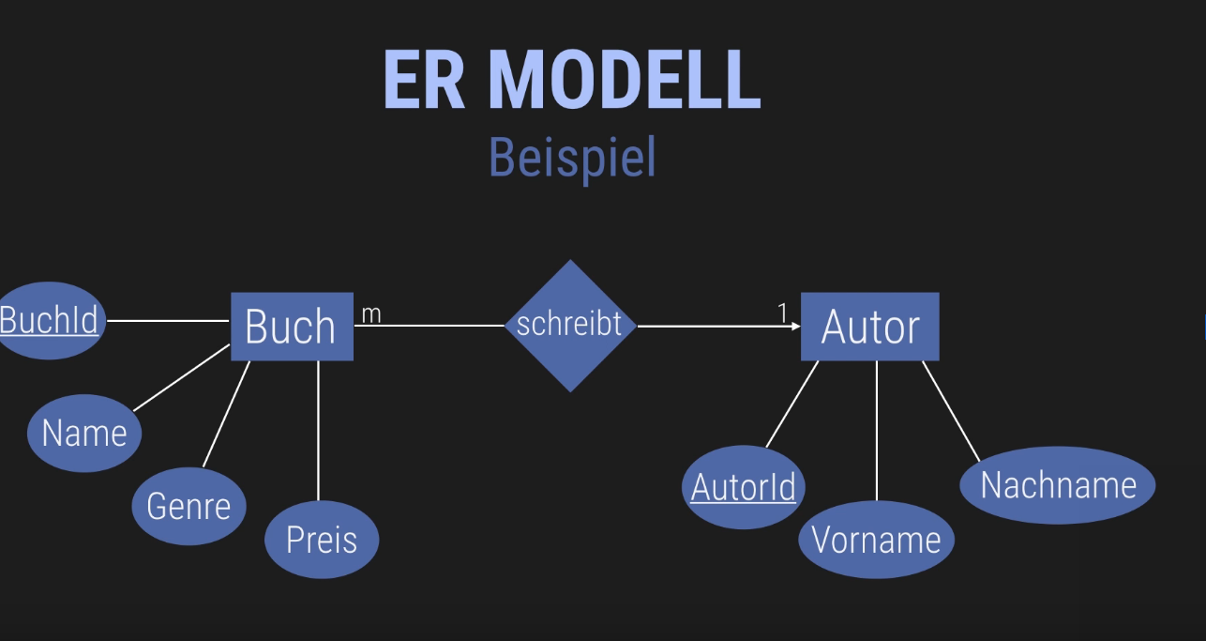
Es gibt also 3 beziehungen

Normalformen sind entwurfsregeln für eine gute relation (qualität steigern) um redzbdabzfreiheit und datenanimalien zu vermeiden

1NF
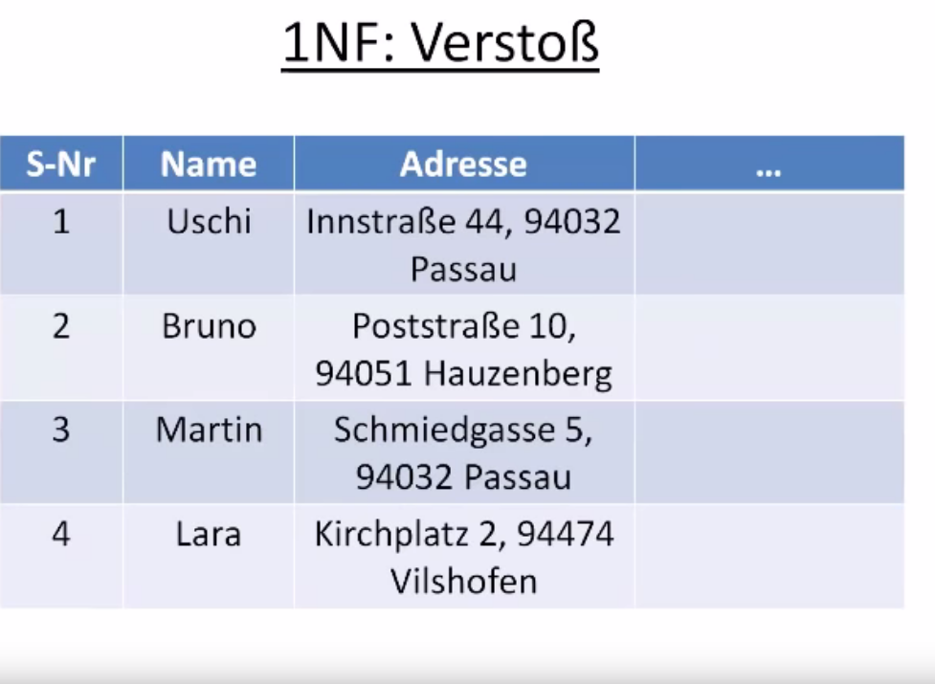
Verstoß weil die atribut werte von adresse nicht elementar (atomar) sind

jede weitere NF setzt die jeweils vorangegangene voraus

3NF ist wenn alle nicht-schlüsselatribute von einander unabhängig sind.

2NF alle nicht schlüsselatribute hängen vom gesamten primärschlüssel ab

