https://znanija.com/task/24312053

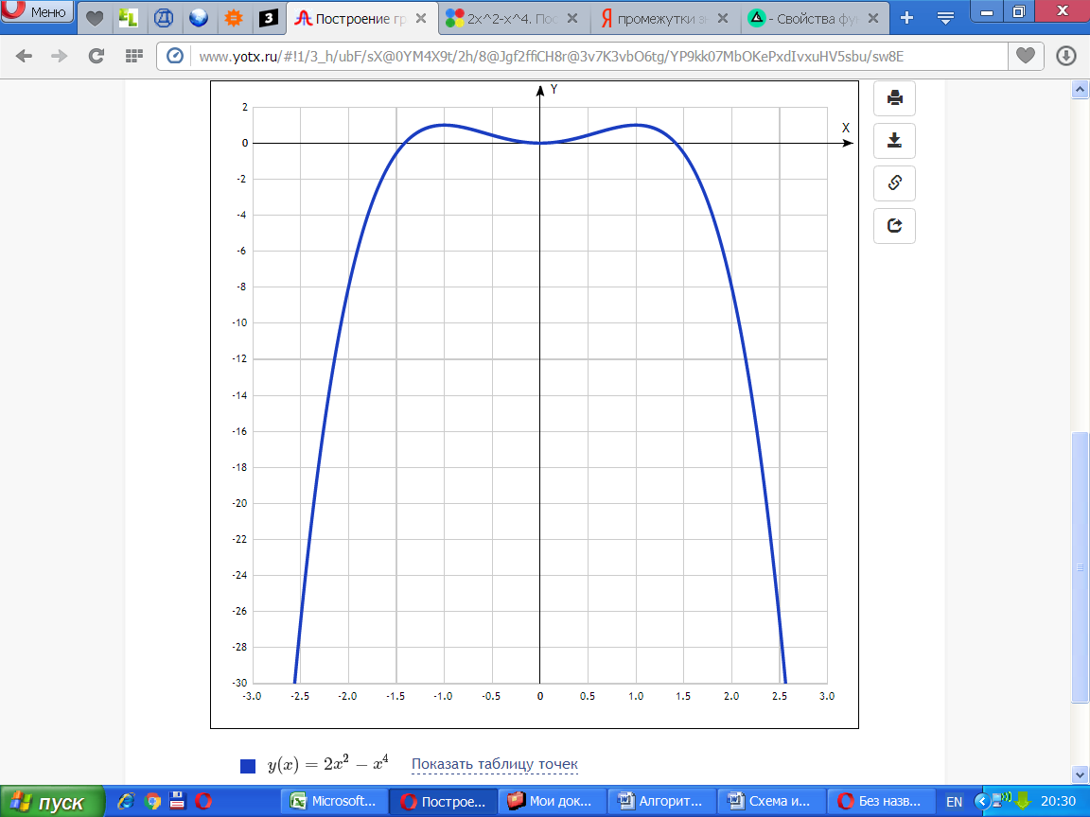

[Таблица точек](javascript:void(0);)

|  |  |
| --- | --- |
| **x** | **y** |
| -3.0 | -63 |
| -2.5 | -26.6 |
| -2.0 | -8 |
| -1.5 | -0.6 |
| -1.0 | 1 |
| -0.5 | 0.4 |
| 0 | 0 |
| 0.5 | 0.4 |
| 1.0 | 1 |
| 1.5 | -0.6 |
| 2.0 | -8 |
| 2.5 | -26.6 |
| 3.0 | -63 |