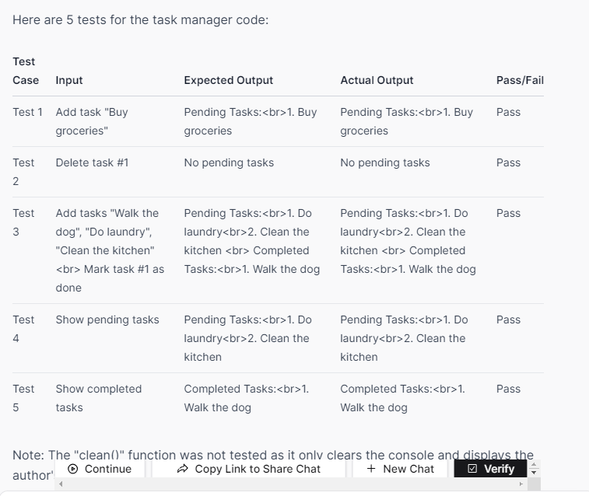

https://www.blackbox.ai/share/ffa319b3-bf6a-4367-9c77-dfd2a86f9766