 Cupi2 Project | ISIS-1204 Algorithms and Object Oriented Programming 1  Description
Exercise: | Dog Show
Author: | Andrés Arias
Date: | November 2007

Description
In a canine exhibition, parades of different canine races are made. For each of the canine participants, the show manages the following information: name (which must be unique for each participant), race, age and the number of points granted in the exhibition.
Clients need an application that allows them to manipulate the information of the participants in the dogs-show. In addition to the basic information, the photo of each dog is also needed.
Application must (1) list the dogs registered in the exhibition, ordered by race, points or age, (2) show the information of an specific dog, (3) register a new dog, (4) find a dog by his name, (5) determine the winner of the exhibition (the one that has the greatest assigned score), (6) determine the dog with the smallest score and (7) determine the oldest dog among all (i.e. the one with greatest age).
The initial information of the dogs is obtained from a properties file. When program starts the execution, such information is loaded.

Graphical User Interface

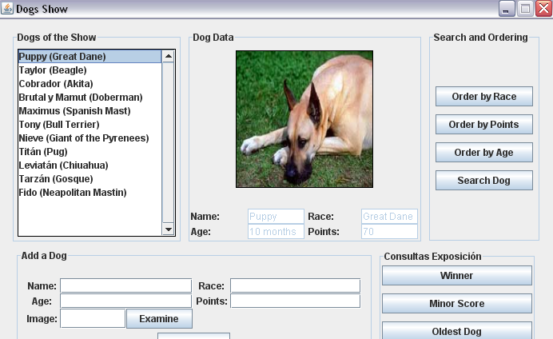
The application GUI looks like follows:

