Cupi2 Project | ISIS-1204 Algorithms and Object Oriented Programming 1  Description
Exercise: | DNA Chains
Author: | Andrés Arias
Date: | January 2008

Application Description
The application to be built allows the manipulation and visualization of DNA chains.
Initial chains must be loaded from text files, the chains built modifying the initial chains could be saved in text files using the same format.
The operations that could be done over the chains are:
- Load a chain
- Save a chain
- Delete a chain
- Add to a chain the nitrogenous bases from another
- Correct a mutation from a chain
- Find the longest common fragment between two chains
- Delete a fragment from a chain

Graphic User Interface

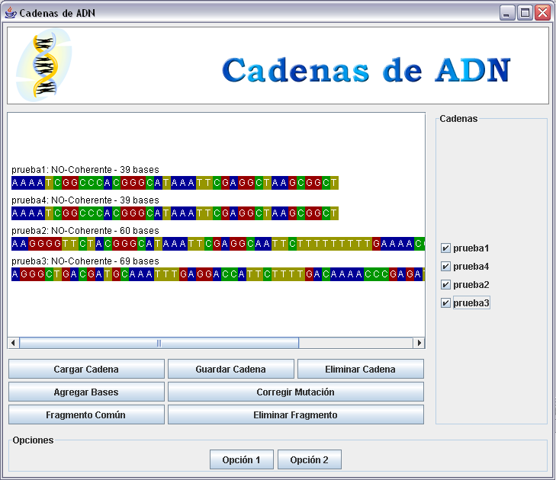
Main Window

Problem Description
DNA chains are very long sequences of simpler elements called nitrogenous bases. In this context, there are 4 types of nitrogenous bases: Adenine (A), Thymine (T), Guanine (G) and Cytosine (C). Different sections from a chain determine different characteristics from an individual: The expression of that characteristic depends exclusively from the types of nitrogenous bases inside the chain.
In the life beings, DNA chains are not a single string but two of them linked in a double helix, united by nitrogenous bases. The formation of this helix is ruled in a specific way: Adenine can only match with Thymine and Cytosine can only match with Guanine. Given a DNA chain, if this chain can be bent by its center and form the right matches, in this context, it will be a coherent chain.
In this application, the concepts Nitrogenous Bases and DNA Chains have to be modeled. It will also have to work with several DNA chains.
The files in which the chain information will be saved have two lines. In the first one there is the description of the chain, in the second one there is the nitrogenous bases sequence, expressed in the four correspondent letters (A, T, G and C).

Analysis
The nitrogenous bases are the simplest element in the system. In this context the only relevant information about them will be their type (A, T, G or C).
Chains to be handled will be only a string and will be made of nitrogenous bases. In those chains the order is important and they will be a lineal structure. This means that there has to be two ends and it has to be possible go from one end to the other.
Finally, it is necessary to handle sets of chains. This responsibilities of handling will be owned by a DNA Processor.

Design
Next, the solution design based on singly-linked and doubly-linked lists.

Solution Structure

Elements detected in the analysis, will have a representation on a three classes model: DNAProcessor, Chain and NitrogenousBase.
NitrogenousBase class only model the type of a nitrogenous base.
Chain class represents a list of nitrogenous bases. For efficiency reasons, they will be ordered on a doubly-linked list with a head and a tail.
DNAProcessor class will handle a set of Chains, ordered according to their length, in a singly-linked list with just a head.

Classes Description
Name: | NitrogenousBase
Description: | This class represents a nitrogenous base.  Each NitrogenousBase knows the previous element and the next element in the doubly-linked list in which it is.
Associations
none | none
Responsibilities: | 1. Have the information about its type.  2. Have the order relations between the nitrogenous bases inside the list.

Name: | Chain
Description: | This class represents a chain of nitrogenous bases.  Each chain must know the first and the last nitrogenous bases from the list.  The chains are in a singly-linked list of chains, each chain must know the next chain in the list.
Associations
NitrogenousBase | The chain knows the first and the last NitrogenousBase from a chain.
Responsibilities: | This class has to implement the algorithms specified in the functional requeriments and has to create new chains if needed.

Name: | DNAProcessor
Description: | This class handles the multiple instances of the Chain class, ordered in a singly-linked list.
Associations
Chain | DNAProcessor knows the first chain in the list and has to handle several chains as they are created.
Responsibilities: | This class delegates the requirements to the chain, and manages the new created chains. It has to maintain the order of the chains as they are created.

