Cupi2 Project | ISIS-1204 Algorithms and Object Oriented Programming 1  Description
Exercise: | Patient’s Central
Author: | Andrés Arias
Date: | May 2009

Statement
A computer program is needed to manage the information from a group of patients being treated at different clinics in the city. For each patient, the application must store a numeric code that is unique (76527, for example), a name ("Mariana Chacon), the name of the clinic to which was referred the patient ("Hospital Reina Sofía"), the patient medical information ("Earache") and gender (Female).
It is expected that the program is able to add a patient, watching four possible variants: insert at the beginning of the patient list, insert at the end, insert after another patient (given its code) or inserted before another patient (given its code.) It should also allow a patient to remove or edit its medical information, for which the user must supply the respective patient's code.
For ease of implementation, it is not necessary that the information is persistent.

Graphical User Interface
The application must have a gui similar to the following:
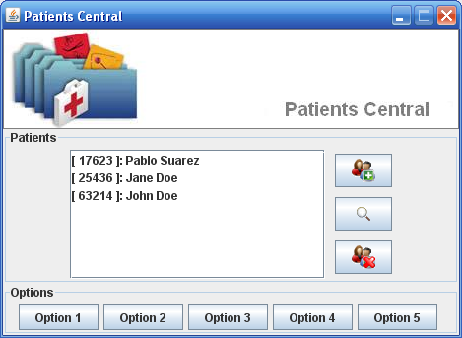
Application main window
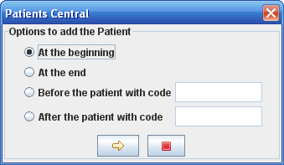  Dialogue to select the preferred addition of a patient | 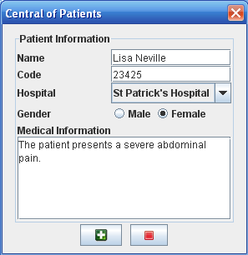  Dialogue to enter patient data
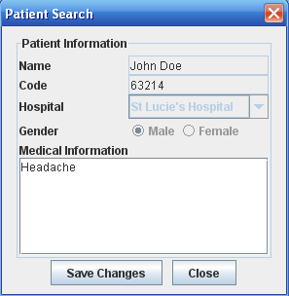
Dialogue to display information from a patient

