Design document for VVA

VVA Version: | 0.6
Last edited: | 2020-ago-07

1. Purpose
Describe the general architecture and modules distribution of VVA (Vehiculo Vigilancia Autonomo).

2. General design

2.1. Currently available orders from the user (v0.6)
This is a list of the orders or commands that the user could give to the robot with the modules implemented so far:
- Manually create or update a map of the current location (From CLI or Mobile App, and Rviz)
- Manually set the initial location of the robot in a map (From Rviz)
- Manually move the robot from a remote controller (From CLI or Mobile App)
- Go to a specific goal location in the map (From Rviz or Voice Command)
- Create an itinerary in the map for patrolling (From CLI)
- Start patrolling by following the itinerary (From CLI or Voice Command)
- Watch live video from the robot’s camera (From Rviz)
- Stop any action performed by the robot at any given time (From Voice Command)

2.2. Desired orders that would require relatively little effort
This is a list of the orders that will be a complement of those listed in the previous item, but still require some additional work to have them ready.
- Manually create or update a map of the current location (Using only Mobile App) (To be implemented in BL-41 “Mejorar la aplicación móvil (mobile app) para usarla como cliente del robot o robots”)
- Manually set the initial location of the robot in a map (From Mobile App) (To be implemented in BL-41 “Mejorar la aplicación móvil (mobile app) para usarla como cliente del robot o robots”)
- Create an itinerary in the map for patrolling (From Mobile App) (To be implemented in BL-41 “Mejorar la aplicación móvil (mobile app) para usarla como cliente del robot o robots”)
- Watch live video from the robot’s camera (From Mobile App) (To be implemented in BL-41 “Mejorar la aplicación móvil (mobile app) para usarla como cliente del robot o robots”)
- Manually change the tilt of the Kinect (From Mobile App) (To be implemented in BL-41 “Mejorar la aplicación móvil (mobile app) para usarla como cliente del robot o robots”)
- Listen an audio clip recorded from the microphones of the robot (From Mobile App)
- Ask the robot to follow me (From Voice Command) (Related to BL-8 “Vigilancia con identificación de objetos del entorno y reporte de anomalías por correo” and BL-14 “Reconocimiento de personas y de gestos”)

2.3. Design principles for Voice Intent Recognition

1. | Create a mapping between transcriptions and intents. This must be in a separate file, easy to edit, to add new transcripts and intents very easily. Take into account that this file would become big in time.
2. | There will be different modules in charge of executing the intents.
3. | The Intent Execution Node will be invoked by VVA Voice Interact Laptop through a ROS Service, but the Intent Execution Node will execute the intent in a separate thread, so it will reply immediately once the service is invoked, to avoid blocking VVA Voice Interact Laptop.

2.4. General Design of the Voice Commands processing
The Audio Listening Intent will not be implemented yet (VVA v0.6).

Diagrams created with “draw.io”
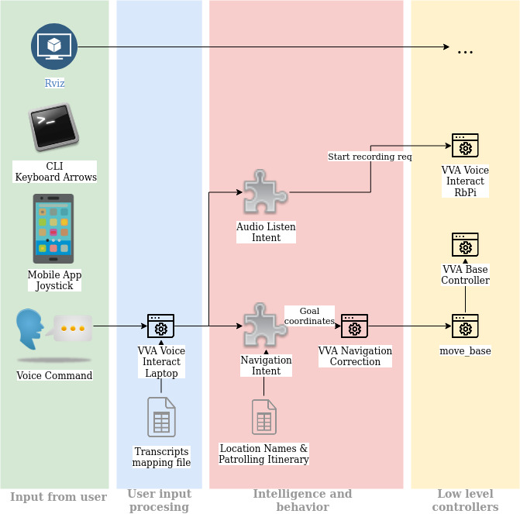

2.5. Dependencies between ROS nodes
The following diagram shows the ROS nodes along with some external modules used in VVA v0.6. Not all possibilities offered by the modules are used at this stage, hence are not shown here. For example, the Mobile App has a joystick but is not used because it still requires some tuning, then is not mentioned in the diagram.

Only the dependencies of the nodes in the layers “Intent execution and behaviors” and “Middle processing” are shown. The dependencies of the low level layer executed in the Laptop are not shown to keep the diagram clean and simple. The dependencies at that layer are more like a full mesh: Almost all the nodes depend on the “State publishers”, “move base” also depends on “vva lidar odom” and on “vva rtabmap”, and so on.

