Heterogeneous LoRa-Based Wireless Network Offline
Andres Gonzalez H.¹
¹ Universidad Distrital Francisco José de Caldas, Bogotá, Colombia
acgonzalezh@correo.udistrital.edu.co
Abstract. The abstract should summarize the contents of the paper in short terms, i.e. 150-250 words.
Keywords: LoRa, wireless sensor networks
- Introduction
The study of the environmental changes and their effects been one of the most important topics to study in the present usually in places with difficult access to the people like forest and deserts or rural places where is not easy to have an access to Ethernet, is necessary know some characteristics like temperature, humidity, precipitations, Water and air quality allows make models to the estimate or predict some changes like a forest fire or rivers states [1,2] for that reason is necessary a method to get data in these large environments without impact them, LPWAN technology is one of these methods that be used

The LPWAN technology is created for machine-to-machine (M2M) and internet of things (IoT) networks, LPWANs operate at a lower cost with greater power efficiency than traditional mobile networks. They are also able to support a greater number of connected devices over a larger area, LPWAN is not a single technology, but a group of various low-power, wide area network technologies that take many shapes and forms [3]. LPWANs usually it is used to get data in large areas and give it to a central point where a user can see and process to get some information that they wish [4], one of the most used LPWAN around the world is LoRaWAN and SigFox.

Some environments don't have an access point to Ethernet and is very difficult to build the structure to implement it because the cost and difficult to bring the equipment to this places for this is not possible to implement a IoT network to get data and take them to a central processing point base on this is proposed a network based on LPWAN than in any node of the net it can get the data in all the nodes that are available in the net and make some processing with it.

In this article wil

- Related Work
Low power WAN networks known as LPWAN are the best basis for M2M and Internet of Things (IoT) applications develop their full potential. Currently, both environments have limitations due to the necessary investment as well as for issues related to the distance of the energy source. The LPWAN networks seem to solve these problems by offering low power consumption, reduced cost and long range, these networks make it possible to have many thousands of sensors collecting and sending data at lower cost, longer reach, and with better duration of the battery that other connectivity options between its applications we find:

At the University of Prague, Czech Republic, a work was presented by Lukas Krupka about LPWAN in this paper the terms of LPWAN are described and their representatives LoRa, SigFox and IQRF, where characteristics were inspected, topologies and some techniques to implement, from which LoRa and SigFox promise a great development and more than thousands of devices placed with the ability to cover a large area [13].

LoRa being one of the alternatives implemented for an LPWAN in Brazil at 2017, a network of Long range modules (LoRa) was implemented for the monitoring of navigation, The system had a low packet loss rate below 6% and a long range of more than 2 km in flat areas but is influenced by obstacles such as tall buildings and trees, which lead to the high rate of packet loss of more than 34% in those areas with many obstacles [15].

In the District University LoRa modules are used for communication between nodes generating a network of sensors on two rivers to monitor the warm water (EC, pH, TDS, T), among the problems encountered arises due to impedance coupling, as well as the need for high power antennas to cover the ground. [24].
- LoRa Overview
LoRaWAN defines the communication protocol and system architecture of the network while the LoRa® physical layer allows the long-term communication link cancel The protocol and network architecture have the greatest influence on the determination of a node's battery life, network capacity, quality of service, security, and the variety of applications across the network. [16].

LoRa is the physical layer used to create long-distance communications links. Many systems use FSK modulation because it is very efficient for low power. LoRa uses CSS which is a modulation that maintains the same characteristics low power FSK but increases the communication distance range.

In a LoRaWAN the network nodes are not associated with a gateway specific. Instead, data transmitted by a node is typically received. through several gateways. Each gateway will resend the package received from the end-node for the cloud-based network server through some backhaul (be it cellular, Ethernet, satellite, or Wi-Fi).

Many existing deployed networks use a mesh network architecture. In a mesh network, at the end of the individual nodes will transmit the information of others nodes to increase the size of the communication range and the network cell. Yes, well this increases the range, but also adds complexity, reduces the ability to the network, and the battery life of the nodes [17].

Modulation | Bandwidth | Max Rate Bits | Bidirectional | Max Frame Length | Range
BPSK | $$125 Khz$$  $$250 Khz$$ | $$50 Kbps$$ | Half-Duplex | $$12 bytes (UL)$$  $$8 bytes (DL)$$ | $$15 Km Urban$$  $$40 Km Rural$$

Table 1. Overview of LPWAN technologies: LoRa [21]
LoRa modulation provides alternatives for spread spectrum communication that are low power and low cost compared to conventional spread spectrum technique. LoRa modulation uses the chirp signal, which is a signal with a frequency that varies over time. By using this method, complexity for the receiver side will be reduced. The output signal of this modulation matches the bandwidth used by the chirp signal.

Apart from bandwidth, there is also a diffusion factor. If the Bandwidth shows the speed of the chip, the Scatter Factor shows how much chip is used to represent a symbol. Apart from that, the Extension Factor also shows how many bits a symbol contains.

Symbol.
As discussed earlier, LoRa is an extended spectrum modulation of chirp. The transmitted data, which is a symbol, will be represented by a chirp signal with a frequency range of f_{min} to f_{max}. In LoRa modulation, we can configure the symbol by changing the parameters of Extension factor and Bandwidth. According to the [31], a symbol will take T_{S} per second to transmit, which is a function of the bandwidth (BW) and the scatter factor (SF) can be displayed with the following equation:
T_{S} = $2^{SF}/BW$ (1)

Bandwidth
Bandwidth is the frequency range of the chirp signal used to transport the baseband data. In Figure 1, the bandwidth can be seen from the frequency width used between $ fmin to fmax. Apart from that, bandwidth can also represent the chip speed of the LoRa signal modulation.
R_{c} = BW (2)

Spreading Factor
The spreading factor (SF) value determines how many tokens are used to represent a symbol. The higher the SF value, the more chips will be used to represent a symbol, which means there will be more processing gain from the receiver side. This will allow the receiver to accept data signals with a negative SNR value
R_{S} = $BW/2^{SF}$ (3)

The scatter factor shows how many tokens are used to represent a symbol, with an exponential factor of 2. 1 symbol can consist of N chip where N = $2^{SF}$. A cyclic change can be made to represent a bit and a sent symbol. If there are N number of chips, then the value of the resulting symbol may vary from 0 to N-1, or that symbol 1 may represent SF bits.
R_{S} = $SF *\frac{BW}{2^{SF}}$ (4)

Coding Rate
LoRa modulation also adds forward error correction (FEC) in each data transmission. This implementation is done by encoding 4-bit data with redundancies in 5 bits, 6 bits, 7 bits or even 8 bits. The use of this redundancy will allow the LoRa signal to support short interference. The value of the coding rate (CR) must be adjusted according to the conditions of the channel used for data transmission. If there is too much interference in the channel, it is recommended to increase the CR value. However, the increase in the CR value will also increase the duration of the transmission.
R_{b} $=SF*(\frac{\frac{4}{4+CR}}{\frac{2^{SF}}{BW}})$ (5)
- Methods and Data

  - Objectives
  - Design
  - Implementation

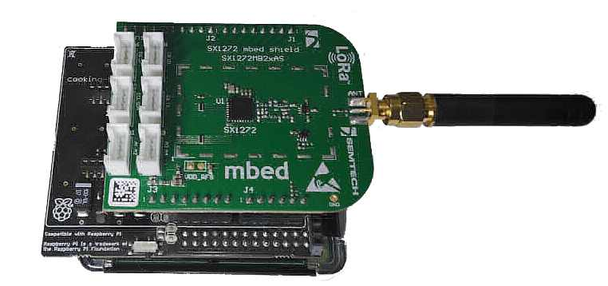
Fig. 1.
  - Data
  - Results

- Conclusions

Based on the purpose of the project, it is required that all the nodes belonging to the network have the possibility of obtaining the information of each node of the network in an offline environment (Ethernet), we look for a topology that allows the transmission of information between the different nodes of the network which It allows each of the nodes to have all the network information for processing and that the user can have access to that information in every one of the nodes.

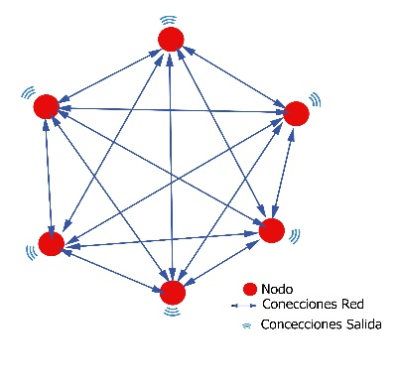
Fig. 2. Network topology
It is proposed that each node of the network can be a hub that designates from which node it wants to request the information (polling) thus crossing all the nodes of the network, and at the end of the list of available nodes, pass the control of the network to another node. Thus being based on a network with a mesh connection, with the possibility of centralizing information as you would a star-connected network, making a network like showed in figure 2.

To make the network we used de module SX1272, it was carried out by means of an adapter, which allows direct control by means of the SX1272 library designed for Arduino, so it is necessary to implement the arduPi in the raspberry pi that allows to use Arduino libraries based on the documentation [11]

It is taken as the central node and is responsible for polling the other nodes of the network, through the SX1272, which has several functions for the transmission of information in this case, the "sendPacketTimeoutACK" function was used where a packet is sent and a confirmation is expected by means of an AKC for a certain time. At the time of polling, the message indicating that it expects to receive information from the node, in case of not finding a response from the node in the stipulated time, the polling will proceed to the next node in the network until it travels the other nodes in the net, at the end of the polling it is sent a message “b” to the next node available on the net, thus establishing itself as the new hub point of the network.

To evaluate the function of the net there are made some prove with different configurations on Number of Symbols, Bandwidth, Diffusion Factor and Data Rate knowing that’s those variable depends on each other in the table 2 we see the different configurations to the nodes.

Bandwidth | Spreading Factor | Bit Rate | S/N
125 KHz | 12 | 366.21 | -20dB
125 KHz | 7 | 6835.93 | -7.5dB
500 KHz | 12 | 1464.84 | -20dB
500 KHz | 7 | 27.343.75 | -7.5dB
Table 2. Configurations by node of the LPWAN

References
- Satir, O., Berberoglu, S., & Donmez, C. (2016). Mapping regional forest fire probability using artificial neural network model in a Mediterranean forest ecosystem. Geomatics, Natural Hazards and Risk, 7(5), 1645-1658. Author, F.: Article title. Journal 2(5), 99–110 (2016).
- Ordoñez, B., & Yamiith, C. (2017). Implementación de una Red de Sensores Inalámbricos LPWAN Mediante Módulos LoRa para el Monitoreo de la Calidad del Agua en 2 Ríos.
- Krupka, L., Vojtech, L., & Neruda, M. (2016, December). The issue of LPWAN technology coexistence in IoT environment. In 2016 17th International Conference on Mechatronics-Mechatronika (ME) (pp. 1-8). IEEE.
- Pham, C., Ferrero, F., Diop, M., Lizzi, L., Dieng, O., & Thiaré, O. (2017, June). Low-cost antenna technology for LPWAN IoT in rural applications. In 2017 7th IEEE International Workshop on Advances in Sensors and Interfaces (IWASI) (pp. 121-126). IEEE.

- Author, F., Author, S.: Title of a proceedings paper. In: Editor, F., Editor, S. (eds.) CONFERENCE 2016, LNCS, vol. 9999, pp. 1–13. Springer, Heidelberg (2016).
- Author, F., Author, S., Author, T.: Book title. 2nd edn. Publisher, Location (1999).
- Author, F.: Contribution title. In: 9th International Proceedings on Proceedings, pp. 1–2. Publisher, Location (2010).
- LNCS Homepage, http://www.springer.com/lncs, last accessed 2016/11/21.

