Bridge

Abstract
This document describes the goals and design of the component we are calling “bridge”.

Main Purpose
The bridge is a service that needs to be installed locally in all IDT factories, its main purpose is to manage the communication with printers assuming that those printers can:
- Accept a direct TCP connection, or
- Print PDFs directly through the OS

TCP/IP bridge
The bridge can be configured to connect to any printer that can accept a direct TCP connection (IP/port). For each printer (or end point) configured in this way, the bridge will create a connection to the device using TCP. The bridge will also connect to the Print platform using Web Sockets and process commands sent by the server.
Each printer configured in the bridge requires the following pieces of information:
- A locally unique DeviceID and name for each printer
- The IP and Port of the device we will connect to.
- A flag indicating if the printer can accept RAW TCP connections or not.
- A device driver, which will be used in the Print platform to instantiate the appropriate objects to handle communication with the printer.

Overall architecture
The following diagram depicts the role the bridge service plays in the Print platform.
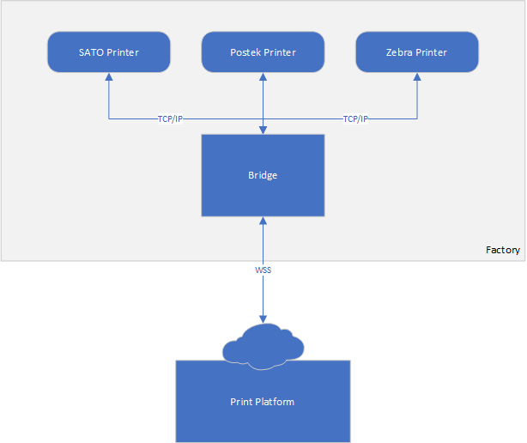

Bridge configuration
The bridge will have no UI and will be configured in its entirety through a json file with the following structure:
{
“Uri”: “wss://print.smartdots.es/bridge”,
“Printers”: [
{
“DeviceID”: “PrinterA”,
“Name”: “Printer name”,
“IP”: “192.168.11.152”,
“Port”: “9100”,
“IsRaw”: “true”,
“Driver”: “[PrinterControllerClassName]”
},
{
“DeviceID”: “PrinterB”,
“Name”: “Printer name”,
“IP”: “192.168.11.153”,
“Port”: “9100”,
“IsRaw”: “false”,
“Driver”: “[PrinterControllerClassName]”
},
…
]
}

- DeviceIDs is used by the Print Server to send commands to specific printers.
- Name MUST match the name with which the printer is registered in the system (from the printer dialog)
- IP and Port are only required if the printer accepts raw TCP connections (such as SATO, Postek or Zebra for instance). This information is used by the bridge to connect to the printer.
- IsRaw specifies if the printer can accept direct TPC connections (true); or if we should interact with the printer exclusively through the OS and the printer queues (false).
- Finally, Driver must contain the name of the driver that should be instantiated to handle communication with the printer. Basically, each type of printer might have a different driver class. This is required to account for differences in how printers will actually print/encode labels.

Bridge Protocol
This section describes the messages that can be exchanged between the Print platform and the Bridge service. New messages might be defined later if needed.
Messages exchanged between the server and the bridge have the following general structure:
RQID;OpCode[;Target][;Arguments]<CR><LF>
[Content]
Where:
- RQID MUST be a number that is automatically incremented on each request sent. It is used to associate responses with its original message. NOTE: It can also be 0, in which case it means that no response message is expected.
- OpCode is the action (or command) to execute.
- Target is optional unless the opcode involves a command for a specific printer. If present, it must be a valid DeviceID indicating which printer should the command be executed on, or from which printer a message comes from.
- Arguments is a comma delimited list of values that varies depending on the opcode being executed. In most cases this is empty.
- Semicolons between each component of the message are required even if the component itself is empty.
- The <CR><LF> characters (Carriage Return and Line Feed) must be used to separate the message header from its content. These characters must be present even if the content is empty.
- Content is optional, its meaning depends on the OpCode being executed. If present it can be either a byte array encoded as a Base64 string, or an object serialized as json.
- All messages are assumed to be text using UTF-8 encoding.

Each message received by either side of the connection will be processed and then in some cases a response message might be sent back to the other end to ensure request was processed correctly.
Receiving any message that does not conform to the specification of this protocol will cause the connection to be closed by the end that received the invalid message.
Example:
The server can send a raw message to a printer by sending the RAW opcode:
34;RAW;PrinterA;<CR><LF>
[Content]
The bridge will receive and process this message, sending the [Content] to PrinterA as a raw message. Then after doing so, it will return a response back with the result of the operation ensuring that the RQID matches the one received in the request.

Response opcode (RES)
The RES opcode is used as the response to a previously received request. The RQID and Target will correspond with the ID and Target specified in the original request. The content of the response message will always be a json object as shown in the example below.
Response message example:
34;RES;PrinterA;<CR><LF>
{
“Success”: “true”,
“Message”: “Raw message sent”,
“Data”: null
}

As can be seen in the example, all response messages include: The RQID of the original command (34 in this example), the RES opcode, the Target received in the original command (PrinterA in this example), Arguments are always empty, Content will always be a json object with the following properties:
- Success, a boolean indicating if the operation was completed successfully or not.
- Message, which in case of error might contain a description of the error found, or in case of success it might simply contain a description of the action taken. It can also be an empty string or null.
- Data, which will be a base64 string that once decoded will be another json object. The properties found in this object will depend on the opcode that was executed by the original request message. This will usually be null unless the opcode executed generates some data.

Send Raw Command (RAW)
This command allows to send arbitrary content to a printer that accepts TCP connections. It does not use any input arguments and the content must be a base64 string containing the byte array that will be sent to the printer.
This base64 string is first decoded into a byte array by the bridge, and then sent raw to the printer, no interpretation or filtering of the content is attempted. The printer specified in Target must be configured as RAW, otherwise the command will fail.

Example request:
90;RAW;PrinterA;<CR><LF>
Content

Example response:
90;RES;PrinterA;<CR><LF>
{
“Success”: “true”,
“Message”: “Raw message sent”,
“Data”: null
}

The response generated by this opcode does not include any data. You should only check for the value in the Success flag to determine if the message was delivered to the intended printer or not.
This response indicates only that the raw message was delivered to the printer, it will not include any message generated by the printer in response. In general, messages generated by the printer are sent to the server using the PMSG opcode.

Printer Message (PMSG)
If a printer sends anything to the bridge, the bridge will forward all the data received to the server using a PMSG opcode. The server is not expected to send any response back, that is why the RQID in this type of message is always 0. Target is the DeviceID of the printer that generated the message, Arguments will be empty, and content will be a base64 string representing the data received from the printer (as binary).
Example:
0;PMSG;PrinterA;<CR><LF>
Content

Printer on status (PRNON)
A printer on status message is sent by the bridge whenever the online/offline state of a printer is updated.
Example:
0;PRNON;PrinterA;true|false<CR><LF>

Like with most messages originating from the Bridge, the RQID is 0, meaning that we do not expect to receive a response back from the server.
The Target is the DeviceID of the printer whose status has changed, Arguments will be either true or false depending on if the bridge is connected to the printer or not.

Bridge Registration Message (REG)
This message is sent by the bridge to the Server when the WebSocket connection is first stablished. You can think of this message as a handshake between the bridge and the server.
Example:
0;REG;;<CR><LF>
Configuration
RQID is 0, meaning we do not expect any response back from the server. Target and Arguments are empty.
Configuration is basically the json file containing the bridge configuration we defined before. Which contains the information of all registered printers.
The server will process this message and if the Key supplied within the configuration matches the key in the server, then the connection will be accepted. If the Key is not present or does not match what is expected by the server, the connection will be closed right away by the server.

Printer Configuration Update (CFGUPD)
This message can be sent by the server to update the configuration of a printer connected to the bridge.
Example:
54;CFGUPD;PrinterA;[Add|Edit|Delete]<CR><LF>
[Printer configuration]
In this case, Target indicates the printer whose configuration will be updated. Arguments indicate if the printer is being added, edited or deleted. While the printer configuration is a json string with the following format:
{
“DeviceID”: “PrinterB”,
“Name”: “Display name”,
“IP”: “192.168.11.153”,
“Port”: “9100”,
“IsRaw”: “true”,
“Driver”: “[PrinterControllerClassName]”
}

Response example:
54;RES;;<CR><LF>
{
“Success”: “true”,
“Message”: “Printer configuration updated”,
“Data”: null
}

Enqueue PDF (QPDF)
This opcode can be used to request the bridge to enqueue a PDF to be printed on the specified device.
Example:
63;QPDF;PrinterA;https://print.smartdots.es/printerjobs/pdf/123<CR><LF>
This opcode does not require any content. Target (PrinterA in this example) must be the DeviceID of the printer. Arguments must contain the URL from which the document to print should be downloaded.
The Bridge will download the requested document and enqueue it on the specified printer.
Response example:
63;RES;PrinterA;<CR><LF>
{
“Success”: “true”,
“Message”: “PDF enqueued for printing”,
“Data”: null
}

NOTE: Additional commands will be added as needed.

