**LINUX COMMAND PRACTICE**

**MANAGING DIRECTORIES**

1. Change the current directory to /home/

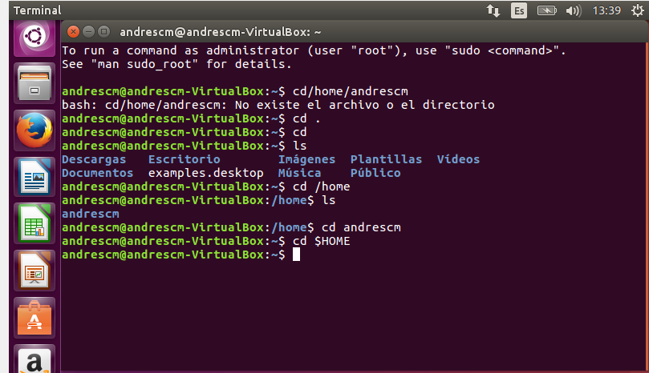

1. Create a directory called systems

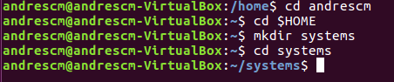

1. Create a directory called exercises. Go to this directory and create another new directory called programming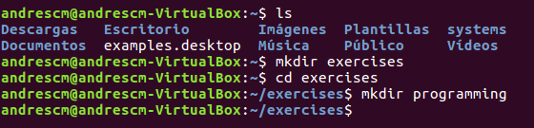
2. Go back to the user’s home directory. Delete the directories “exercises” and “programming” using just one command. Create the directories again with one command.



1. Print the contents of the root directory

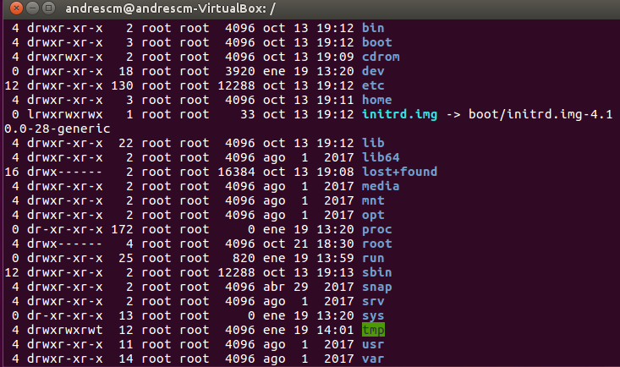

1. Print all the files and directories that begin with d in the /usr/bin directory 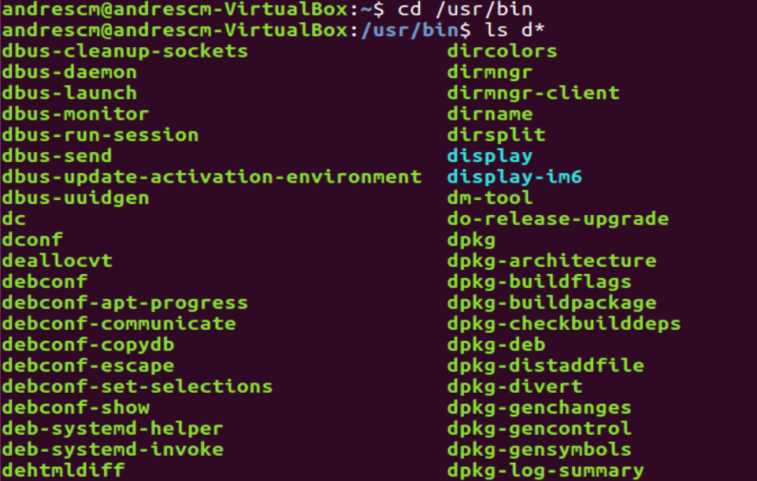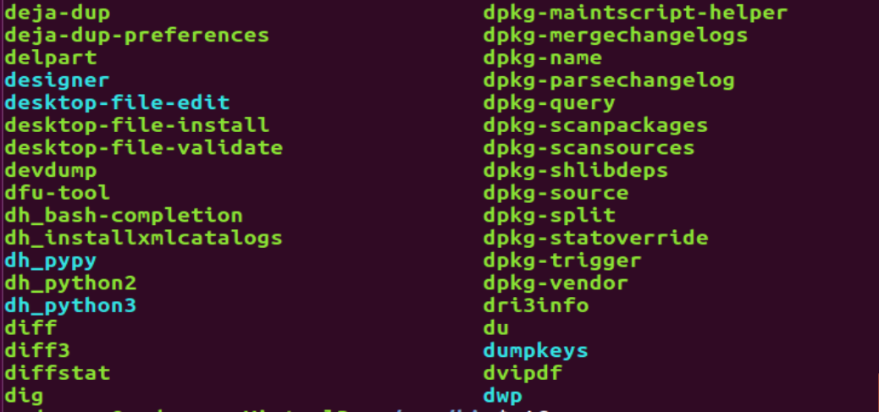
2. List all the files and directories in /etc, including subdirectories

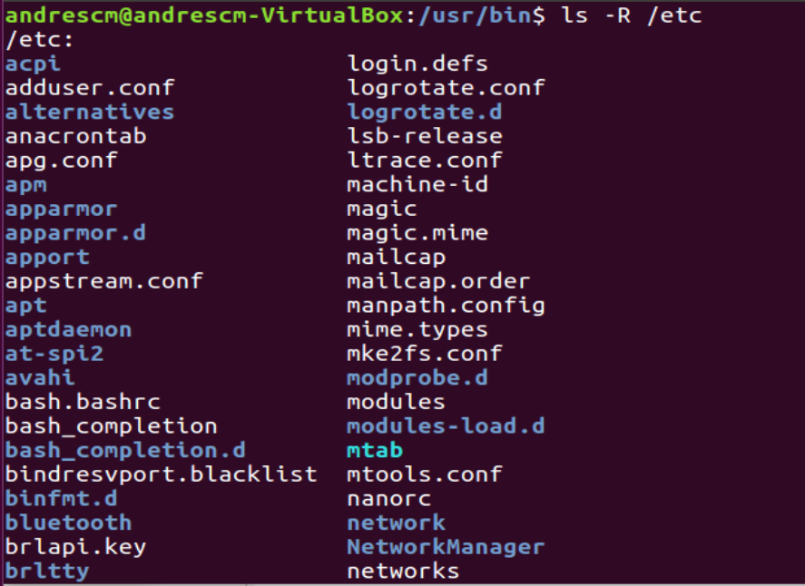

(This have a lot of lines below)

1. Create the empty files called student.txt, student1.txt, student2.txt, list, luggage and last in the directory named “systems”

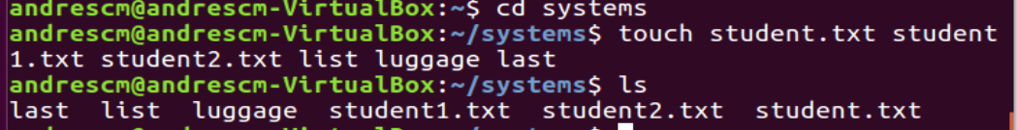

1. Print all the files that begin with “l” in the directory “systems”



1. . Print all the files that end with “txt” in the directory “systems” 
2. Create a new directory into $HOME called “config” 
3. Copy all the files in /etc which begin with “a” into “config” 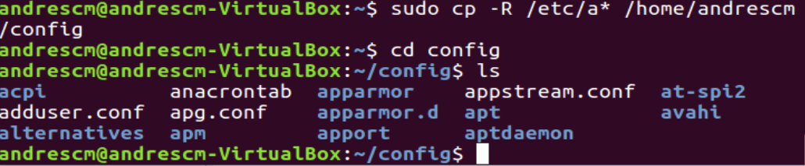
4. Delete all the files in “config” which end with “conf” 