**Biomimetic Mechatronic Hand**

Revision -.2

|  |  |
| --- | --- |
| Nilheim Mechatronics | Will Cogley |

**Table of content**

1. List of figures I

2. List of tables I

3. History 1

4. Abstract 3

5. Mechanical 3

5.1. Overview 3

5.2. Mechanical map 3

6. Electrical 3

6.1. Overview 3

6.2. Pinout 3

# List of figures

# List of tables

Table 1 – Revision history 2

Table 2 – Electrical Pinout 4

# History

*Revision naming convention: (X.Y), X: major update, Y:minor update*

|  |  |  |
| --- | --- | --- |
| **Name** | **Changes** | **Rev** |
| Olivier Morin-Lupien | Initial release | -.1 |
| Will Cogley | Added mechanical map | -.2 |
|  |  |  |
|  |  |  |
|  |  |  |
|  |  |  |
|  |  |  |
|  |  |  |
|  |  |  |
|  |  |  |
|  |  |  |
|  |  |  |
|  |  |  |
|  |  |  |
|  |  |  |
|  |  |  |
|  |  |  |

Table 1 – Revision history

# Abstract

The purpose of this document is to establish a common groundwork between mechanical and electrical teams. This document shall remain nothing but a high-level overview of the project. The first part shall consist of a brief description of the different mechanical parts whereas the following part shall describe the required electrical connections and their respective types. This control document will facilitate the development for the software team. For more in depth information on the design, different documents will be created: (Not yet released)

# Mechanical

## Overview

## Mechanical map

Table 2 shows the ranges of motion in the various joints of the bionic hand. Figure 1 shows the physical locations of the joints in the hand.

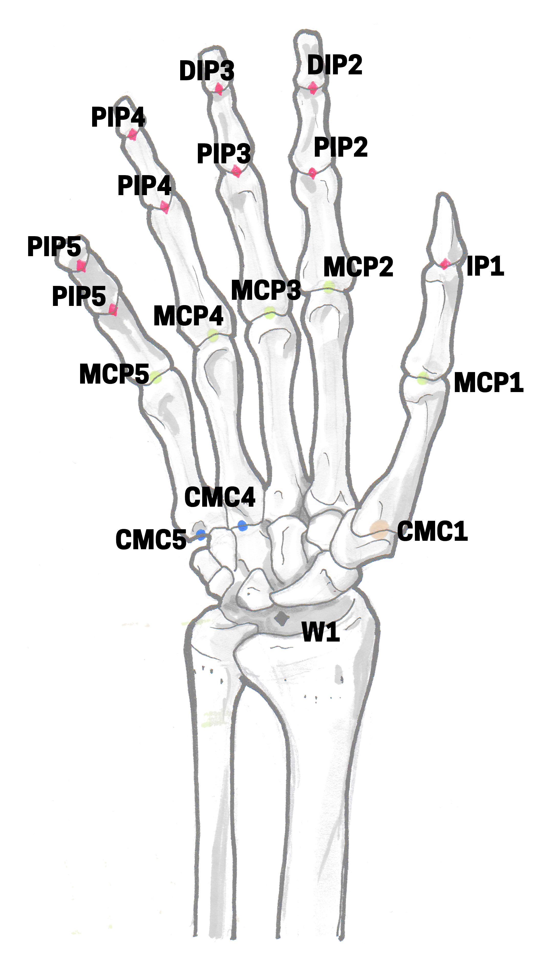

Figure 1 - Joint locations in the hand

|  |  |
| --- | --- |
| **Name** | **DOF** |
| PIPs, DIPs, IP | 1 |
| MCPs | 2 |
| CMC1 | 2/3 TBC |
| CMC4 + CMC5 | 1 (Mechanically linked) |
| W1 | 2 |

Table 2 - Ranges of motion in the hand's joints

# Electrical

## Overview

This section will mainly focus on the electrical requirements and pinouts concerning software and mechanical. Another document will be created to describe the electrical system in depth (Schematics, power requirement, calculations).

## Pinout

*Naming convention: Location_DescriptiveName_Type. For locations refer to the mechanical map*

|  |  |  |  |
| --- | --- | --- | --- |
| **Pin name** | **Type** | **Location** | **Description** |
| Ex: MCP_pos_sensor | Ex: Analog 0 to 5V | Ex: MCP-1 | Analog feedback signal proportional to the angle of the joint |
|  |  |  |  |
|  |  |  |  |
|  |  |  |  |
|  |  |  |  |

Table 3 – Electrical Pinout