Learning activity 3 / Actividad de aprendizaje 3

Evidence: Cell phones for sale / Evidencia: Celulares a la venta

Read the description of the two cell phones that are for sale. Then write ten comparisons. / Lea la descripción de dos teléfonos celulares. Luego escriba diez comparaciones entre ellos.

Silver X100 | Titanium Z1
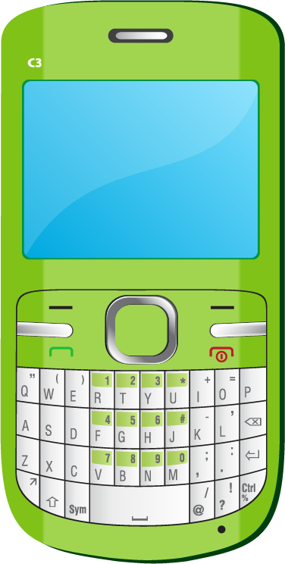 | 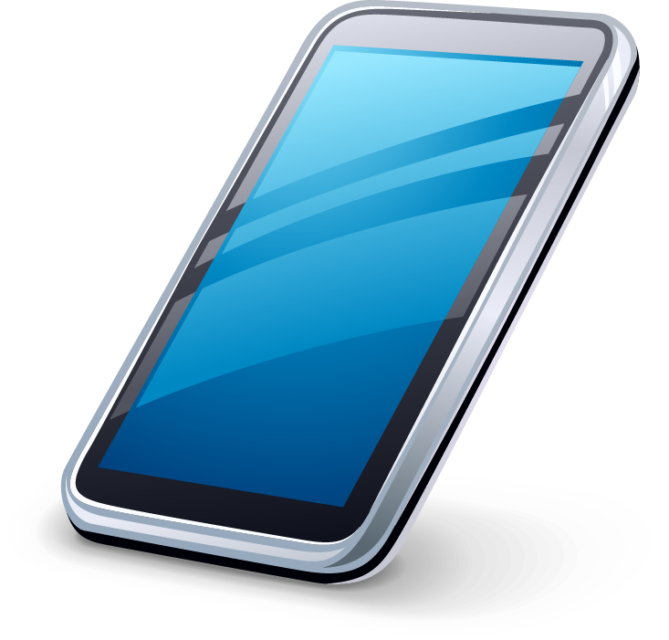
This new smartphone weighs 145 grams. It is 14 cm wide and 7.5 centimeters long. It has an Android operating system. It is water and dust resistant. The screen is 5.1 inches wide and the resolution is 1060 x 1900 pixels. It has a multi-touch screen. It has a light sensor, proximity sensor, and scratch-resistant glass. It has a 16 megapixel camera. The system memory has 2048 MB RAM and the built-in storage memory is 32 GB. You can talk for 20 hours and the battery stays charged. | The Titanium Z1 weighs 135 grams. It is 10 cm wide and 13 centimeters long. It has an Android operating system. It is water resistant. The screen is 3.8 inches wide and the resolution is 860 x 1200 pixels. It has a multi-touch screen. It has a light sensor and scratch-resistant glass. It has a 13 megapixel camera. The system memory has 1048 MB RAM and the built-in storage memory is 32 GB. You can talk for 10 hours and the battery stays charged.

Fuente de imágenes: SENA

Example / Ejemplo:

Titanium Z1 is not as heavy as Silver X100. / Titanium Z1 no es tan pesado como el Silver X100.

As … as
1. Titanium Z1 is as water resistant as Silver X100
2. Silver X100 is as storage memory as Titanium Z1
3. Silver X100 is as multi-touch scream as Titanium Z1
4. Silver X100 is as light sensor as Titanium Z1
5. Silver X100 is as scratch-resistant glass as Titanium Z1
Less … than - not as … as
1.Titanium Z1 is less weight than Silver X100
2.Titanium Z1 is not as dust resistant as Silver X100
3. Titanium Z1 camera’s is less resolution than Silver X100
4. Titanium Z1 battery’s is less durability than Silver X100
5. Titanium Z1 resolution is not as high as Silver X100

When you finish your work, send the file to your instructor through the platform as follows:

- Click the title of this evidence.
- Click Examinar mi equipo and look for the file in your computer. Make sure the file is attached.
- Leave a comment for the instructor (optional).
- Click Enviar.

Una vez finalice la evidencia envíe al instructor el archivo a través de la plataforma, así:

- Dé clic en el título de esta evidencia.
- Dé clic en el enlace Examinar mi equipo y busque el archivo en su
computador. Asegúrese de adjuntar el archivo.
- Escriba algún comentario si lo considera pertinente.
- Dé clic en Enviar.

Note: This evidence is an individual activity. Remember to check the learning guide in order to know if you have done all the assigned activities, know how to develop them and deliver them correctly.

Nota: Esta evidencia es de carácter individual. Recuerde revisar la guía de aprendizaje con el fin de verificar que ha realizado todas las actividades propuestas, saber cómo desarrollarlas y entregarlas correctamente.

Criterios de evaluación
Compara aparatos tecnológicos teniendo en cuenta la estructura gramatical, vocabulario y contexto requerido.

