Architecture Document
Role Dictionary Review App
Role Dictionary review application (control ITGC.LA.05)
Node.js · Express 5 · Google Cloud Run · Firestore · Cloud Storage · IAP
Date: June 11, 2026 · Version 1.1

1. Executive summary
Role Dictionary Review App is a web application built with Node.js and the Express framework that supports the Role Dictionary review process. The application serves a static frontend, reads its source data (roles, approvers and permissions) from Excel files, records review submissions and exposes administration pages for the audit log (Admin Log) and admin user management.
The design follows a layered monolithic architecture: a single Express service serves both the static content and a JSON REST API. Authentication is delegated to Google Cloud Identity-Aware Proxy (IAP). Persistent state is stored in Google Firestore, and the source Excel files are served from a versioned Google Cloud Storage bucket so they can be updated without redeploying the application.
Main features:
- Approver identification from the approver list.
- Administrator and Technical Support access (protected accounts).
- Business role review table with a permission acknowledgement workflow.
- Role rejection workflow with a mandatory rejection reason.
- Client-side PDF generation for the outcomes (keep / modify / reject).
- Admin Log with filters, CSV export, and RITM number/status editing.
- Admin user management page with protected Technical Support accounts.

2. Architecture overview
The solution is organized in four logical layers, summarized in Figure 1: (1) the users and their browser; (2) the Google Cloud IAP authentication gateway; (3) the Cloud Run container running the Express server with its frontend, in-memory data and persistence layer; and (4) the data sources — a versioned Cloud Storage bucket for the source Excel files and Firestore for persistent state.
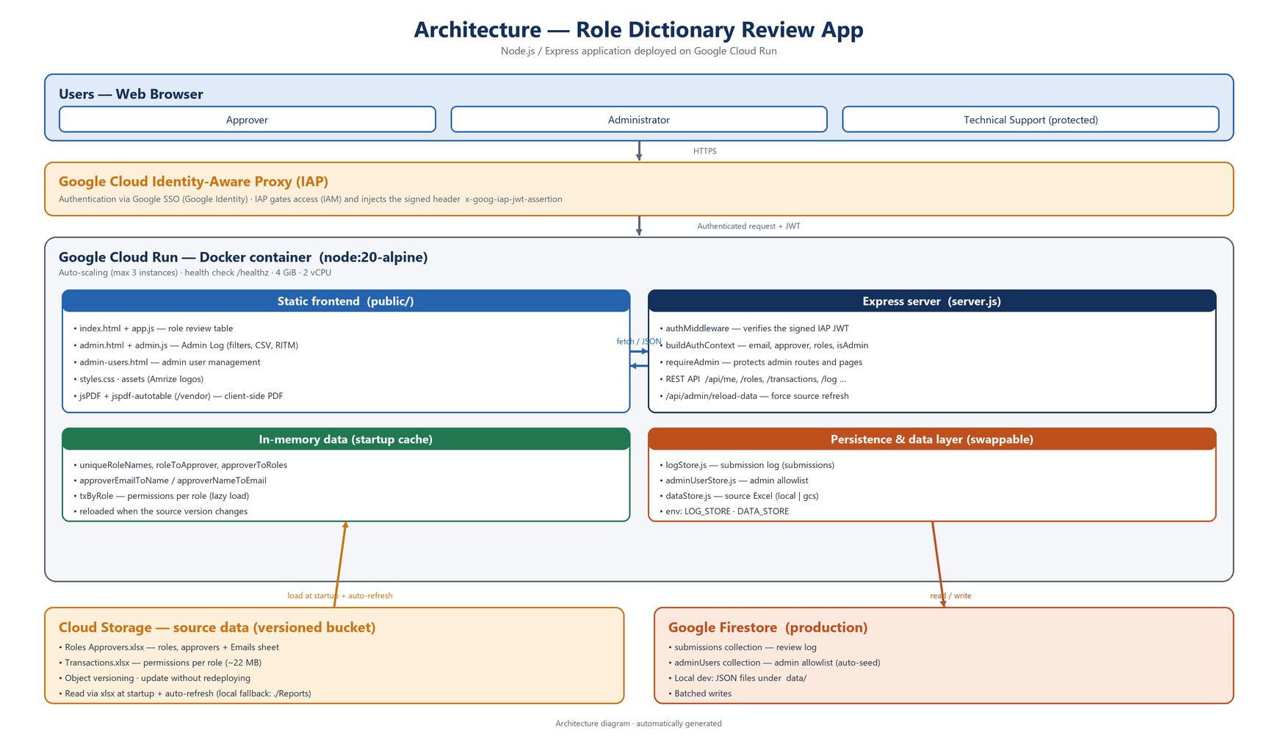
Figure 1. Layered architecture of Role Dictionary Review App.
Design principles:
- Layered monolith. A single Node process serves frontend + API, which keeps deployment and operations simple.
- Stateless container. Source data is read-only and persistent state lives in Firestore, so the service scales horizontally on Cloud Run.
- Swappable persistence & data layer. Storage is abstracted behind common interfaces and selected by configuration (file/firestore for state, local/gcs for source data).
- Security delegated to the edge. Identity is guaranteed by IAP; the server only verifies the signed JWT and applies role-based authorization.
- Externalized, versioned source data. Excel files live in a Cloud Storage bucket and are refreshed automatically, so updating data does not require a redeploy.

3. Runtime architecture
Figure 2 details the runtime flow and the GCP services involved at run time. An end user reaches the service through Cloud IAP, which delegates authentication to Google SSO, enforces its IAM access policy and injects a signed JWT. Cloud Run runs the container that serves the frontend and the REST API; the Express server verifies the JWT, reads/writes review state in Firestore, and loads the source Excel files from Cloud Storage at startup and on a periodic refresh.
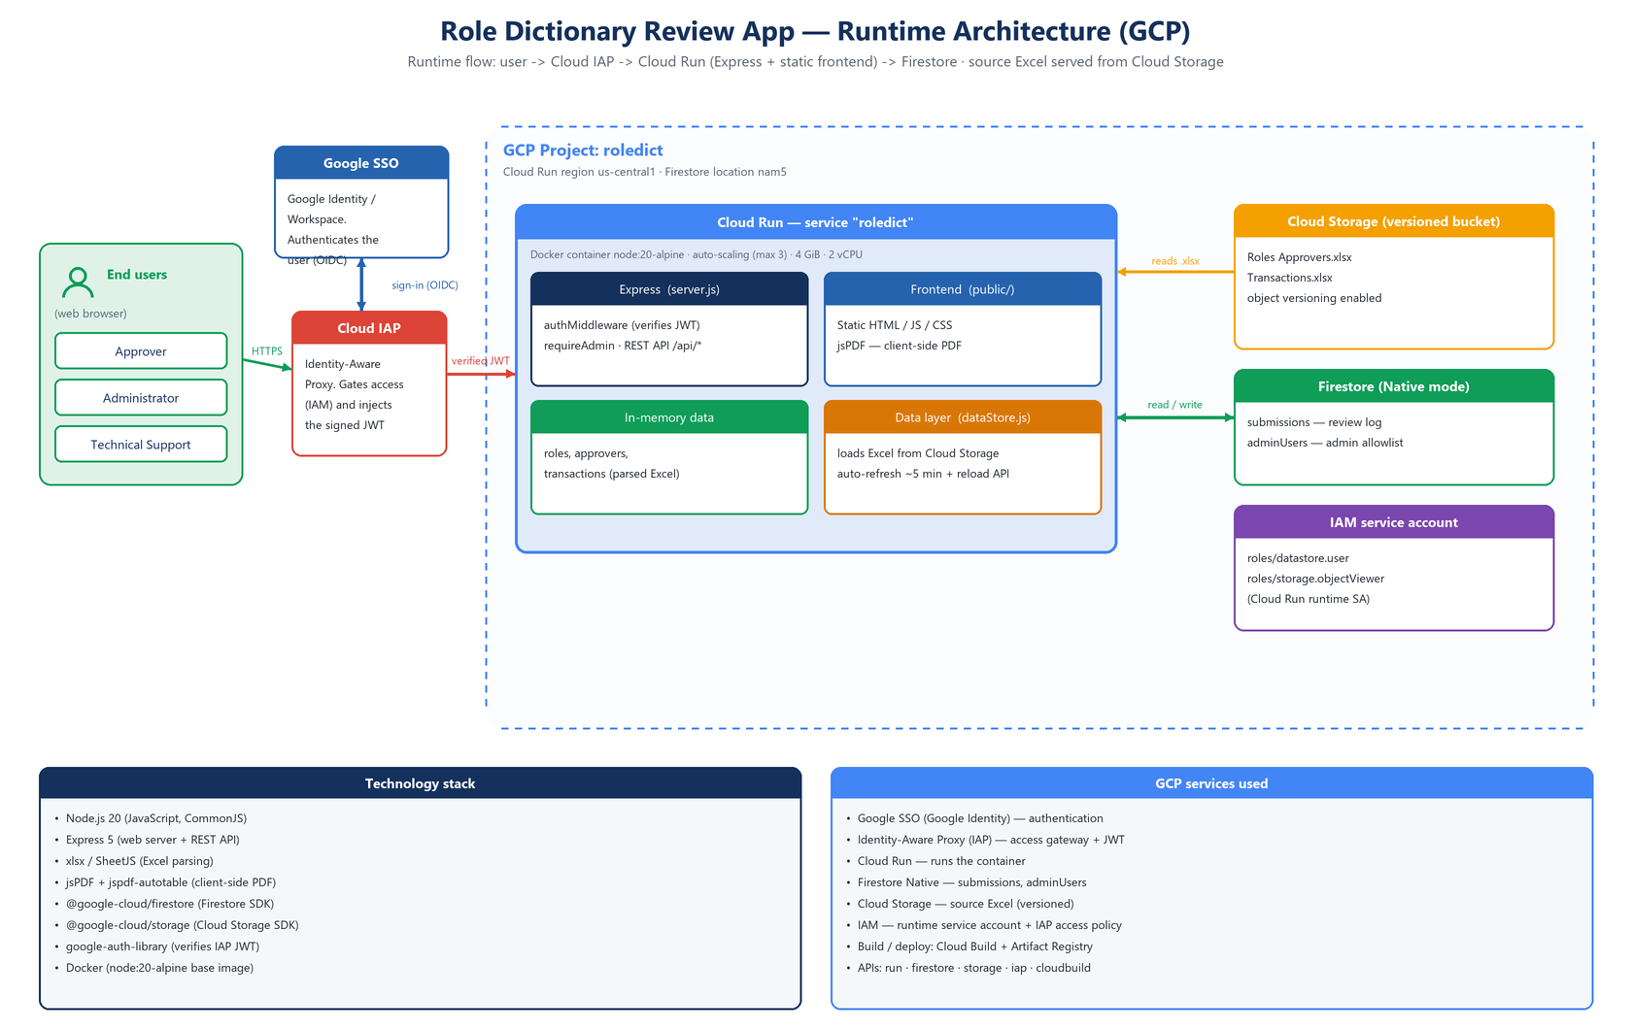
Figure 2. Runtime architecture and GCP services.

4. Main components

4.1 Static frontend (public/)
The frontend is a set of HTML pages, browser JavaScript and stylesheets served as static files by Express. There is no SPA framework; each page consumes the REST API via fetch.
- index.html + app.js — main role review table, permission and rejection modals, and the submission flow.
- admin.html + admin.js — Admin Log with filters, CSV export, and RITM number/status editing.
- admin-users.html + admin-users.js — adding and removing admin email addresses.
- styles.css and assets/ — styles and visual identity (Amrize logos).
- jsPDF + jspdf-autotable — served from /vendor; generate the outcome PDFs directly in the browser.

4.2 Application server (server.js)
The Express server is the core of the application. On startup it loads the roles and approvers, registers the authentication/authorization middleware, serves the static content and exposes the REST API. The large transactions workbook is loaded in the background after the server starts listening, so the /healthz health check responds immediately on Cloud Run.
- authMiddleware — builds the per-request auth context; returns 401 without identity and 403 if the user is not authorized. /healthz is exempt.
- buildAuthContext — resolves email, approver name, assigned roles and admin status.
- requireAdmin / requireAdminPage — protect admin endpoints and the admin.html and admin-users.html pages.
- REST API — JSON endpoints under /api/* (see section 6).

4.3 Authentication and authorization
In production, identity and access are handled across three complementary layers: Google SSO authenticates the user, Cloud IAP gates access to the service, and the application enforces fine-grained role-based authorization.
- Google SSO (authentication). Google Identity / Workspace single sign-on verifies the user's identity and issues an OIDC identity token. It is the identity provider that IAP delegates authentication to.
- Cloud IAP (access gateway). IAP sits in front of Cloud Run and intercepts every request. If the user is not yet authenticated it redirects them to Google SSO; once signed in, it enforces a coarse-grained, IAM-based access policy (only principals granted the IAP-secured Web App User role may reach the service) and forwards the request with the signed x-goog-iap-jwt-assertion header carrying the verified email.
- Application JWT verification. The server validates the IAP token signature with the IAP public keys (google-auth-library) and checks the expected audience (IAP_JWT_AUDIENCE) and issuer before trusting the identity.
- Application role-based authorization. The verified email is mapped to an application role — approver (email present in the Emails sheet) or administrator (email in the allowlist) — and roles, transactions and admin operations are restricted accordingly. Approvers only access their own roles; administrators can impersonate an approver (?impersonate= query parameter).
- Development mode. Locally IAP is bypassed and identity comes from the DEV_AUTH_EMAIL variable, which lets you simulate an approver, an administrator or an unauthorized user.
In short: Google SSO answers “who are you?”, Cloud IAP answers “are you allowed to reach this application?”, and the application answers “what can you do inside it?”.

4.4 In-memory data
The source data is parsed from the Excel workbooks with the xlsx library and kept in in-memory structures for fast access. It is parsed once at startup and re-parsed only when the source version changes (see section 5).
- Roles Approvers.xlsx — Complete sheet (or the first one): column A = role, column D = approver name. The Emails sheet maps email address to approver full name.
- Transactions.xlsx — permissions/transactions per role (~22 MB). Header labels are renamed for display (Role Name → Business Role, Associated Role → Technical Role, etc.) and the workbook is loaded in the background.

4.5 Persistence layer
Persistence is abstracted into two modules that share the same async interface, each with a file backend and a Firestore backend. The backend is selected with the LOG_STORE environment variable (file by default locally; firestore on Cloud Run).
- logStore.js — review submission log. FileLogStore writes to data/submissions.json; FirestoreLogStore uses the submissions collection with batched writes (up to 450 per batch). Methods: appendEntries, readAll (filtered, newest-first), updateRitm, updateRitmStatus.
- adminUserStore.js — admin allowlist. FileAdminUserStore uses data/admin-users.json; FirestoreAdminUserStore uses the adminUsers collection and seeds the default admins if empty. Protected Technical Support accounts cannot be removed.

5. Source data and automatic refresh (Cloud Storage)
The source Excel files are served through a dedicated data layer (dataStore.js) that follows the same factory pattern as the persistence modules. The backend is selected with the DATA_STORE environment variable:
- DATA_STORE=local (default) — reads the files from ./Reports. Used for local development and as an in-image fallback.
- DATA_STORE=gcs — reads the files from a versioned Google Cloud Storage bucket. Recommended for production.
Each Cloud Run instance periodically re-checks the store and reloads the in-memory data automatically, so updating the data is as simple as uploading the file to the bucket — no redeploy is required:
- Change detection. The lightweight getVersion() reads the object metadata (GCS generation, or the file mtime locally) and a workbook is only re-downloaded when its version actually changed — the ~22 MB Transactions file is not fetched on every check.
- Periodic refresh. Controlled by DATA_REFRESH_SECONDS (default 300 s; 0 disables it). Each instance becomes consistent within that window.
- On-demand reload. An administrator can POST /api/admin/reload-data to force an immediate reload instead of waiting for the next refresh.
- Versioning. Object versioning is enabled on the bucket, so previous versions of each file are retained.
Relevant environment variables:
Variable | Default | Purpose
DATA_STORE | local | Source backend: local or gcs.
DATA_BUCKET | — | Bucket name (required when DATA_STORE=gcs).
DATA_PREFIX | (empty) | Optional folder/prefix inside the bucket.
ROLES_FILE_NAME | Roles Approvers.xlsx | Roles/approvers file name.
TX_FILE_NAME | Transactions.xlsx | Transactions file name.
DATA_REFRESH_SECONDS | 300 | Re-check interval per instance (0 disables).

6. REST API
All endpoints (except /healthz) go through the authentication middleware. Those marked Admin additionally require administrator privileges.
Method | Path | Access | Description
GET | /healthz | — | Health check for Cloud Run (no authentication).
GET | /api/me | User | Current identity: email, approver, roles and isAdmin.
GET | /api/approvers | User | Approver list (all if admin; own otherwise).
GET | /api/roles | User | Roles for the user or for a given approver.
GET | /api/approver | User | Approver assigned to a role (vlookup-style).
GET | /api/transactions | User | Permissions/transactions for a role.
POST | /api/transactions/bulk | User | Transactions for several roles (PDF annex).
POST | /api/log | User | Records a review submission (generates submissionId).
GET | /api/log | Admin | Reads the log with filters (approver, action, role).
PATCH | /api/log/:id/ritm | Admin | Updates the RITM number of an entry.
PATCH | /api/log/:id/ritm-status | Admin | Updates the RITM status (Open/Resolved/…).
GET | /api/admin-users | Admin | Lists admins and protected admins.
POST | /api/admin-users | Admin | Adds an admin email address.
DELETE | /api/admin-users/:email | Admin | Removes an admin (not the protected ones).
POST | /api/admin/reload-data | Admin | Forces an immediate reload of the source Excel data.

7. Main flows

7.1 Sign-in and authorization
The browser requests the page; IAP authenticates and injects the JWT. The frontend calls /api/me: the server verifies the token, resolves the context (approver/admin) and returns the identity. Unauthorized users receive 401/403 and an access-denied page.

7.2 Review and submission
The approver reviews their roles; for each role they open the permissions modal and must explicitly acknowledge the full list. They choose an action (keep or modify the business/technical role) or reject the role with a mandatory reason. On submit, the client POSTs to /api/log; the server validates that the roles belong to the approver, generates a 6-digit submissionId and a logEntryId per row, and persists the entries. The outcome PDF is then generated in the browser with jsPDF.

7.3 Administration (Admin Log and users)
The administrator opens Admin Log (GET /api/log) with filters and CSV export, and can edit the RITM number and status (PATCH). On the users page they manage the admin allowlist (GET/POST/DELETE /api/admin-users), respecting the protected accounts.

7.4 Updating source data
An operator uploads a new Excel file to the Cloud Storage bucket. Within DATA_REFRESH_SECONDS each running instance detects the new object version and reloads the affected workbook in memory; an admin can also POST /api/admin/reload-data to apply it immediately. No redeploy is needed.

8. Data model
Each review submission produces one or more log entries (one per row/role). Main fields of an entry:
Field | Description
logEntryId | Entry id: submissionId + row index (e.g. 000123-001).
submissionId | Submission id, 6-digit incremental.
timestamp | ISO timestamp of the submission.
approver | Approver the review belongs to.
submittedByEmail | Authenticated email that performed the submission.
impersonated | True if an admin submitted on behalf of another approver.
roleName / action | Reviewed role and chosen action (keep/modify).
ritm / ritmStatus | RITM ticket number and its status (Open by default).
actionDetails / comments | Detail of the requested modification.
rejectionReason | Rejection reason (when applicable).
Firestore collections in production: submissions (log) and adminUsers (allowlist).

9. Deployment and infrastructure
The application is packaged into a Docker image based on node:20-alpine and deployed to Google Cloud Run. The image installs production dependencies and copies the code and the frontend. Deployment is manual via gcloud run deploy --source . (backed by Cloud Build and Artifact Registry); there is no GitLab/GitHub CI pipeline in the repository.
- Google Cloud Run — runs the container in region us-central1 with auto-scaling (up to 3 instances), 4 GiB memory, 2 vCPU, cpu-boost and a 300 s timeout.
- Google Firestore — database (location nam5) for submissions and adminUsers when LOG_STORE=firestore.
- Google Cloud Storage — versioned bucket holding the source Excel files when DATA_STORE=gcs.
- Cloud Build + Artifact Registry — build the image from source and store the container revisions.
- IAP — authentication gateway in front of the service.
- IAM — Cloud Run runtime service account with roles/datastore.user (Firestore) and roles/storage.objectViewer (the data bucket).
First-time setup (deploy/deploy.ps1 -Bootstrap) enables the required APIs (run, firestore, cloudbuild, artifactregistry, storage), creates the Firestore database and the versioned bucket, and grants the runtime service account access to Firestore and the bucket. Thereafter, source data is updated by uploading files to the bucket — no new revision required.

10. Security considerations
- Authentication delegated to IAP with verification of the signed JWT (signature, audience and issuer) in production.
- Role-based authorization: approvers only access their own roles and transactions; the server validates ownership on every operation.
- Admin endpoints and pages protected by requireAdmin.
- Protected Technical Support accounts that cannot be removed from the allowlist.
- Least-privilege IAM: the runtime service account only has datastore.user and storage.objectViewer (read-only on the bucket).
- HTML escaping (escapeHtml) in server-generated responses, and email normalization/validation when managing admins.

11. Technology stack
Layer | Technology
Runtime | Node.js 20 (Alpine)
Web framework | Express 5
Excel parsing | xlsx (SheetJS)
PDF generation | jsPDF + jspdf-autotable (client-side)
Authentication | google-auth-library (IAP JWT verification)
Database | @google-cloud/firestore
Source data store | @google-cloud/storage (versioned bucket)
Container / Cloud | Docker · Cloud Run · Cloud Build · Artifact Registry · Firestore · Cloud Storage · IAP
Testing | Playwright (test-e2e.js)

12. Future improvements
- Harden the administrator identity flow with real SSO for sensitive scenarios.
- Add pagination and indexes in Firestore for the log as its volume grows.
- Broaden automated test coverage (unit and integration) in addition to the Playwright e2e tests.
- Optionally add an admin UI button that calls /api/admin/reload-data to refresh data on demand.

