AMRIZE
Business Requirements Document
Role Dictionary App
Role-review application for SAP business roles and permissions (control ITGC.LA.05).

1 Executive Summary
The Role Dictionary App is a web application that supports the periodic review of SAP business roles and their associated permissions as part of the IT General Controls process (control ITGC.LA.05). It centralizes and standardizes a workflow that was previously handled through spreadsheets and email.
Approvers review the business roles assigned to them, acknowledge the complete set of permissions (transactions) each role grants, and record a decision — keep the business role, modify the business role, modify the technical role, or reject the role with a documented reason. For each review the application produces an auditable PDF and stores a complete submission log that administrators can filter, export and track against remediation tickets (RITM).
The application runs on Google Cloud Run, authenticates corporate users with Google SSO through Identity-Aware Proxy (IAP), stores review records in Firestore, and reads its source data (roles, approvers and permissions) from versioned Excel files in Cloud Storage that can be updated without redeploying the application.

2 Overview

2.1 Business Objectives
- Standardize the role review. Provide a single, guided workflow for the periodic review of SAP business roles and permissions required by control ITGC.LA.05.
- Guarantee permission acknowledgement. Ensure every reviewed role has an explicit, recorded acknowledgement of the full set of permissions it grants.
- Produce audit evidence. Generate a PDF per review and maintain a complete, filterable and exportable submission log for audit.
- Enforce least-privilege access. Authenticate users with corporate SSO and ensure approvers only review the roles assigned to them.
- Reduce manual effort. Replace spreadsheet/email tracking with a centralized application and allow source data to be updated without redeploying.

2.2 Background
The periodic review of SAP roles and their permissions is required by IT General Controls (ITGC.LA.05). The prior process relied on spreadsheets distributed by email: approvers received their assigned roles, reviewed them informally and replied with decisions. This manual, fragmented model had significant limitations:
- No guaranteed acknowledgement. There was no reliable way to confirm that an approver had reviewed the complete permission set of each role.
- Inconsistent capture. Decisions, reasons and remediation references were recorded inconsistently across spreadsheets and mailboxes.
- Manual consolidation. Results had to be aggregated by hand, and audit evidence assembled manually.
- No system of record. There was no centralized, authenticated and auditable record of who reviewed what, when, and with which outcome.
The Role Dictionary App addresses these limitations with a guided, authenticated and auditable workflow backed by a centralized log.

2.3 Stakeholders
Project Role | Stakeholder Name & Title
Sponsor(s) | Lisa Mueller - IT Compliance Director  Steph Greenland - Director, O2C / BPSO Building Envelope
Demand team | Caitlin Ritchie - IT BRM
Functional Leader | Benjamin Otis - IT Compliance Manager
Project Team | Eduar Cantillo - IT Compliance Specialist  Juan Jaramillo - SAP Security Squad Coordinator
Business PM / BA | Andrés Escárraga - BSC PMO
Key Users | Business role approvers / role owners; Tool administrators

3 Scope

3.1 In Scope
- Authenticated web application to review SAP business roles and their permissions (transactions).
- Corporate SSO sign-in through IAP and role-based access (an approver sees only their own roles).
- Per-role permission acknowledgement workflow (mandatory acknowledgement of the full transaction list).
- Decision capture: keep business role, modify business role, modify technical role, or reject with a mandatory reason; with RITM reference and comments.
- Client-side PDF generation of review outcomes as audit evidence for ITGC.LA.05.
- Submission/audit log with filters, CSV export, and RITM number/status tracking.
- Administration: admin user allowlist management and review-on-behalf-of (impersonation).
- Source data (roles, approvers, permissions) read from versioned Excel files that can be updated without redeploying.

3.2 Out of Scope
- Modifying SAP roles or permissions directly — the app records decisions; remediation is executed in SAP via RITM tickets.
- User access provisioning/deprovisioning or SAP user administration.
- Approval routing or workflow orchestration beyond the review submission and logging.
- Integration with ticketing systems beyond recording the RITM reference.
- Maintaining the source of truth of the role/approver data (provided as input Excel files).
- Any Accounts Payable / invoice-processing functionality.

4 Business Process Overview

4.1 Current Business Process (As-Is)
Today the ITGC.LA.05 role review is performed manually. A spreadsheet of business roles and their assigned approvers is distributed by email. Each approver reviews the roles assigned to them — often without a structured view of every permission the role grants — and replies with their decisions and any comments. A coordinator then consolidates the responses, follows up on missing items, and assembles the evidence required for the control. The process is effort-intensive, hard to standardize, and provides limited assurance and traceability.

4.2 Proposed Business Process (To-Be Functional Use Cases)
The application implements the following functional use cases:
- UC-1 Authenticated sign-in. The user reaches the app through IAP, authenticates with Google SSO, and the app resolves their profile (approver and/or administrator).
- UC-2 Review assigned roles. The approver sees the business roles assigned to them in a review table.
- UC-3 Acknowledge permissions. For each role the approver opens the full permission/transaction list and explicitly acknowledges it before continuing.
- UC-4 Record decision. The approver selects keep / modify business role / modify technical role, or rejects the role with a mandatory reason, and adds a RITM reference and comments.
- UC-5 Generate evidence. An outcome PDF is generated for the review.
- UC-6 Submit and log. The submission is recorded with a unique submission identifier, timestamp and the authenticated identity.
- UC-7 Audit (Admin Log). An administrator filters submissions, exports them to CSV, and tracks the RITM number and status.
- UC-8 Manage administrators. An administrator maintains the admin allowlist; protected Technical Support accounts cannot be removed.
- UC-9 Review on behalf of (impersonation). An administrator can review on behalf of a specific approver; the submission is flagged as impersonated.
- UC-10 Update source data. An operator uploads a new Excel file to Cloud Storage and the application reloads it automatically, without a redeploy.

4.3 Components: Architecture & Security
The application is a layered monolith built with Node.js and Express, deployed as a container on Google Cloud Run. A single service serves the static frontend and a JSON REST API. The source Excel data is parsed into in-memory structures for fast access; review state is persisted in Firestore; and the source files are served from a versioned Cloud Storage bucket and refreshed automatically. Figure 1 summarizes the runtime architecture and the Google Cloud services involved.
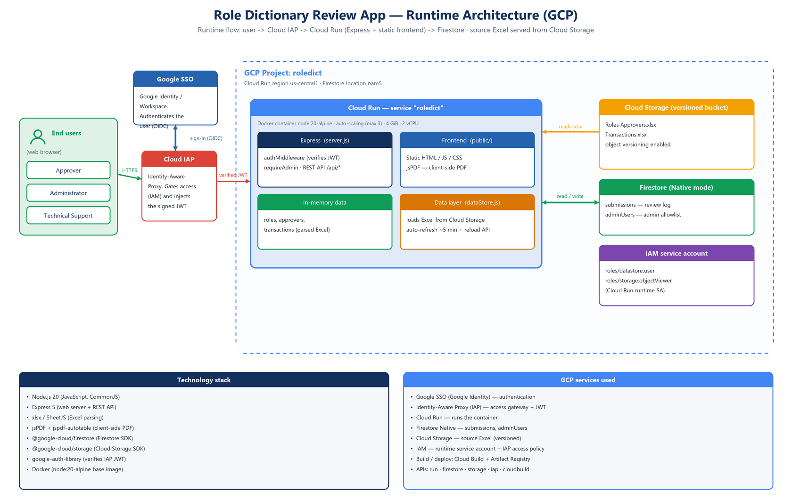
Figure 1. Runtime architecture and GCP services.
Main components:
- Static frontend (public/). Review table, permission and rejection modals, Admin Log and admin-users pages; client-side PDF generation (jsPDF).
- Express server (server.js). REST API, authentication/authorization middleware, and source-data loading/refresh.
- Data layer (dataStore.js). Reads the source Excel from Cloud Storage (or local files) with automatic, version-aware refresh.
- Persistence (logStore.js / adminUserStore.js). Submission log and admin allowlist, backed by Firestore in production.
- Google Cloud services. Cloud Run (compute), Cloud Storage (versioned source data), Firestore (state), Identity-Aware Proxy (access), IAM (least-privilege service account).
Security — three complementary layers:
- Google SSO (authentication). Google Identity / Workspace single sign-on verifies the user's identity and issues an OIDC token. It answers “who are you?”.
- Cloud IAP (access gateway). IAP sits in front of Cloud Run, delegates authentication to Google SSO, enforces an IAM-based access policy (only authorized principals reach the service) and forwards the request with a signed JWT. It answers “are you allowed to reach the app?”.
- Application authorization. The server verifies the signed IAP JWT (signature, audience, issuer) and maps the identity to a role — approver or administrator — restricting roles, transactions and admin operations. It answers “what can you do inside it?”.
- Least-privilege IAM: the runtime service account only reads the data bucket and the Firestore database.
- Protected Technical Support administrator accounts that cannot be removed from the allowlist.
- Server-side HTML escaping and email normalization/validation.

5 Business Requirements

5.1 Process Stakeholders
- Approver — business role owner who reviews the roles assigned to them.
- Administrator — manages the audit log, RITM tracking and the admin allowlist; can review on behalf of an approver.
- Technical Support — protected administrator accounts responsible for technical operation of the tool.
- Compliance / Auditor — consumes the submission log and PDF evidence for control ITGC.LA.05.

5.2 Requirements & User Stories
All application functionalities:
ID | Requirement | User Story | Acceptance Criteria
US#001 | Authentication | As an approver, I want to sign in with my corporate Google account so that only authorized users can access the app. | User authenticated via Google SSO/IAP; unauthorized users see an access-denied page (401/403).
US#002 | Role-based access | As an approver, I want to see only the business roles assigned to me. | Only the approver's own roles are listed; requests for other approvers' roles are denied.
US#003 | Review table | As an approver, I want a table of my roles to drive the review. | Assigned roles are listed with approver and per-role review controls.
US#004 | View permissions | As an approver, I want to open the full list of permissions/transactions for a role. | A modal shows the complete transaction list for the selected role.
US#005 | Acknowledgement | As an approver, I must acknowledge the complete permission list before confirming a role. | The confirm action is disabled until the acknowledgement checkbox is ticked.
US#006 | Record action | As an approver, I want to choose Keep / Modify Business Role / Modify Technical Role per role. | The selected action is recorded for each role row.
US#007 | Reject role | As an approver, I want to reject a role with a mandatory reason. | Rejection cannot be submitted without a non-empty rejection reason.
US#008 | RITM & comments | As an approver, I want to add a RITM reference and action details/comments. | RITM and comments are stored with the submission entry.
US#009 | Submit review | As an approver, I want to submit my review and have it recorded. | A submission ID is generated; entries are persisted; only the approver's own roles are accepted.
US#010 | PDF evidence | As an approver, I want a PDF of my review outcome as evidence. | A PDF is generated client-side with the keep/modify/reject outcomes.
US#011 | Admin Log | As an administrator, I want to view all submissions with filters (approver, action, role). | Filtered log returned; access restricted to administrators.
US#012 | CSV export | As an administrator, I want to export the (filtered) log to CSV. | A CSV file with the displayed entries is produced.
US#013 | RITM tracking | As an administrator, I want to edit the RITM number and status. | RITM number/status (Open, Resolved, On Hold, Cancelled) is updated and persisted.
US#014 | Admin users | As an administrator, I want to add/remove admin email addresses. | Allowlist updated; protected Technical Support accounts cannot be removed.
US#015 | Impersonation | As an administrator, I want to review on behalf of an approver. | The approver's roles load; the submission is flagged as impersonated.
US#016 | Source data update | As an administrator/operator, I want to update the role/permission data without redeploying. | A new Excel uploaded to Cloud Storage is loaded automatically within the refresh window; a reload action forces it immediately.
US#017 | Audit trail | As a compliance reviewer, I want each submission to be timestamped and attributable. | Each entry stores submission ID, timestamp, approver and the authenticated submitter email.

6 Appendices

6.1 Glossary
- ITGC — IT General Controls.
- ITGC.LA.05 — the IT general control covering periodic review of roles and permissions.
- RITM — Request Item; reference to the remediation ticket.
- SSO — Single Sign-On (corporate Google identity).
- IAP — Identity-Aware Proxy (Google Cloud access gateway).
- Business Role / Technical Role — SAP role concepts; a business role bundles technical roles, which bundle transactions.
- Approver — business role owner responsible for reviewing assigned roles.

6.2 Related Documents
- Source data: Roles Approvers.xlsx, Transactions.xlsx (versioned in Cloud Storage).
- Control documentation: ITGC.LA.05.
This Business Requirements Document is the single source of documentation for the application.

