Code Guide
Role Dictionary Review App on Google Cloud
Detailed guide to the architecture, key files and workflow — English edition.
Node.js · Express 5 · Cloud Run (us-central1) · Firestore (nam5) · Cloud Storage · IAP
Date: June 11, 2026 · Version 2.0 (updated)
Intended to ease the migration, maintenance and evolution of the system by a new technical owner. Reflects the current code, including IAP authentication, admin user management, and externalized source data on Cloud Storage with automatic refresh.

1. General architecture
- Backend: Node.js + Express 5 (single service serving frontend + REST API).
- Frontend: static HTML, CSS and JS served by Express (no SPA framework).
- Authentication: Google Cloud Identity-Aware Proxy (IAP); the server verifies the signed JWT. Locally, identity comes from DEV_AUTH_EMAIL.
- State persistence: Firestore in production, local JSON files in development — selected by LOG_STORE.
- Source data: Excel files served from a versioned Cloud Storage bucket (DATA_STORE=gcs), with ./Reports as a local fallback; reloaded automatically when changed.
- Deployment: Google Cloud Run (Docker container) in region us-central1; Firestore location nam5.
The layered architecture is summarized below.
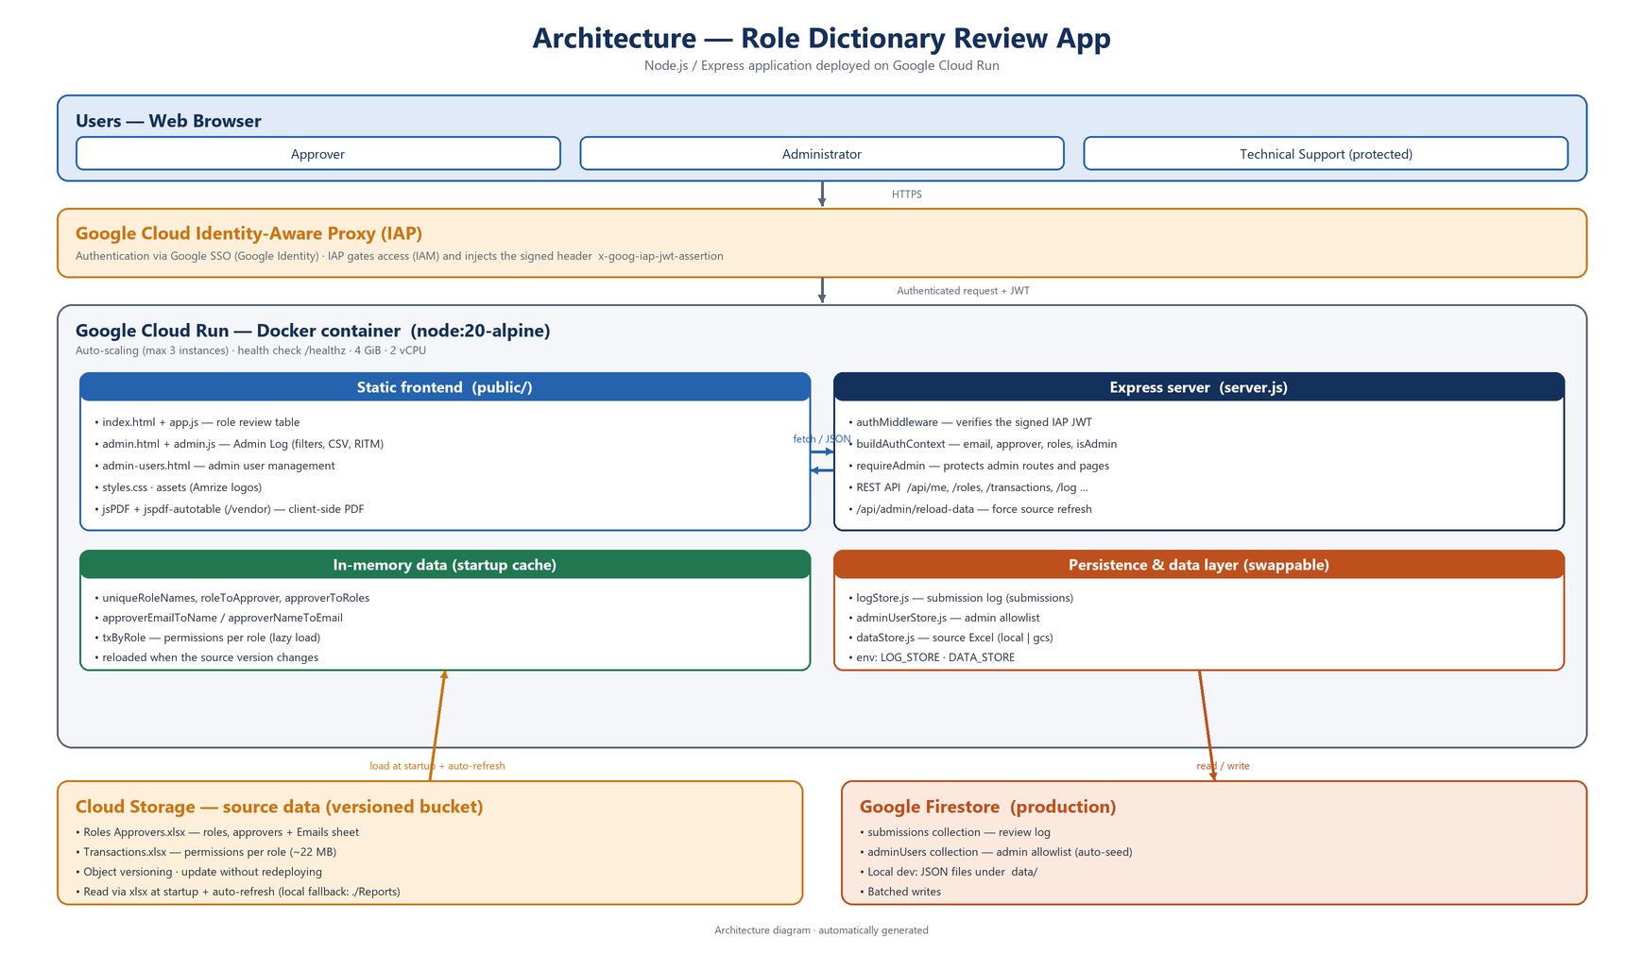
Figure 1. Layered architecture (users → IAP → Cloud Run → data sources).

2. Key files and folders
Path / file | Main purpose
server.js | Express server, REST API, auth middleware, data loading/refresh.
logStore.js | Submission-log persistence abstraction (file or Firestore).
adminUserStore.js | Admin allowlist persistence (file or Firestore) + protected admins.
dataStore.js | Source Excel access layer (local ./Reports or GCS bucket).
public/ | Static frontend (HTML, JS, CSS, assets; user + admin logic).
Reports/ | Excel files — local fallback when DATA_STORE=local.
data/*.json | Local persistence (submissions, admin users) — dev only.
Dockerfile | Container image definition for Cloud Run.
package.json | Dependencies and npm scripts.
deploy/deploy.ps1 | PowerShell script to automate deploy and bootstrap.
deploy/README-DEPLOY*.md | Deployment and handover guides.
Folder structure:
server.js
logStore.js
adminUserStore.js
dataStore.js
package.json
Dockerfile
Reports/
Roles Approvers.xlsx
Transactions.xlsx
public/
index.html app.js
admin.html admin.js
admin-users.html admin-users.js
styles.css assets/
data/ (dev only)
submissions.json
admin-users.json
deploy/
deploy.ps1
README-DEPLOY-ES.md README-CODE-EN.docx

3. Workflow and business logic

3.1 Initialization and data loading
- On startup the roles/approvers workbook is loaded (awaited) so the API has data immediately.
- After app.listen(), the large Transactions workbook is loaded in the background so /healthz responds at once on Cloud Run.
- Data is parsed from Excel into in-memory structures for fast queries.
- Each instance re-checks the source store every DATA_REFRESH_SECONDS (default 300 s) and reloads only the workbook whose version changed.

3.2 REST endpoints (API)
All endpoints except /healthz go through the auth middleware; Admin endpoints also require admin privileges.
Method | Path | Access | Description
GET | /healthz | — | Health check (no auth).
GET | /api/me | User | Current identity: email, approver, roles, isAdmin.
GET | /api/approvers | User | Approver list (all if admin; own otherwise).
GET | /api/roles | User | Roles for the user, or ?approver=Name.
GET | /api/approver | User | Approver assigned to a role (?role=).
GET | /api/transactions | User | Transactions for a role (?role=).
POST | /api/transactions/bulk | User | Transactions for several roles (PDF annex).
POST | /api/log | User | Records a review submission.
GET | /api/log | Admin | Reads the log (filters: approver, action, role).
PATCH | /api/log/:id/ritm | Admin | Updates the RITM number of an entry.
PATCH | /api/log/:id/ritm-status | Admin | Updates RITM status (Open/Resolved/On Hold/Cancelled).
GET | /api/admin-users | Admin | Lists admins and protected admins.
POST | /api/admin-users | Admin | Adds an admin email.
DELETE | /api/admin-users/:email | Admin | Removes an admin (not protected ones).
POST | /api/admin/reload-data | Admin | Forces an immediate source-data reload.
Example — POST /api/log body:
{
"approver": "Juan Perez",
"rows": [
{ "roleName": "SAP_BZP_ADMIN", "action": "Keep Business Role",
"ritm": "RITM123", "actionDetails": "OK" }
]
}
Response:
{ "ok": true, "submissionId": "000123", "recorded": 1 }

3.3 Authentication and authorization
Identity and access are split across three layers in production:
- Google SSO (authentication). Google Identity / Workspace SSO verifies the user and issues an OIDC token; IAP delegates authentication to it. SSO answers “who are you?”.
- Cloud IAP (access gateway). Sits in front of Cloud Run; redirects unauthenticated users to Google SSO, enforces an IAM-based access policy (IAP-secured Web App User role) and injects the signed x-goog-iap-jwt-assertion header. IAP answers “are you allowed to reach the app?”.
- Application verification. server.js validates the JWT signature, audience (IAP_JWT_AUDIENCE) and issuer with google-auth-library.
- Application roles. Approver = email in the Emails sheet; Administrator = email in the allowlist. Approvers access only their own roles; admins can impersonate via ?impersonate=Name. requireAdmin protects admin endpoints/pages. This answers “what can you do inside it?”.

3.4 State persistence (logStore.js)
- LOG_STORE=firestore → Firestore collection submissions (recommended on Cloud Run).
- LOG_STORE=file → local data/submissions.json (development only).
- Both expose appendEntries(entries), readAll(filters), updateRitm(), updateRitmStatus().
- Admin users live in adminUserStore.js (collection adminUsers / data/admin-users.json), seeded with default admins; protected accounts cannot be removed.
Structure of a submission log entry:
{
"logEntryId": "000123-001",
"submissionId": "000123",
"timestamp": "2026-06-11T12:34:56.789Z",
"approver": "Juan Perez",
"submittedByEmail": "juan.perez@amrize.com",
"impersonated": false,
"roleName": "SAP_BZP_ADMIN",
"action": "Keep Business Role",
"ritm": "RITM123",
"ritmStatus": "Open",
"actionDetails": "OK",
"rejectionReason": "",
"rowIndex": 1
}

3.5 Source-data layer (dataStore.js)
- Two backends. DATA_STORE=local reads ./Reports; DATA_STORE=gcs reads a versioned Cloud Storage bucket (DATA_BUCKET, optional DATA_PREFIX).
- Change detection. getVersion() reads object metadata (GCS generation, or file mtime); a workbook is downloaded only when its version changed — the ~22 MB Transactions file is not fetched every check.
- Auto-refresh. Each instance refreshes every DATA_REFRESH_SECONDS (default 300; 0 disables).
- On-demand. POST /api/admin/reload-data forces an immediate reload.
- Update flow. Upload the new .xlsx to the bucket — no redeploy needed.

4. Components in detail
- server.js — configures Express and middleware, serves public/, loads/refreshes Excel data, defines all REST endpoints, integrates logStore/adminUserStore/dataStore, and applies IAP auth + authorization.
- logStore.js — createLogStore() → FileLogStore or FirestoreLogStore (collection submissions, batched writes).
- adminUserStore.js — createAdminUserStore() → file or Firestore (collection adminUsers); default + protected admins.
- dataStore.js — createDataStore() → LocalDataStore or GcsDataStore; getVersion()/getFile().
- public/ — app.js (user logic, review table, PDF, submit), admin.js (audit/CSV), admin-users.js, index/admin/admin-users .html, styles.css.
- Reports/ — Excel data; used as fallback when DATA_STORE=local.
- Dockerfile — node:20-alpine, npm ci --omit=dev, copies code + frontend + Reports, NODE_ENV=production, PORT 8080.
- deploy/deploy.ps1 — enables APIs, creates Firestore + versioned bucket, grants IAM, and deploys.
- package.json — express, xlsx, @google-cloud/firestore, @google-cloud/storage, google-auth-library, jspdf, jspdf-autotable; dev: playwright.

5. Environment variables
Variable | Purpose
LOG_STORE | State backend: firestore (prod) or file (dev).
DATA_STORE | Source backend: gcs (prod) or local (dev, default).
DATA_BUCKET | Cloud Storage bucket name (required for DATA_STORE=gcs).
DATA_PREFIX | Optional folder/prefix inside the bucket.
ROLES_FILE_NAME / TX_FILE_NAME | Source file names (defaults: Roles Approvers.xlsx / Transactions.xlsx).
DATA_REFRESH_SECONDS | Source re-check interval per instance (default 300; 0 disables).
IAP_JWT_AUDIENCE | Expected audience to verify the signed IAP JWT in production.
FIRESTORE_COLLECTION / ADMIN_USERS_COLLECTION | Optional Firestore collection name overrides.
NODE_OPTIONS | --max-old-space-size=3500 (heap for large Excel).
PORT | Injected by Cloud Run (do not hardcode).
DEV_AUTH_EMAIL | Local-only identity override (development).

6. Migration, security and best practices
- Firestore. Collections submissions and adminUsers; runtime service account needs roles/datastore.user.
- Cloud Storage. Versioned bucket for source Excel; runtime service account needs roles/storage.objectViewer (read-only).
- Updating base data. Upload the new Excel to the bucket; instances auto-reload within DATA_REFRESH_SECONDS, or trigger /api/admin/reload-data. No redeploy.
- Authentication. Access is gated by IAP; the server verifies the signed JWT. Avoid relying on --allow-unauthenticated without IAP in front.
- Least privilege. The runtime SA holds only datastore.user and storage.objectViewer.
- Protected admins. Technical Support accounts cannot be removed from the allowlist.
- Extension. To add fields, update frontend, backend and the Firestore document shape consistently.
- Auditing. The submission log is filterable and CSV-exportable from admin.html.

7. Simplified flow
End user --(web UI, public/)--> IAP --(verified JWT)--> Express API (Cloud Run)
Express --reads source Excel--> Cloud Storage (versioned bucket) [startup + auto-refresh]
Express --reads/writes--------> Firestore (submissions, adminUsers)
Express --serves-------------> Frontend (public/)
Admin --(admin UI)---------> Express API

8. Troubleshooting
- Out-of-memory loading Excel. Use NODE_OPTIONS=--max-old-space-size=3500 and Cloud Run memory 4Gi.
- Firestore 403. Check the service account has roles/datastore.user.
- Cloud Storage 403 / file not found. Check roles/storage.objectViewer, DATA_BUCKET/DATA_PREFIX and file names.
- Excel changes not visible. With GCS they apply automatically within DATA_REFRESH_SECONDS; force with /api/admin/reload-data. (Local/in-image mode requires a redeploy.)
- Slow first request. Cold start after idle; consider --min-instances 1 (has cost).
- Local debugging. Run node server.js with LOG_STORE=file and DATA_STORE=local; set DEV_AUTH_EMAIL to simulate a user.

9. Useful resources
- Google Cloud Console — https://console.cloud.google.com
- Cloud Run — https://console.cloud.google.com/run
- Firestore — https://console.cloud.google.com/firestore
- Cloud Storage — https://console.cloud.google.com/storage
- Node.js docs — https://nodejs.org/ · Express docs — https://expressjs.com/

10. Use cases and business scenarios

Case 1 — Role review by an approver
- The user opens the app; IAP authenticates and the app loads their assigned roles.
- For each role they open the permissions modal and must tick the acknowledgement checkbox.
- They choose an action (keep/modify) or reject with a mandatory reason, add comments and RITM.
- On finish, the outcome PDF is generated and the submission is stored in Firestore for audit.

Case 2 — Audit and log export
- An admin opens admin.html and filters submissions by approver, action or role.
- They edit RITM number/status and export the (filtered) log to CSV.

Case 3 — Updating base data
- An operator uploads the new Excel to the Cloud Storage bucket.
- Running instances auto-reload within DATA_REFRESH_SECONDS (or via /api/admin/reload-data) — no redeploy.
This guide should accompany any migration or handover of the system.

