**Fractal Analysis of the Optimal Hydraulic Gradient Surface in Water Distribution Networks**

**Andres Jaramillo**, Researcher, Water Distribution and Sewerage Systems Research Center (CIACUA), Universidad de los Andes, Carrera 1 Este No. 19A-40, Bogotá 111711018, Colombia.

Email: af.jaramillo@uniandes.edu.co

**Juan Saldarriaga**, Professor, Dept. of Civil and Environmental Engineering, Water Distribution and Sewerage Systems Research Center (CIACUA), Universidad de los Andes, Carrera 1 Este No. 19A-40, Bogotá 111711018, Colombia.

Email: jsaldarr@uniandes.edu.co

# Reproducibility Guide

This document provides a list of steps and directions to reproduce figures and tables in the paper. In terms of software, the authors employed the Python programming language (v. 3.7.9), Spyder and EPANET hydraulic modelling software (v. 2.0) to calculate results. All tools are available online for free with the corresponding installation instructions. The user can find useful links to access these resources in the references section of this document. It is also important that the user learns how to run Python scripts before attempting to reproduce figures and tables. Although Spyder was employed by the authors to run Python scripts, the user is free to run the scripts in any way.

## Figures

To reproduce figures, the user must enter the “Figures” folder in the repository. The user will find ten available Python scripts. The name of each script specifies the figure that will be generated when the user runs the script.

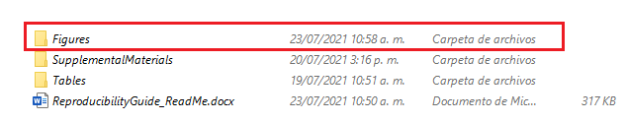

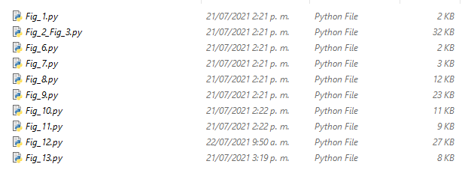

Figure 1 will be generated to exemplify the use of Spyder to run the scripts. First, the user should click on the folder symbol in the upper left corner of the screen. Then, the user must locate and open the “Fig_1.py” file.

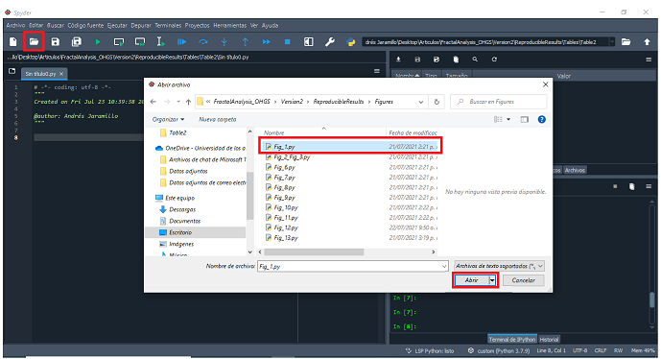

Afterwards, the script can be run by clicking on the run symbol as specified in the following screenshot:

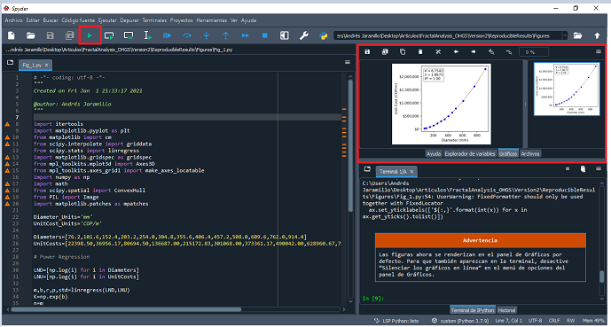

Figure 1 will then be generated in the same folder that contains the “Fig_1.py” script. The remaining figures can be generated in the same manner.

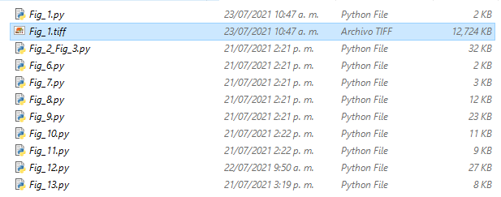

## Table 2

To reproduce Table 2, the user must enter the “Tables” folder and then the “Table2” subfolder in the repository. The user will find multiple folders, text files and a Python script named “Table2.py”.

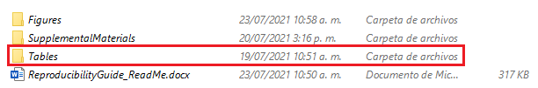

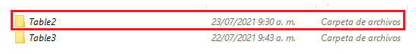

The user can choose between two possible ways to reproduce Table 2. The first one is to run the “Table2.py” script available in the folder. Text files should not be modified or altered in any way. Otherwise, the script may not compile or may estimate different results. In addition, all input text files must be at the same folder as “Table2.py” in order for the script to run.

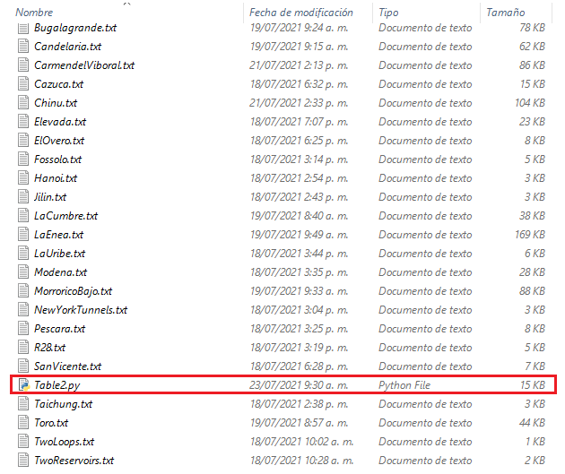

If the user employs Spyder to run the script, the following process should be done. First, the user should click on the folder symbol in the upper left corner of the screen. Then, the user must locate and open the “Table2.py” file.

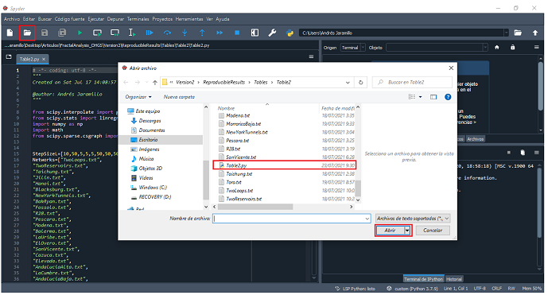

The script can be run by clicking on the run symbol as specified in the following screenshot:

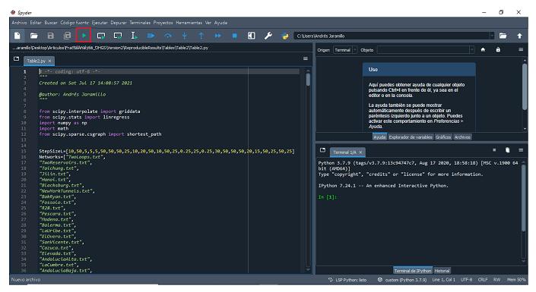

After running the script, a text file is generated. Each column of the table is separated by a dashed line.

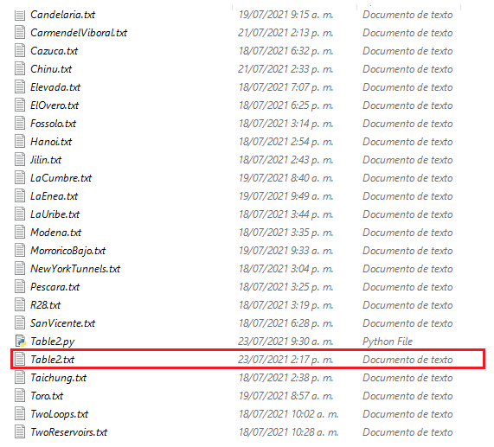

The user should be aware that “Table2.py” script takes a long time to be processed. Therefore, if the user only desires to reproduce the information for certain case studies, it is more appropriate to obtain the results in an alternative way. The “Table2” subfolder contains twenty-eight subfolders, named after the nomenclature in which networks are differentiated in the paper. Each “ID” subfolder contains the necessary files to obtain a specific row of Table 2.

For example, if the user desires to obtain the results for Two Reservoirs network, i.e., the second row of Table 2, the “ID_2” subfolder should be opened. The user will find a Python script named after the ID of the network and a text file with the input information. The text file should not be modified or altered in any way. If the user employs Spyder to run the script, the following process should be done. First, the user should click on the folder symbol in the upper left corner of the screen. Then, the user must locate and open the “ID_2.py” file.

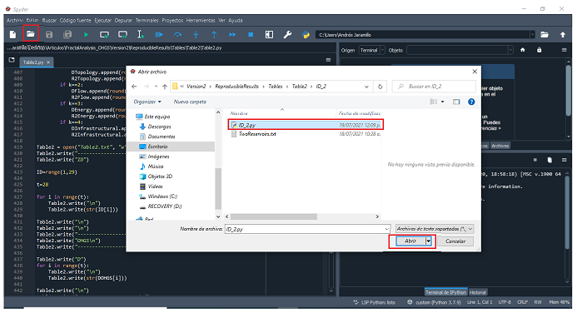

The script can be run by clicking on the run symbol as specified in the following screenshot:

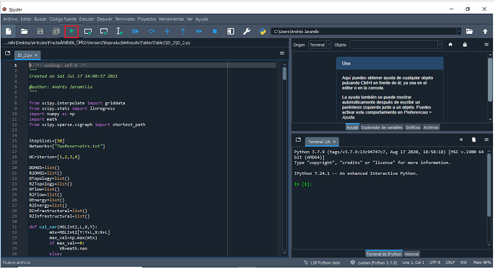

After running the script, a text file is generated (“ID_2.txt”). If the user desires to obtain additional rows of Table 2 it is necessary to run the Python scripts inside the corresponding “ID” subfolders in the same manner.

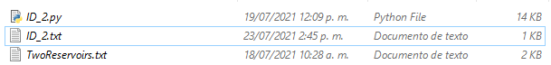

## Table 3

To reproduce Table 3, the user must enter the “Tables” folder and then the “Table3” subfolder in the repository. The user will find one available Python script.



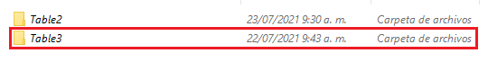



If the user employs Spyder to run the script, the following process should be done. First, the user should click on the folder symbol in the upper left corner of the screen. Then, the user must locate and open the “Table3.py” file.

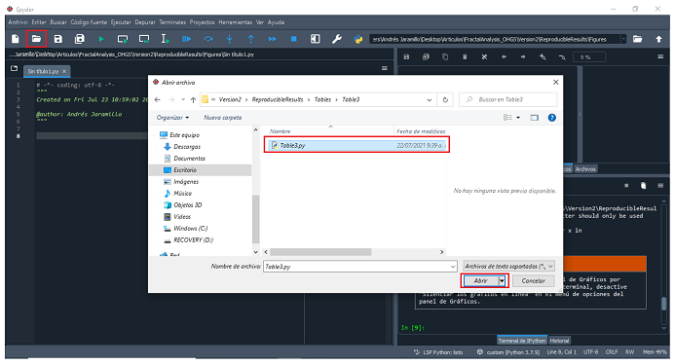

The script can be run by clicking on the run symbol as specified in the following screenshot:

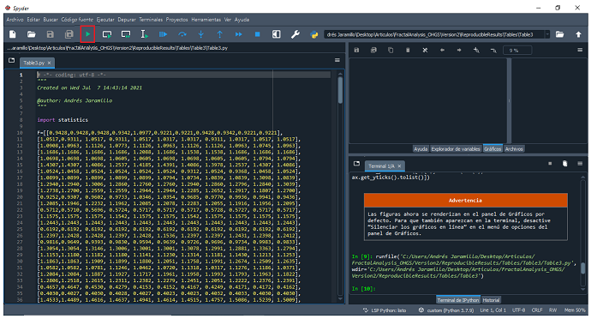

After running the script, a text file is generated. Each column of the table is separated by a dashed line.

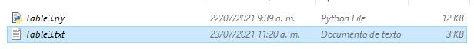

## Supplemental Materials

Supplemental Materials were also included in the repository.

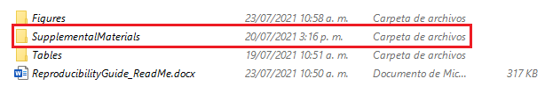

EPANET “.inp” data files of the corresponding optimal and non-optimal designs can be found in the folder “EPANET_Designs”.

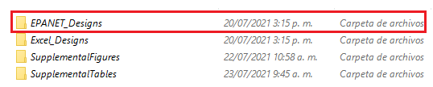

These files can be processed by importing them in EPANET. For example, if the user desires to perform the hydraulic simulation of R28 optimal design, the following process should be followed. First, the user should click on the folder symbol in the upper left corner of the screen. Then, the user must locate and open the “R28Opt.inp” file.

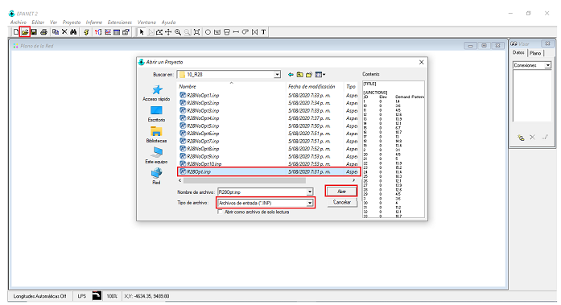

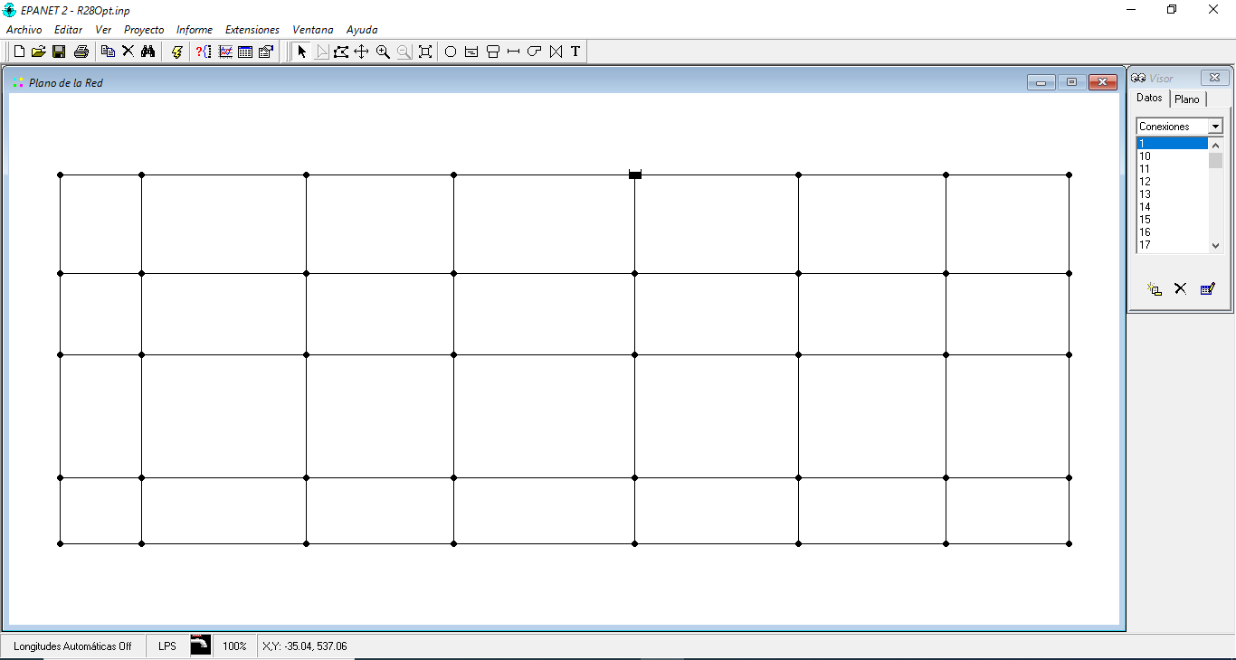

The hydraulic simulation can be performed by clicking on the lightning symbol in the upper toolbar.

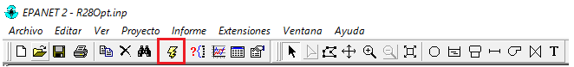

To obtain a tabular listing of results, the user should click the Table button and specify the desired parameters to print out.

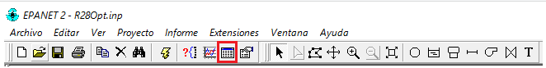

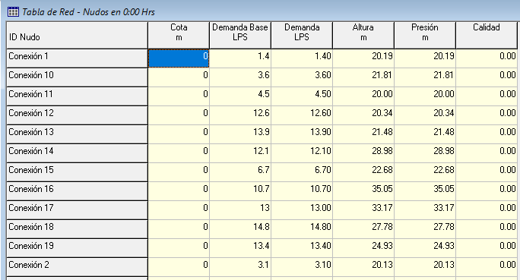

In addition, the hydraulic simulation of each design was stored in a separate Excel spreadsheet and can be found in the “Excel_Designs” subfolder. The following screenshots exemplify how the R28 optimal design Excel spreadsheet can be located:

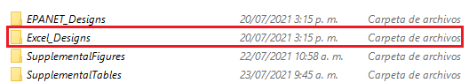

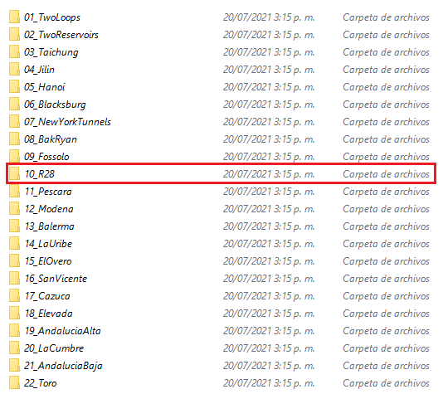

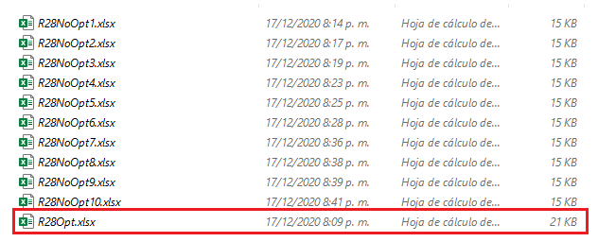

In terms of the supplemental figures, the user must enter the “SupplementalFigures” subfolder. The user will find two Python scripts inside. “FigS1_FigS13.py” reproduces from Fig. S1 to Fig. S13, while “FigS14_FigS40.py” reproduces from Fig. S14 to Fig. S40.

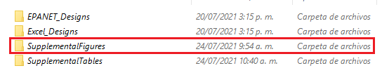



Each script can be run in Spyder in the same manner. Once the scripts are run, supplemental figures are generated.

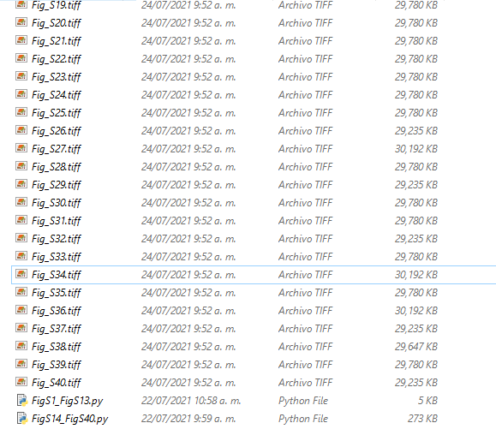

Finally, Table S15 to Table S19 can be reproduced by accessing the “SupplementalTables” subfolder. The user will find two Python scripts and several text files. “TableS15_FigTable.py” reproduces from Table S15 to Table S17, while “TableS18_Table19.py” reproduces Table S18 and Table S19. The text files should not be modified or altered in any way. In addition, these input text files must be located in the same folder as the “TableS15_FigTable.py” and “TableS18_Table19.py” files. Both scripts can be run in the same way as in previous cases.

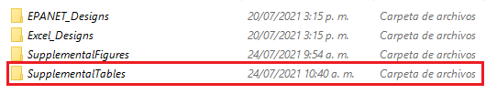

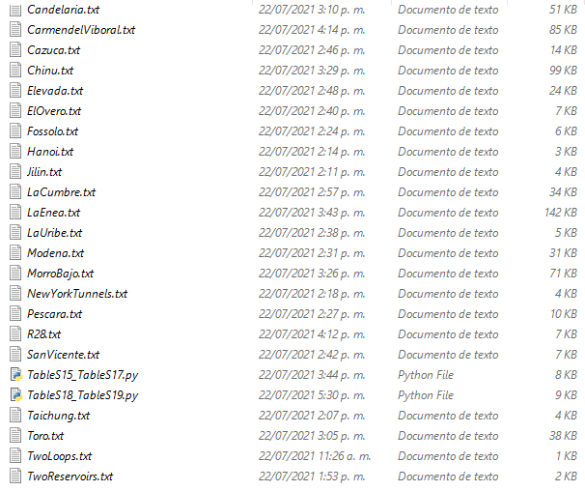

Once the scripts are run, tables are printed in text files. Dashed lines are used to separate each column of the tables.

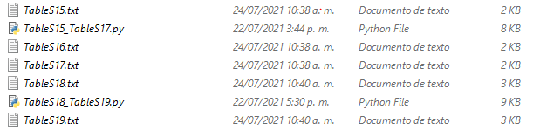

# References

Abdalfattah, S.F., Y.M. Makeen, I. Abdulbariu, and H.A. Ayinla. 2019. “Basic gravity geophysical processing and display in MATLAB: Application on NE African Sudanese Red Sea Province.” *J. Afr. Earth Sci.*,150, 346-354. https://doi.org/10.1016/j.jafrearsci.2018.10.018

Alperovits, E., and U. Shamir. 1977. “Design of Optimal Water Distribution Systems.” *Water Resour. Res.*,13 (6), 885-900. https://doi.org/10.1029/WR013i006p00885

Barber, C.B., D.P. Dobkin, and H. Huhdanpaa. 1996. “The quickhull algorithm for convex hulls.” *ACM Trans. Math. Software*,22 (4), 469-483. https://doi.org/10.1145/235815.235821

Bi, W., and G.C. Dandy. 2014. “Optimization of Water Distribution Systems Using Online Retrained Metamodels.” *J. Water Resour. Plan. Manag.* 140 (11): 04014032. https://doi.org/10.1061/(ASCE)WR.1943-5452.0000419

Bishop-Taylor, R., S. Sagar, L. Lymburner, and R.J. Beaman. 2019. “Between the tides: Modelling the elevation of Australia´s exposed intertidal zone at continental scale.” *Estuar. Coast. Shelf Sci.*, 223 (31), 115-128. https://doi.org/10.1016/j.ecss.2019.03.006

Bisoi, A.K., and J. Mishra. 2001. “On calculation of fractal dimension of images.” *Pattern Recognit. Lett.*,22 (6-7), 631-637. https://doi.org/10.1016/S0167-8655(00)00132-X

Bragalli, C., C. D’Ambrosio, J. Lee, A. Lodi, and P. Toth. 2012. “On the optimal design of water distribution networks: a practical MINLP approach.” *Optim. Eng.*,13 (2), 219-246. https://doi.org/ 10.1007/s11081-011-9141-7

Clarke, K.C. 1986. “Computation of the fractal dimension of topographic surfaces using the triangular prism surface area method.” *Comput. Geosci.*,12 (5), 713-722. https://doi.org/10.1016/0098-3004(86)90047-6

Cunha, M., J. Marques, E. Creaco, and D. Savic. 2019. “A Dynamic Adaptive Approach for Water Distribution Network Design.” *J. Water Resour. Plan. Manag.*, 145 (7): 04019026. https://doi.org/ 10.1061/(ASCE)WR.1943-5452.0001085

Cunha, M.C., and J. Sousa. 1999. “Water Distribution Network Design Optimization: Simulated Annealing Approach”. *J. Water Resour. Plan. Manag.* 125(4), 215-221. https://doi.org/10.1061/(ASCE)0733-9496(1999)125:4(215)

Cunha, M.C., and L. Ribeiro. 2004. “Tabu search algorithms for water network optimization.” *Eur. J. Oper. Res.*,157(3), 746-758. https://doi.org/10.1016/S0377-2217(03)00242-X

Dandy, G.C., A.R. Simpson, and L.J. Murphy. 1996. “An improved genetic algorithm for pipe network optimization.” *Water Resour. Res.*,32(2), 449-458. https://doi.org/10.1029/95WR02917

Di Nardo, A., M. Di Natale, C. Giudicianni, R. Greco, and G.F. Santonastaso. 2017. “Complex network and fractal theory for the assessment of water distribution network resilience to pipe failures.”  *Water Sci. Technol. Water Supply*,18 (3), 767-777. https://doi.org/10.2166/ws.2017.124

Diao, K., D. Butler, and B. Ulanicki. 2017. “Fractality in Water Distribution Networks.” In *Proc., 15th International Computing and Control for the Water Industry (CCWI)*. Sheffield: University of Sheffield. https://doi.org/10.15131/shef.data.5364151.v1

Edgar, G. 2008. *Measure, Topology and Fractal Geometry*. New York, USA: Springer-Verlag New York.

EPA. 2021. “EPANET: Application for Modeling Drinking Water Distribution Systems”. Accessed July 23, 2021. https://www.epa.gov/water-research/epanet

Erkal, B.G., and J.F. Hajjar. 2017. “Laser-based surface damage detection and quantification using predicted surface properties.” *Autom. Constr.*,83, 285-302. https://doi.org/10.1016/j.autcon.2017.08.004

Ezzeldin, R., B. Djebedjian, and T. Saafan. 2013. “Integer Discrete Particle Swarm Optimization of Water Distribution Networks.” *J. Pipeline Syst. Eng.* 5 (1): 04013013. https://doi.org/10.1061/(ASCE)PS.1949-1204.0000154

Falconer, K. 1990. *Fractal Geometry: Mathematical Foundations and Applications*. West Sussex, England: John Wiley & Sons Ltd.

Falconer, K. 1997. *Techniques in Fractal Geometry*. West Sussex, England: John Wiley & Sons Ltd.

Farmani, R., R. Abadia, and D. Savic. 2007. “Optimum Design and Management of Pressurized Branched Irrigation Networks.” *J Irrig. Drain. Eng.* 133 (6), 528-537. https://doi.org/10.1061/(ASCE)0733-9437(2007)133:6(528)

Featherstone, R.E., and K.K. El-Jumaily. 1983. “Optimal Diameter Selection for Pipe Networks.” *J. Hydraul. Eng.* 109 (2), 221-234. https://doi.org/10.1061/(ASCE)0733-9429(1983)109:2(221)

Fujiwara, O., and D. Khang. 1990. “A two-phase decomposition methods for optimal design of looped water distribution networks.” *Water Resour. Res.*,26(4), 539-549. https://doi.org/10.1029/WR026i004p00539

Geem, Z.W. 2008. “Particle-swarm harmony search for water network design.” *Eng. Optimiz.,* 41 (4), 297-311. https://doi.org/10.1080/03052150802449227

Gessler, J. 1985. “Pipe network optimization by enumeration.” In *Proc., Computer applications in water resources*, 572-581. New York, NY: ASCE.

Giudicianni, C., A. Di Nardo, R. Greco, and A. Scala. “A Community-Structure-Based Method for Estimating the Fractal Dimension, and its Application to Water Networks for the Assessment of Vulnerability to Disasters.” *Water Resour. Manag.*, 35, 1197-1210. https://doi.org/10.1007/s11269-021-02773-y

Harris, C.R., K.J. Millman, S.J. van der Walt, R. Gommers, P. Virtanen, D. Cournapeau, …, T.E. Oliphant. 2020. “Array programming with NumPy.” *Nature,* 585, 357-362. https://doi.org/10.1038/s41586-020-2649-2

Hunter, J.D. 2007. “Matplotlib: A 2D Graphics Environment.” *Comput. Sci. Eng.,* 9 (3), 90-95. https://doi.org/10.1109/MCSE.2007.55

Iwanek, M., D. Kowalski, B. Kowalska, and P. Suchorab. 2020. “Fractal Geometry in Designing and Operating Water Networks.” *J. Ecol. Eng.,* 21(6), 229-236. https://doi.org/10.12911/22998993/123501

Jaramillo, A. 2020. “Análisis de la geometría fractal de la superficie óptima de presiones en el diseño optimizado de redes de distribución de agua potable” [Analysis of the fractal geometry of the Optimal Pressure Surface in the optimized design of water distribution networks]. [In Spanish.] Universidad de los Andes.

Jaramillo, A. 2021. “FractalAnalysis_OHGS_v2”. Accessed July 25, 2021. http://doi.org/10.5281/zenodo.5136608

Jian-Hua, L., Y. Bo-Ming, and Z. Ming-Qing. 2009. “A Model for Fractal Dimension of Rough Surfaces.” *Chin. Phys. Lett.,* 26(11): 116101. https://doi.org/10.1088/0256-307X/26/11/116101

Ju, W., and N.S.-N. Lam. 2009. “An improved algorithm for computing local fractal dimension using the triangular prism method.” *Comput. and Geosci.,* 35 (6), 1224-1233. https://doi.org/10.1016/j.cageo.2008.09.008

Kadu, M.S., R. Gupta and P.R. Bhave. 2008. “Optimal Design of Water Distribution Networks Using a Modified Genetic Algorithm with Reduction in Search Space*.” J. Water Resour. Plan. Manag.,* 134 (2), 147-160. https://doi.org/10.1061/(ASCE)0733-9496(2008)134:2(147)

Kim, J.S., K.I. Goh, G. Salvi, E. Oh, B. Kahng, and D. Kim. 2007. “Fractality in complex networks: Critical and supercritical skeletons.” *Phys. Rev. E,* 75 (1): 016110. https://doi.org/10.1103/PhysRevE.75.016110

Kowalska, B., D. Kowalski, and H. Ewa. 2020. “Fractal-Heuristic Method of Water Quality Sensor Locations in Water Supply Network.” *Water,* 12(3): 832. https://doi.org/10.3390/w12030832

Kowalski, D., B. Kowalska, T. Blawucki, P. Suchorab, and K. Gaska. 2019. “Impact Assessment of Distribution Network Layout on the Reliability of Water Delivery.” *Water*, 11 (3): 480. https://doi.org/10.3390/w11030480

Kyriakou, M.S., and S.G. Vrachimis. 2019. “EPANET-Benchmarks.” KIOS Research and innovation Center of Excellence. Accessed July 25, 2020. https://github.com/KIOS-Research/EPANET-Benchmarks

Lam, N.S.N., H. Qium, D.A. Quattrochi, and C.W. Emerson. 2002. “An Evaluation of Fractal Methods for Characterizing Image Complexity.” *Cartogr. Geogr. Inf. Sci.,* 29 (1), 25-35. https://doi.org/10.1559/152304002782064600

Lansey, K.E., and L.W. Mays. 1989. “Optimization Model for Water Distribution System Design.” *J. Hydraul. Eng.,* 115(10), 1401-1418. https://doi.org/10.1061/(ASCE)0733-9429(1989)115:10(1401)

Lee, S.C., and S.I. Lee. 2001. “Genetic algorithms for optimal augmentation of water distribution networks.” *J. Korea Water Resour. Assoc.,* 34 (5), 567-575.

Lin, M.D., Y.H. Liu, G.F. Liu, and C.W. Chu. 2007. “Scatter search heuristic for least-cost design of water distribution networks.” *Eng. Optimiz.,* 39 (7), 857-876. https://doi.org/10.1080/03052150701503611

Liu, H., C.A. Shoemaker, Y. Jiang, G. Fu, and C. Zhang. 2020. “Preconditioning Water Distribution Network Optimization with head Loss-Based Design Method” *J. Water Resour. Plan. Manag.*, 146 (12): 04020093. https://doi.org/10.1061/(ASCE)WR.1943-5452.0001299

Lopez-Giraldo, S., and J. Saldarriaga, J. (2004). “Optimal Cost Potable Water Network Distribution Design with Genetic Algorithms.” In *Proc.,* *World Water and Environmental Resources Congress 2004*. Salt Lake City, UT: ASCE. https://doi.org/10.1061/40737(2004)251

Mandelbrot, B. 1977. *Fractals: Form, chance and dimension*. San Francisco, USA: W.H. Freeman and Company.

Mandelbrot, B. 1983. *The Fractal Geometry of Nature*. New York, USA: W.H. Freeman and Company.

Marchi, A., G. Dandy, A. Wilkins, and H. Rohrlach. 2014. “Methodology for Comparing Evolutionary Algorithms for Optimization of Water Distribution Systems.” *J. Water Resour. Plan. Manag.,* 140(1), 22-31. https://doi.org/10.1061/(ASCE)WR.1943-5452.0000321

Mitchell, M. 1999. *An Introduction to Genetic Algorithm*. Cambridge, USA: Massachussetts Institute of Technology.

Montesinos, P., A. Garcia-Guzman, and J.L. Ayuso. 1999. “Water distribution network optimization using a modified genetic algorithm.” *Water Resour. Res.,* 35(11), 3467-3473. https://doi.org/10.1029/1999WR900167

Moosavian, N., and B.J. Lence. 2020. “Flow-Uniformity Index for Reliable-Based Optimal Design of Water-Distribution Networks.” *J. Water Resour. Plan. Manag.*, 146 (3): 04020005. https://doi.org/10.1061/(ASCE)WR.1943-5452.0001161

Ormsbee, L, and T. Walski. 2016. “Darcy-Weisbach versus Hazen-Williams: No Calm in West Palm.” In *World Environmental and Water Resources Congress 2016*. West Palm Beach, Florida: ASCE. https://doi.org/10.1061/9780784479865.048

Páez, D., C. Salcedo, A. Garzón, M.A. González, and J. Saldarriaga. 2020. “Use of Energy-Based Domain Knowledge as Feedback to Evolutionary Algorithms for the Optimization of Water Distribution Networks.” *Water,* 12 (11): 3101. https://doi.org/10.3390/w12113101

Páez, D., D. Hernández, and J. Saldarriaga. 2013. “Optimal design of pipes in series with pressure driven demands.” In *Proc.,* *World Environmental and Water Resources Congress 2013: Showcasing the Future*, 857-868. Cincinnati, OH: ASCE. https://doi.org/10.1061/9780784412947.082

Páez, D., J. Saldarriaga, L. López, and C. Salcedo. 2014. “Optimal Design of Water Distribution Systems with Pressure Driven Demands.” *Procedia Eng.,* 89*,* 839-847. https://doi.org/10.1016/j.proeng.2014.11.515

Persson, B.N.J. 2014. “On the Fractal Dimension of Rough Surfaces.” *Tribol. Lett.,* 54 (1), 99-106. https://doi.org/10.1007/s11249-014-0313-4

Prasad, T.D., and N.S. Park. 2004. “Multiobjective Genetic Algorithms for Design of Water Distribution Networks.” *J. Water Resour. Plan. Manag* 130(1): 73-92. https://doi.org/10.1061/(ASCE)0733-9496(2004)130:1(73)

Przestacki, D., R. Majchrowski, and L. Marciniak-Podsadna. 2016. “Experimental research of surface roughness and surface texture after laser cladding.” *Appl. Surf. Sci.,* 388 (A), 420-423. https://doi.org/10.1016/j.apsusc.2015.12.093

Python. 2021. “Active Python Releases”. Accessed July 23, 2021. https://www.python.org/downloads/

Qiu, M., M. Housh, and A. Ostfeld. 2021. “Analytical Optimization Approach for Simultaneous Design and Operation of Water Distribution-Systems Optimization.” *J. Water Resour. Plan. Manag.*, 147 (3): 06020014. https://doi.org/10.1061/(ASCE)WR.1943-5452.0001330

Reca, J., and J. Martínez. 2006. “Genetic algorithms for the design of looped irrigation water distribution networks.” *Water Resour. Res.,* 42 (5): W05416. https://doi.org/10.1029/2005WR004383

Reca, J., J. Martínez, C. Gil, and R. Baños. 2008. “Application of Several Meta-Heuristic Techniques to the Optimization of Real Looped Water Distribution Networks.” *Water Resour. Manag.,* 22 (10), 1367-1379. https://doi.org/10.1007/s11269-007-9230-8

Saldarriaga J., S. Takahashi, F. Hernández, D.M. Díaz, and S. Ochoa. 2010. “An energy methodology for the design of water distribution systems.” In *Proc.,* *World Environmental and Water Resources Congress 2010: Challenges of Change*. Providence, RI: ASCE. https://doi.org/10.1061/41114(371)437

Saldarriaga, J. 2016. *Hidráulica de Tuberías: Abastecimiento de Agua, Redes y Riegos* [Pipeline Hydraulics: Water Supply, Networks and Irrigation]. [In Spanish.] Bogotá D.C., República de Colombia: Alfaomega.

Saldarriaga, J., D. Páez, C. Salcedo, P. Cuero, L.L. López, N. León, and D. Celeita. 2020. “A Direct Approach for the Near-Optimal Design of Water Distribution Networks Based on Power Use.” *Water,* 12 (4): 1037. https://doi.org/10.3390/w12041037.

Saldarriaga, J., D. Páez, N. León, L. López and P. Cuero. 2014. “Historical Development of Power Used Methods for WDS Design and their Evolution towards Optimization Metaheuristics.” *Procedia Eng.,* 70, 1470-1484. https://doi.org/10.1016/j.proeng.2014.02.162

Saldarriaga, J., D. Páez, N. León, L. López, and P. Cuero. 2015. “Power use methods for optimal design of WDS: history and their use as post-optimization warm starts.” *J. Hydroinfor.,* 17(3), 404-421. https://doi.org/10.2166/hydro.2014.013

Saldarriaga, J., D. Páez, P. Cuero, and N. León. 2013. “Optimal Design of Water Distribution Networks Using Mock Open Tree Topology.” In *Proc.,* *World Environmental and Water Resources Congress 2013: Showcasing the Future*, 869-880. Cincinnati, OH: ASCE. https://doi.org/10.1061/9780784412947.083

Saldarriaga, J., G. Villalba, and S. Takahashi. 2005. “Algorithms of Combinatorial Optimization Applied to Water Distribution Networks Design.” In *Proc., World Water and Environmental Resources Congress 2005*. Anchorage, AK: ASCE. https://doi.org/10.1061/40792(173)9

Saldarriaga, J., L. Pulgarín, P. Cuero, and N. Duque. 2017. “Pipeline Hydraulics Academic Software.” [In Spanish.] In *Proc.,* *Ibero-American Seminar on Water and Drainage Networks (SEREA 2017)*. Bogotá D.C., República de Colombia: Universidad de los Andes http://doi.org/10.2139/ssrn.3113745

Sarkar, N., and B.B. Chaudhuri. 1992. “An Efficient Approach to Estimate Fractal Dimension of Textural Images.” *Pattern Recognit.,* 25 (9), 1035-1041. https://doi.org/10.1016/0031-3203(92)90066-R

Savic, D.A., and G.A. Walters. 1997. “Genetic Algorithms for Least-cost Design of Water Distribution Networks.” *J. Water Resour. Plan. and Manag.,* 123(2), 67-77. https://doi.org/10.1061/(ASCE)0733-9496(1997)123:2(67)

Schaake, J., and Lai, D. 1969. *Linear programming and dynamic programming application to water distribution network design*. 69-69. Cambridge, MA: Massachusetts Institute of Technology, Department of Civil Engineering.

Sherali, H.D., S. Subramanian, and G.V. Loganathan. 2001. “Effective Relaxations and Partitioning Schemes for Solving Water Distribution Network Design Problems to Global Optimality.” *J. Glob. Optim.,* 19 (1), 1-26. https://doi.org/10.1023/A:1008368330827

Sirsant, S., and M.J. Reddy. 2020. “Assessing the Performance of Surrogate Measures for Water Distribution Network Reliability.” *J. Water Resour. Plan. Manag.*, 146 (7): 04020048. https://doi.org/10.1061/(ASCE)WR.1943-5452.0001244

Sivanandam, S.N., and S.N. Deepa. 2008. *Introduction to Genetic Algorithms.* New York, USA: Springer-Verlag Berling Heidelberg.

Song, C., L.K. Gallos, S. Havlin, and H.A. Makse. 2007. “How to calculate the fractal dimension of a complex network: the box covering algorithm.” *J. Stat. Mech.: Theory Exp.,* 2007 (3), P03006. https://doi.org/10.1088/1742-5468/2007/03/P03006

Spasic, S. 2014. “On 2D generalization of Higuchi’s fractal dimension.” *Chaos Solitons Fractals,* 69, 179-187. https://doi.org/10.1016/j.chaos.2014.09.015

Spyder. 2020. “Spyder: The Scientific Python Development Environment”. Accessed July 23, 2021. https://www.spyder-ide.org/

Sun, W., G. Xu, P. Gong, and S. Liang. 2006. “Fractal analysis of remotely sensed images: A review of methods and applications.” *Int. J. Remote Sens.,* 27 (22), 4963-4990. https://doi.org/10.1080/01431160600676695

Sung, Y.H., M.D. Lin, Y.H Lin, and Y.L. Liu. 2007. “Tabu Search Solution of Water Distribution Network Optimization.” *J. Environ. Manage.,* 17(3), 177-187.

Székely, G.J., M.L. Rizzo, and N.K. Bakirov. 2007. “Measuring and Testing Dependence by Correlation of Distances.” *Ann. Stat.,* 35(6), 2769-2794. https://doi.org/10.1214/009053607000000505.

Todini, E., and S. Pilati. 1987. “A gradient algorithm for the analysis of pipe networks.” In *Computer Applications in Water Supply: Volume 1 – Systems Analysis and Simulation,* 1-20. Letchworth, England: John Wiley & Sons, Inc.

Tolle, C.R., T.R. McJunkin, and D.J. Gorsich. 2003. “Suboptimal Minimum Cluster Volume Cover-Based Method for Measuring Fractal Dimension.” *IEEE Trans. Pattern Anal. Mach. Intell.,* 25 (1), 32-41. https://doi.org/10.1109/TPAMI.2003.1159944

Vargas, K., and J. Saldarriaga. 2019. “Analysis of Fractality in Water Distribution Networks Using Hydraulic Criteria.” In *Proc.,* *World Environmental and Water Resources Congress 2019*. Pittsburg, PA: ASCE. https://doi.org/10.1061/9780784482353.054

Vargas, K., C. Salcedo and J. Saldarriaga. 2019. “Dimensión fractal e identificación de potenciales sectores de servicio en redes de distribución de agua potable utilizando criterios hidráulicos.” [Fractal dimension and identification of potential service sectors in water distribution networks using hydraulic criteria]. [In Spanish.] *Revista Recursos Hídricos,* 40 (2), 27-38. https://doi.org/10.5894/rh40n2-cti3

Virtanen, P., R. Gommers, T.E. Oliphant, M. Haberland, T. Reddy, D. Cournapeau, …, P. van Mulbregt. 2020. “SciPy 1.0: fundamental algorithms for scientific computing in Python.” *Nat. Methods,* 17 (3), 261-272. doi: 10.1038/s41592-019-0686-2

Wang, Q., M. Guidolin, D. Savic, and Z. Kapelan. 2015. “Two-Objective Design of Benchmark Problems of a Water Distribution System via MOEAs: Towards the Best-Known Approximation of the True Pareto Front.” *J. Water Resour. Plan. Manag.,* 141(3): 04014060. https://doi.org/10.1061/(ASCE)WR.1943-5452.0000460

Wen, T., and K.H. Cheong. 2021. “The fractal dimension of complex networks: A review.” *Inform. Fusion,* 73, 87-102. https://doi.org/10.1016/j.inffus.2021.02.001

Wu, I. 1975. “Design of drip irrigation main lines.” *J. Irrig. Drain. Div*., 101 (IR 4), 265–278.

Zheng, F., A.R. Simpson, and C. Zecchin. 2011. “A combined NLP-differential evolution algorithm approach for the optimization of looped water distribution systems.” *Water Resour. Res.,* 47 (8). https://doi.org/10.1029/2011WR010394

Zhou, G., and N.S.-N. Lam. 2005. “A comparison of fractal dimension estimators based on multiple surface generation algorithms.” *Comput. and Geosci.,* 31 (10),1260-1269. https://doi.org/10.1016/j.cageo.2005.03.016