**Handbook for how to get data from the sensor hub through your own laptop**

1. **XAMPP**

XAMPP (Apache+MySQL+PHP+PERL) is a powerful integrated website building package. It can be installed and used under Windows, Linux, Solaris, Mac OS X and many other operating systems.

Download XAMPP Control Panel v3.3.0. Once installed, click the Start button for both Apache and MySQL.

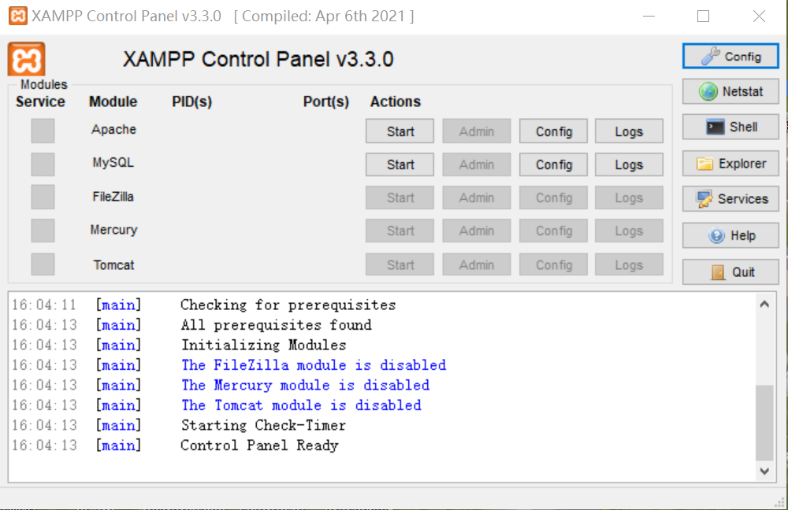

1. **Node-RED**

Node-RED is a visual programming language development tool based on process programming from IBM that allows developers to connect hardware devices with application programming interfaces and online services to form a small Internet of Things. Node-Red is based on Node.js. To install Node-Red, you need to also install Node.js. (*node-v16.18.0-x64.msi*) <https://nodejs.org/en/download/>

It is easy to install Node-Red using NPM：npm install -g node-red.The documentation for the node-red node of this sensor can be found in Appendix 1 flows.json.

(1)Connecting the sensor hub to the laptop through USB. After that, open the command prompt and type “node-red”, then press “Enter”.

The website of node-red is [http://127.0.0.1:1880](http://127.0.0.1:1880/#flow/4d96a413d9d897fb)

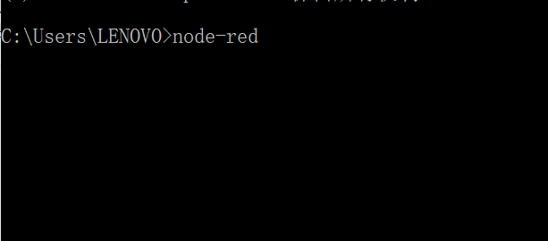

(2)Remember to check in your own laptop if the hub’s interface is COM3 or others.

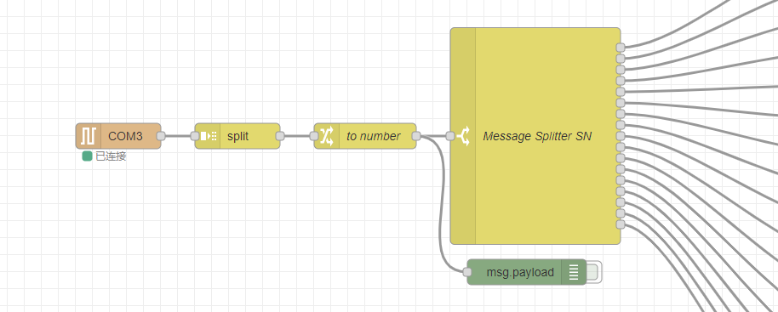

1. This is the information about the properties of Database

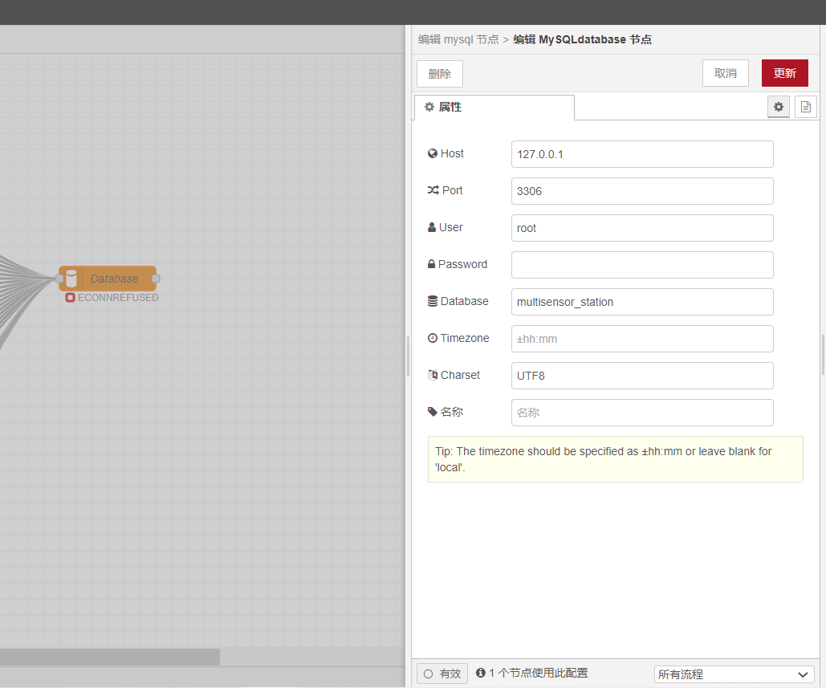

1. **Database**

Open the database, where all the data collected by the sensors are located. <http://localhost/phpmyadmin/>

[http://127.0.0.1/](http://127.0.0.1/%20)  🡪 phpMyAdmin

## Here is a link about how to create a database using phpMyAdmin and XAMPP

<https://skillforge.com/how-to-create-a-database-using-phpmyadmin-xampp/>

1. Create a new database called *multisensor_station*(Feel free to name it as you wish, but the name should be the same as the one in Database.)

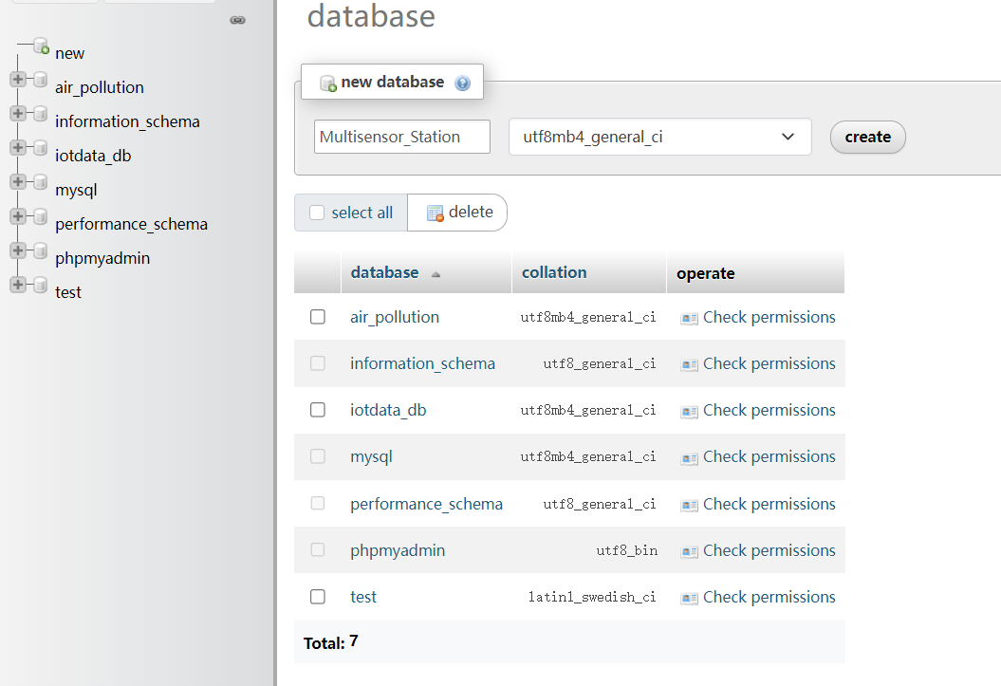

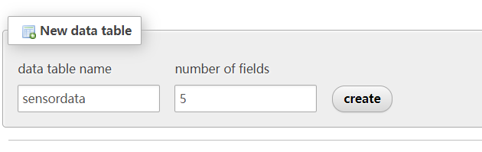

**Note**: data table name should be the same as the name in the MySQL insert statement in the function node in Node-RED. So the data table name must be sensordata.

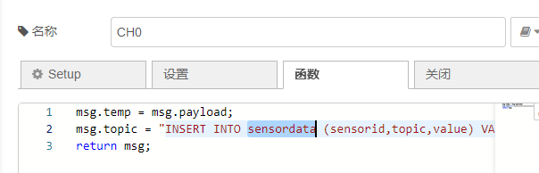

1. Click new to create a structure, then save.

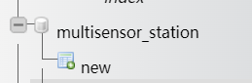

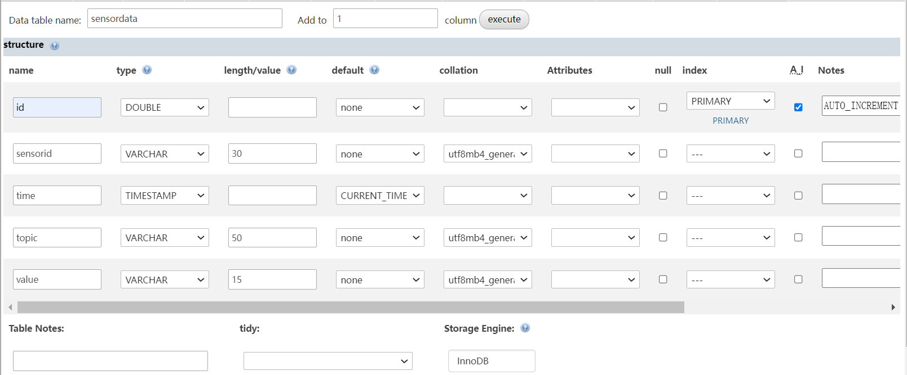

The following is a new and complete multisensor_station database structure.

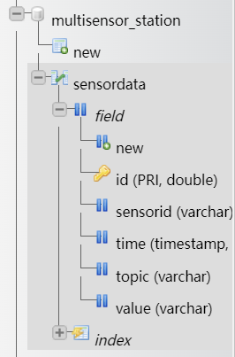

1. Open Node-red again and the following picture shows the successful connection.

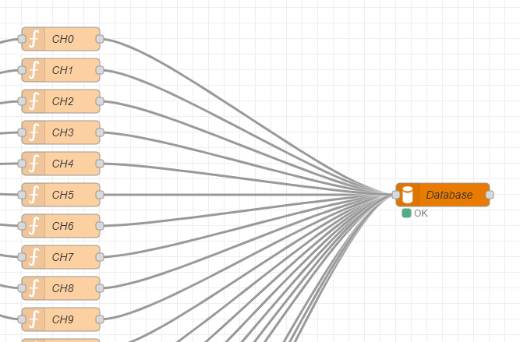

1. Go back to the database, refresh the Table: sensordata. Then here shows the data collected by the sensor hub.

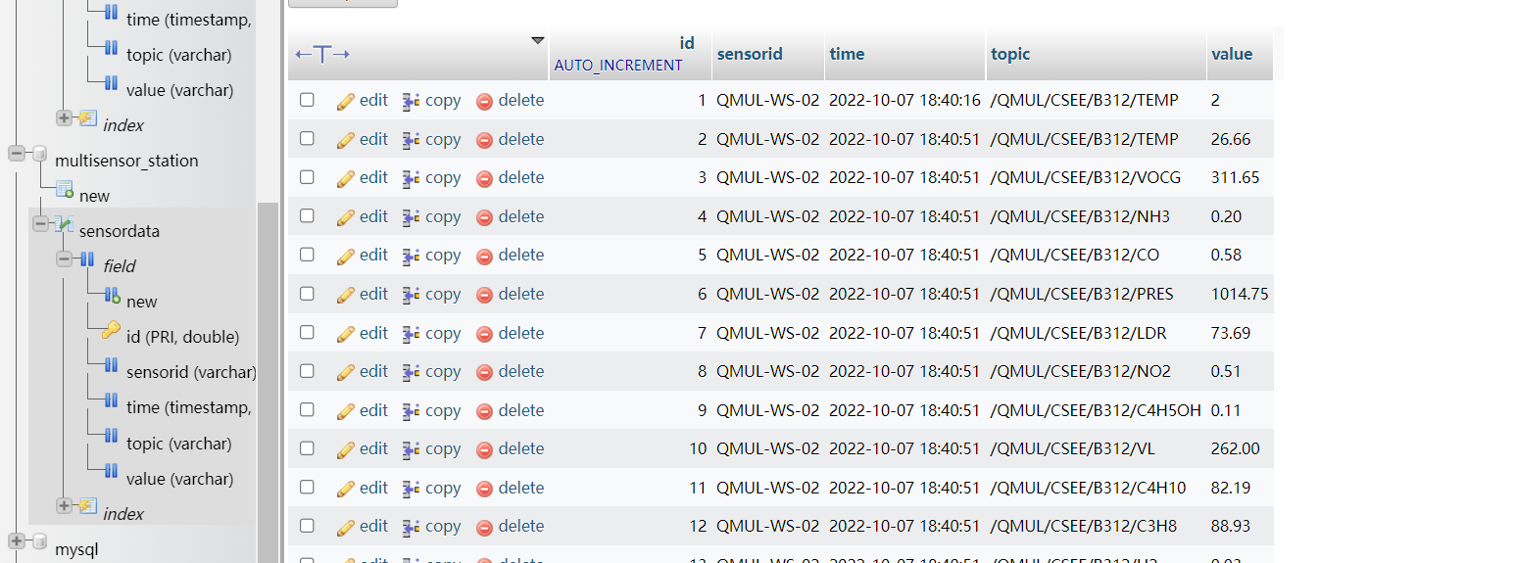

1. **Grafana**

Grafana is a monitoring instrumentation system that is open-sourced by Grafana Labs, a system monitoring tool. It helps you to simplify the complexity of monitoring by providing you with only the data you need to monitor and it will generate various visual gauges for you. It also has an alarm function to notify you if there is a problem with the system.

Download Grafana

Open Grafana <http://127.0.0.1:3000/login>

Login Username: admin

(1)Click Configuration. Then Click MySQL-1, here are the settings details. Remember that the name of Database in Grafana should be the same as it in the database. In this project, the name of Database is multisensor_station. Finally, click Save&test.

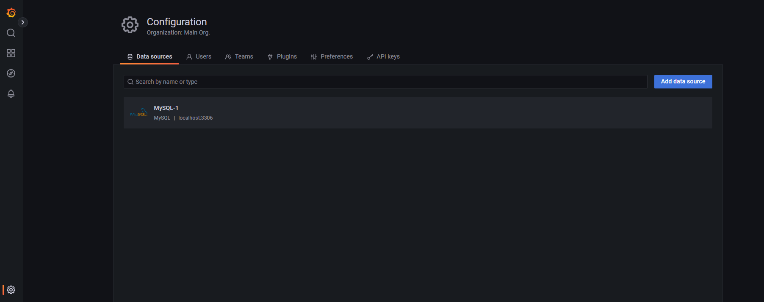

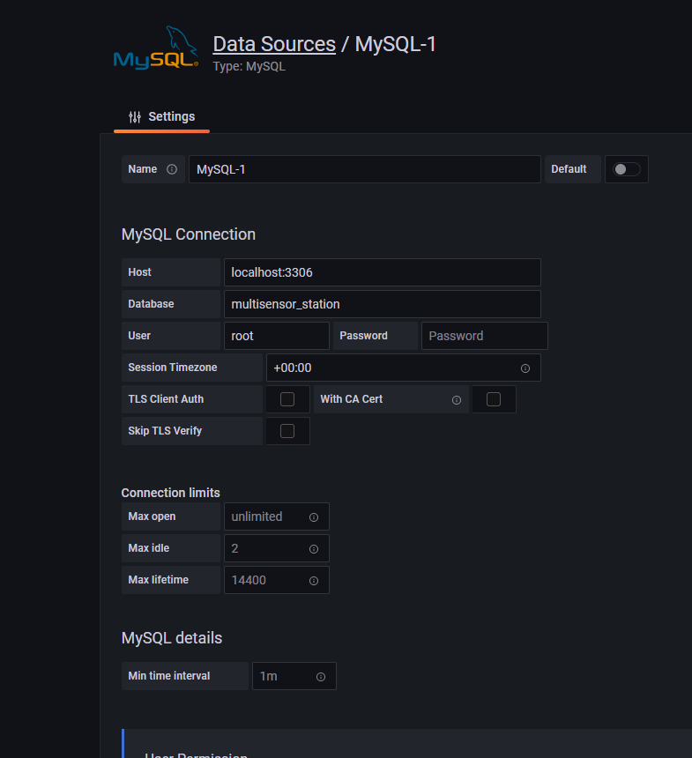

1. Open Dashboards, click QMLU-CSEE-LLP-dASHBOARD.

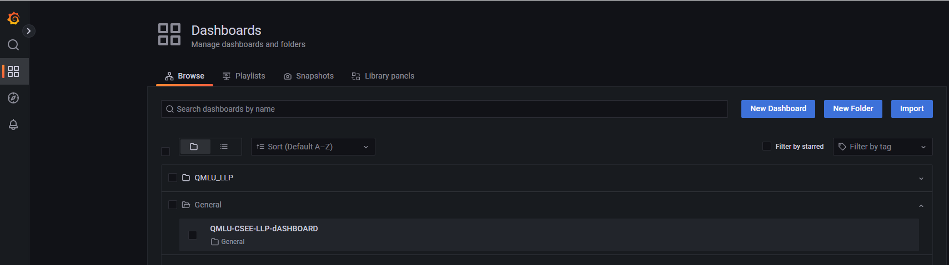

1. The visualisation of the data measured by the sensor hub is shown here.

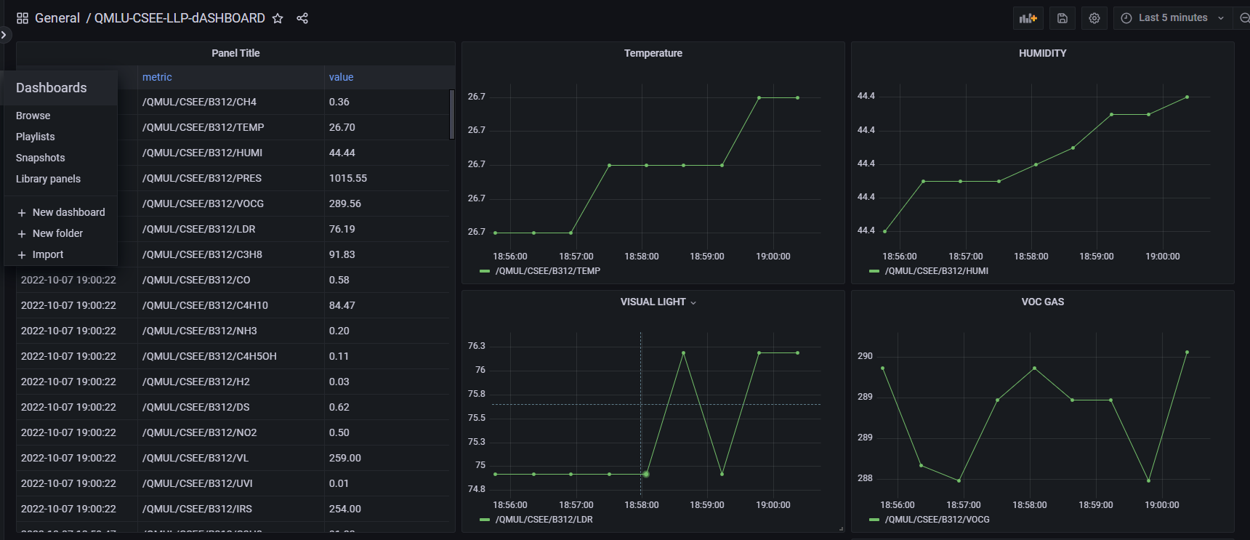

1. Here is to add new panels. This is the step to add the NO2 panel, click Apply after completing the configuration.

