# OCTAVE

**Heres the peer certificate patch**

https://www.coursera.org/learn/machine-learning/discussions/forums/8LDwTL2SEeSEJSIACyEKsQ/threads/_et09TGlEea-YhKdNUv9pQ

**Element operations**

<https://en.wikibooks.org/wiki/Octave_Programming_Tutorial/Vectors_and_matrices>

**For loops**

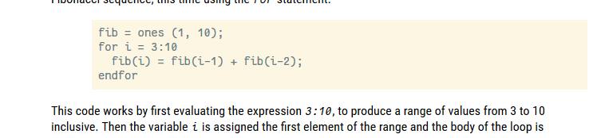

https://www.tutorialspoint.com/matlab/matlab_matrix_scalar_operation.htm