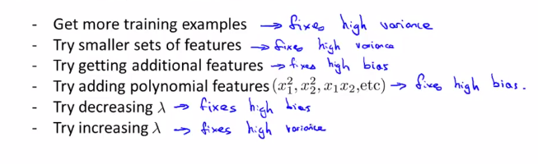

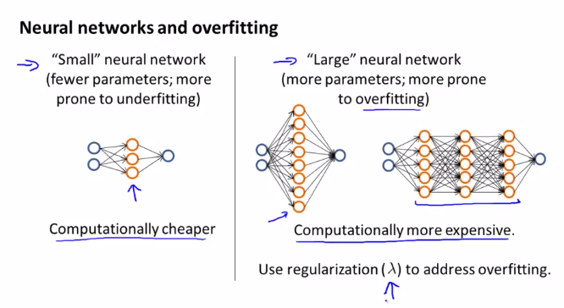

Larger neural networks are slightly better, because they cause high variance, which can be improved my regularization. With smaller neural networks this is not the case.

You can always test how many hidden nn to use with cross validation.