UML HW 1

Andres Namm

Table of Contents

Assigment Information 2

Background 2

User Requirements 2

Assignment Deliverables 2

Step 1 3

Actors 3

Use cases 3

Step 2 3

Keypoints 3

Step 3 4

**Use case 1** 4

**Use case 2** 4

**Use case 3** 5

Step 4, 5 7

Step 6 8

Keypoints 8

# Assigment Information

## Background

Top System Enterprise (TSE) is going to develop a system for a cinema. A potential customer can register to be a member of the system. The registered customer will be given a membership card. Every membership card contains an embedded RFID tag, which can be detected by sensors in the cinema. The membership card production and RFID sensor deployment are outsourced to another company. Your task is to analyse the application software system.

## User Requirements

The detailed user requirements for the TSE system are as follows:

1. A new customer can register to join as a member. They need to input personal information such as name, address and mobile phone number. Then, a membership number and a password will be issued to the customer together with a membership card.

2. When a member wants to buy film tickets, they may either tap the membership card at an RFID sensor or enter their membership number.

3. If the member enters the correct password, the system will display the available films.

4. After the member has selected a film, the system will display the available dates and times. The member will select the preferred date and time. Then, the system will display the available seats.

5. After the member has selected the preferred seats and paid the price, the system will record the membership number, date, time, film, seats, amount paid and payment method.

6. For additional membership attraction, the cinema gives monthly awards. At the end of each month, the system will sort the members according to their total payment for that month. The top 3 members will be selected and, after confirmation by the manager, the system will send discount e-coupons to these members by email.

## Assignment Deliverables

Conduct object-oriented analysis. Perform the following standard steps based on the given user requirements of the system:

1. Identify the actors and use cases in the system.

2. Construct a use case diagram of the system with use case relationships, if any. 3. Document the use case normal and alternative courses of events.

4. Find the potential classes based on deliverable #3.

5. Select the proposed classes based on deliverable #4.

6. Construct a class diagram based on deliverable #5.

Produce the diagrams using **IBM Rational Software Architect V9.1.1 (or above)** and the descriptions using MS Word. Consolidate the deliverables into one document in MS Word or Adobe PDF.

Remind yourself to be consistent with variables.

# Step 1

*Identify the actors and use cases in the system.*

## Actors

1. Potential Member
2. Member of Cinema
3. Manager
4. Time

## Use cases

1. Creating account  *Based on user requirement 1*
2. Buying a ticket for a film. *Based on user requirements 2,3,4,5*
3. Giving discount to member *Based on user requirement* *6*

# Step 2

*Construct a use case diagram of the system with use case relationships, if any.*

## Keypoints

1. Because every use case currently stands alone as a separate entity, additional regrouping with subsystems is not required.
2. Use Case relationships are not required because current use case diagrams consist of simple scenarios without any repetition.

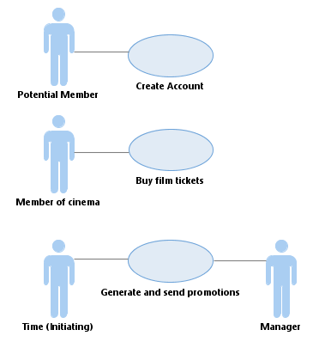

# Step 3

*Document the use case normal and alternative courses of events.*

## **Use case 1**

|  |  |  |
| --- | --- | --- |
| Use case name: | Creating account | |
| Actor (s): | Potential Member | |
| Description: | This use case describes the process of a **potential member** submitting an **application** for membership in **TSE cinema** and the **system** issuing the **member** a **membership number**, **password and mebership card.** | |
| Reference: | HW1 | |
| Typical Course of Events: | Actor Action:   1. Initiate this use case when a **potential member** applies for membership. | System Response.   1. Validate that the **potential member** has entered all the **required information** such as **name, address and mobile phone number.** 2. Conclude this use case when the **membership** **number**, **password and a membership card** **with embedded RFID** tag has been assigned to the **member**. |
| Pre-condition: | None | |
| Post-condition: | Member Account has been created. | |
| Assumptions: | None | |
| Alternatives: | Step 2 – I some information is missing from the application. The user has specified that they allow the appropriate action to be designed by the designer. | |

## **Use case 2**

|  |  |
| --- | --- |
| Use case name: | Buying a ticket for a film |
| Actor (s): | Member of Cinema |
| Description: | This use case describes the process of  **Current Member** buying a ticket for a film. |
| Reference: | HW1 |

|  |  |  |
| --- | --- | --- |
| Typical Course of Events: | Actor Action:   1. Initiate this use case when a member taps their **membership card**  at the **RFID sensor** or enters their **member number.** 2. Choose a **film**. 3. Choose preferred **date ant time** 4. Select preferred **seats** and pay for the **ticket order** for chosen **session.** | System Response.   1. Validate **user authentity** with **password**. 2. Show the user the available **films.** 3. Display **available dates with times**  to watch the chosen film. 4. Display available **seats** at the current date. 5. Conclude this use case when the **membership number, date, time, film, seats, amount paid, and payment method** have been recorded in a **database.** |
| Pre-condition | Actor has membership. | |
| Post-condition | .has been completed. | |
| Assumptions | None | |
| Alternatives: | Step 2 - If wrong **password** is entered, dont continue to the next steps of the ticket buying process.  Step 8 – Payment failure. Dont continue to the next steps of the ticket paying process. | |

## **Use case 3**

|  |  |
| --- | --- |
| Use case name: | Giving discount to member |
| Actor (s): | Time (Initiating), Manager |
| Description: | This use case describes tbe monthly award giving process for promotion purposes. |
| Reference: | HW1 |

|  |  |  |  |
| --- | --- | --- | --- |
| Typical Course of Events: | Actor Time Action:   1. Initiate **award** process when time reaches to the end of the month | System Response.   1. Sort the **members** according to their **total payment** for current moth and choose top 3 members. 2. End this use case when discount **e-coupons** to the **members** by email have been sent. | Manager   1. Confirm award |
| Pre-condition | None | | |
| Post-condition | Promotions have been sent to the Members | | |
| Assumptions | None | | |
| Alternatives: | Step 3 - Manager does not confirm the promotion. User has not specified how this action must be delpth with. Regarding the fact that user has specified this step, it must be important enough to ask for further clarification. | | |

# Step 4, 5

*Find the potential classes based on deliverable #3.*

I have already bolded the Nouns in the use cases in the previous assignment. Here they are brought out in a table form in the first column.

Classes I shall delete*: Synonyms; Nouns outside the scope of the system; Nouns that are roles wihtout unique behaviour or external roles; Unclear nouns that need foucs – System ; Nounst that are really actions or attributes*

USE CASE 1

|  |  |  |
| --- | --- | --- |
| 1. Potential member | Yes | Kind of member POTENTIAL_MEMBER |
| 1. application for membership | No | MEMBERSHIP_APPLICATION |
| 1. Member | Yes | MEMBER |
| 1. Required information | No | This is an aggregate of attributes used in member class |
| 1. Name | No | Attribute |
| 1. Address | No | Attribute |
| 1. Mobile phone number | No | Attribute |
| 1. System | No | Unclear noun, that needs more focus |
| 1. Membership number | No | Attribute for member |
| 1. Password | No | Attribute for member |
| 1. Membership card with embedded RFID | No | It doesnt have any unique behaviour- universal authentication |
| 1. TSE cinema | No | Nouns outside the scope |
| 1. System | No | Unclear |

USE CASE 2

|  |  |  |
| --- | --- | --- |
| 1. Current Member | Yes | CURRENT_MEMBER |
| 1. Membership card | No | Irrelevant for the system |
| 1. RFID sensor | No | Not unique |
| 1. Member number | No | Attribute for member |
| 1. User authentity | No | No unique behaviour |
| 1. Film | Yes | FILM |
| 1. Date and time | No | Universal nouns |
| 1. Seats | No | Attribute for session |
| 1. Ticket order | Yes | FILM_TICKET_ORDER |
| 1. Session | Yes | SESSION |
| 1. Payment | Yes | PAYMENT_TRANSACTION |
| 1. Amount paid | No | Attribute |
| 1. Database | No | Unclear |

USE CASE 3

|  |  |  |
| --- | --- | --- |
| 1. Award | Yes | AWARD |
| 1. Total payment | No | Attribute, synonym |
| 1. Discount e-coupon | No | Synonym in this context to award |
| 1. Time | No | External actor. |
| 1. Manager | Yes | MANAGER |

# Step 6

My purpose is to create a model of the system's functional requirements that is independent of implementation constraints, so it could be used by the designer to get a better overview of the user requirements and by the user to get a better overview of the system we are building through which to understand and analyse their needs easier.

## Keypoints

* To the classes like film, session, order I didn’t add ID , Primary key – attributes to identify specifically each object, because the user hasn’t specified such details and these are rather a technical implementation part. *This is my decision having considered the principle of separating design from analysis, am I correct ?*
* 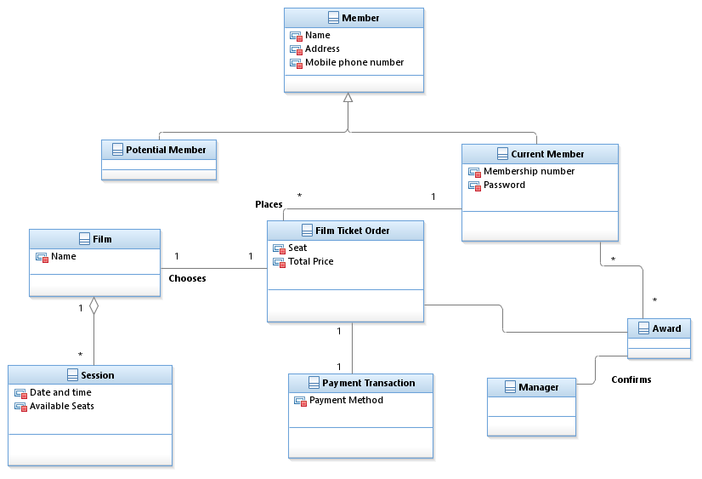I didn’t specify the association between Award and order because it wasn’t specified in the User Requirements part. Should ask the user more details regarding that.