WARNING
The HC-05 is a 3.3V system but the breakout board offers current limiting resistors for some protection. While it's not advisable to keep the HC-05 connected to the 5V Arduino Uno pins, for this short exercise I decided to skip the voltage dividers which I use to drop 5V to 3.3V. I advise you to use voltage dividers whenever you connect the HC-05 pins to 5V pins such as the Arduino Uno. If you skip the voltage divider, do so at your own risk.
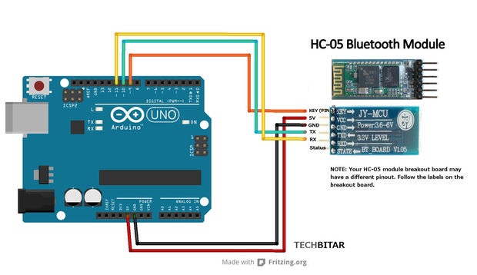

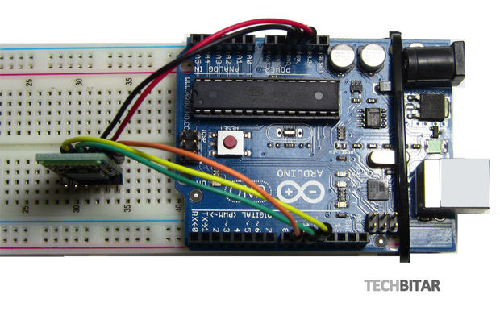

WIRING
- HC-05 GND --- Arduino GND Pin
- HC-05 VCC (5V) --- Arduino 5V
- HC-05 TX --- Arduino Pin 10 (soft RX)
- HC-05 RX --- Arduino Pin11 (soft TX)
- HC-05 Key (PIN 34) --- Arduino Pin 9

