LOT  07851 | P142036-R6-1-0  14X20X36 R6 PLNM EC/RAW  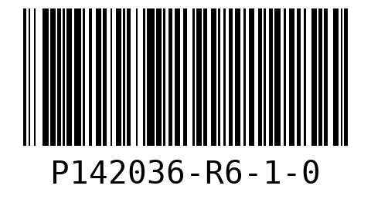  WO 02  LOT 07851  QTY 20
P162036-R6-1-0
16X20X36 R6 PLENUM END CAP/RAW
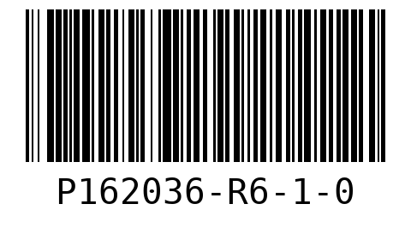
WO 02
LOT 07851
QTY 30

SHEET  1 | P142036-R6-1-0  14X20X36 R6 PLNM EC/RAW  WO 02  LOT 07851
P142036-R6-1-0  14X20X36 R6 PLNM EC/RAW  WO 02  LOT 07851 | P142036-R6-1-0  14X20X36 R6 PLNM EC/RAW  WO 02  LOT 07851
P142036-R6-1-0  14X20X36 R6 PLNM EC/RAW  WO 02  LOT 07851 | P142036-R6-1-0  14X20X36 R6 PLNM EC/RAW  WO 02  LOT 07851

P142036-R6-1-0  14X20X36 R6 PLNM EC/RAW  WO 02  LOT 07851 | P142036-R6-1-0  14X20X36 R6 PLNM EC/RAW  WO 02  LOT 07851
P142036-R6-1-0  14X20X36 R6 PLNM EC/RAW  WO 02  LOT 07851 | P142036-R6-1-0  14X20X36 R6 PLNM EC/RAW  WO 02  LOT 07851
P142036-R6-1-0  14X20X36 R6 PLNM EC/RAW  WO 02  LOT 07851 | P142036-R6-1-0  14X20X36 R6 PLNM EC/RAW  WO 02  LOT 07851

P142036-R6-1-0  14X20X36 R6 PLNM EC/RAW  WO 02  LOT 07851 | P142036-R6-1-0  14X20X36 R6 PLNM EC/RAW  WO 02  LOT 07851
P142036-R6-1-0  14X20X36 R6 PLNM EC/RAW  WO 02  LOT 07851 | P142036-R6-1-0  14X20X36 R6 PLNM EC/RAW  WO 02  LOT 07851
P142036-R6-1-0  14X20X36 R6 PLNM EC/RAW  WO 02  LOT 07851 | P142036-R6-1-0  14X20X36 R6 PLNM EC/RAW  WO 02  LOT 07851

P142036-R6-1-0  14X20X36 R6 PLNM EC/RAW  WO 02  LOT 07851 | P142036-R6-1-0  14X20X36 R6 PLNM EC/RAW  WO 02  LOT 07851
P142036-R6-1-0  14X20X36 R6 PLNM EC/RAW  WO 02  LOT 07851 | P162036-R6-1-0  16X20X36 R6 PLENUM END CAP/RAW  WO 02  LOT 07851
P162036-R6-1-0  16X20X36 R6 PLENUM END CAP/RAW  WO 02  LOT 07851 | P162036-R6-1-0  16X20X36 R6 PLENUM END CAP/RAW  WO 02  LOT 07851

P162036-R6-1-0  16X20X36 R6 PLENUM END CAP/RAW  WO 02  LOT 07851 | P162036-R6-1-0  16X20X36 R6 PLENUM END CAP/RAW  WO 02  LOT 07851
P162036-R6-1-0  16X20X36 R6 PLENUM END CAP/RAW  WO 02  LOT 07851 | P162036-R6-1-0  16X20X36 R6 PLENUM END CAP/RAW  WO 02  LOT 07851
P162036-R6-1-0  16X20X36 R6 PLENUM END CAP/RAW  WO 02  LOT 07851 | P162036-R6-1-0  16X20X36 R6 PLENUM END CAP/RAW  WO 02  LOT 07851

P162036-R6-1-0  16X20X36 R6 PLENUM END CAP/RAW  WO 02  LOT 07851 | P162036-R6-1-0  16X20X36 R6 PLENUM END CAP/RAW  WO 02  LOT 07851
P162036-R6-1-0  16X20X36 R6 PLENUM END CAP/RAW  WO 02  LOT 07851 | P162036-R6-1-0  16X20X36 R6 PLENUM END CAP/RAW  WO 02  LOT 07851
P162036-R6-1-0  16X20X36 R6 PLENUM END CAP/RAW  WO 02  LOT 07851 | P162036-R6-1-0  16X20X36 R6 PLENUM END CAP/RAW  WO 02  LOT 07851

SHEET  2 | P162036-R6-1-0  16X20X36 R6 PLENUM END CAP/RAW  WO 02  LOT 07851
P162036-R6-1-0  16X20X36 R6 PLENUM END CAP/RAW  WO 02  LOT 07851 | P162036-R6-1-0  16X20X36 R6 PLENUM END CAP/RAW  WO 02  LOT 07851
P162036-R6-1-0  16X20X36 R6 PLENUM END CAP/RAW  WO 02  LOT 07851 | SHEET  3

P162036-R6-1-0  16X20X36 R6 PLENUM END CAP/RAW  WO 02  LOT 07851 | P162036-R6-1-0  16X20X36 R6 PLENUM END CAP/RAW  WO 02  LOT 07851
P162036-R6-1-0  16X20X36 R6 PLENUM END CAP/RAW  WO 02  LOT 07851 | P162036-R6-1-0  16X20X36 R6 PLENUM END CAP/RAW  WO 02  LOT 07851
P162036-R6-1-0  16X20X36 R6 PLENUM END CAP/RAW  WO 02  LOT 07851 | P162036-R6-1-0  16X20X36 R6 PLENUM END CAP/RAW  WO 02  LOT 07851

P162036-R6-1-0  16X20X36 R6 PLENUM END CAP/RAW  WO 02  LOT 07851 | P162036-R6-1-0  16X20X36 R6 PLENUM END CAP/RAW  WO 02  LOT 07851
P162036-R6-1-0  16X20X36 R6 PLENUM END CAP/RAW  WO 02  LOT 07851 | P162036-R6-1-0  16X20X36 R6 PLENUM END CAP/RAW  WO 02  LOT 07851
P162036-R6-1-0
16X20X36 R6 PLENUM END CAP/RAW
WO 02
LOT 07851

