LOT  08555 | fdfsdfsdf  fsdfsfdssdsfsfdsdfsd  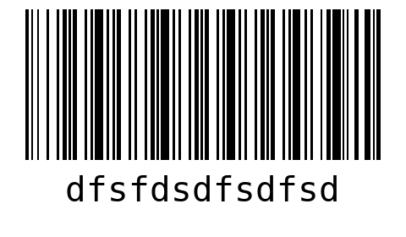  WO dfsdfsdf  LOT 08555  QTY 20
dfsdfsdfsdfsdfdsfds  sdfsdfsdfdsfdsf  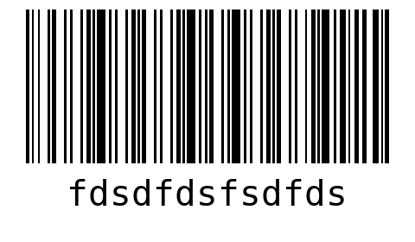  WO fdfdsfsdfds  LOT 08555  QTY 20 | dsfsdfsdfdsfdfds  dfsdfsdfdsfsdfds  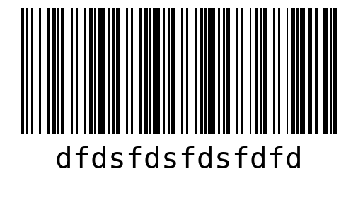  WO dfdsfsdfdsfds  LOT 08555  QTY 15
sdfsdfsfdsffsd
dfsdfsdfsfsd
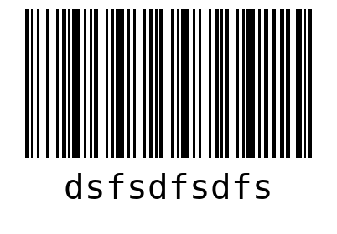
WO dfsdfsdf
LOT 08555
QTY 30

SHEET  1 | fdfsdfsdf  fsdfsfdssdsfsfdsdfsd  WO dfsdfsdf  LOT 08555
fdfsdfsdf  fsdfsfdssdsfsfdsdfsd  WO dfsdfsdf  LOT 08555 | fdfsdfsdf  fsdfsfdssdsfsfdsdfsd  WO dfsdfsdf  LOT 08555
fdfsdfsdf  fsdfsfdssdsfsfdsdfsd  WO dfsdfsdf  LOT 08555 | fdfsdfsdf  fsdfsfdssdsfsfdsdfsd  WO dfsdfsdf  LOT 08555

dfsdfsdfsdfsdfdsfds  sdfsdfsdfdsfdsf  WO fdfdsfsdfds  LOT 08555 | dfsdfsdfsdfsdfdsfds  sdfsdfsdfdsfdsf  WO fdfdsfsdfds  LOT 08555
dfsdfsdfsdfsdfdsfds  sdfsdfsdfdsfdsf  WO fdfdsfsdfds  LOT 08555 | dfsdfsdfsdfsdfdsfds  sdfsdfsdfdsfdsf  WO fdfdsfsdfds  LOT 08555
dfsdfsdfsdfsdfdsfds  sdfsdfsdfdsfdsf  WO fdfdsfsdfds  LOT 08555 | dfsdfsdfsdfsdfdsfds  sdfsdfsdfdsfdsf  WO fdfdsfsdfds  LOT 08555

dsfsdfsdfdsfdfds  dfsdfsdfdsfsdfds  WO dfdsfsdfdsfds  LOT 08555 | dsfsdfsdfdsfdfds  dfsdfsdfdsfsdfds  WO dfdsfsdfdsfds  LOT 08555
dsfsdfsdfdsfdfds  dfsdfsdfdsfsdfds  WO dfdsfsdfdsfds  LOT 08555 | dsfsdfsdfdsfdfds  dfsdfsdfdsfsdfds  WO dfdsfsdfdsfds  LOT 08555
sdfsdfsfdsffsd  dfsdfsdfsfsd  WO dfsdfsdf  LOT 08555 | sdfsdfsfdsffsd  dfsdfsdfsfsd  WO dfsdfsdf  LOT 08555

sdfsdfsfdsffsd  dfsdfsdfsfsd  WO dfsdfsdf  LOT 08555 | sdfsdfsfdsffsd  dfsdfsdfsfsd  WO dfsdfsdf  LOT 08555
sdfsdfsfdsffsd  dfsdfsdfsfsd  WO dfsdfsdf  LOT 08555 | sdfsdfsfdsffsd  dfsdfsdfsfsd  WO dfsdfsdf  LOT 08555
sdfsdfsfdsffsd  dfsdfsdfsfsd  WO dfsdfsdf  LOT 08555 | sdfsdfsfdsffsd  dfsdfsdfsfsd  WO dfsdfsdf  LOT 08555

SHEET  2 | fdfsdfsdf  fsdfsfdssdsfsfdsdfsd  WO dfsdfsdf  LOT 08555
fdfsdfsdf  fsdfsfdssdsfsfdsdfsd  WO dfsdfsdf  LOT 08555 | fdfsdfsdf  fsdfsfdssdsfsfdsdfsd  WO dfsdfsdf  LOT 08555
fdfsdfsdf  fsdfsfdssdsfsfdsdfsd  WO dfsdfsdf  LOT 08555 | fdfsdfsdf  fsdfsfdssdsfsfdsdfsd  WO dfsdfsdf  LOT 08555

fdfsdfsdf  fsdfsfdssdsfsfdsdfsd  WO dfsdfsdf  LOT 08555 | dfsdfsdfsdfsdfdsfds  sdfsdfsdfdsfdsf  WO fdfdsfsdfds  LOT 08555
dfsdfsdfsdfsdfdsfds  sdfsdfsdfdsfdsf  WO fdfdsfsdfds  LOT 08555 | dfsdfsdfsdfsdfdsfds  sdfsdfsdfdsfdsf  WO fdfdsfsdfds  LOT 08555
dfsdfsdfsdfsdfdsfds  sdfsdfsdfdsfdsf  WO fdfdsfsdfds  LOT 08555 | dsfsdfsdfdsfdfds  dfsdfsdfdsfsdfds  WO dfdsfsdfdsfds  LOT 08555

dsfsdfsdfdsfdfds  dfsdfsdfdsfsdfds  WO dfdsfsdfdsfds  LOT 08555 | dsfsdfsdfdsfdfds  dfsdfsdfdsfsdfds  WO dfdsfsdfdsfds  LOT 08555
dsfsdfsdfdsfdfds  dfsdfsdfdsfsdfds  WO dfdsfsdfdsfds  LOT 08555 | dsfsdfsdfdsfdfds  dfsdfsdfdsfsdfds  WO dfdsfsdfdsfds  LOT 08555
sdfsdfsfdsffsd  dfsdfsdfsfsd  WO dfsdfsdf  LOT 08555 | sdfsdfsfdsffsd  dfsdfsdfsfsd  WO dfsdfsdf  LOT 08555

sdfsdfsfdsffsd  dfsdfsdfsfsd  WO dfsdfsdf  LOT 08555 | sdfsdfsfdsffsd  dfsdfsdfsfsd  WO dfsdfsdf  LOT 08555
sdfsdfsfdsffsd  dfsdfsdfsfsd  WO dfsdfsdf  LOT 08555 | sdfsdfsfdsffsd  dfsdfsdfsfsd  WO dfsdfsdf  LOT 08555
sdfsdfsfdsffsd  dfsdfsdfsfsd  WO dfsdfsdf  LOT 08555 | sdfsdfsfdsffsd  dfsdfsdfsfsd  WO dfsdfsdf  LOT 08555

SHEET  3 | fdfsdfsdf  fsdfsfdssdsfsfdsdfsd  WO dfsdfsdf  LOT 08555
fdfsdfsdf  fsdfsfdssdsfsfdsdfsd  WO dfsdfsdf  LOT 08555 | fdfsdfsdf  fsdfsfdssdsfsfdsdfsd  WO dfsdfsdf  LOT 08555
dfsdfsdfsdfsdfdsfds  sdfsdfsdfdsfdsf  WO fdfdsfsdfds  LOT 08555 | dfsdfsdfsdfsdfdsfds  sdfsdfsdfdsfdsf  WO fdfdsfsdfds  LOT 08555

dfsdfsdfsdfsdfdsfds  sdfsdfsdfdsfdsf  WO fdfdsfsdfds  LOT 08555 | dfsdfsdfsdfsdfdsfds  sdfsdfsdfdsfdsf  WO fdfdsfsdfds  LOT 08555
dsfsdfsdfdsfdfds  dfsdfsdfdsfsdfds  WO dfdsfsdfdsfds  LOT 08555 | dsfsdfsdfdsfdfds  dfsdfsdfdsfsdfds  WO dfdsfsdfdsfds  LOT 08555
sdfsdfsfdsffsd  dfsdfsdfsfsd  WO dfsdfsdf  LOT 08555 | sdfsdfsfdsffsd  dfsdfsdfsfsd  WO dfsdfsdf  LOT 08555

sdfsdfsfdsffsd  dfsdfsdfsfsd  WO dfsdfsdf  LOT 08555 | sdfsdfsfdsffsd  dfsdfsdfsfsd  WO dfsdfsdf  LOT 08555
sdfsdfsfdsffsd  dfsdfsdfsfsd  WO dfsdfsdf  LOT 08555 | sdfsdfsfdsffsd  dfsdfsdfsfsd  WO dfsdfsdf  LOT 08555
sdfsdfsfdsffsd  dfsdfsdfsfsd  WO dfsdfsdf  LOT 08555 | sdfsdfsfdsffsd  dfsdfsdfsfsd  WO dfsdfsdf  LOT 08555

SHEET  4 | fdfsdfsdf  fsdfsfdssdsfsfdsdfsd  WO dfsdfsdf  LOT 08555
fdfsdfsdf  fsdfsfdssdsfsfdsdfsd  WO dfsdfsdf  LOT 08555 | fdfsdfsdf  fsdfsfdssdsfsfdsdfsd  WO dfsdfsdf  LOT 08555
fdfsdfsdf  fsdfsfdssdsfsfdsdfsd  WO dfsdfsdf  LOT 08555 | fdfsdfsdf  fsdfsfdssdsfsfdsdfsd  WO dfsdfsdf  LOT 08555

fdfsdfsdf  fsdfsfdssdsfsfdsdfsd  WO dfsdfsdf  LOT 08555 | dfsdfsdfsdfsdfdsfds  sdfsdfsdfdsfdsf  WO fdfdsfsdfds  LOT 08555
dfsdfsdfsdfsdfdsfds  sdfsdfsdfdsfdsf  WO fdfdsfsdfds  LOT 08555 | dfsdfsdfsdfsdfdsfds  sdfsdfsdfdsfdsf  WO fdfdsfsdfds  LOT 08555
dfsdfsdfsdfsdfdsfds  sdfsdfsdfdsfdsf  WO fdfdsfsdfds  LOT 08555 | dfsdfsdfsdfsdfdsfds  sdfsdfsdfdsfdsf  WO fdfdsfsdfds  LOT 08555

dfsdfsdfsdfsdfdsfds  sdfsdfsdfdsfdsf  WO fdfdsfsdfds  LOT 08555 | dsfsdfsdfdsfdfds  dfsdfsdfdsfsdfds  WO dfdsfsdfdsfds  LOT 08555
dsfsdfsdfdsfdfds  dfsdfsdfdsfsdfds  WO dfdsfsdfdsfds  LOT 08555 | dsfsdfsdfdsfdfds  dfsdfsdfdsfsdfds  WO dfdsfsdfdsfds  LOT 08555
dsfsdfsdfdsfdfds  dfsdfsdfdsfsdfds  WO dfdsfsdfdsfds  LOT 08555 | sdfsdfsfdsffsd  dfsdfsdfsfsd  WO dfsdfsdf  LOT 08555

sdfsdfsfdsffsd  dfsdfsdfsfsd  WO dfsdfsdf  LOT 08555 | sdfsdfsfdsffsd  dfsdfsdfsfsd  WO dfsdfsdf  LOT 08555
sdfsdfsfdsffsd  dfsdfsdfsfsd  WO dfsdfsdf  LOT 08555 | sdfsdfsfdsffsd  dfsdfsdfsfsd  WO dfsdfsdf  LOT 08555
sdfsdfsfdsffsd
dfsdfsdfsfsd
WO dfsdfsdf
LOT 08555

