UNIVERSIDAD DEL VALLE
Physics and Laboratory I
Newton's Laws of Motion
Chapter 5 — Problem Set (Class 10) · Exercises 5–8

Student | EDWARD ANDRÉS RODRÍGUEZ MAZUERA
Student code | 2535250-2713
Date | July 2, 2026

General problem-solving strategy: (1) think, (2) sketch, (3) research, (4) simplify, (5) calculate, (6) round, (7) analyse. Free-body diagrams and Newton's second law (ΣF = ma) are applied to each body; g = 9.8 m/s².
Exercise 5
Mass m₁ on a frictionless horizontal table is connected to mass m₂ by means of a very light movable pulley P₁ and a light fixed pulley P₂, as shown in the figure. (a) If a₁ and a₂ are the accelerations of m₁ and m₂ respectively, what is the relationship between these accelerations? Express (b) the tensions in the strings and (c) the accelerations a₁ and a₂ in terms of the masses m₁, m₂ and g.

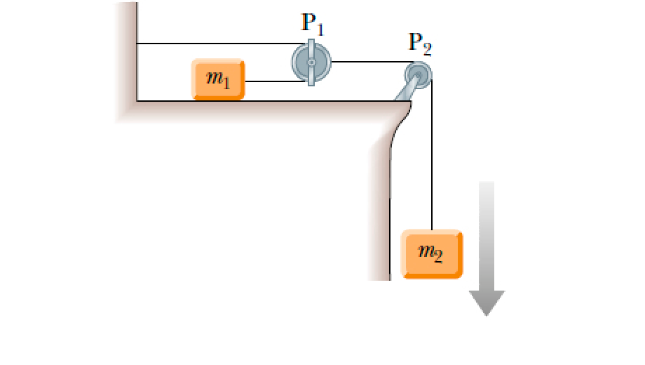
Figure. m₁ pulled by a single string; m₂ is carried by the movable pulley (two supporting strands).
(a) Constraint between the accelerations
A single string of tension T₁ runs from m₁, over the fixed pulley P₂, and around the movable pulley P₁ that carries m₂. Because two strands support the movable pulley, when m₁ advances a distance x the pulley (and m₂) moves only x/2. Differentiating twice:
$$a_{1}=2a_{2}$$
Answer (a): $a_{1}=2a_{2}$

Newton's second law
Block m₁ (frictionless table, single tension T₁):
$$T_{1}=m_{1}a_{1}$$
Block m₂ hangs from the movable pulley, so two strands (each T₁) pull it up; the net upward pull is T₂ = 2T₁:
$$m_{2}g−2T_{1}=m_{2}a_{2}$$
(c) Solving for the accelerations
Substituting T₁ = m₁a₁ = 2m₁a₂ into the m₂ equation:
$$m_{2}g−4m_{1}a_{2}=m_{2}a_{2} ⇒ m_{2}g=\left(4m_{1}+m_{2}\right)a_{2}$$
$$a_{2}=\frac{m_{2}g}{4m_{1}+m_{2}} , a_{1}=2a_{2}=\frac{2m_{2}g}{4m_{1}+m_{2}}$$
Answer (c): $a_{1}=\frac{2m_{2}g}{4m_{1}+m_{2}} , a_{2}=\frac{m_{2}g}{4m_{1}+m_{2}}$

(b) Tensions
$$T_{1}=m_{1}a_{1}=\frac{2m_{1}m_{2}g}{4m_{1}+m_{2}} , T_{2}=2T_{1}$$
Answer (b): $T_{1}=\frac{2m_{1}m_{2}g}{4m_{1}+m_{2}} , T_{2}=2T_{1}=\frac{4m_{1}m_{2}g}{4m_{1}+m_{2}}$

Exercise 6
Block A in the figure weighs 1.90 N, and block B weighs 4.20 N. The coefficient of kinetic friction between all surfaces is 0.30. Find the magnitude of the horizontal force F necessary to drag block B to the left at constant speed if A and B are connected by a light, flexible cord passing around a fixed, frictionless pulley.

Data
- w_A = 1.90 N, w_B = 4.20 N, μ_k = 0.30, constant speed ⇒ ΣF = 0
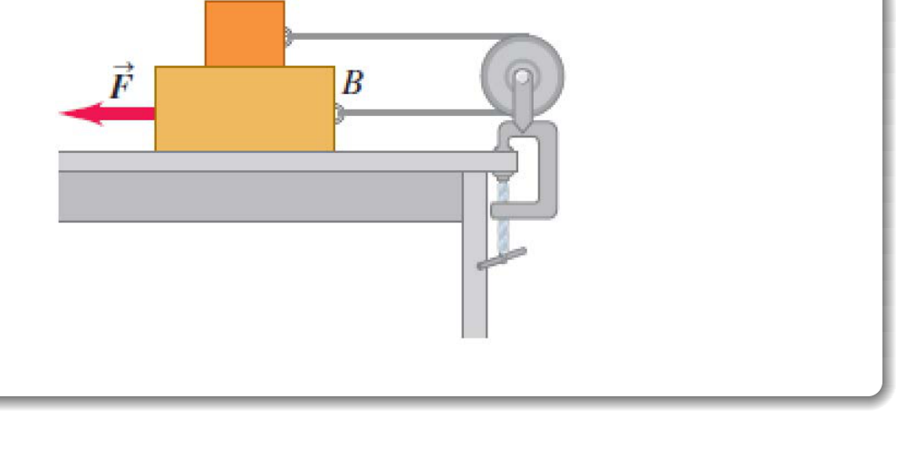
Figure. A rests on B; the cord links A to B over a wall pulley. Dragging B left makes A slide right.
Free-body analysis
Because the cord runs over the fixed pulley, when B moves left, A moves right. There are two sliding contacts (A–B and B–floor), so three friction effects plus the cord tension resist the motion.
Block A (constant velocity): the cord tension balances the friction from B, with normal force N_A = w_A:
$$T=μ_{k}w_{A}=0.30×1.90=0.57 N$$
Block B (constant velocity): F must overcome the cord tension T, the friction from A on top (μ_k·w_A), and the floor friction (μ_k·(w_A + w_B)):
$$F=T+μ_{k}w_{A}+μ_{k}\left(w_{A}+w_{B}\right)$$
$$F=0.57+0.57+0.30\left(1.90+4.20\right)=0.57 + 0.57 + 1.83=2.97 N$$
Answer: $F≈2.97 N$

Note. The listed answer key of 2.52 N corresponds to the original textbook value w_A = 1.40 N; with that weight F = μ_k(3w_A + w_B) = 0.30(4.20 + 4.20) = 2.52 N. The value above (2.97 N) is the correct result for the weights printed in this exercise (w_A = 1.90 N).
Exercise 7
In terms of m₁, m₂ and g, find the acceleration of each block in the figure. There is no friction anywhere in the system.

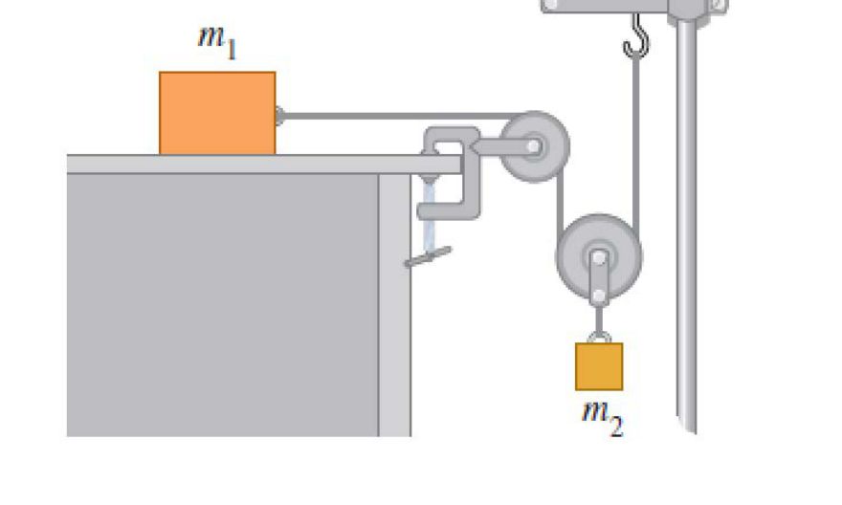
Figure. m₁ on a frictionless table connected through a fixed pulley to a movable pulley carrying m₂.
Setup
The arrangement is mechanically identical to Exercise 5, now completely frictionless. A single string (tension T) is attached to m₁, passes over the fixed pulley at the table edge, wraps around the movable pulley that holds m₂, and ends at a fixed hook. Two strands support the movable pulley.
(a) Constraint and equations
$$a_{1}=2a_{2}$$
Block m₁ (frictionless table):
$$T=m_{1}a_{1}$$
Block m₂ (carried by the movable pulley, net upward pull 2T):
$$m_{2}g−2T=m_{2}a_{2}$$
Solving
With T = m₁a₁ = 2m₁a₂:
$$m_{2}g−4m_{1}a_{2}=m_{2}a_{2} ⇒ a_{2}=\frac{m_{2}g}{4m_{1}+m_{2}}$$
Answer: $a_{2}=\frac{m_{2}g}{4m_{1}+m_{2}} , a_{1}=2a_{2}=\frac{2m_{2}g}{4m_{1}+m_{2}}$

Note. The movable pulley makes m₁ move twice as fast as m₂, hence a₁ = 2a₂ (the answer key's “a₁ = a₂” drops this factor of 2; its value of a₂ is consistent with the 2 : 1 pulley shown).
Exercise 8
A 20-kg monkey has a firm hold on a light rope that passes over a frictionless pulley and is attached to a 20-kg bunch of bananas. The monkey looks up, sees the bananas, and starts to climb the rope to get them. (a) As the monkey climbs, do the bananas move up, down, or stay at rest? (b) As the monkey climbs, does the distance between the monkey and the bananas decrease, increase, or stay the same? (c) The monkey releases her hold on the rope. What happens to the distance between the monkey and the bananas while she is falling? (d) Before reaching the ground, the monkey grabs the rope to stop her fall. What do the bananas do?

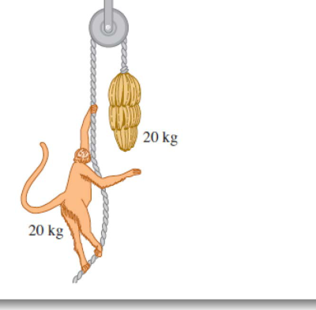
Figure. Equal masses (20 kg each) on a light rope over a frictionless pulley.
Key idea
The monkey (mass m) and the bananas (mass m) are equal. Applying Newton's second law to each body with the same rope tension T (upward positive):
$$T−mg=ma_{monkey} , T−mg=ma_{bananas}$$
The two equations are identical, so the monkey and the bananas always have the same acceleration (and, starting from rest, the same velocity) measured from the ground.
(a) Do the bananas move up, down, or stay at rest?
When the monkey climbs, she increases the tension, so T > mg and both bodies accelerate upward equally. The bananas move UP, at the same rate as the monkey.
Answer (a): The bananas move up (at the same speed as the monkey).

(b) Distance between monkey and bananas
Since both rise with identical velocity relative to the ground, the vertical gap between them does not change.
Answer (b): The distance stays the same (remains constant).

(c) After the monkey releases the rope
With no one holding one end, the rope tension drops to zero, so the monkey and the bananas are both in free fall with acceleration g. Their velocities change identically, so the gap between them is unchanged.
Answer (c): The distance stays the same (both fall freely at g).

(d) The monkey grabs the rope to stop her fall
Grabbing the rope restores the tension. Equal masses again force equal accelerations, so the same braking that stops the monkey also acts on the bananas. Having equal downward speeds, both decelerate together and come to rest.
Answer (d): The bananas also stop (they decelerate identically and come to rest).

