UNIVERSIDAD DEL VALLE
Physics and Laboratory I
Kinematics in Two Dimensions (2D)
Chapter 4 — Problem Set (Class 08)

Student | EDWARD ANDRÉS RODRÍGUEZ MAZUERA
Student code | 2535250-2713
Date | July 2, 2026

General problem-solving strategy: (1) think, (2) sketch, (3) research, (4) simplify, (5) calculate, (6) round, (7) analyse. Unless stated otherwise, g = 9.8 m/s² and air resistance is neglected.
Exercise 1
A projectile is launched so that the horizontal distance it travels (its range) is twice its maximum height. Find the launch angle.

Data
- R = 2h, y₀ = 0, x₀ = 0
Governing relations
The horizontal range and the maximum height of a projectile launched from ground level are:
$$R=\frac{v_{0}^{2}sin\left(2θ\right)}{g} , h=\frac{v_{0}^{2}{sinθ}^{2}}{2g}$$
Solution
Imposing R = 2h:
$$\frac{v_{0}^{2}sin\left(2θ\right)}{g}=2\frac{v_{0}^{2}{sinθ}^{2}}{2g} ⇒ sin\left(2θ\right)={sinθ}^{2}$$
Using the identity sin(2θ) = 2 sin θ cos θ:
$$2sinθcosθ={sinθ}^{2} ⇒ 2cosθ=sinθ ⇒ tanθ=2$$
Answer: $θ=\tan^{−1}\left(2\right)=63.4°$

Exercise 2
A bomber flies horizontally over flat ground with a speed of 275 m/s relative to the ground, at an altitude of 3 000 m. (a) How far will the bomb travel horizontally between release and impact? (b) If the plane keeps its original course and speed, where is it when the bomb hits the ground? (c) At what angle from the vertical, at the point of release, should the bomb-sight be set so that the bomb hits the target seen in the sight at the instant of release?

Data
- θ = 0° (horizontal release), v₀ = 275 m/s, y₀ = 3 000 m
Solution
(a) Vertical motion is a free fall from rest (v₀ᵧ = 0). Setting y = 0 at impact:
$$0=y_{0}−\frac{1}{2}gt^{2} ⇒ 4.9t_{b}^{2}−3000=0$$
$$t_{b}=\sqrt{\frac{3000}{4.9}}=24.7 s$$
The horizontal distance travelled by the bomb is then:
$$x=v_{0}t_{b}=275×24.7=6 805 m$$
Answer (a): x ≈ 6.80 × 10³ m (about 6 805 m).

(b) The bomb keeps the plane's horizontal velocity, so it stays directly below the plane throughout the fall. When the bomb hits the ground the plane is directly above the impact point — i.e. 6 805 m past the release point (3 000 m above the bomb).
Answer (b): The plane is directly over the bomb (6 805 m from release, 3 000 m up).

(c) The line of sight to the target makes an angle φ with the vertical, where:
$$tanφ=\frac{x}{y_{0}}=\frac{6 805}{3 000} ⇒ φ=66.2°$$
Answer (c): $φ≈66° from the vertical$

Exercise 3
Jimmy is at the bottom of a hill, while Billy is 30 m up the same hill. Jimmy is at the origin of an xy-system and the line of the slope is given by y = 0.4x. If Jimmy throws an apple to Billy at an angle of 50° above the horizontal, with what speed must he throw the apple so that it reaches Billy?

Data
- d = 30 m (distance along the slope), θ = 50°, slope: y = 0.4x
Approach
The trajectory of the apple is the parabola
$$y=tanθx−\frac{g}{2v_{0}^{2}{cosθ}^{2}}x^{2}$$
Since Billy lies on the line y = 0.4x, at every point of that line y/x = 0.4. Substituting and using x = d·cos(tan⁻¹0.4) for Billy's horizontal coordinate:
$$0.4=tanθ−\frac{g}{2v_{0}^{2}{cosθ}^{2}}x$$
Solving for v₀:
$$v_{0}=\sqrt{\frac{gdcos\left[\tan^{−1}\left[0.4\right]\right]}{2{cosθ}^{2}\left(tanθ−0.4\right)}}$$
With x = 30·cos(21.8°) = 27.85 m, tan 50° = 1.1918 and cos²50° = 0.4132:
$$v_{0}=\sqrt{\frac{(9.8)(27.85)}{2(0.4132)(1.1918−0.4)}}=20.4 m/s$$
Answer: $v_{0}≈20.4 m/s$

Exercise 4
A child slides down a frozen roof. He starts from the top of the roof, which is 8.0 m long and makes an angle of 40° with the horizontal, accelerating at 5.0 m/s². The edge of the roof is 6.0 m above a soft snowbank, on which he will land. Find the horizontal distance between the house and the landing point.

Data
- v₀ = 0, L = 8.0 m, a = 5.0 m/s², θ = 40°, y₀ = 6.0 m
Approach
There are two motions: uniformly accelerated straight-line motion on the roof, then projectile motion after the edge.
Motion 1 (on the roof) — from v² = v₀² + 2aL the speed at the edge is:
$$v^{2}=v_{0}^{2}+2aL=2(5.0)(8.0)=80 m²/s²$$
This is the launch speed for the second stage, directed 40° below the horizontal.
Motion 2 (projectile) — taking the edge as origin and downward launch:
$$0=y_{0}−tanθx−\frac{g}{2v^{2}{cosθ}^{2}}x^{2}$$
$$0.1044x^{2}+0.8391x−6.0=0 ⇒ x=4.56 m$$
Answer: $x≈4.6 m$

Exercise 5
A skier leaves the ramp of a ski jump with a velocity of 10.0 m/s, 15.0° above the horizontal. The slope below is inclined at 50.0°, and air resistance is negligible. Find (a) the distance from the ramp to the landing point, and (b) the velocity components just before landing. (How might the results change if air resistance were included? Note that jumpers lean forward into an airfoil shape to increase their distance — why does this work?)

Data
- v₀ = 10.0 m/s, θ = 15.0° (above horizontal), slope angle = 50.0°
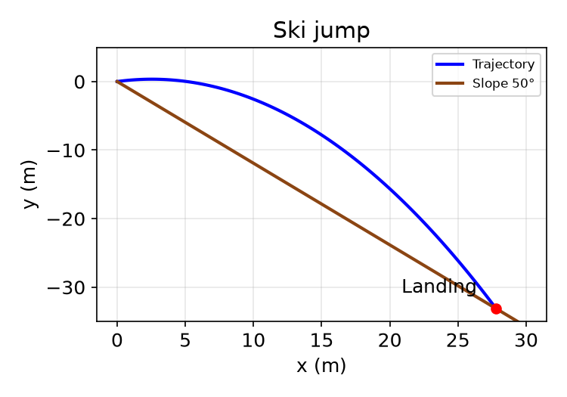
Figure. Parabolic trajectory meeting the 50° slope.
Solution
Take the ramp as origin, x horizontal, y upward. The landing point on the slope satisfies y = −x·tan 50°. With x = v₀cosθ·t and y = v₀sinθ·t − ½gt²:
$$\frac{v_{0}sinθt−\frac{1}{2}gt^{2}}{v_{0}cosθt}=−tan50°$$
$$t=\frac{v_{0}\left(sinθ+cosθtan50°\right)}{\frac{1}{2}g}=2.88 s$$
(a) Horizontal reach x = (10.0 cos15°)(2.88) = 27.8 m, so the distance along the slope is:
$$d=\frac{x}{cos50°}=\frac{27.8}{0.6428}=43.2 m$$
Answer (a): $d≈43.2 m$

(b) Velocity components just before landing:
$$v_{x}=v_{0}cosθ=9.7 m/s$$
$$v_{y}=v_{0}sinθ−gt=2.59 − (9.8)(2.88)=−25.6 m/s$$
Answer (b): v = (9.7 î − 25.6 ĵ) m/s.

Discussion: with air resistance the horizontal component would decay, shortening the range. By leaning into an airfoil shape the jumper generates lift and reduces drag, extending the flight time and therefore the distance.
Exercise 6
A daring 510 N swimmer dives off a cliff with a running horizontal leap. What must her minimum speed be as she leaves the top so that she clears the ledge at the bottom, which is 1.75 m wide and 9.00 m below the top of the cliff?

Data
- Horizontal launch (θ = 0), ledge width x = 1.75 m, drop y = 9.00 m
Note: the 510 N weight is extra information; the motion does not depend on mass.
Solution
Time to fall 9.00 m from rest in the vertical direction:
$$y=\frac{1}{2}gt^{2} ⇒ t=\sqrt{\frac{2y}{g}}=\sqrt{\frac{2(9.00)}{9.8}}=1.355 s$$
To just clear the ledge she must cover 1.75 m horizontally in that time:
$$v_{0}=\frac{x}{t}=\frac{1.75}{1.355}=1.29 m/s$$
Answer: $v_{0}≈1.3 m/s$

Exercise 7
A water hose fills a large cylindrical storage tank of diameter D and height 2D. The hose shoots water at 45° above the horizontal, from the same level as the base of the tank and a distance 6D away. For what range of launch speeds v₀ will the water enter the tank? Ignore air resistance and express the answer in terms of D and g.

Data
- θ = 45°, near wall at x = 6D, far wall at x = 7D, rim height y = 2D
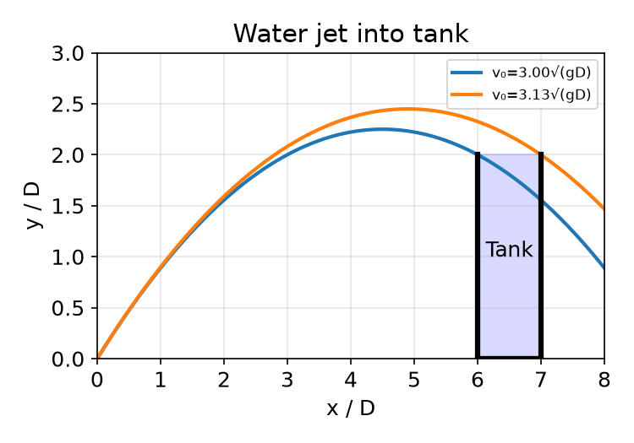
Figure. Slowest jet just clears the near rim; fastest just reaches the far rim.
Solution
With θ = 45° the trajectory (launched from ground level) simplifies to:
$$y=x−\frac{g}{v_{0}^{2}}x^{2}$$
Slowest speed — the jet just clears the near rim (x = 6D, y = 2D):
$$2D=6D−\frac{g(6D)^{2}}{v_{0}^{2}} ⇒ v_{0}^{2}=9gD$$
$$v{}_{0}=3.0\sqrt{gD}$$
Fastest speed — the jet just reaches the far rim (x = 7D, y = 2D):
$$2D=7D−\frac{g(7D)^{2}}{v_{0}^{2}} ⇒ v_{0}^{2}=9.8gD$$
$$v_{0}=3.1\sqrt{gD}$$
Answer: $3.0\sqrt{gD}<v_{0}<3.1\sqrt{gD}$

Exercise 8
A flea can jump to a vertical height h. (a) What is the maximum horizontal distance it can jump? (b) What is the time in the air in both cases (the vertical jump and the maximum-range jump)?

Solution
A vertical jump to height h fixes the take-off speed v₀ through energy/kinematics:
$$h=\frac{v_{0}^{2}}{2g} ⇒ v_{0}^{2}=2gh$$
(a) The horizontal range is maximum at 45°, where R = v₀²/g:
$$R_{max}=\frac{v_{0}^{2}}{g}=\frac{2gh}{g}=2h$$
Answer (a): $R_{max}=2h$

(b) Time aloft in each case (v₀ = √(2gh)):
$$Vertical (90°): t_{v}=\frac{2v_{0}}{g}=2\sqrt{\frac{2h}{g}}$$
$$Range (45°): t_{R}=\frac{2v_{0}sin45°}{g}=2\sqrt{\frac{h}{g}}$$
Answer (b): Vertical jump: t = 2√(2h/g). 45° jump: t = 2√(h/g) (a factor √2 shorter).

